 | Lycée Guillaume Kroll  BTS Cloud Computing  VIRCL Module  Teachers:  Mrs. RODESCH Christian  Mrs. SPAGNUOLO Maurizio

Server Virtualization
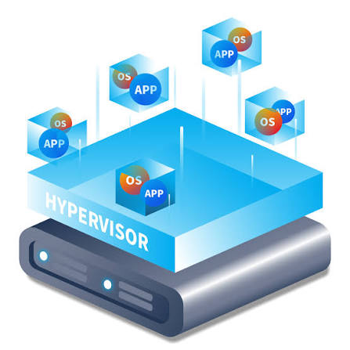
in the cloud

TECHNICAL DOCUMENTATION REPORT

Prepared by  Marios  Christophe Thill | Specialization  Virtual Machine Backup  & Hypervisor Backup
June 2026

Executive Summary
This report documents the implementation of a server virtualization infrastructure using Proxmox Virtual Environment (VE) 9.1.1 on two physical HP ProLiant servers (HP01 and HP03), alongside VMware ESXi/vSphere on two additional HP ProLiant servers (HP02 and HP04). The project covers the full lifecycle of virtualization management: from hypervisor deployment and virtual machine provisioning to advanced operations including live migration, remote storage integration, user management, and system maintenance.
All sixteen required features were successfully implemented on both Proxmox nodes, which were subsequently clustered for centralized management. The CLOIF2 NAS (OpenMediaVault) was integrated via NFS and SMB protocols to provide shared storage for VM disks, backups, and ISO images.
This documentation serves as both a technical reference and a comparative analysis between Proxmox VE and VMware ESXi/vSphere, based on hands-on experience with both platforms during this project.
Table of Contents

Executive Summary 2
1. Introduction 11
1.1 Project Context 11
1.2 Objectives 11
1.3 Scope 11
1.4 Methodology 12
2. Infrastructure Overview 13
2.1 Physical Servers 13
2.2 NAS / Remote Storage 13
2.3 Virtual Machines Inventory 13
3. Hypervisor Deployment 14
3.1 Objective 14
3.2 Theoretical Background 14
3.3 Proxmox Implementation 14
Step 1: Remote ISO Mounting via iLO 14
Step 2: Installation Process 15
Step 3: Post-Installation Verification 17
3.4 VMware Comparison 17
4. Virtual Machine Creation via GUI 19
4.1 Objective 19
4.2 Proxmox Implementation 19
Step 1: Upload ISO Images 19
Step 2: Configure VM Parameters 19
4.3 VMware Comparison 23
5. Virtual Machine Creation via CLI 24
5.1 Objective 24
5.2 Proxmox Implementation 24
5.3 VMware Comparison 25
6. Operating System Installation 26
6.1 Objective 26
6.2 Ubuntu Server Installation (VM 100) 26
6.3 Windows 11 Installation (VM 101) 26
6.4 VMware Comparison 26
7. Virtual Machine Configuration Changes 27
7.1 Objective 27
7.2 Proxmox Implementation 27
7.3 VMware Comparison 28
8. Clone a Virtual Machine 29
8.1 Objective 29
8.2 Proxmox Implementation 29
8.3 VMware Comparison 30
9. Export a Virtual Machine 31
9.1 Objective 31
9.2 Proxmox Implementation 31
9.3 VMware Comparison 31
10. Virtual Machine Backup & Hypervisor Backup 32
10.1 Objective 32
10.2 Theoretical Background 32
Backup Modes 32
10.3 VM Backup — Method 1: Built-in GUI (vzdump) 32
10.4 VM Backup — Method 2: CLI (vzdump) 33
10.5 VM Backup — Method 3: Custom Backup Script 33
10.6 VM Backup — Method 4: Scheduled Jobs 34
10.7 VM Restore 34
10.8 Hypervisor Backup 34
10.9 VMware Comparison 35
10.10 Do's and Don'ts of Virtualization Backup 35
Do's 35
Don'ts 36
11. Snapshots 37
11.1 Objective 37
11.2 Proxmox Implementation 37
11.3 VMware Comparison 38
12. Virtual Machine Templates 39
12.1 Objective 39
12.2 Proxmox Implementation 39
12.3 VMware Comparison 40
13. Remote Storage Integration 41
13.1 Objective 41
13.2 NAS Configuration (OpenMediaVault) 41
13.3 Proxmox Implementation 41
13.4 VMware Comparison 43
14. Live Migration — Storage to Storage 44
14.1 Objective 44
14.2 Proxmox Implementation 44
14.3 VMware Comparison 45
15. Live Migration — Hypervisor to Hypervisor 46
15.1 Objective 46
15.2 Prerequisites: Cluster Configuration 46
15.3 Proxmox Implementation 47
15.4 VMware Comparison 48
16. User Management & Permissions 49
16.1 Objective 49
16.2 Proxmox Implementation 49
16.3 VMware Comparison 51
17. Hypervisor Patching & Updates 52
17.1 Objective 52
17.2 Proxmox Implementation 52
17.3 Issue Resolution 54
17.4 VMware Comparison 54
18. VMware Hypervisor Deployment 55
18.1 Objective 55
18.2 Theoretical Background 55
18.3 VMware Implementation 55
Step 1: ESXi Installation 55
Step 2: vCenter Server Appliance (VCSA) Deployment 57
Step 3: Post-Installation Verification 61
18.4 Proxmox Comparison 62
18.5 Results 62
19. Virtual Machine Creation via GUI (vCenter) 64
19.1 Objective 64
19.2 Theoretical Background 64
19.3 VMware Implementation 64
Step 1: Datacenter and Host Setup 64
Step 2: New VM Wizard 66
19.4 Proxmox Comparison 69
19.5 Results 69
20. Virtual Machine Creation via CLI 71
20.1 Objective 71
20.2 Theoretical Background 71
20.3 VMware Implementation 71
20.4 Proxmox Comparison 72
20.5 Results 72
21. Operating System Installation 74
21.1 Objective 74
21.2 Windows 11 Installation 74
21.3 Ubuntu Server Installation 76
21.4 Proxmox Comparison 79
21.5 Results 79
22. Virtual Machine Configuration Changes 80
22.1 Objective 80
22.2 Theoretical Background 80
22.3 VMware Implementation 80
22.4 Proxmox Comparison 81
22.5 Results 81
23. Clone a Virtual Machine 82
23.1 Objective 82
23.2 Theoretical Background 82
23.3 VMware Implementation 82
23.4 Proxmox Comparison 85
23.5 Results 85
24. Export a Virtual Machine 86
24.1 Objective 86
24.2 Theoretical Background 86
24.3 VMware Implementation 86
24.4 Proxmox Comparison 87
24.5 Results 87
25. Virtual Machine Backup & Hypervisor Backup 88
25.1 Objective 88
25.2 Theoretical Background 88
25.3 Veeam Backup & Replication Installation 88
25.4 Veeam Configuration 90
25.5 Hypervisor Configuration Backup 99
25.6 Proxmox Comparison 100
25.7 Results 101
26. Snapshots 102
26.1 Objective 102
26.2 Theoretical Background 102
26.3 VMware Implementation 102
26.4 Proxmox Comparison 104
26.5 Results 104
27. Virtual Machine Templates 105
27.1 Objective 105
27.2 Theoretical Background 105
27.3 VMware Implementation 105
27.4 Proxmox Comparison 108
27.5 Results 108
28. Remote Storage Integration 109
28.1 Objective 109
28.2 Theoretical Background 109
28.3 VMware Implementation 109
28.4 Proxmox Comparison 112
28.5 Results 112
29. Live Migration — Storage to Storage 113
29.1 Objective 113
29.2 Theoretical Background 113
29.3 VMware Implementation 113
29.4 Proxmox Comparison 115
29.5 Results 115
30. Live Migration — Hypervisor to Hypervisor 116
30.1 Objective 116
30.2 Theoretical Background 116
30.3 VMware Implementation — Running VM 116
30.4 VMware Implementation — Stopped VM 119
30.5 Proxmox Comparison 121
30.6 Results 121
31. User Management & Permissions 122
31.1 Objective 122
31.2 Theoretical Background 122
31.3 VMware Implementation 122
31.4 Proxmox Comparison 124
31.5 Results 124
32. Hypervisor Patching & Updates 125
32.1 Objective 125
32.2 Theoretical Background 125
32.3 VMware Implementation 125
32.4 Proxmox Comparison 127
32.5 Results 127
33. Proxmox vs VMware — Comparative Analysis 128
33.1 Feature Comparison Matrix 128
33.2 Cost Analysis 128
33.3 Use Case Recommendations 129
33.4 Personal Assessment 129
34. Problems & Impediments 130
34.1 Issues Encountered and Solutions 130
34.2 Lessons Learned 130
35. Personal Conclusion 132
35.1 Project Reflection 132
35.2 Technical Growth 132
35.3 Platform Assessment 132
35.4 Final Thoughts 132
Appendix A: Proxmox CLI Quick Reference 133
Appendix B: Glossary 134
Hypervisor 134
KVM (Kernel-based Virtual Machine) 134
LXC (Linux Containers) 134
QEMU 134
QCOW2 134
vzdump 134
VMA 134
LVM (Logical Volume Manager) 134
NFS (Network File System) 134
SMB/CIFS 134
iLO (Integrated Lights-Out) 134
vMotion 135
Storage vMotion 135
DRS (Distributed Resource Scheduler) 135
HA (High Availability) 135
vSAN 135
VMFS (Virtual Machine File System) 135
VADP (vStorage APIs for Data Protection) 135
CBT (Changed Block Tracking) 135
Veeam Backup & Replication 135
VSS (Volume Shadow Copy Service) 135
OVF (Open Virtualization Format) 135
OVA (Open Virtualization Appliance) 135
UEFI (Unified Extensible Firmware Interface) 135
SeaBIOS 136
VirtIO 136
TPM (Trusted Platform Module) 136
cloud-init 136
Content Library 136
RBAC (Role-Based Access Control) 136
SSO (Single Sign-On) 136
EVC (Enhanced vMotion Compatibility) 136
VDI (Virtual Desktop Infrastructure) 136
RAID (Redundant Array of Independent Disks) 136
Thin Provisioning 136
Snapshot 136
Template 137
Live Migration 137
Cluster 137
pmxcfs 137
APT (Advanced Package Tool) 137
ZSTD 137
pvecm 137
qm 137
esxcli 137
vim-cmd 137
PowerCLI 137
vSphere Client 137
vCenter Server Appliance (VCSA) 138
vSphere Lifecycle Manager (vLCM) 138
Proxmox VE 138
VMware ESXi 138
OpenMediaVault 138
Areca RAID 138
Appendix C: Sources and References 139
List of Figures 140

1. Introduction

1.1 Project Context
Server virtualization has been a cornerstone of enterprise IT infrastructure for over two decades. By abstracting physical hardware resources and presenting them as virtualized compute, storage, and network resources, organizations can achieve significant improvements in resource utilization, operational flexibility, and cost efficiency. Where once each service required dedicated physical hardware, modern virtualization platforms enable administrators to consolidate dozens of workloads onto a single physical server.
This project, conducted as part of the VIRCL (Virtualization, Cloud, and Infrastructure) module at Lycée Guillaume Kroll, provides hands-on experience with two leading Type-1 hypervisors: Proxmox Virtual Environment (VE) and VMware ESXi/vSphere. Working in a team of two, each member specialized in one platform while maintaining awareness of the other for comparative analysis.

1.2 Objectives
The primary objectives of this project were to deploy two instances of Proxmox VE on physical servers, create and configure virtual machines using both GUI and CLI methods, install Windows and Linux operating systems, modify VM configurations dynamically, clone and export VMs, implement backup strategies, utilize snapshots, create templates, integrate remote storage, perform live migrations, manage users and permissions, and maintain hypervisor security through patching.

1.3 Scope
Component | Details
Hypervisor Platform | Proxmox VE 9.1.1
Physical Servers | HP ProLiant DL360 Gen9 (HP01, HP03)
Guest Operating Systems | Ubuntu Server 24.04.3 LTS, Windows 11 Enterprise Evaluation (via Windows 10 ISO)
Network | 10.0.10.0/16 (school infrastructure)
Remote Storage | OpenMediaVault (NAS) at 10.0.13.1
Storage Protocols | NFS, SMB/CIFS
Specialization | Virtual Machine Backup & Hypervisor Backup

1.4 Methodology
Each feature was implemented following a consistent methodology: research official documentation, plan the approach, implement with screenshot documentation, verify functionality, record observations, and compare with VMware implementation.

2. Infrastructure Overview

2.1 Physical Servers
Server | Role | LAN1 IP | iLO IP | Hostname | Status
HP01 | Proxmox Node 1 | 10.0.10.11 | 192.168.0.1 | HP01.local | Active, clustered
HP03 | Proxmox Node 2 | 10.0.10.31 | 192.168.0.3 | HP03.local | Active, clustered

2.2 NAS / Remote Storage
The CLOIF2 NAS provides centralized storage for the virtualization infrastructure. It runs OpenMediaVault 7 on Debian 13 Trixie with an Areca RAID5 storage pool. Two shares were created for Proxmox integration: an NFS share (proxmox-nfs) for VM disk images with rw,no_root_squash permissions, and an SMB share (proxmox-smb) for ISO images and backups.

2.3 Virtual Machines Inventory
VM ID | Name | Node | OS | State
100 | UbuntuServer-GUI | HP01 | Ubuntu 24.04.3 Server | Stopped (template)
101 | WindowsClient-CLI | HP01 | Windows 11 Enterprise Eval | Running
102 | UbuntuServer-Clone | HP01 | Ubuntu 24.04.3 Server | Stopped
110 | UbuntuServer-cloneCLI | HP01 | Ubuntu 24.04.3 Server | Stopped
150 | UbuntuServer-fromTemplate | HP01 | Ubuntu 24.04.3 Server | Created

3. Hypervisor Deployment

3.1 Objective
Install Proxmox VE 9.1.1 on two physical HP ProLiant servers using remote ISO mounting via iLO, configure network settings, and verify accessibility through the web interface.

3.2 Theoretical Background
Proxmox VE is a Type-1 (bare-metal) hypervisor built on Debian Linux, using KVM for full virtualization and LXC for containerization. Unlike hosted (Type-2) hypervisors that run on top of an existing operating system, Type-1 hypervisors run directly on the hardware, providing better performance and resource efficiency.

3.3 Proxmox Implementation

Step 1: Remote ISO Mounting via iLO
The Proxmox VE installation ISO was remotely mounted using the HP iLO 4 interface. Accessing the iLO web interface at 192.168.0.1 (HP01) and 192.168.0.3 (HP03), the ISO was attached through Virtual Media and the server was rebooted to boot from the virtual CD-ROM.
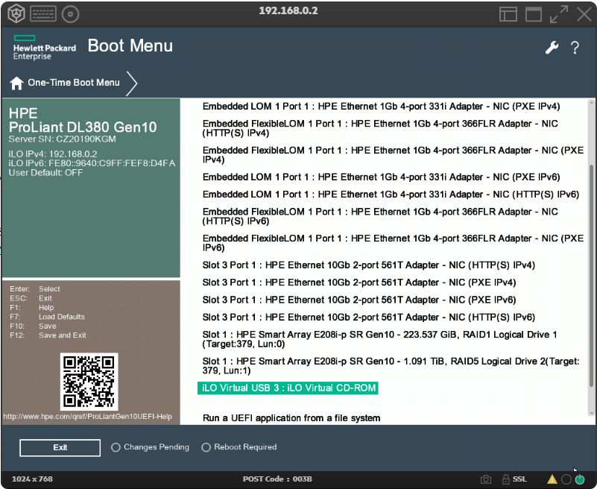
Figure 1: Selecting the boot media in iLO Virtual Media
The HP iLO 4 interface is used to mount the Proxmox VE installation ISO as virtual media, enabling remote boot without physical media.
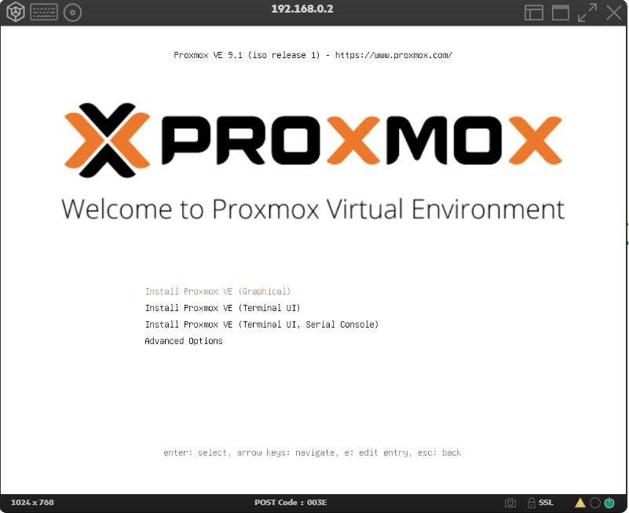
Figure 2: Proxmox boot menu
The Proxmox installer boot menu appears after the server boots from the mounted ISO, initiating the guided installation process.

Step 2: Installation Process
The Proxmox installer presented a guided setup: accepting the GNU AGPL v3 license, selecting the RAID array as the target drive, configuring the timezone to Europe/Luxembourg, setting the network parameters (IP 10.0.10.11/31, netmask 255.255.0.0, gateway 10.0.0.1, DNS 10.0.0.1), setting the hostname and root password, and confirming the installation summary.
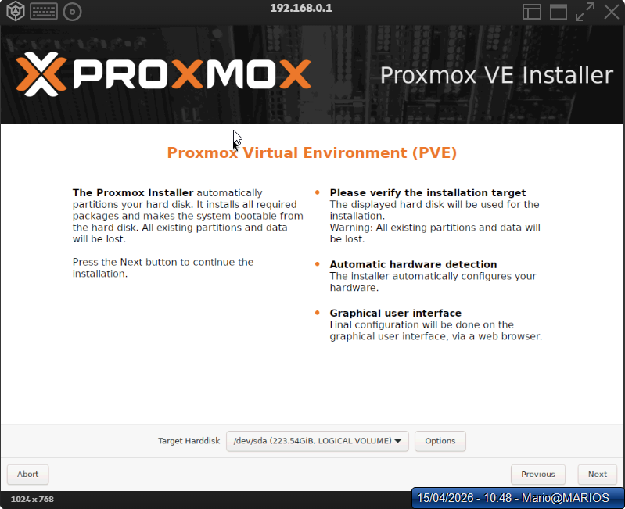
Figure 3: Target drive selection
The installer presents the RAID array as the target drive for the Proxmox VE installation.
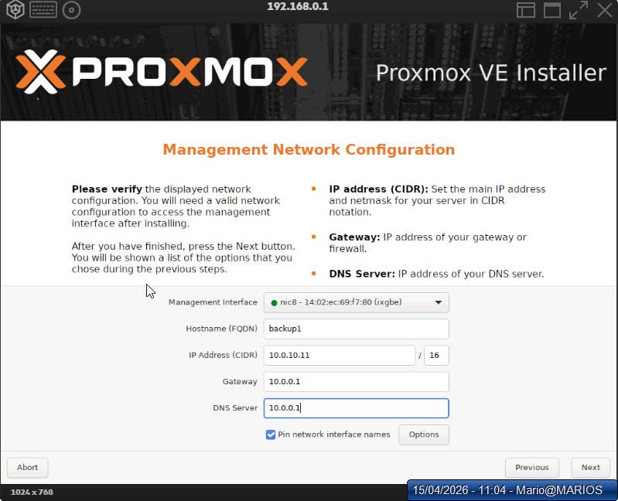
Figure 4: Network configuration
The network configuration screen sets the IP address, netmask, gateway, and DNS for the Proxmox node.
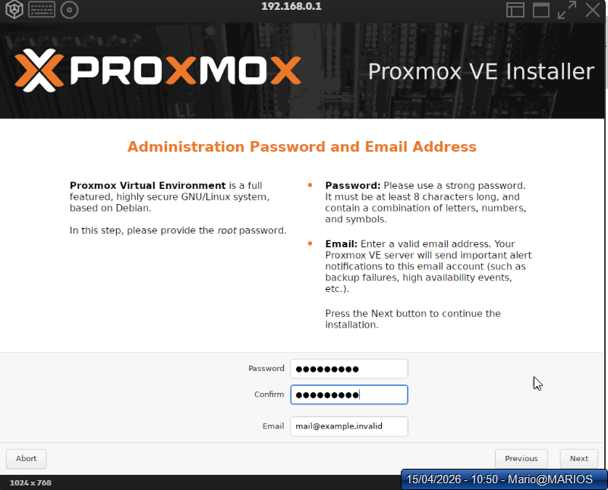
Figure 5: Root password configuration
The root password is set during installation to secure administrative access to the Proxmox node.
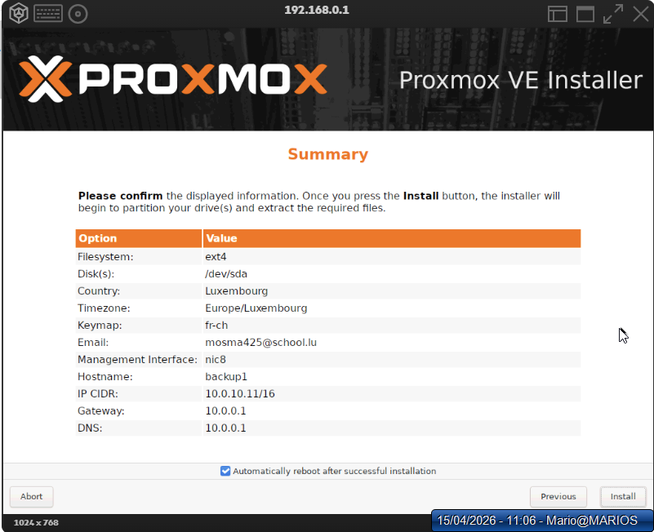
Figure 6: Installation summary
The final summary screen displays the configured settings before committing the installation.

Step 3: Post-Installation Verification
After reboot, both nodes were accessible via web UI at https://10.0.10.11:8006 and https://10.0.10.31:8006. SSH connectivity was confirmed and the Proxmox version was verified using the pveversion command.
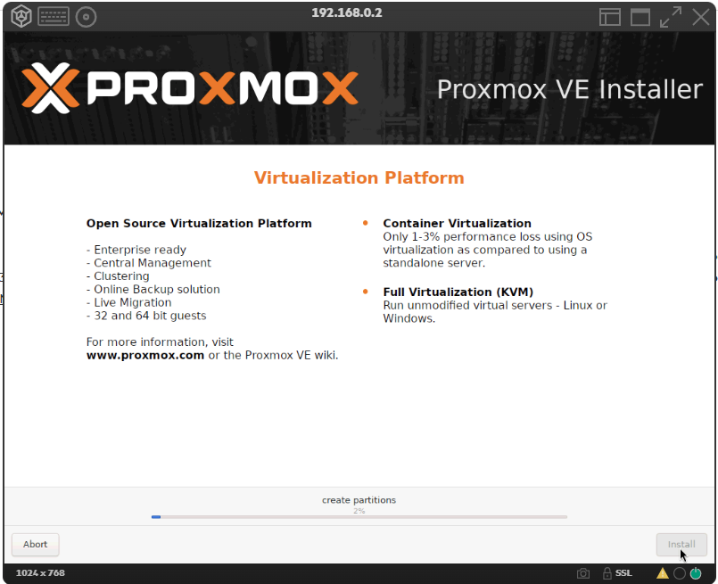
Figure 7: Post-installation web interface
The Proxmox web interface is accessible immediately after installation, confirming successful deployment and node accessibility.

3.4 VMware Comparison
Aspect | Proxmox VE | VMware ESXi
Installation Media | Free ISO download | Requires VMware account and license
Post-Install UI | Built-in web UI (port 8006) | DCUI + vCenter required for full management
Initial Config | Guided installer | Minimal installer; network via DCUI
Licensing | No license required | Requires vSphere license for most features
Key Difference: Proxmox provides a fully functional web interface immediately after installation, while VMware ESXi requires either the limited Host Client or a separate vCenter Server appliance for centralized management. This makes Proxmox more accessible for small deployments or learning environments.

4. Virtual Machine Creation via GUI

4.1 Objective
Create a virtual machine using the Proxmox web interface, configuring all hardware parameters through the graphical wizard.

4.2 Proxmox Implementation

Step 1: Upload ISO Images
Before creating VMs, operating system ISO images were uploaded to Proxmox local storage through Datacenter → HP01 → local → ISO Images → Upload. The Ubuntu Server and Windows 11 ISOs were transferred and verified.
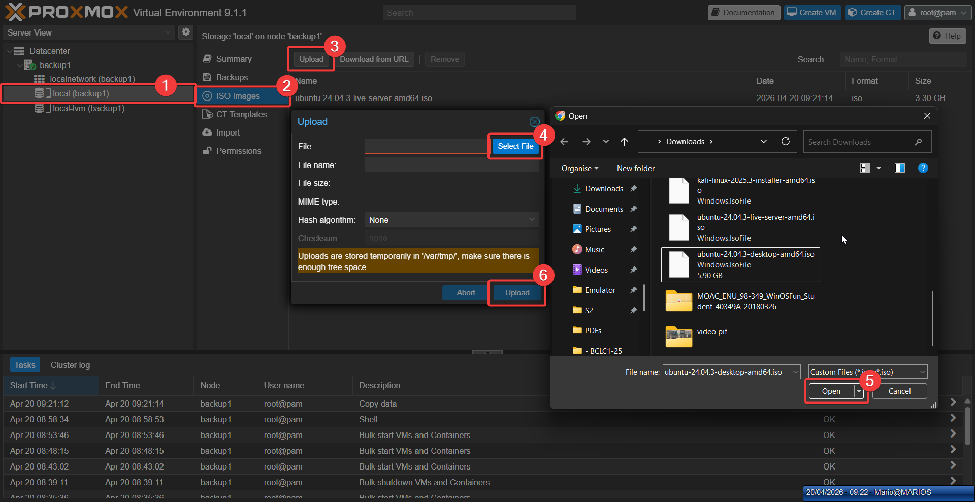
Figure 8: ISO image upload to local storage
Operating system ISO images are uploaded to Proxmox local storage to prepare for virtual machine creation.

Step 2: Configure VM Parameters
The Create VM wizard was launched and configured across seven tabs. The General tab set the VM ID to 100 and name to UbuntuServer-GUI. The OS tab selected the Ubuntu Server ISO. The System tab used SeaBIOS with VirtIO SCSI controller. The Disks tab allocated 32 GiB on local-lvm in QCOW2 format with discard enabled for thin provisioning. The CPU tab assigned 2 cores with host type. The Memory tab set 4096 MiB with ballooning enabled. The Network tab configured a VirtIO NIC on vmbr0.
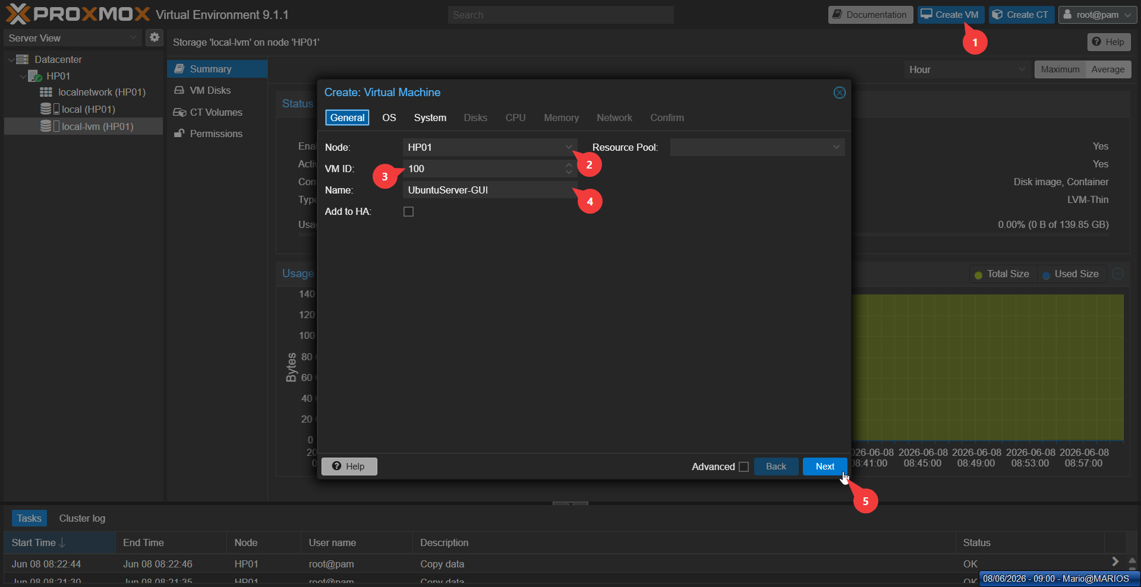
Figure 9: General settings
The General tab of the Create VM wizard assigns the VM ID and name to identify the new virtual machine.
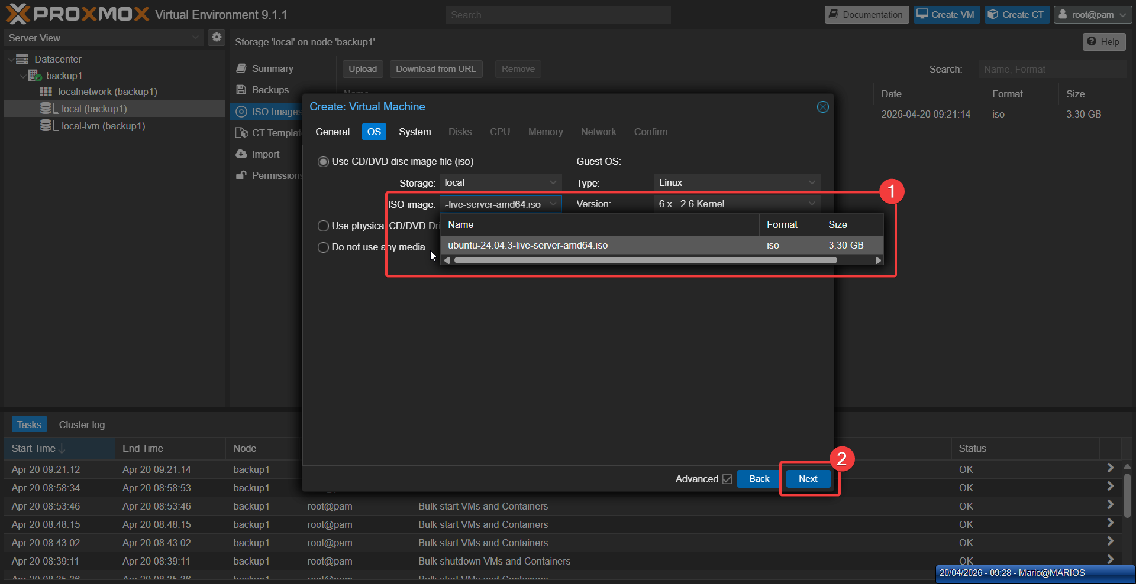
Figure 10: OS selection
The OS tab selects the Ubuntu Server ISO image that will be used to install the guest operating system.
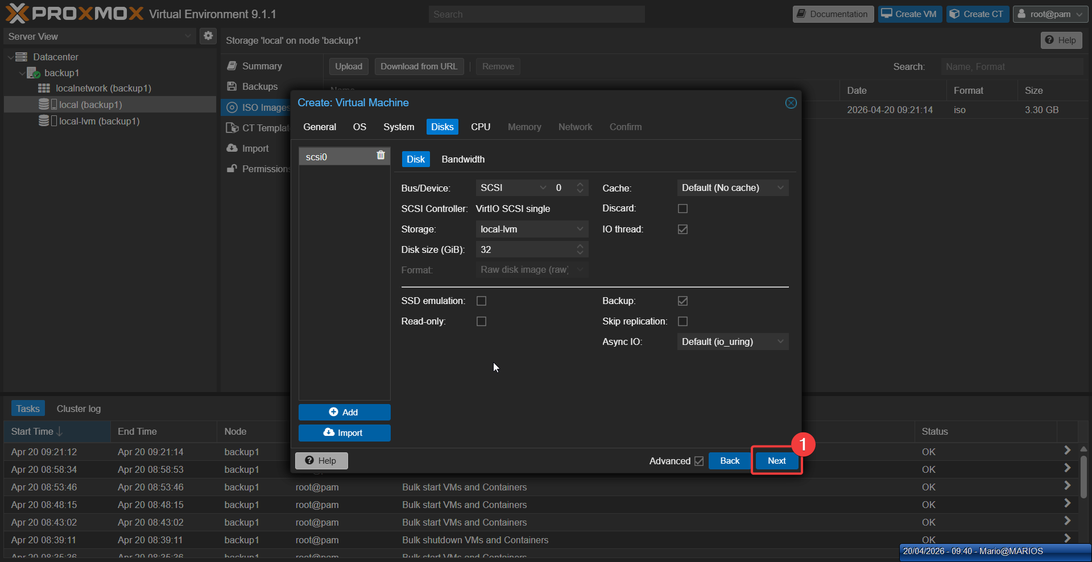
Figure 11: Disk configuration
The Disks tab configures virtual storage parameters for the new VM, including size and format.
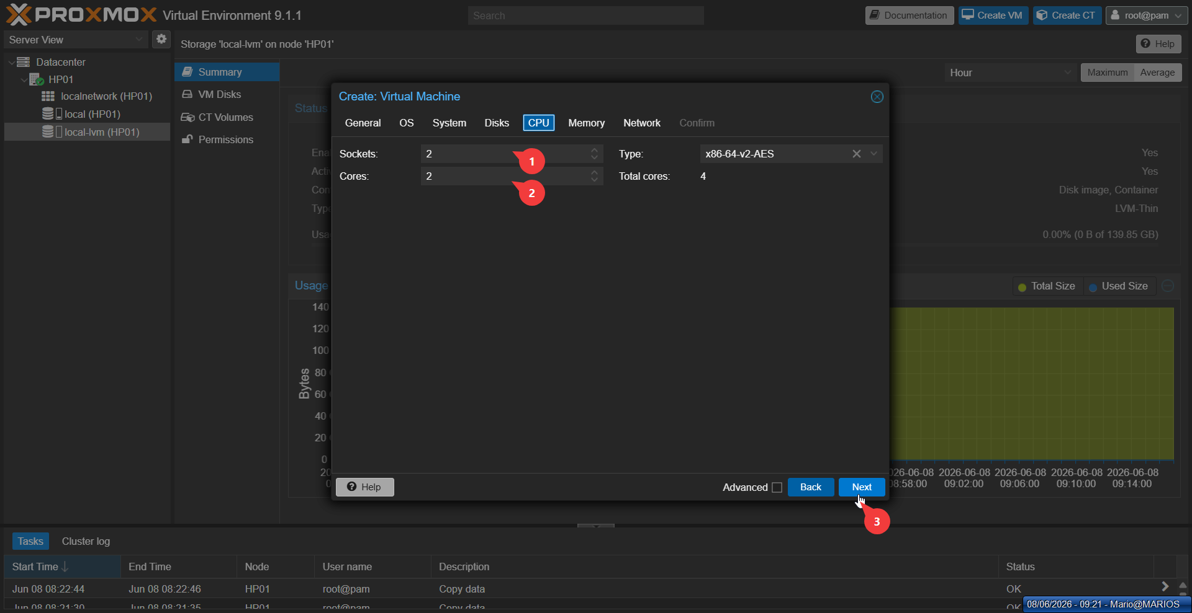
Figure 12: CPU configuration
The CPU tab specifies the processor allocation and core count for the virtual machine.
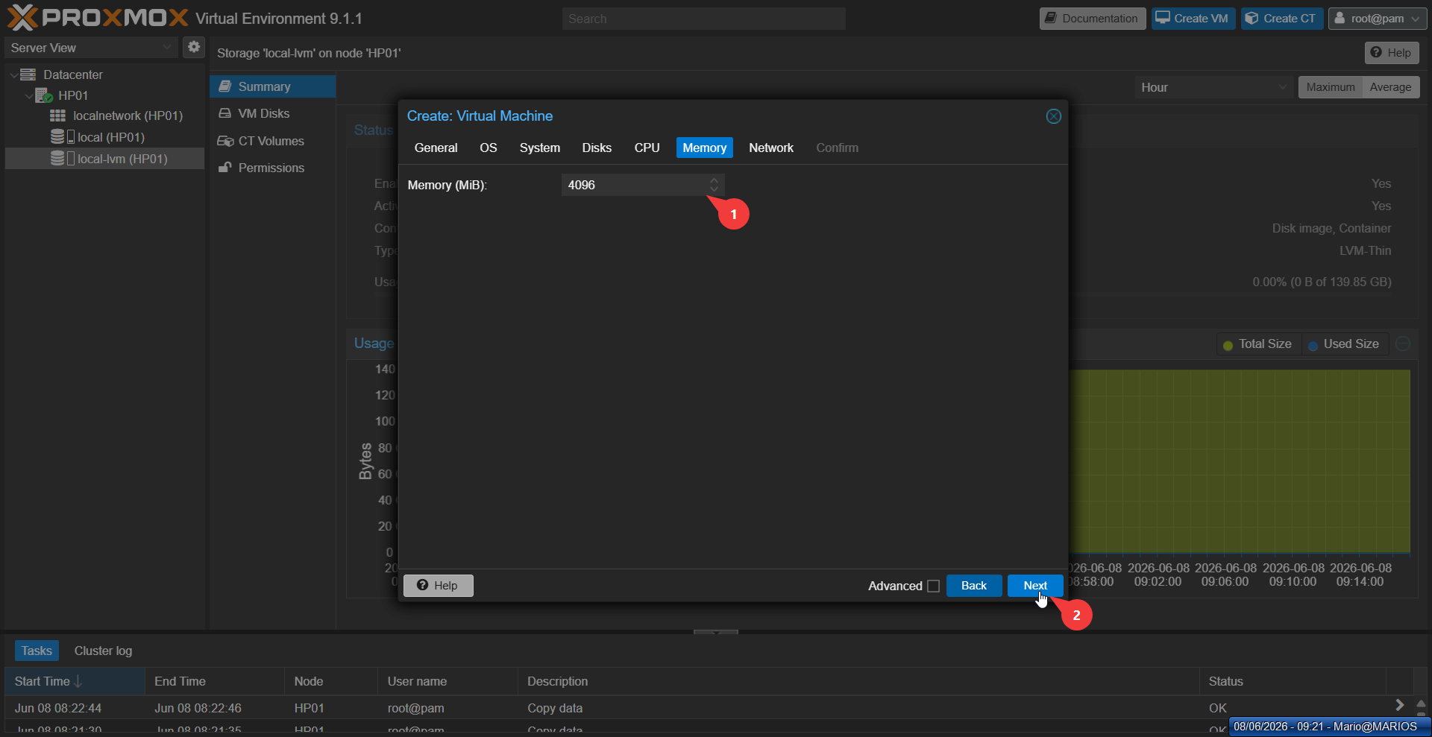
Figure 13: Memory configuration
The Memory tab sets the RAM allocation to ensure the VM has sufficient resources to run.
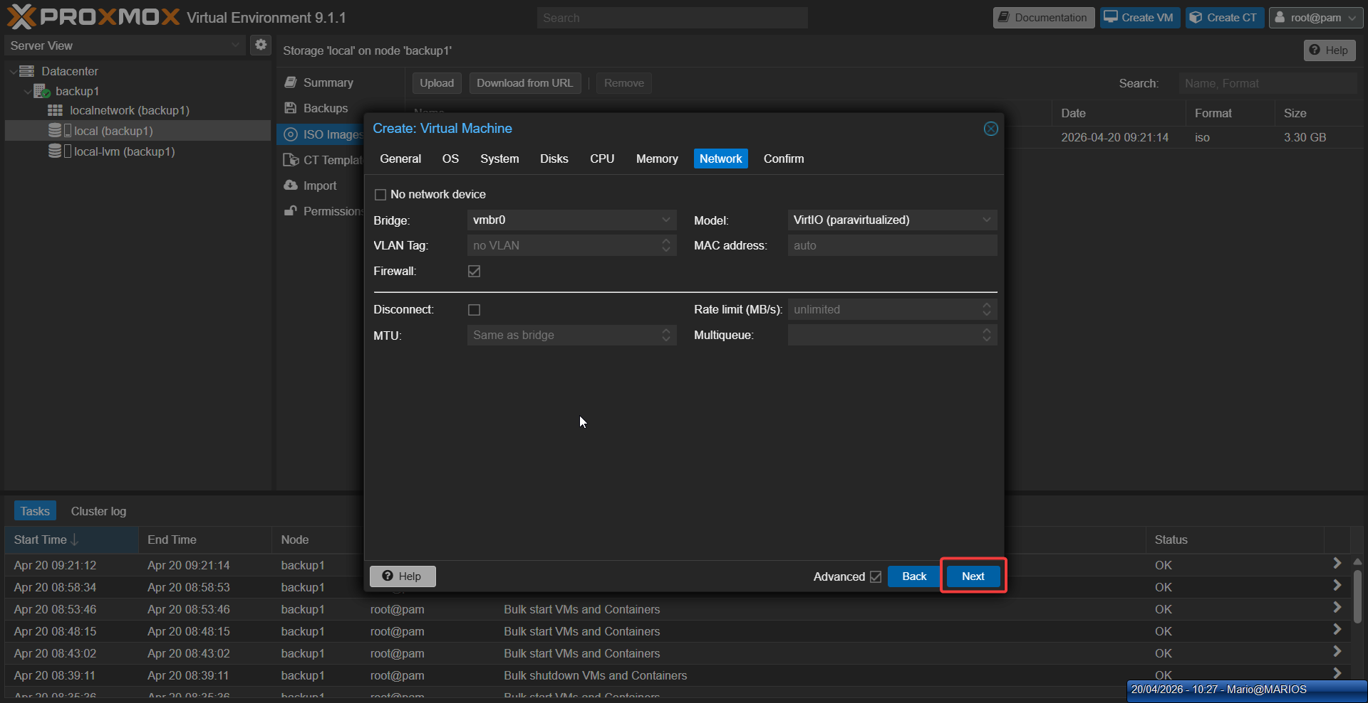
Figure 14: Network configuration
The Network tab configures the virtual network adapter and bridge connection for VM communication.
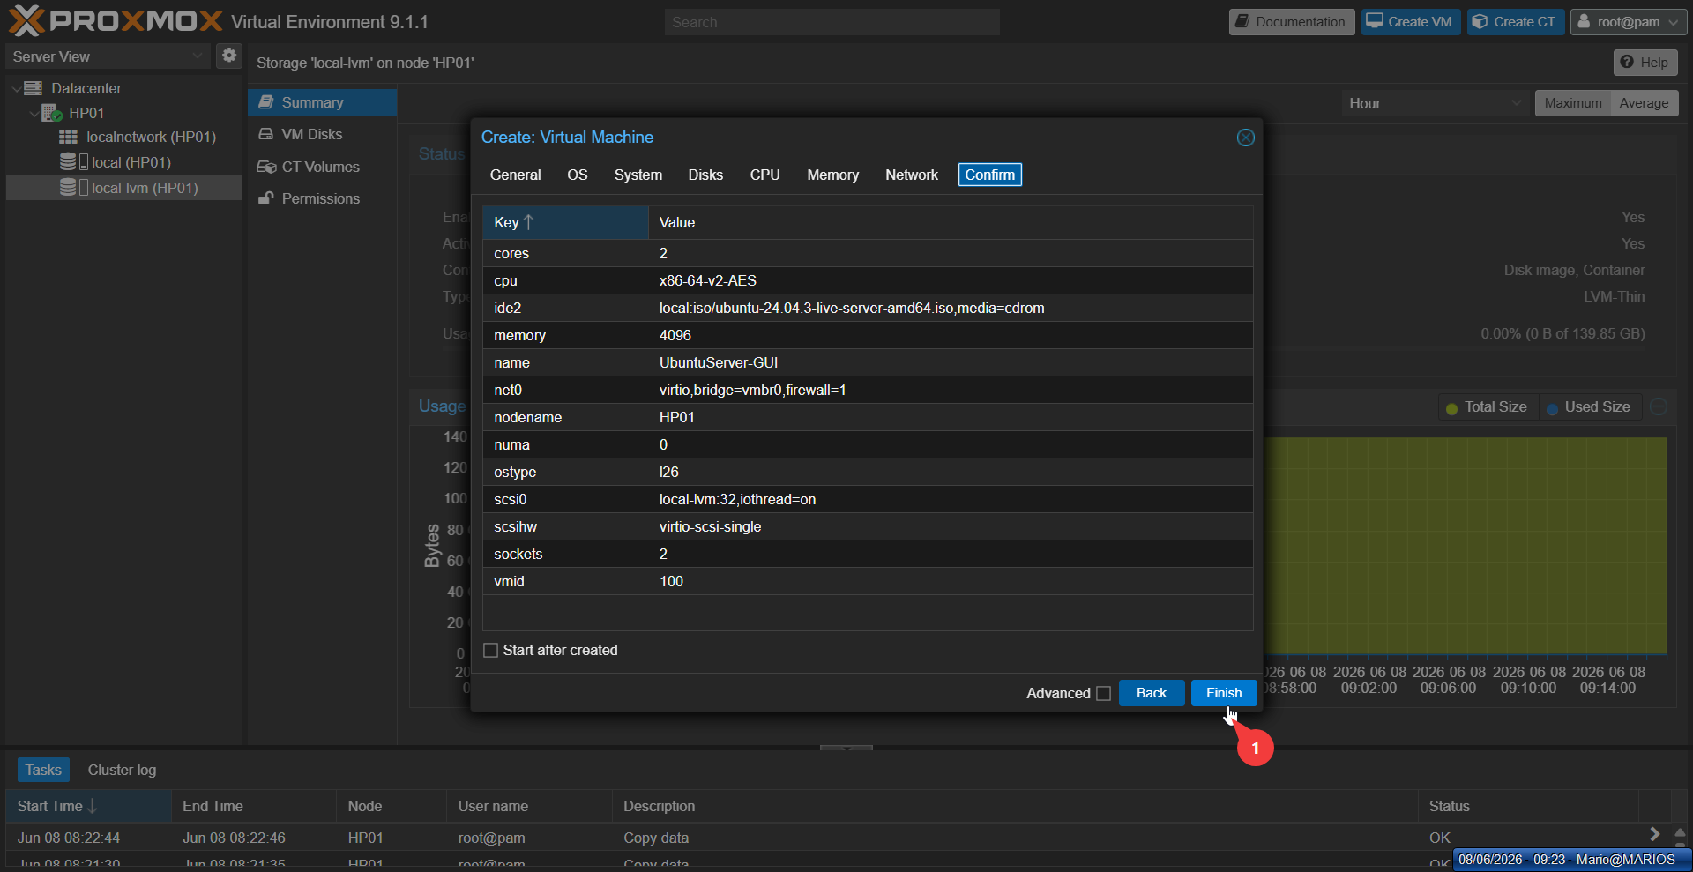
Figure 15: Confirmation and summary
The final wizard screen presents a configuration summary before the VM is created.

4.3 VMware Comparison
VMware's vSphere Client offers more granular control over virtual hardware versions and has a more extensive guest OS compatibility list. However, Proxmox's simpler wizard is faster for standard deployments and does not require a separate vCenter appliance.

5. Virtual Machine Creation via CLI

5.1 Objective
Create a virtual machine using command-line interface commands, demonstrating automation capabilities and understanding of the underlying QEMU/KVM parameters.

5.2 Proxmox Implementation
VM 101 (WindowsClient-CLI) was created via SSH using the qm create command with parameters for Windows 11 compatibility: UEFI firmware (OVMF), Q35 machine type, and virtual TPM 2.0. Note: The ISO file is named Windows10EnterpriseEvaluation.iso but installs Windows 11 Enterprise Evaluation.
qm create 101 --name WindowsClient-CLI --memory 4096 --cores 2 \ --net0 virtio,bridge=vmbr0 --scsihw virtio-scsi-pci \ --scsi0 local-lvm:32 \ --cdrom local:iso/Windows10EnterpriseEvaluation.iso \ --bios ovmf --machine q35 --tpmstate0 local-lvm:1,version=v2.0
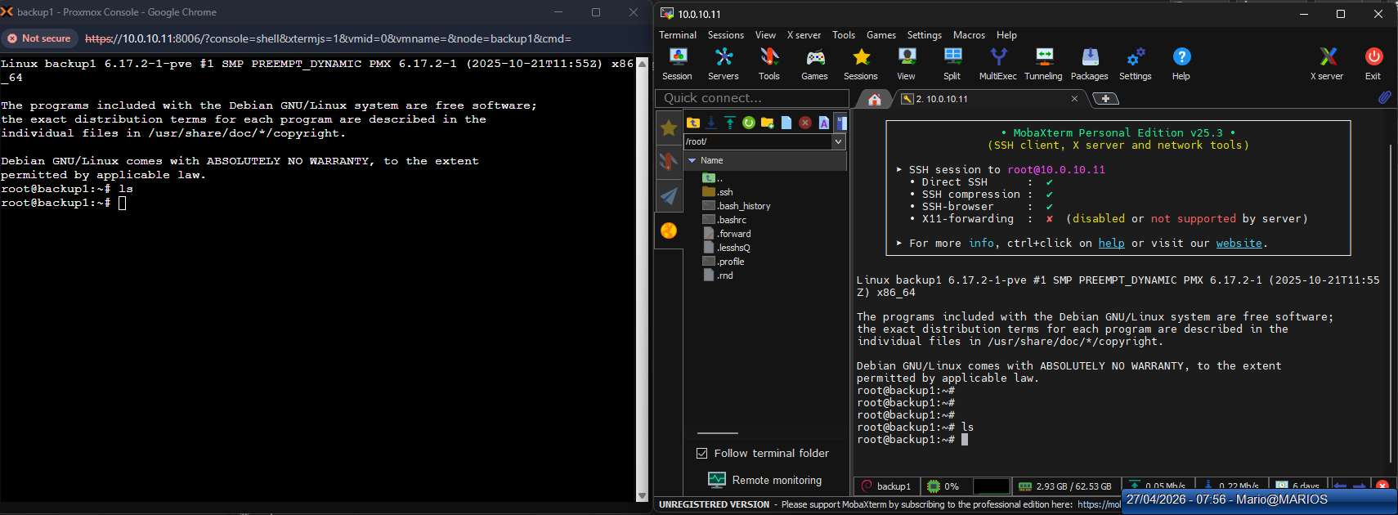
Figure 16: SSH console to Proxmox node
An SSH session connects to the Proxmox node to execute command-line VM creation and management tasks.
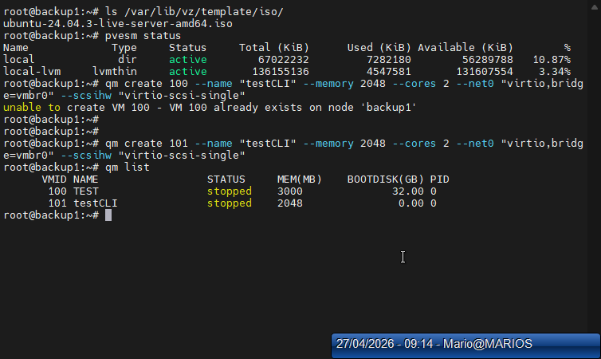
Figure 17: VM creation via CLI command
The qm create command is executed in the terminal to provision a new VM entirely from the command line.

5.3 VMware Comparison
VMware's PowerCLI is significantly more powerful for large-scale automation, offering hundreds of cmdlets for vCenter management. Proxmox's qm tool is simpler but sufficient for single-node or small-cluster operations. Both support REST APIs for programmatic access.

6. Operating System Installation

6.1 Objective
Install Ubuntu Server 24.04.3 LTS and Windows 11 Enterprise Evaluation inside the created virtual machines, documenting the installation process and post-install configuration.

6.2 Ubuntu Server Installation (VM 100)
Ubuntu Server 24.04.3 LTS was successfully installed on VM 100. The system booted to the login prompt and shell access was confirmed via the Proxmox console.
Figure 18: Ubuntu Server — login prompt after installation
Ubuntu Server successfully boots to the login prompt, confirming the guest OS installation completed correctly.

6.3 Windows 11 Installation (VM 101)
Windows 11 Enterprise Evaluation was successfully installed on VM 101. The VM booted to the desktop environment and network connectivity was confirmed.
Figure 19: Windows 11 — desktop environment
The Windows 11 VM boots to the desktop, confirming successful installation and network connectivity.

6.4 VMware Comparison
VMware Tools provides deeper integration (drag-and-drop, shared folders, better graphics) compared to QEMU Guest Agent. However, Windows 11 runs successfully on both platforms when properly configured.

7. Virtual Machine Configuration Changes

7.1 Objective
Demonstrate the ability to dynamically modify virtual machine hardware configuration, including adding/removing CPU cores, RAM, disk space, and network interfaces.

7.2 Proxmox Implementation
VM 100 was reconfigured using both GUI and CLI methods. CPU cores were increased to 4, RAM to 8192 MiB, an additional 20 GB disk was added on SCSI1, and a second VirtIO NIC was added on vmbr1.
qm set 100 --cores 4 qm set 100 --memory 8192 qm set 100 --scsi1 local-lvm:20 qm set 100 --net1 virtio,bridge=vmbr1 qm disk resize 100 scsi0 +10G
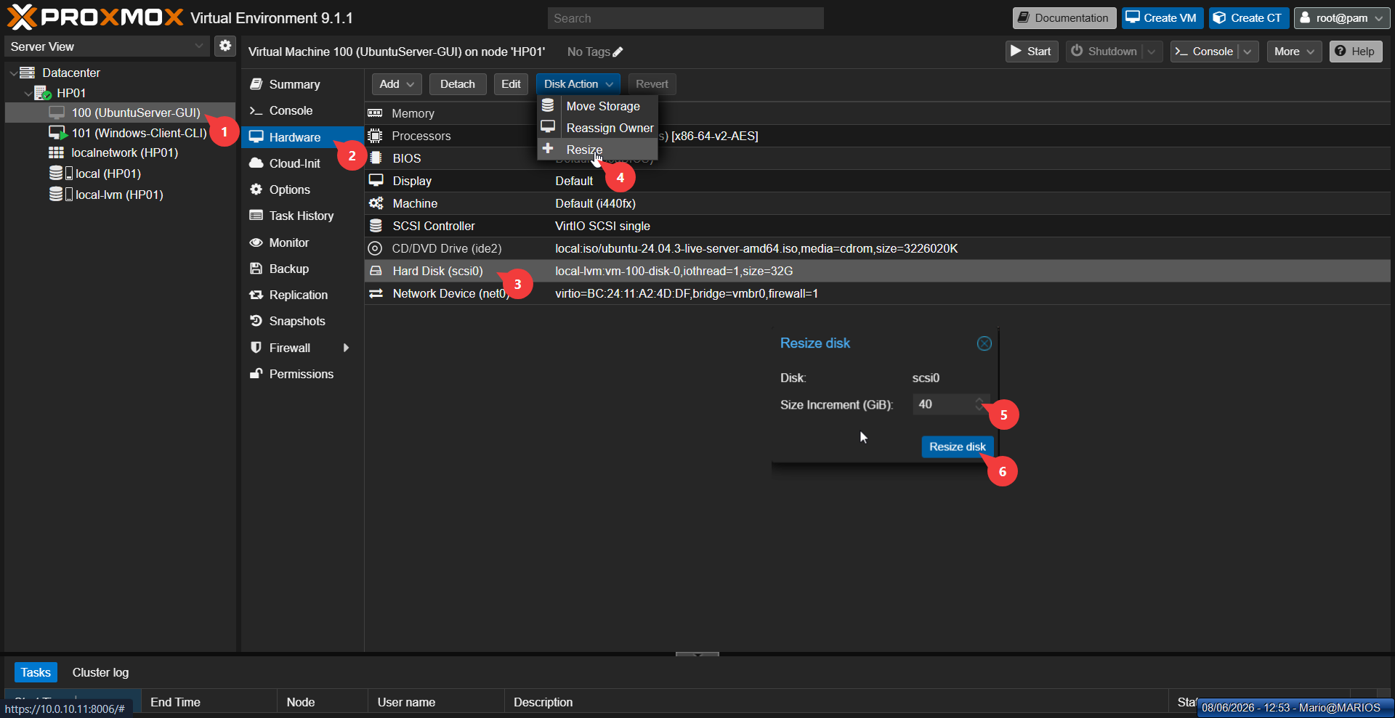
Figure 20: VM hardware configuration tab
The Hardware tab displays the current virtual hardware configuration and allows online modifications.
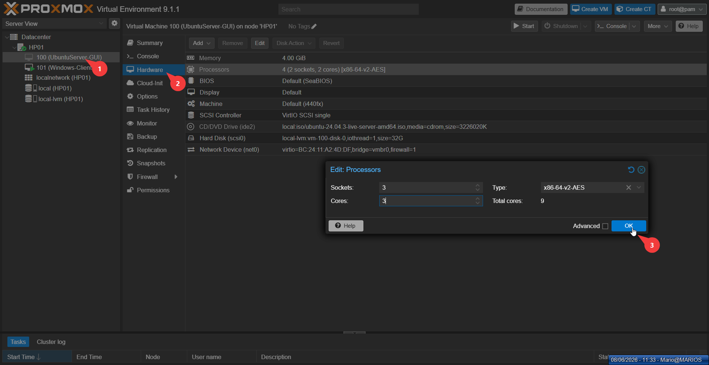
Figure 21: Adding a new disk
A new virtual disk is added to the VM to expand available storage capacity.

7.3 VMware Comparison
VMware vSphere offers more granular hot-add capabilities, particularly for network adapters and SCSI controllers. Proxmox supports hot-add for CPU and RAM but requires a restart for some hardware changes.

8. Clone a Virtual Machine

8.1 Objective
Create exact copies of existing virtual machines using Proxmox's clone functionality, demonstrating both full clones and linked clones.

8.2 Proxmox Implementation
Two clones were created from VM 100: VM 102 as a full clone (independent copy of all disks) and VM 110 as a linked clone (shares base disk with delta overlay).
qm clone 100 102 --name UbuntuServer-Clone --full qm clone 100 110 --name UbuntuServer-cloneCLI --linked
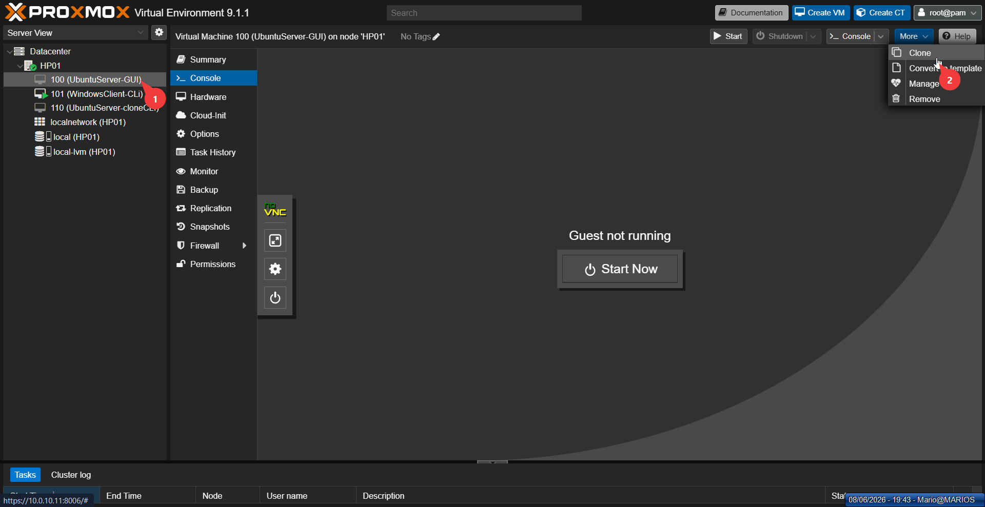
Figure 22: Clone VM — source selection
The clone wizard is launched and the source VM is selected to create a duplicate or linked instance.
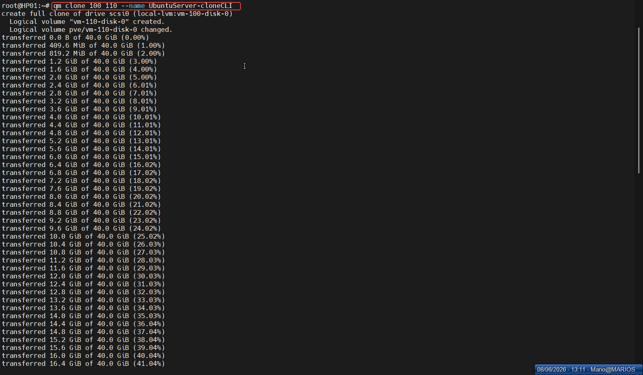
Figure 23: Clone VM — result in VM list
The cloned VM appears in the Proxmox VM list alongside the original, confirming successful duplication.

8.3 VMware Comparison
VMware vSphere offers Instant Clone technology (forking a running VM in memory), which is significantly faster than traditional cloning and ideal for VDI environments. Proxmox does not have an equivalent feature.

9. Export a Virtual Machine

9.1 Objective
Export a virtual machine from Proxmox to a portable format for migration or archival purposes.

9.2 Proxmox Implementation
Proxmox VE does not provide a built-in Export button in the GUI for VMs using LVM storage, because LVM disks are block devices rather than files. The solution was to use qemu-img convert to create a QCOW2 file from the raw LVM device.
qemu-img convert -f raw -O qcow2 \ /dev/pve/vm-100-disk-0 \ /var/lib/vz/images/vm-100-export.qcow2
Result: 4.88 GB QCOW2 file (virtual size: 40 GB, thin-provisioned).
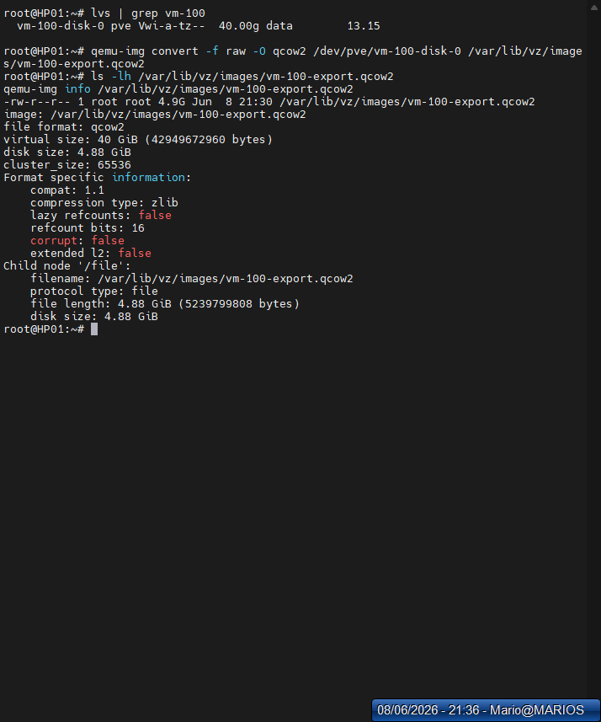
Figure 24: Export VM — qemu-img convert command
The qemu-img convert command exports a VM disk to a portable format for external use or migration.

9.3 VMware Comparison
VMware provides a much more polished export experience through the vSphere Client, with built-in OVF/OVA generation. Proxmox requires command-line knowledge and manual format conversion, reflecting its open-source, DIY philosophy.

10. Virtual Machine Backup & Hypervisor Backup

10.1 Objective
Implement comprehensive backup strategies for both virtual machines and hypervisor configurations, including built-in tools, custom scripts, and scheduled jobs. This is the team's specialization topic and is therefore documented in greater depth.

10.2 Theoretical Background
Backup is the foundation of any robust virtualization strategy. In a virtualized environment, there are two distinct layers requiring protection: the VM backup layer (capturing the entire state of a VM) and the hypervisor backup layer (protecting the management configuration).

Backup Modes
Mode | Description | Downtime | Consistency
Snapshot | Uses QEMU live snapshot; VM stays running | None | Crash-consistent
Suspend | Suspends VM, backs up, resumes | Seconds | Better consistency
Stop | Shuts down VM, backs up, starts | Minutes | Full consistency

10.3 VM Backup — Method 1: Built-in GUI (vzdump)
The built-in backup feature was accessed through VM 100's Backup tab. A snapshot-mode backup with ZSTD compression was configured and executed, producing a 2.86 GB VMA archive.
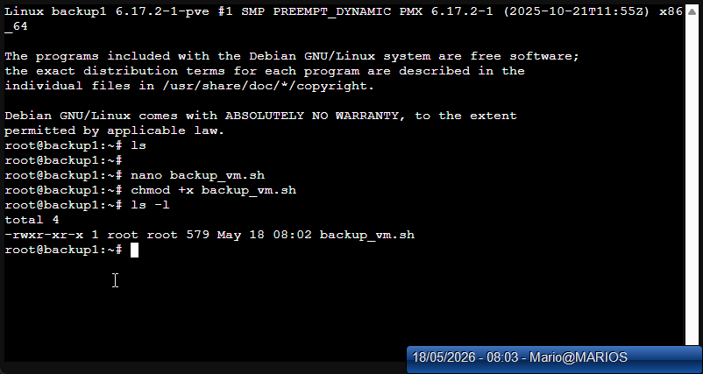
Figure 25: VM Backup — Backup tab interface
The built-in backup interface configures a snapshot-mode backup with ZSTD compression to protect VM data.
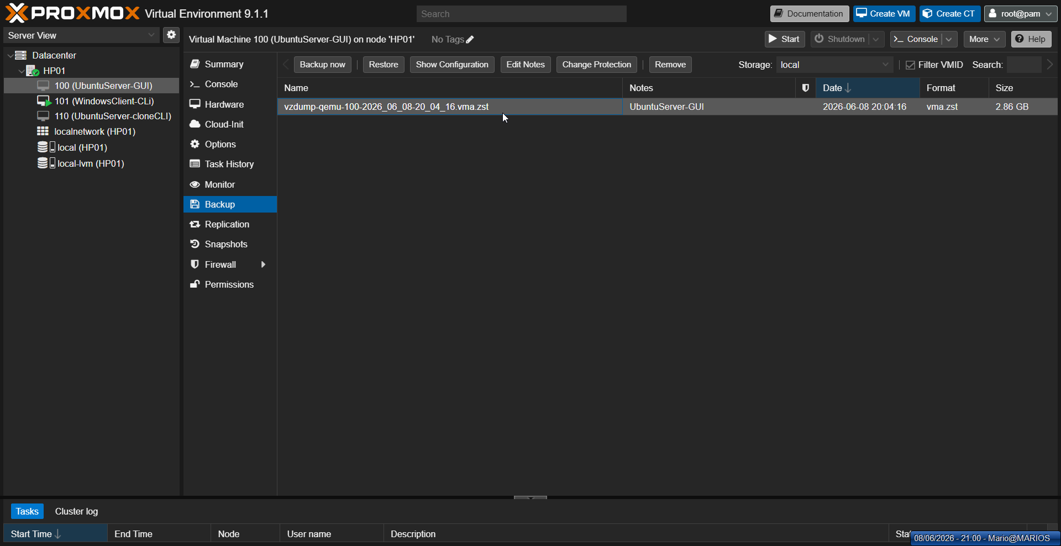
Figure 26: VM Backup — Completed backup file (2.86 GB)
The completed backup file demonstrates the efficiency of ZSTD compression, producing a 2.86 GB archive.

10.4 VM Backup — Method 2: CLI (vzdump)
The vzdump command provides flexible backup options through the command line, supporting all three modes and various compression algorithms.
vzdump 100 --mode snapshot --compress zstd --storage local vzdump 100 --mode suspend --compress zstd vzdump 100 --mode stop --compress zstd vzdump 100 101 102 --mode snapshot

10.5 VM Backup — Method 3: Custom Backup Script
A custom Bash script was developed for automated, logged backups. The script accepts a VM ID as a parameter, performs a snapshot backup with ZSTD compression, and logs success or failure to a dedicated log file.
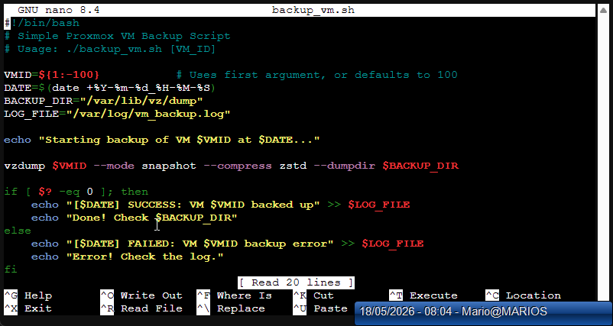
Figure 27: Custom backup script in nano editor
A custom Bash script is written in nano to automate snapshot backups with logging for operational reliability.
#!/bin/bash VMID=${1:-100} DATE=$(date +%Y-%m-%d-%H-%M-%S) BACKUP_DIR="/var/lib/vz/dump" LOG_FILE="/var/log/vm_backup.log" echo "Starting backup of VM $VMID at $DATE..." vzdump $VMID --mode snapshot --compress zstd --dumpdir $BACKUP_DIR if [ $? -eq 0 ]; then echo "[$DATE] SUCCESS: VM $VMID backed up" >> $LOG_FILE else echo "[$DATE] FAILED: VM $VMID backup error" >> $LOG_FILE fi

10.6 VM Backup — Method 4: Scheduled Jobs
Proxmox supports scheduled backup jobs through Datacenter → Backup → Add. A weekly schedule was configured for Saturday at 02:00, targeting all VMs with snapshot mode, ZSTD compression, and retention of the last 3 backups.

10.7 VM Restore
Restoration was tested using both GUI and CLI methods to verify backup integrity.
qmrestore /var/lib/vz/dump/vzdump-qemu-100-2026_06_08-20_04_16.vma.zst 200

10.8 Hypervisor Backup
Proxmox VE does not provide a built-in GUI button for hypervisor configuration backup. The /etc/pve/ directory is a special cluster filesystem (pmxcfs) that requires specific handling. A tar archive was created to capture all critical configuration files.
tar -czf /var/lib/vz/backup/hp01-config-$(date +%Y%m%d-%H%M).tar.gz \ /etc/pve /etc/network/interfaces /etc/hosts \ /etc/hostname /etc/resolv.conf
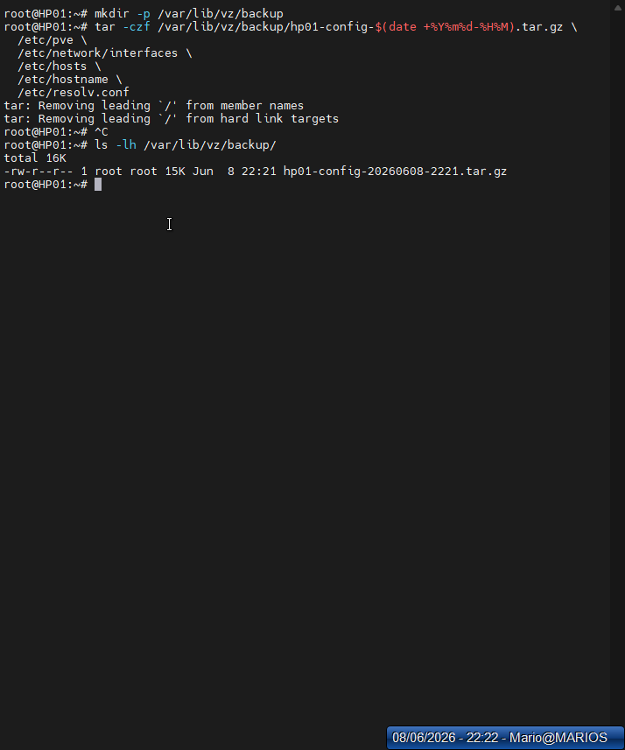
Figure 28: Hypervisor backup — tar command and archive verification
The tar command archives critical hypervisor configuration files to enable rapid disaster recovery.
Result: hp01-config-20260608-2221.tar.gz (15 KB) containing cluster configuration, network settings, host identity, and DNS resolution files.

10.9 VMware Comparison
Aspect | Proxmox | VMware
VM Backup Tool | vzdump (built-in) | vSphere Data Protection (discontinued) or 3rd party
Backup GUI | Built-in backup tab | Requires vCenter or 3rd party (Veeam)
Backup Format | VMA (Proxmox native) | VMDK + VMX
Scheduling | Built-in scheduler | vCenter backup scheduler or 3rd party
Hypervisor Backup | Manual tar of /etc/pve/ | vCenter Configuration Backup
Enterprise Backup | Proxmox Backup Server (free) | Veeam, Rubrik, Cohesity (paid)
Incremental Backup | Yes (with PBS) | Yes (with CBT + VADP)

10.10 Do's and Don'ts of Virtualization Backup

Do's
• Use snapshot mode for production VMs to minimize downtime
• Store backups on separate storage (NAS or off-site), not local disks
• Test restores regularly — a backup you cannot restore is useless
• Compress backups using ZSTD for excellent compression ratios
• Schedule automated backups — human memory is unreliable
• Backup hypervisor config after network, storage, or user changes
• Use retention policies to prevent storage bloat

Don'ts
• Rely solely on snapshots as backups — snapshots depend on the base disk
• Backup to the same storage as VMs — if storage fails, you lose both
• Ignore backup verification — corrupted backups are discovered during restore
• Forget to backup hypervisor config — rebuilding cluster settings manually is painful
• Use stop mode for critical production — use snapshot or suspend instead
• Keep unlimited backups — define retention (daily 7, weekly 4, monthly 12)

11. Snapshots

11.1 Objective
Create, manage, and rollback virtual machine snapshots to enable point-in-time recovery and safe testing environments.

11.2 Proxmox Implementation
A snapshot named clean-install was created on VM 101 through the Snapshots tab. The snapshot captures the disk state at a specific moment, creating a read-only base disk and a new delta disk for subsequent changes.
qm snapshot 101 clean-install --description "Before software installation" qm listsnapshot 101 qm rollback 101 clean-install qm delsnapshot 101 clean-install
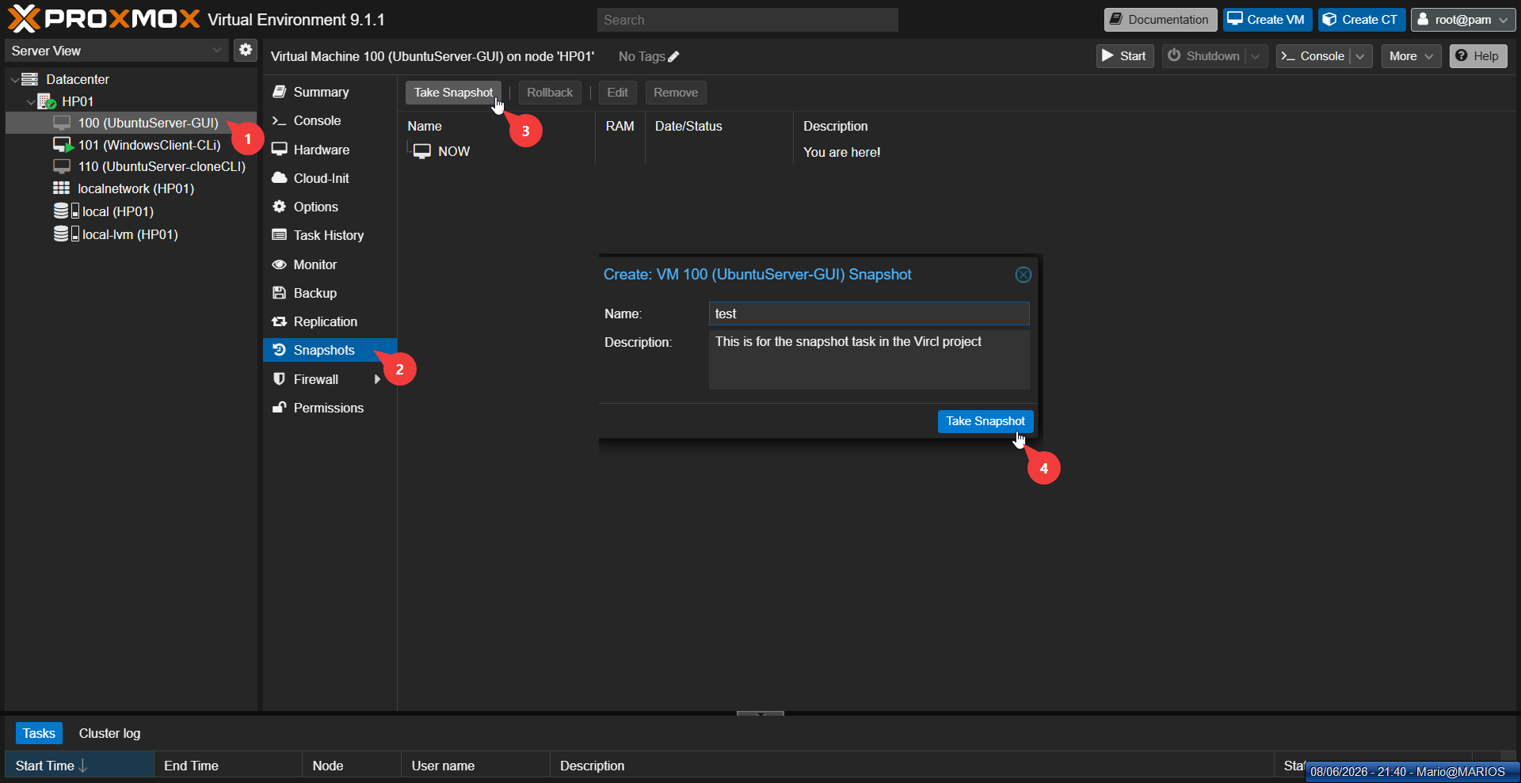
Figure 29: Snapshot creation dialog
The snapshot creation dialog captures the current VM disk state for quick rollback if needed.
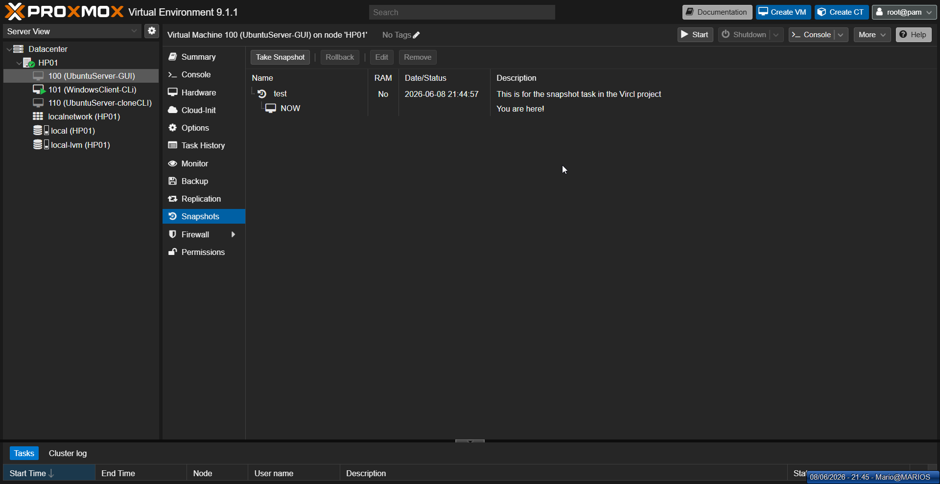
Figure 30: Snapshot list and management
The snapshot management interface displays existing snapshots and provides controls for rollback or deletion.

11.3 VMware Comparison
VMware's Snapshot Manager provides a superior visual interface for managing complex snapshot trees, including branching and consolidation. Proxmox uses a simpler linear model. VMware also offers quiesced snapshots through VSS on Windows guests.

12. Virtual Machine Templates

12.1 Objective
Convert a configured virtual machine into a template for rapid, standardized deployment of new VMs.

12.2 Proxmox Implementation
VM 100 was converted to a template after removing all snapshots (Proxmox forbids template conversion with snapshots). VM 150 was then deployed from this template using the clone function.
qm delsnapshot 100 test qm template 100 qm clone 100 150 --name UbuntuServer-fromTemplate --full
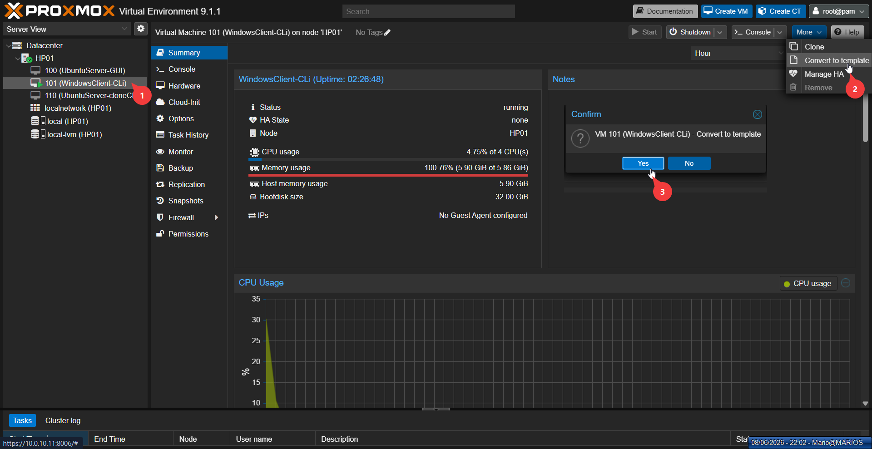
Figure 31: Template conversion
A VM is converted to a template to create a standardized, reusable deployment image.
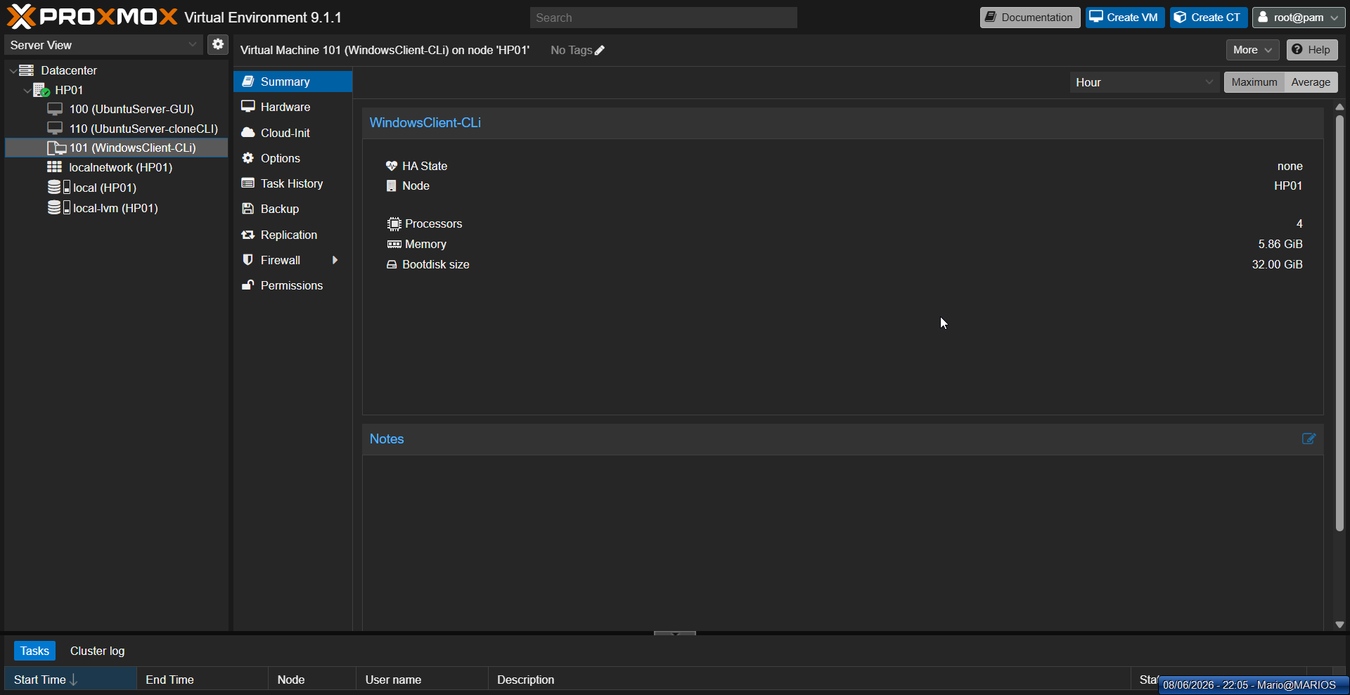
Figure 32: Template icon and deployment
The converted template displays a distinct icon in the VM list, ready for rapid cloning and deployment.

12.3 VMware Comparison
VMware's Content Library and Guest Customization Specifications provide enterprise-grade template management. When deploying from a template, vSphere can automatically customize the guest OS. Proxmox requires manual post-deployment customization or external tools like cloud-init.

13. Remote Storage Integration

13.1 Objective
Connect Proxmox to the CLOIF2 NAS using NFS and SMB/CIFS protocols for shared VM storage, backups, and ISO images.

13.2 NAS Configuration (OpenMediaVault)
Two shares were created in OpenMediaVault: proxmox-nfs (NFS v4, rw,no_root_squash for 10.0.10.0/16) for VM disk images, and proxmox-smb (SMB/CIFS, anonymous access) for ISOs and backups.
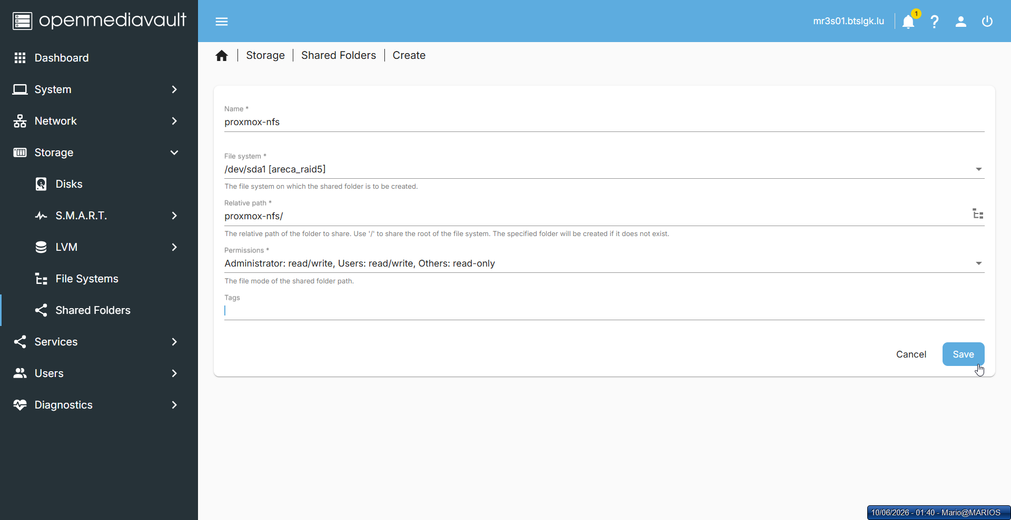
Figure 33: NAS share creation in OpenMediaVault
NAS shares are configured in OpenMediaVault to provide centralized storage for ISOs, backups, and disk images.

13.3 Proxmox Implementation
Both NFS (nas-nfs) and SMB (proxmox-smb) storage were added to both HP01 and HP03 through Datacenter → Storage → Add. The NFS share was enabled for disk images, container templates, ISO images, backups, and snippets. The SMB share was enabled for ISO images, backups, and snippets.
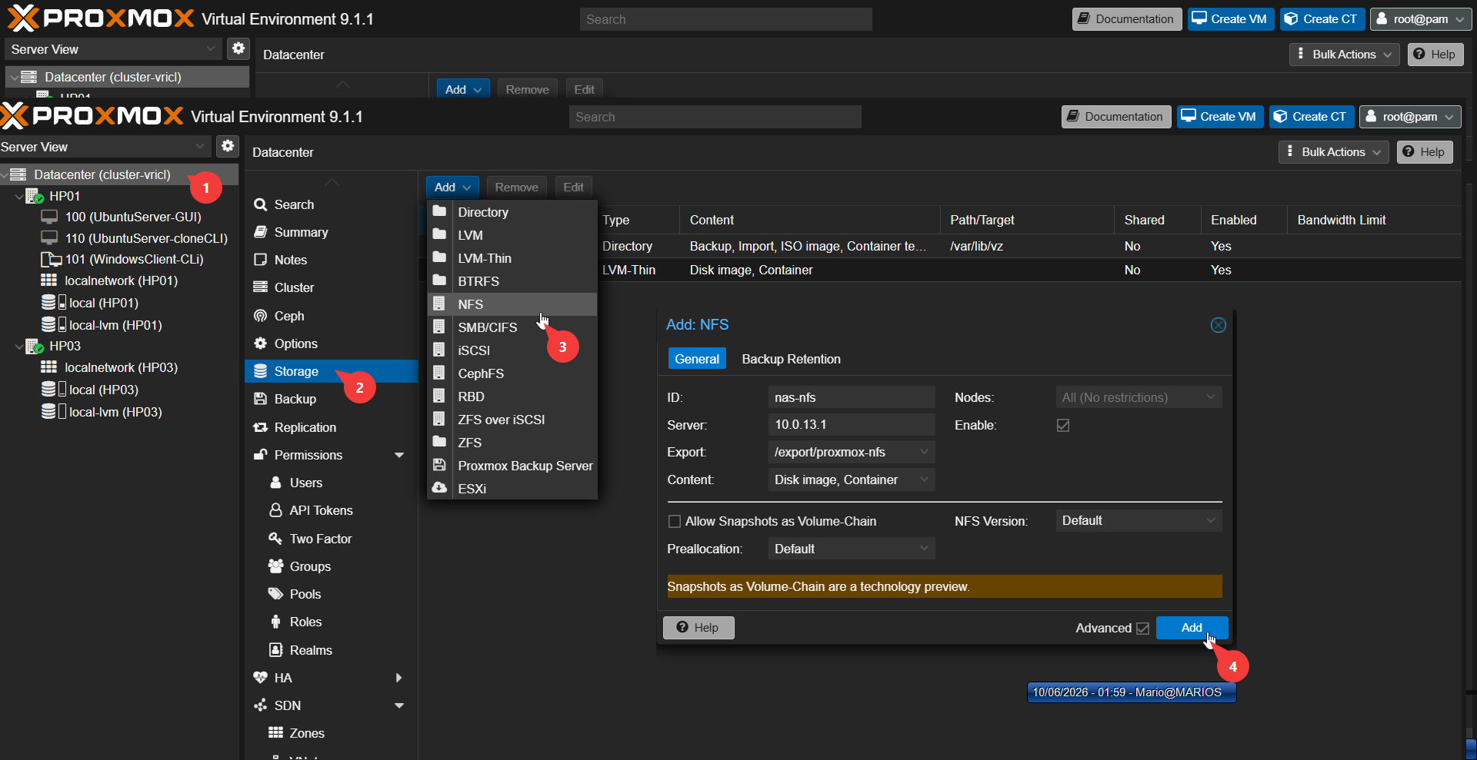
Figure 34: Proxmox NFS storage add dialog
The Add Storage dialog integrates the NFS share into Proxmox for shared access across the cluster.
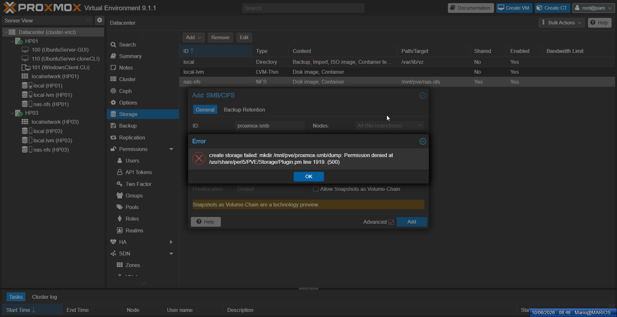
Figure 35: NFS storage configuration
The NFS storage configuration specifies the server address, export path, and supported content types.
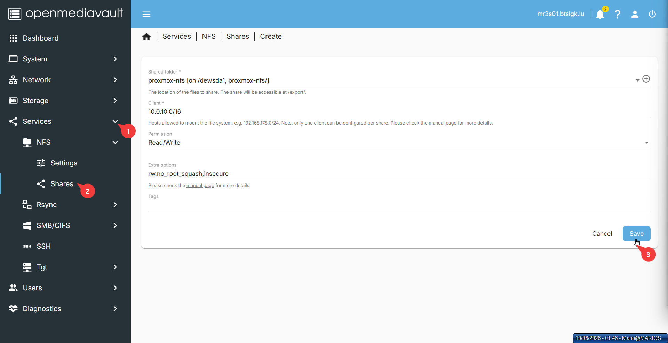
Figure 36: SMB storage add dialog
The SMB/CIFS storage dialog adds the NAS share to Proxmox for ISO and backup repository access.
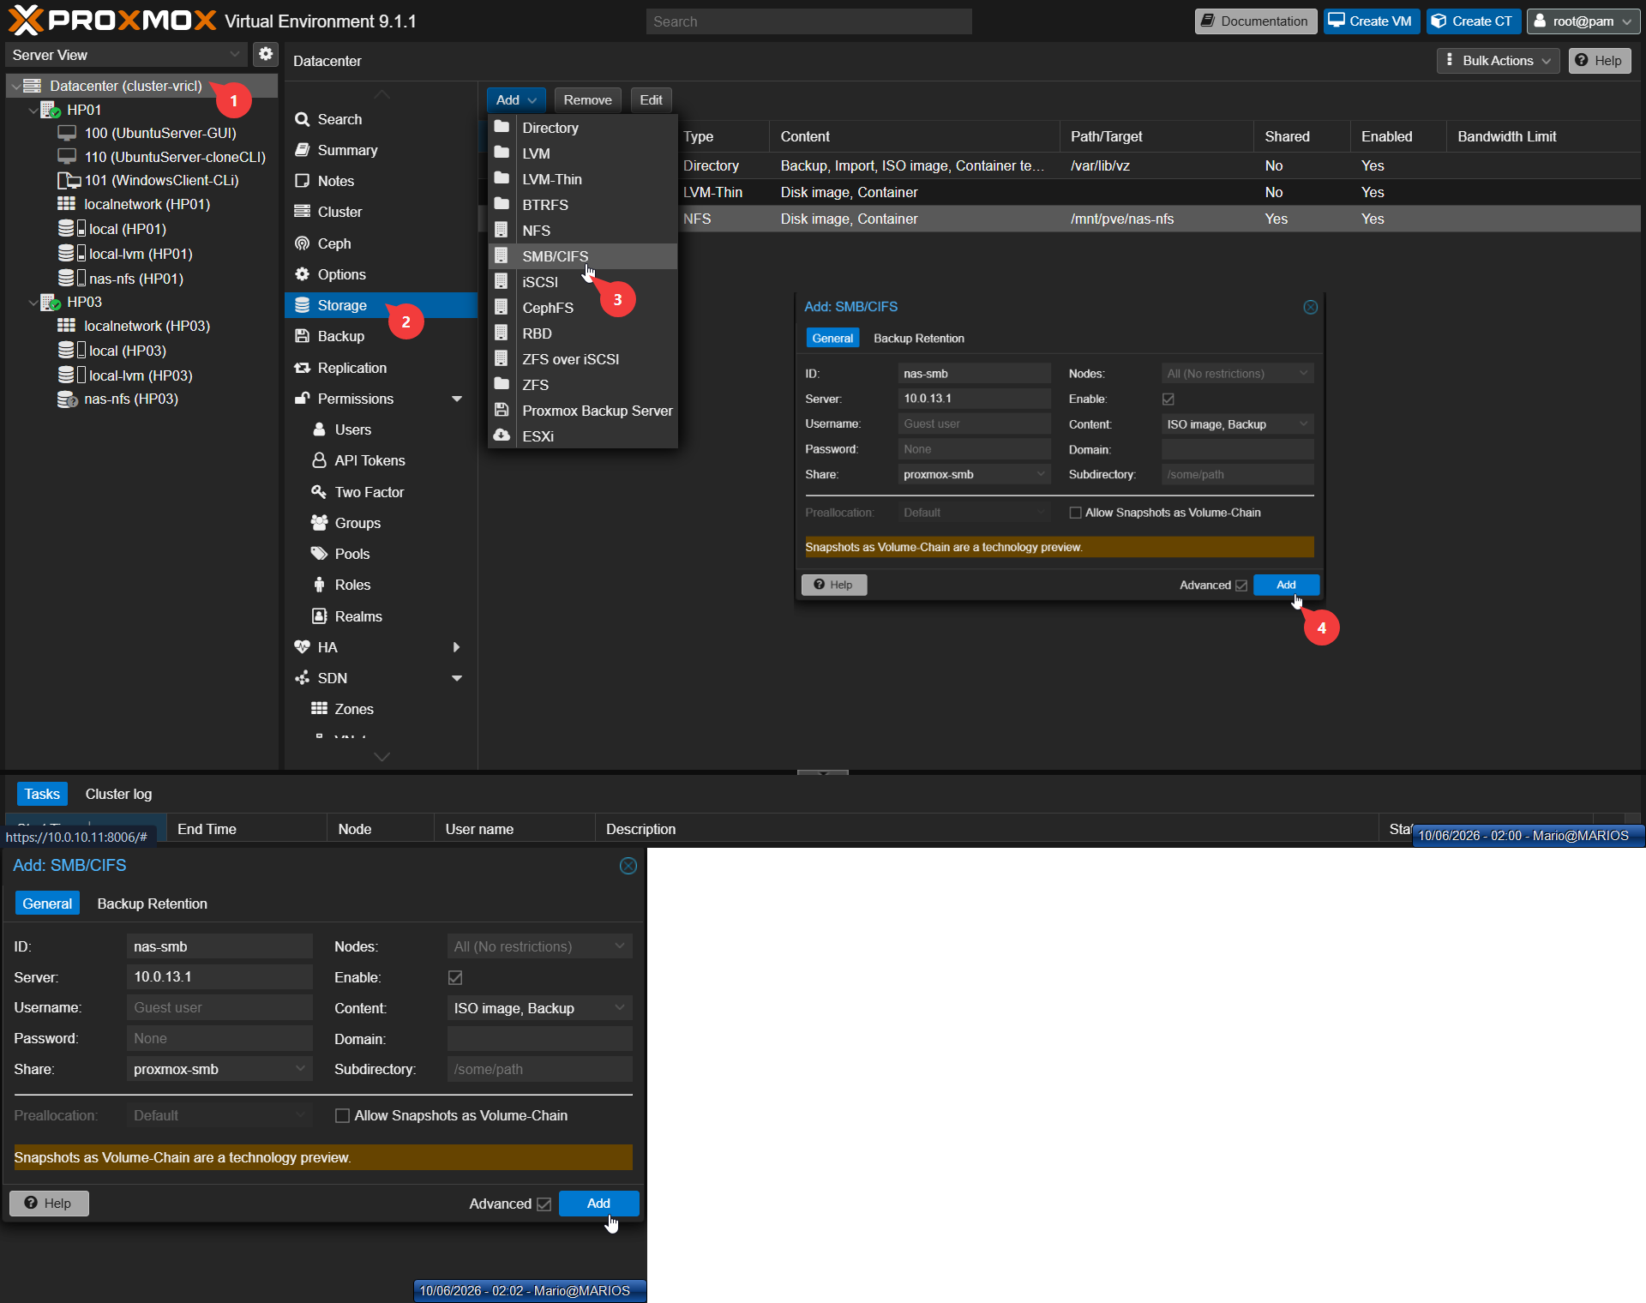
Figure 37: Storage list showing both NFS and SMB
The Proxmox storage list confirms both NFS and SMB shares are mounted and available for use.

13.4 VMware Comparison
Proxmox supports a wider variety of storage types natively, including ZFS and Ceph. VMware focuses on VMFS (its proprietary filesystem) and vSAN for enterprise deployments. Both handle NFS well for shared storage.

14. Live Migration — Storage to Storage

14.1 Objective
Move a virtual machine's disk from local storage to remote NAS storage while the VM is both running and stopped, demonstrating storage live migration.

14.2 Proxmox Implementation
VM 110's disk was moved from local-lvm to nas-nfs using the Hardware → Hard Disk → Move Disk function. This was tested in both running and stopped states.
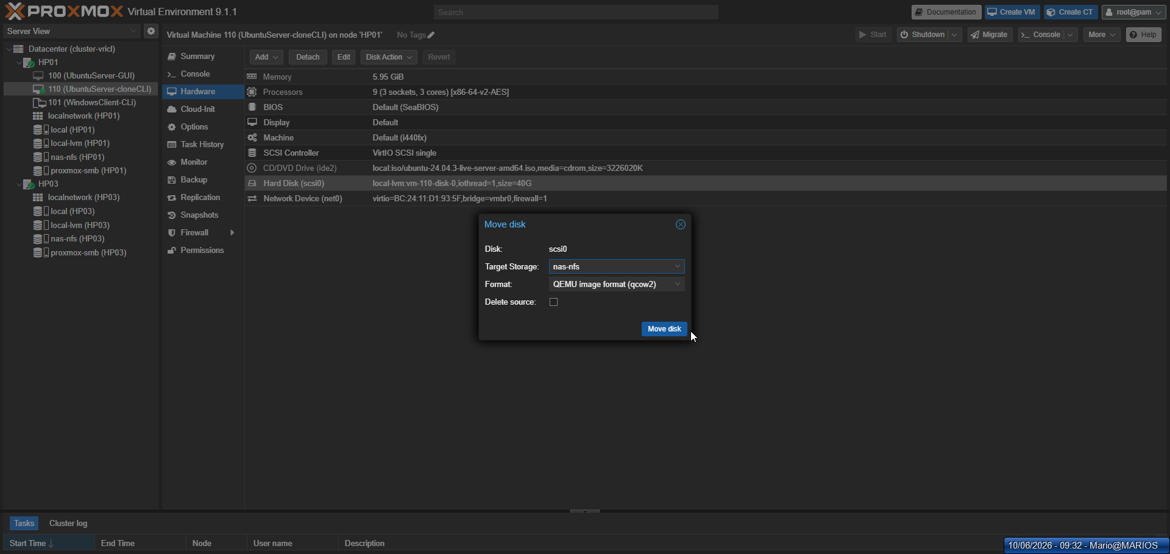
Figure 38: Storage migration — running VM
A running VM's virtual disk is migrated from local storage to the NAS without service interruption.
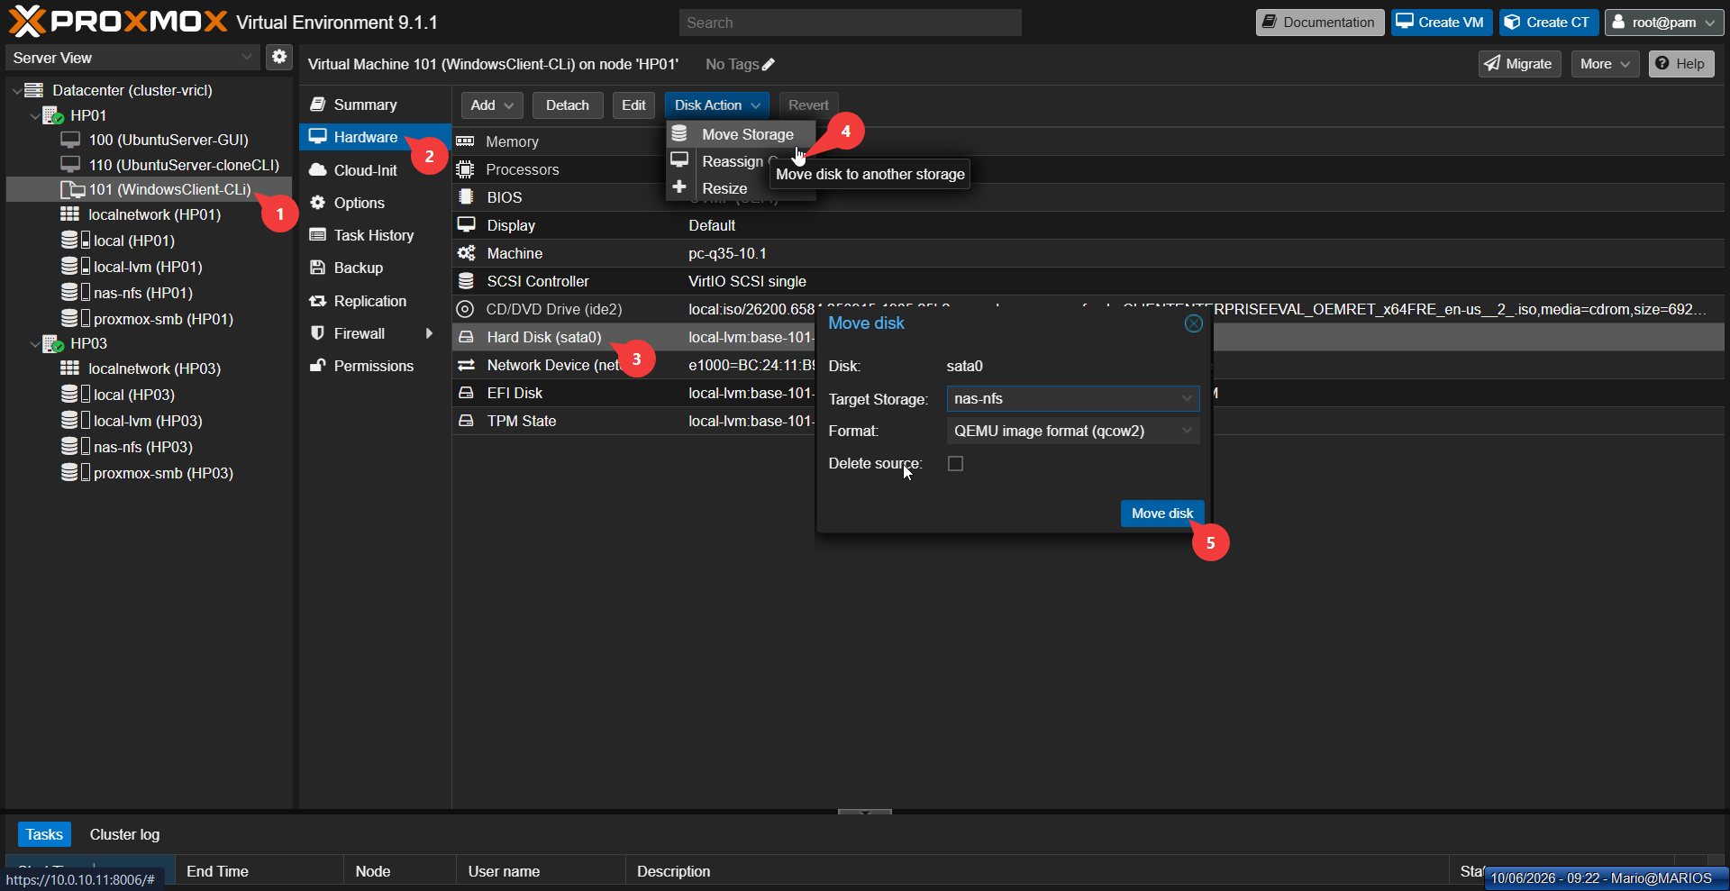
Figure 39: Storage migration — stopped VM
A stopped VM's disk is moved to shared storage, demonstrating offline storage migration capabilities.
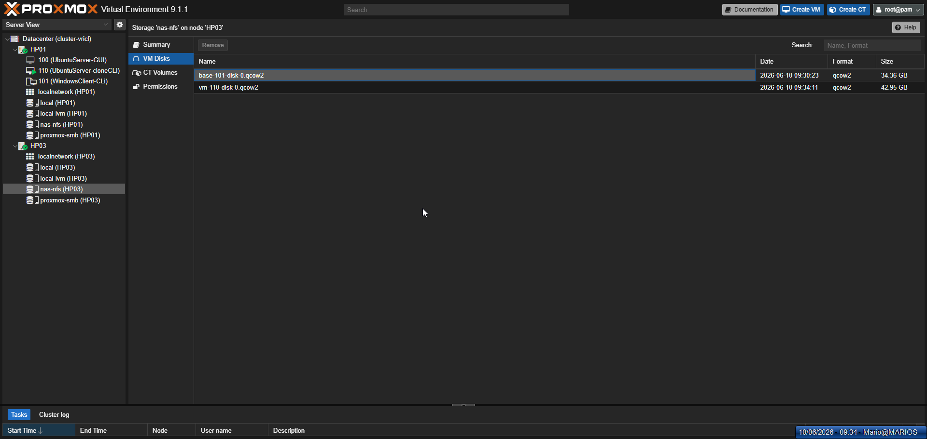
Figure 40: Storage migration — progress dialog
The progress dialog tracks the storage migration status, showing data transfer between storage backends.

14.3 VMware Comparison
VMware's Storage vMotion is a mature, highly optimized feature with deep integration into vCenter's resource management. Proxmox's Move Disk achieves the same functional result but with a simpler implementation. Both support live migration of running VMs between different storage types.

15. Live Migration — Hypervisor to Hypervisor

15.1 Objective
Migrate a virtual machine from one Proxmox node (HP01) to another (HP03) while the VM is both running and stopped, demonstrating hypervisor live migration.

15.2 Prerequisites: Cluster Configuration
Before migration, nodes must be in the same cluster. HP01 created the cluster and HP03 joined it.
pvecm create vircl-cluster pvecm add 10.0.10.11 pvecm status
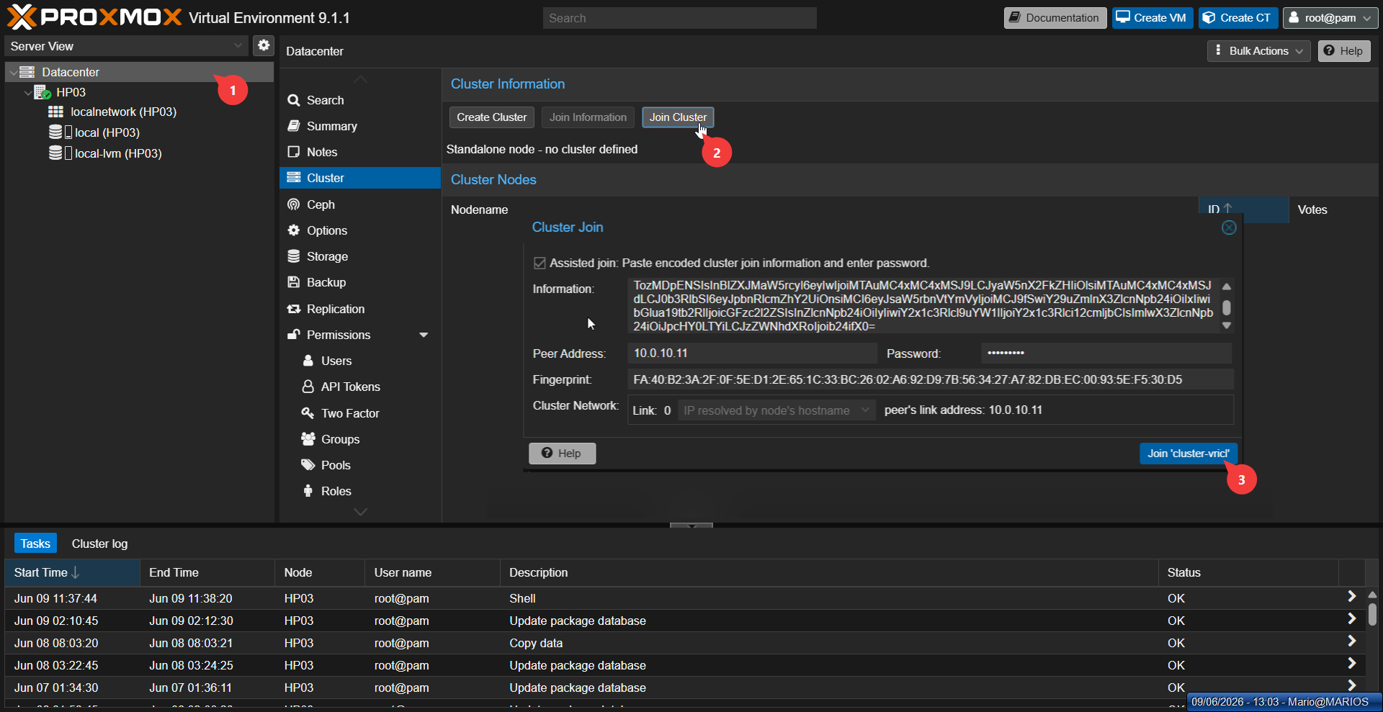
Figure 41: Cluster creation
The cluster creation command establishes a Proxmox cluster to enable centralized multi-node management.
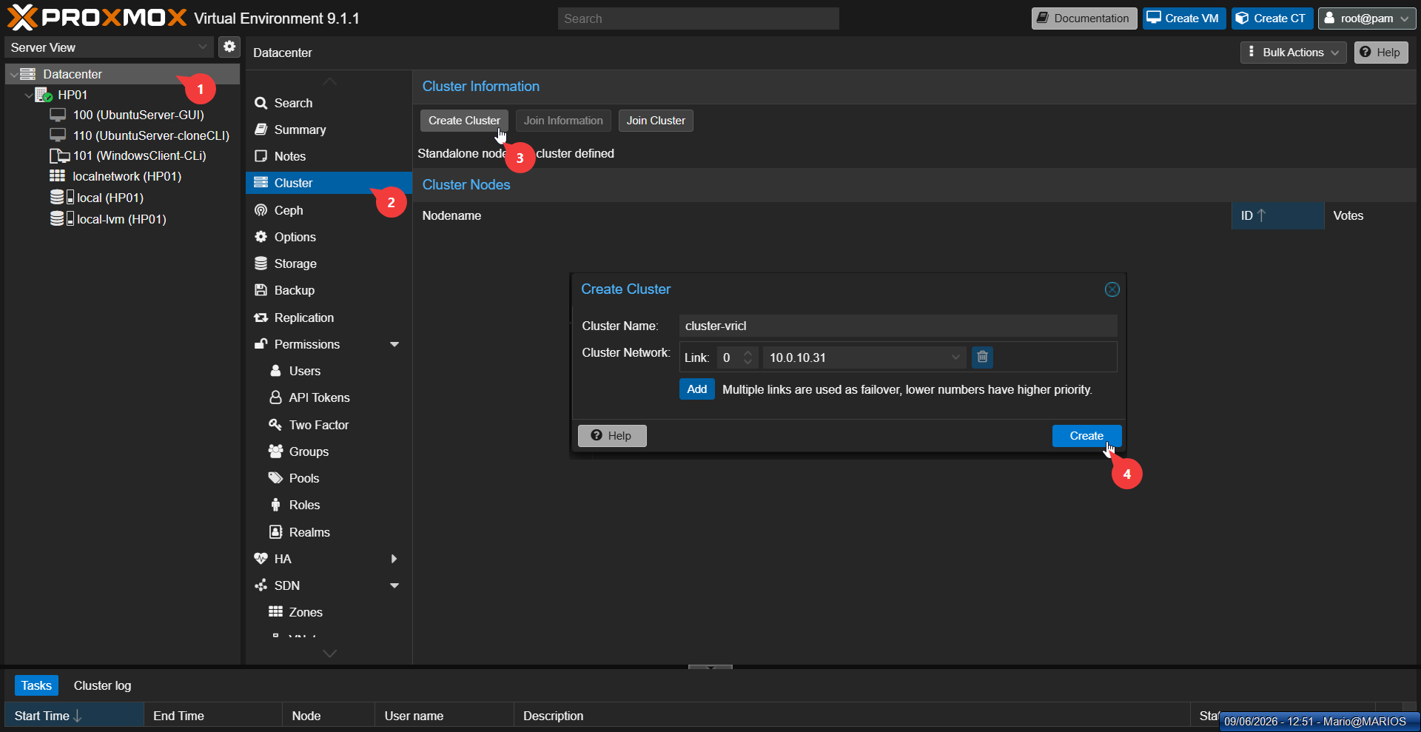
Figure 42: Cluster status verification
The cluster status output confirms both nodes are joined and communicating correctly.

15.3 Proxmox Implementation
VM 102 was migrated from HP01 to HP03 using the Migrate function. Both offline (stopped) and online (running) migrations were tested. An important finding: snapshots containing CD/DVD hardware configurations can block migration. The solution is to remove the snapshot or detach the CD/DVD device.
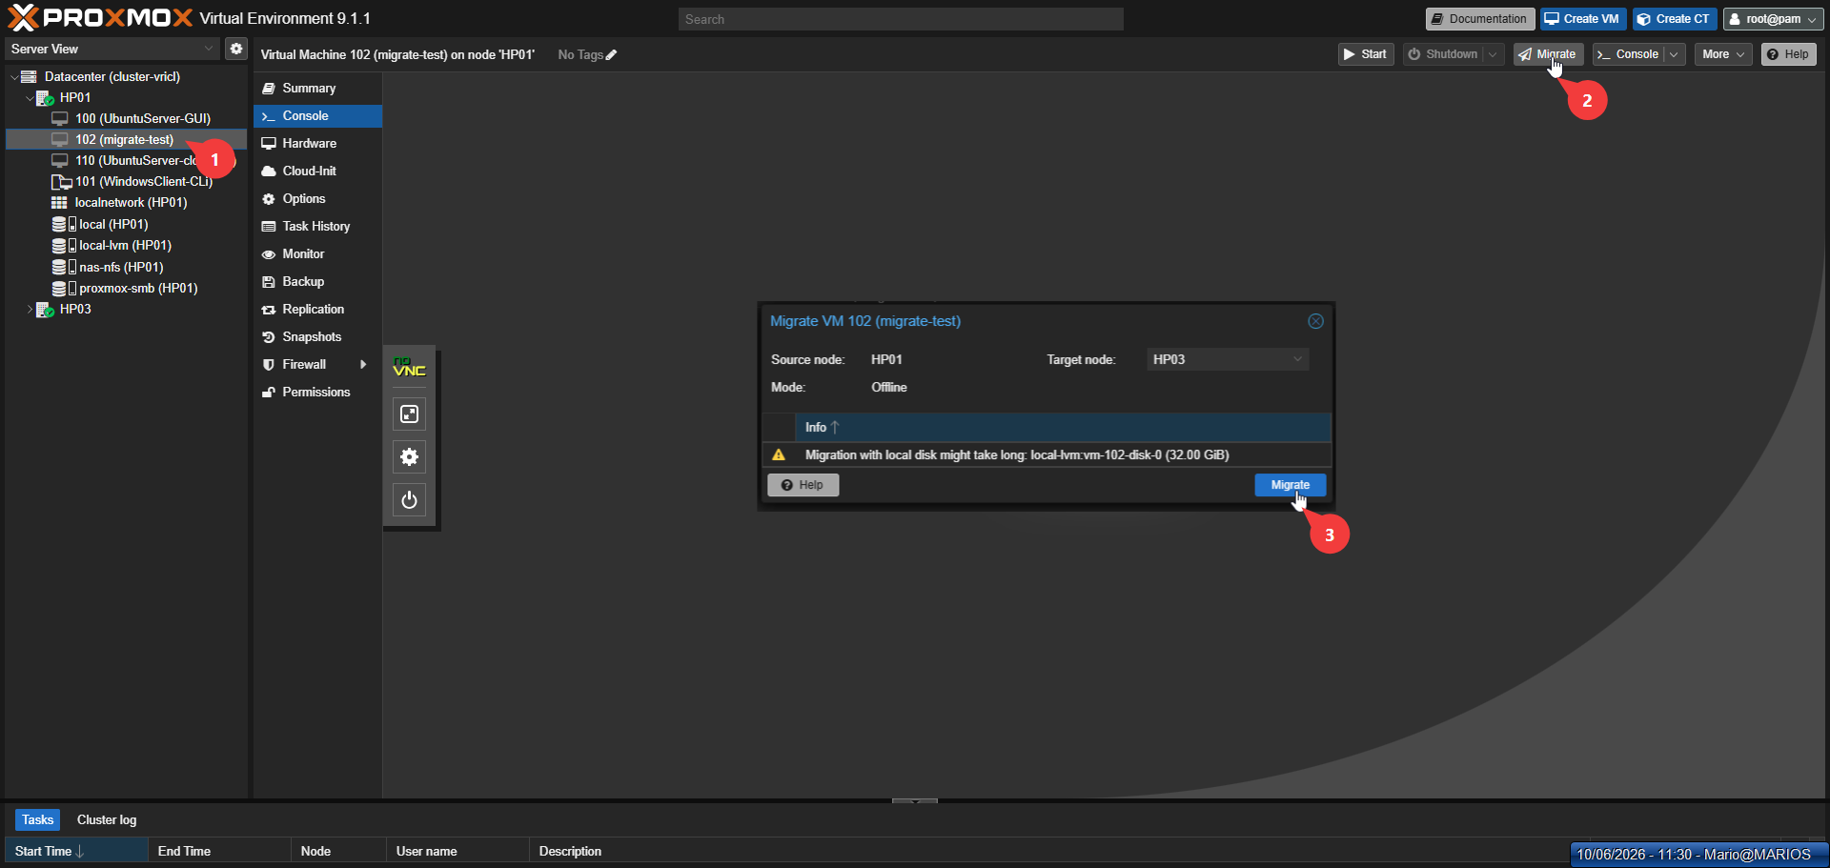
Figure 43: Hypervisor migration — select VM and click Migrate
The Migrate button is selected for VM 102 to initiate live migration from HP01 to HP03.
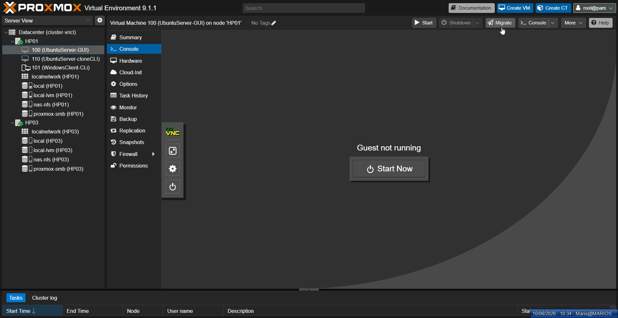
Figure 44: Migration dialog — source and target nodes
The migration dialog displays the source and target nodes, allowing the administrator to confirm the move.
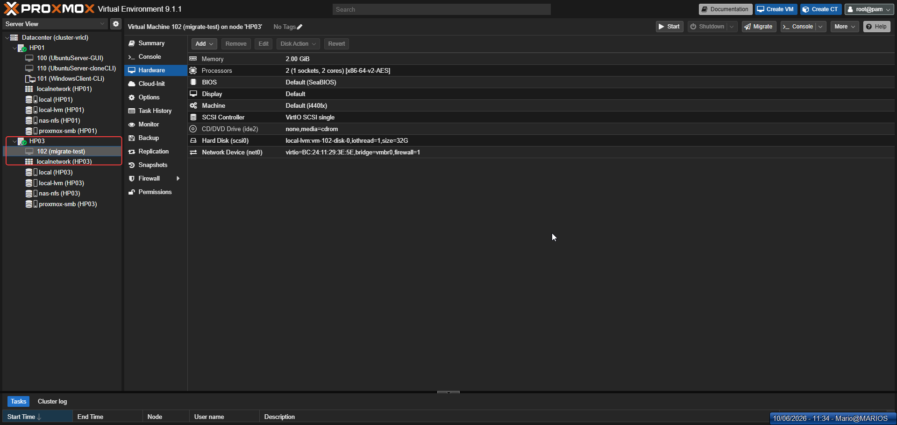
Figure 45: Migration progress
The progress indicator tracks the live migration of the VM across the cluster nodes.
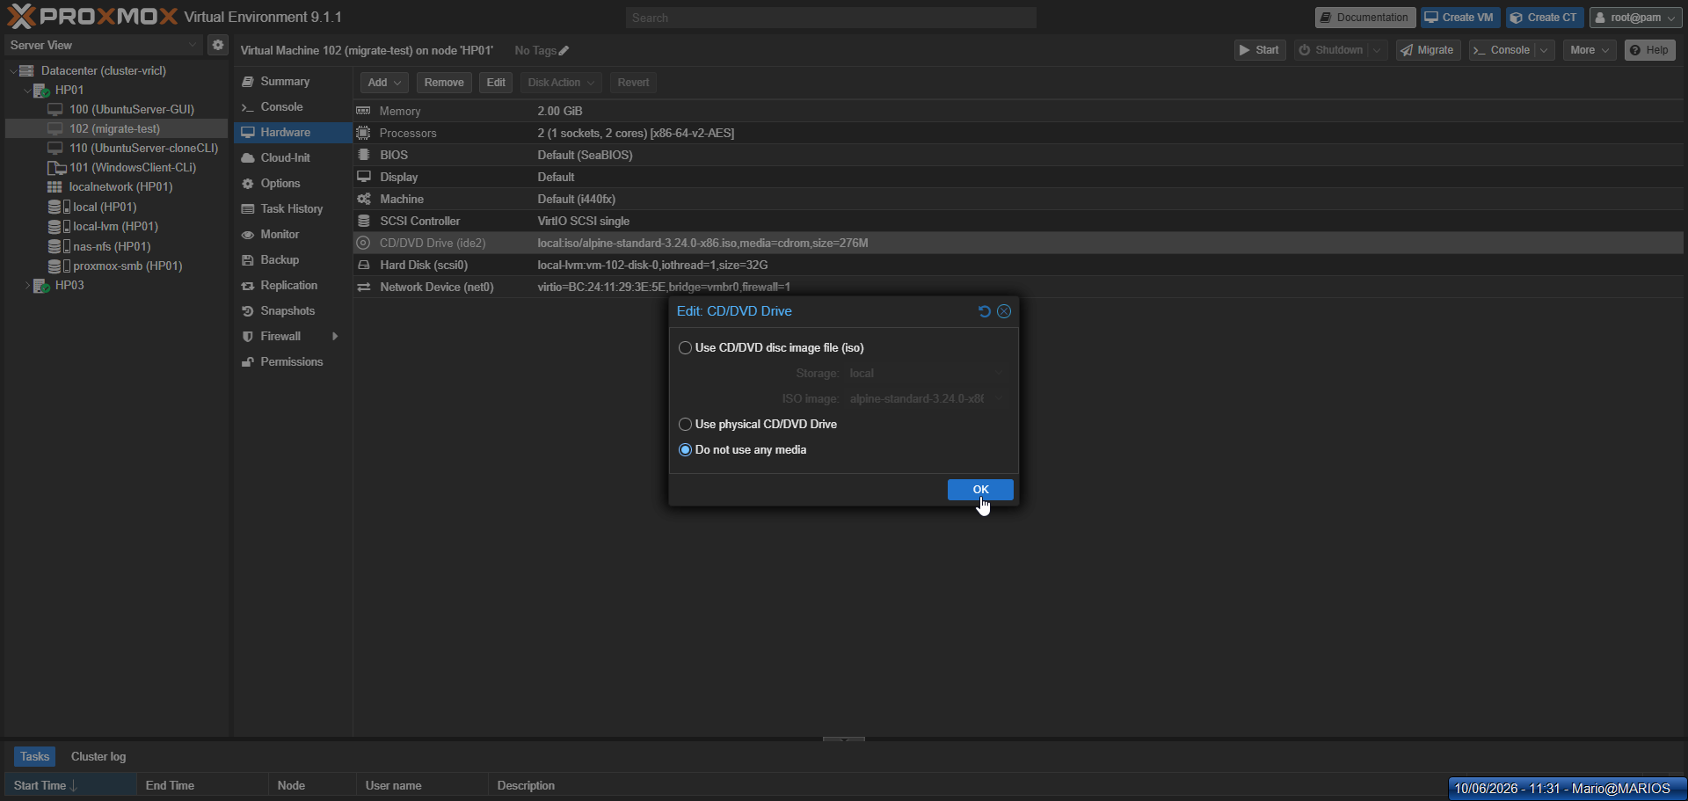
Figure 46: VM successfully migrated to HP03
The VM now appears on HP03, confirming that the live migration completed without downtime.

15.4 VMware Comparison
VMware vMotion is the industry benchmark for live migration, with decades of optimization and features like EVC (masking CPU differences between hosts). Proxmox migration works well for homogeneous environments but lacks advanced CPU compatibility features.

16. User Management & Permissions

16.1 Objective
Create user accounts, groups, and role-based access control (RBAC) policies to secure the Proxmox environment and delegate limited access to specific resources.

16.2 Proxmox Implementation
Two groups were created: students (limited VM access) and Admins (full administrative access). Two users were created: student1@pve (assigned to students group with PVEVMUser role on VM 100) and admin2@pve (assigned to Admins group with PVEAdmin role on the root path with propagation).
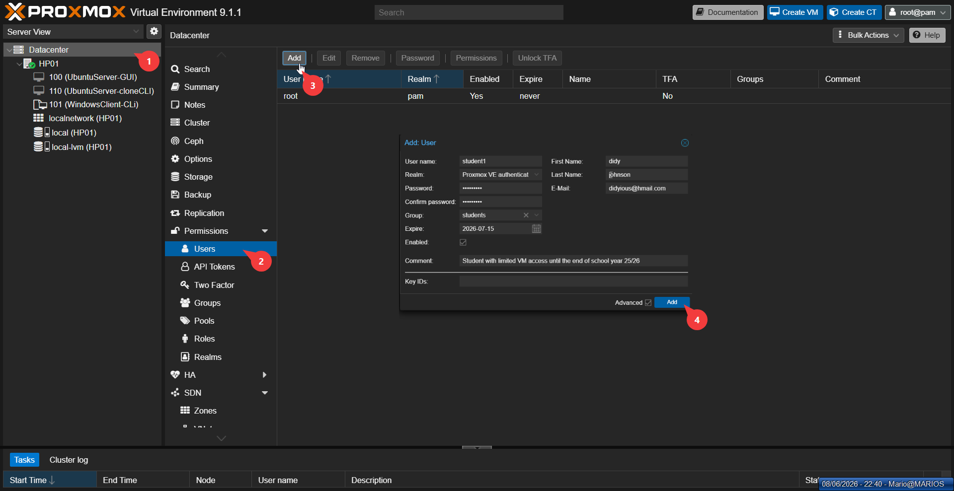
Figure 47: User creation dialog
The user creation dialog adds a new Proxmox user account with group membership and role assignment.
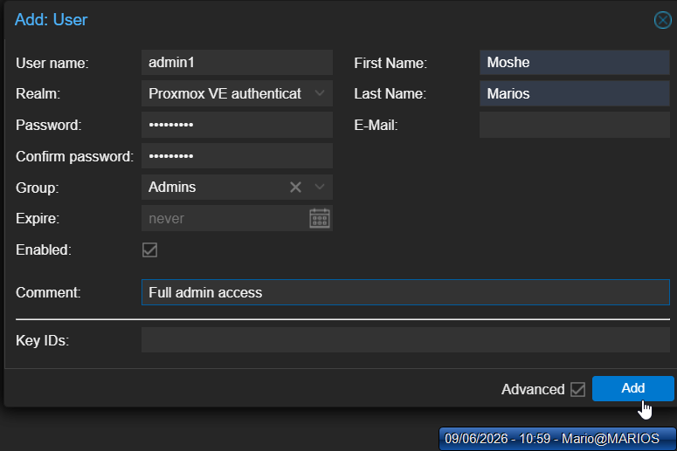
Figure 48: User list with groups
The user list displays all created accounts and their assigned groups for quick access control review.
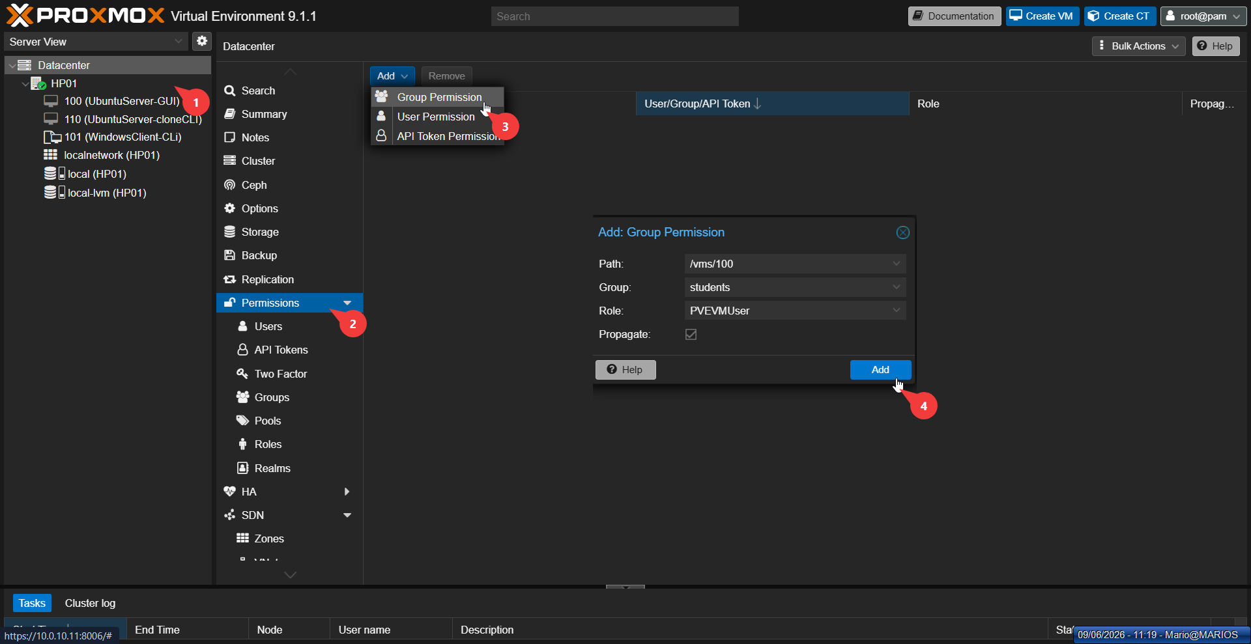
Figure 49: Permission assignment
The permissions interface assigns specific roles to users or groups on resources, enforcing least privilege.
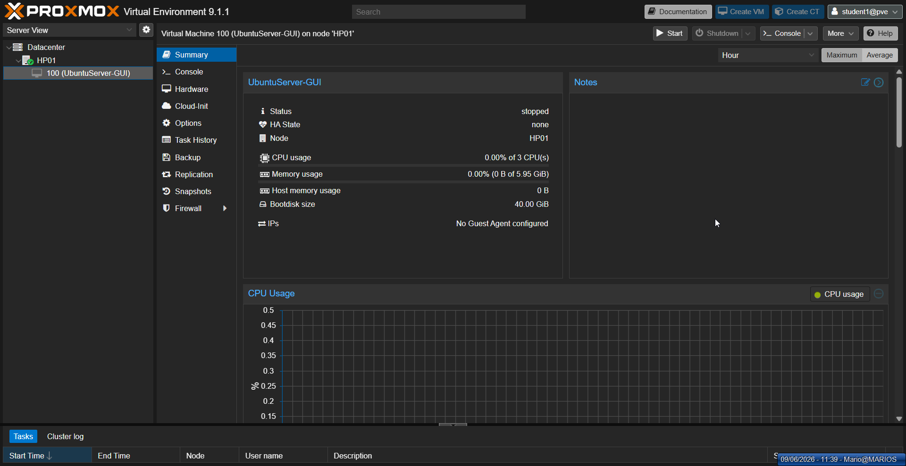
Figure 50: Group permissions configuration
The group permissions screen applies role-based access to multiple users simultaneously.
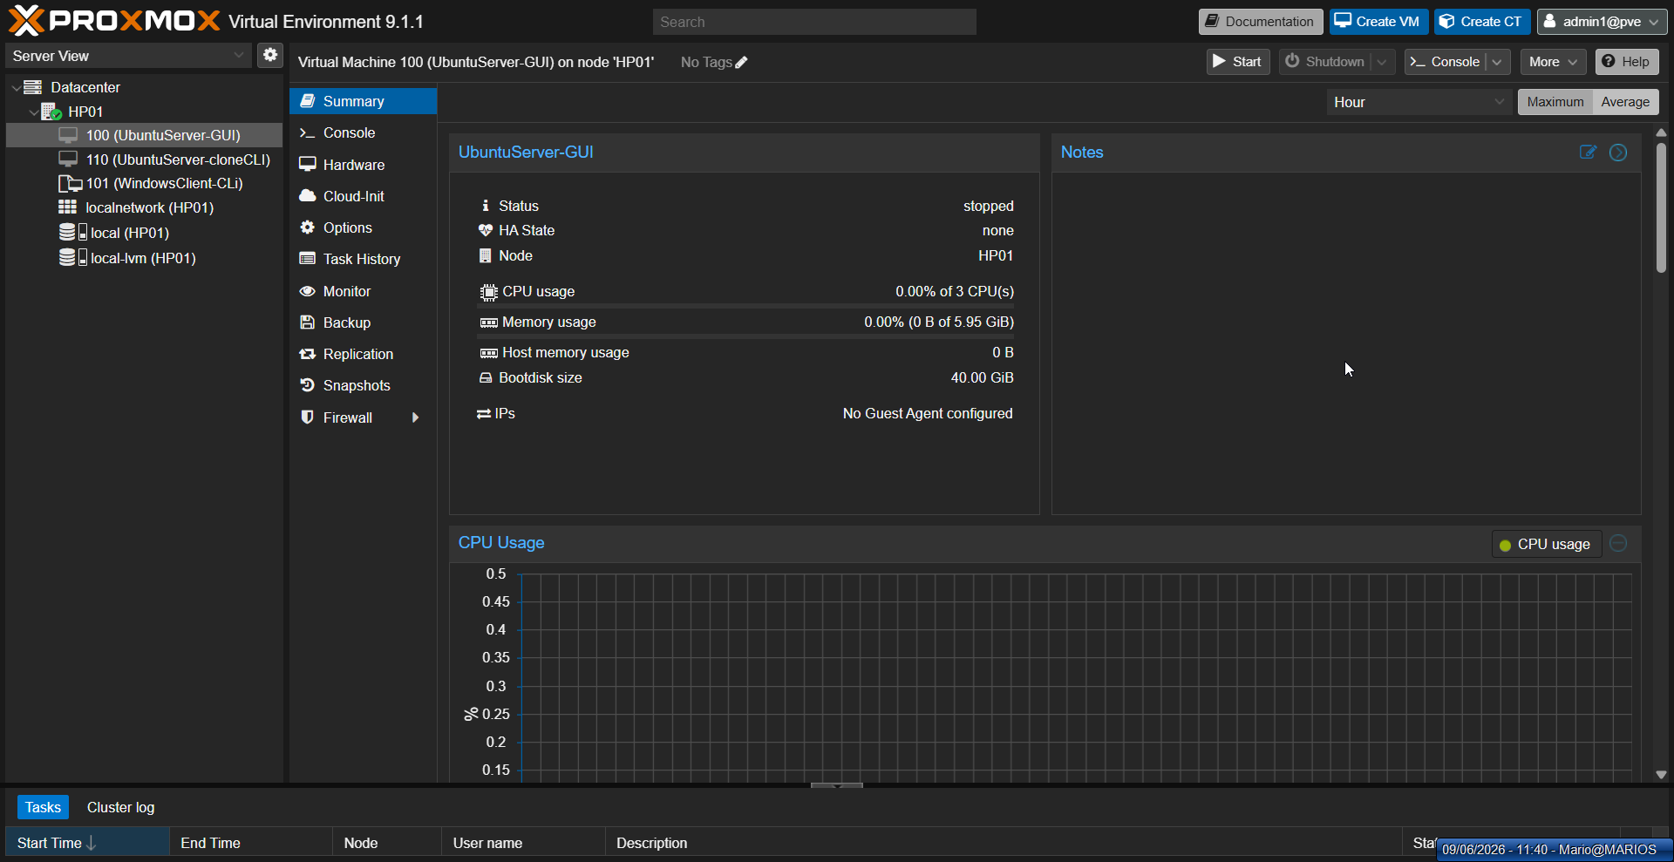
Figure 51: Role-based access control overview
The role overview displays available built-in and custom roles that define what actions users can perform.

16.3 VMware Comparison
VMware vCenter provides more granular permission management with object-level inheritance and integration with enterprise identity systems. Proxmox uses a simpler path-based permission model that is easier to understand but less flexible for complex hierarchies.

17. Hypervisor Patching & Updates

17.1 Objective
Update both Proxmox nodes to the latest available packages, ensuring security patches and bug fixes are applied while maintaining cluster stability.

17.2 Proxmox Implementation
A rolling update strategy was employed: HP03 was updated first, verified stable, then HP01 was updated. The no-subscription repository was enabled since no paid subscription was available.
apt update apt list --upgradable apt upgrade -y pveversion
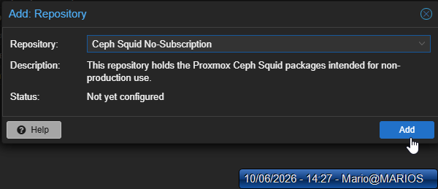
Figure 52: Repository configuration — adding no-subscription repo
The no-subscription repository is added to enable access to free Proxmox updates without a commercial license.
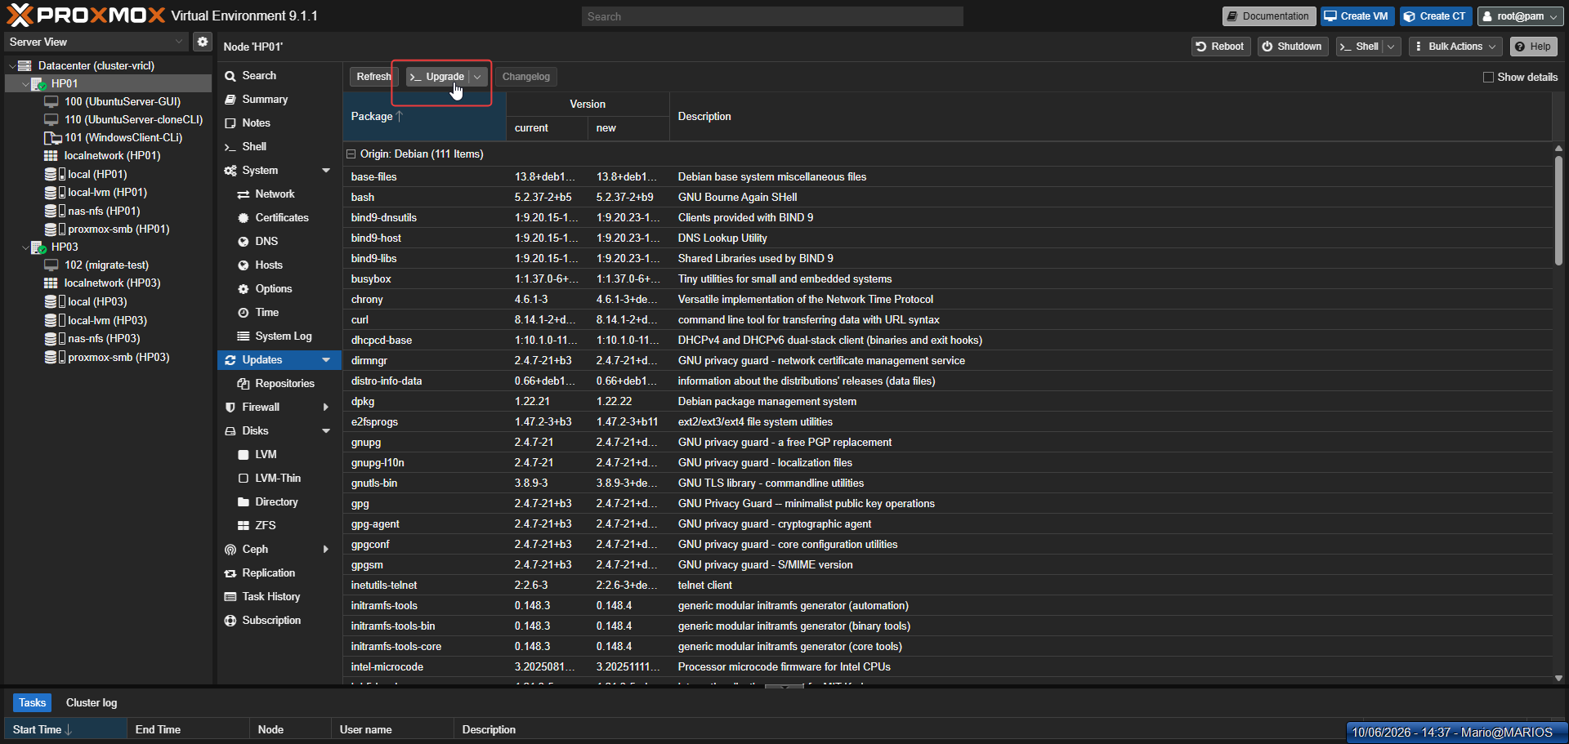
Figure 53: Repository list
The repository list displays all configured APT sources, including the newly added no-subscription repo.
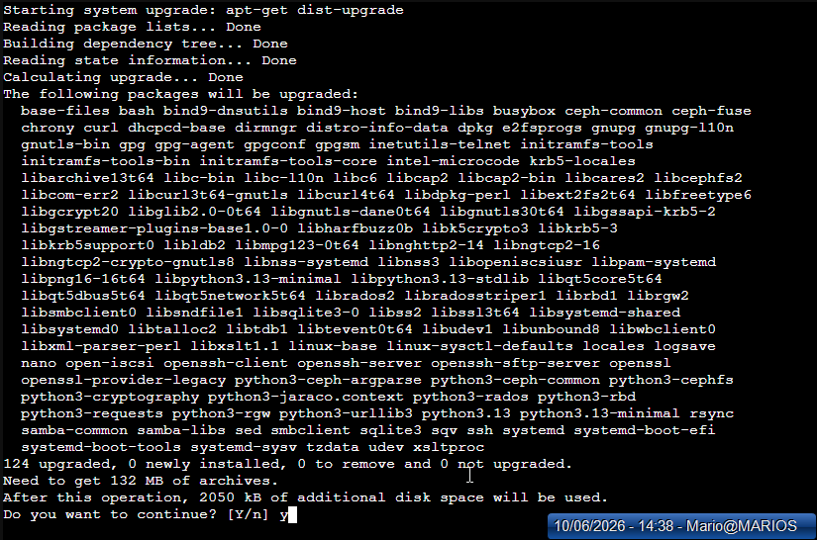
Figure 54: apt update output
The apt update output refreshes the package index from the configured repositories.
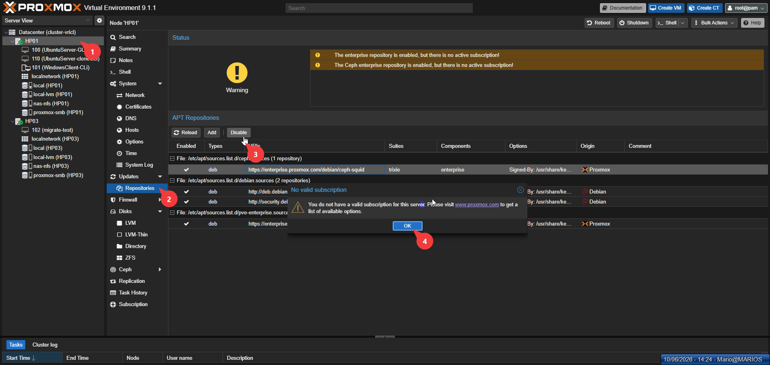
Figure 55: apt upgrade output
The apt upgrade output installs the latest available security patches and package updates.
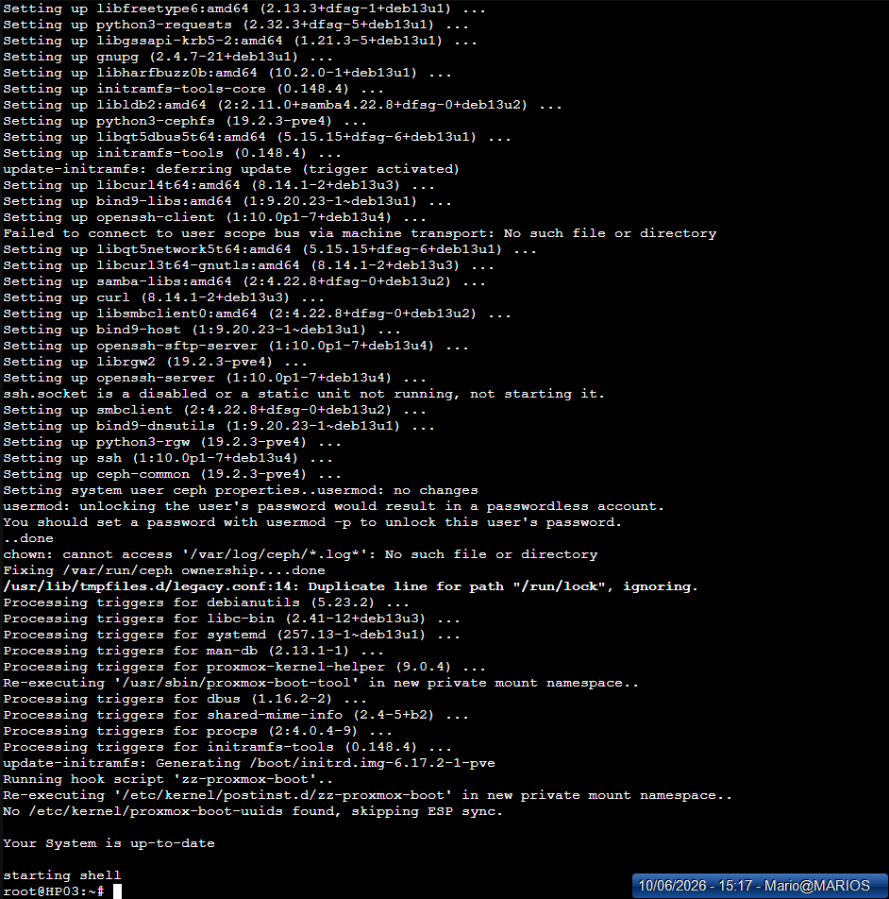
Figure 56: Version verification after patching
The pveversion command verifies the installed Proxmox version after patching, confirming the update succeeded.

17.3 Issue Resolution
HP03 initially failed to resolve domain names during apt update due to a missing /etc/resolv.conf file. The issue was resolved by creating the file with a public DNS server (8.8.8.8), after which updates proceeded normally.

17.4 VMware Comparison
VMware's vSphere Lifecycle Manager provides enterprise-grade update orchestration with baseline compliance checking and automated remediation. Proxmox uses standard Linux package management (APT), which is simpler but requires more manual oversight.

18. VMware Hypervisor Deployment

18.1 Objective
Install VMware ESXi 8.0 U2 on two physical HP ProLiant servers (HP02 at 10.0.10.21 and HP04 at 10.0.10.41) using remote ISO mounting via iLO, configure network settings, and deploy the vCenter Server Appliance (VCSA 8.0) for centralized management.

18.2 Theoretical Background
VMware ESXi is a Type-1 (bare-metal) hypervisor developed by VMware, now under Broadcom. Unlike Proxmox which is Debian-based, ESXi uses a proprietary microkernel architecture (VMkernel) optimized specifically for virtualization. The vCenter Server Appliance (VCSA) provides centralized management, enabling features like vMotion, DRS, and HA that require a management plane.

18.3 VMware Implementation

Step 1: ESXi Installation
The ESXi 8.0 U2 ISO was remotely mounted via iLO on both HP02 and HP04. The installation process is minimal: accept the EULA, select the target drive, set the root password, and confirm. Post-installation, network settings were configured through the Direct Console User Interface (DCUI) including IP address, subnet mask, gateway, and DNS.
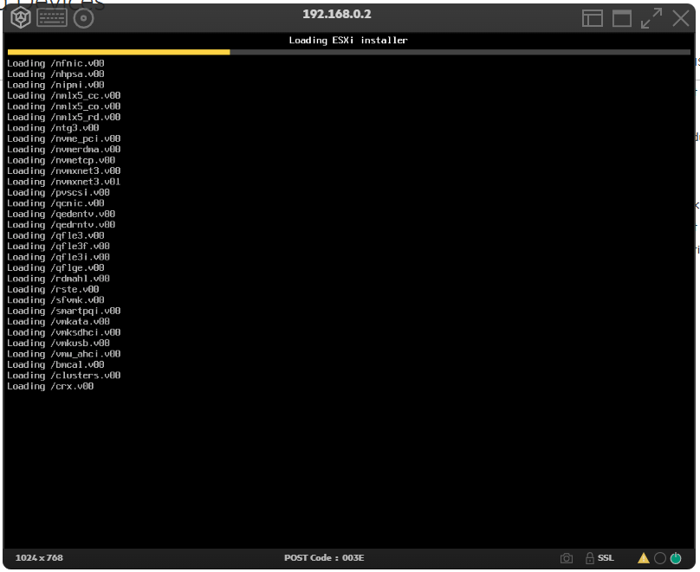
Figure 57: ESXi installation screen
This screenshot shows the ESXi installer interface, demonstrating the initial installation step where the target hypervisor is deployed. This is the foundation of the VMware environment.
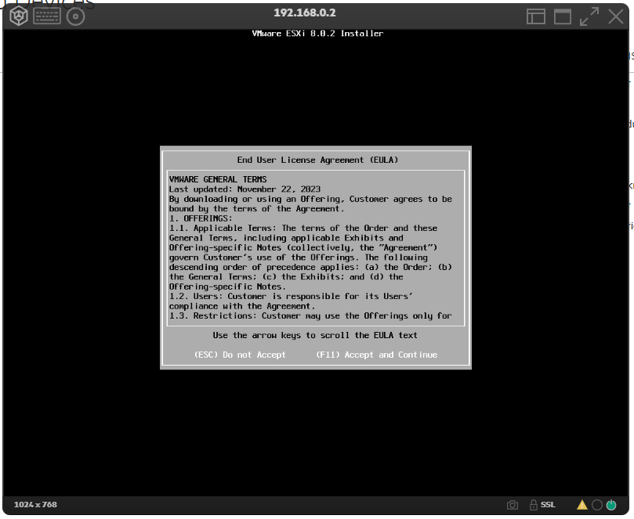
Figure 58: End User License Agreement
This screenshot shows the VMware End User License Agreement screen, representing the mandatory acceptance step during ESXi installation. Agreeing to the EULA is required before proceeding with the hypervisor deployment.
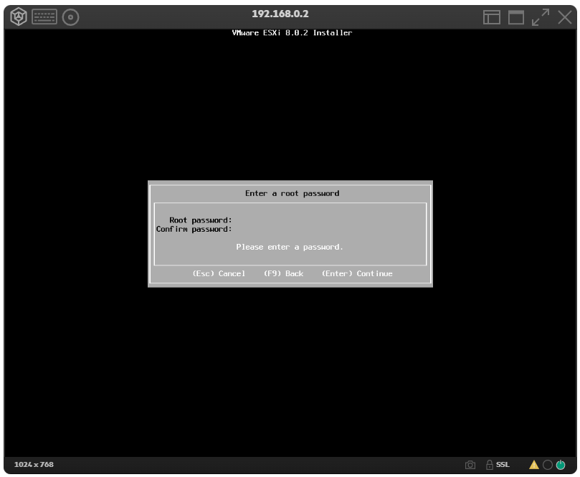
Figure 59: Root password configuration
This screenshot shows the root password configuration step during ESXi installation. Setting a secure root password is essential for protecting hypervisor access and maintaining system security.
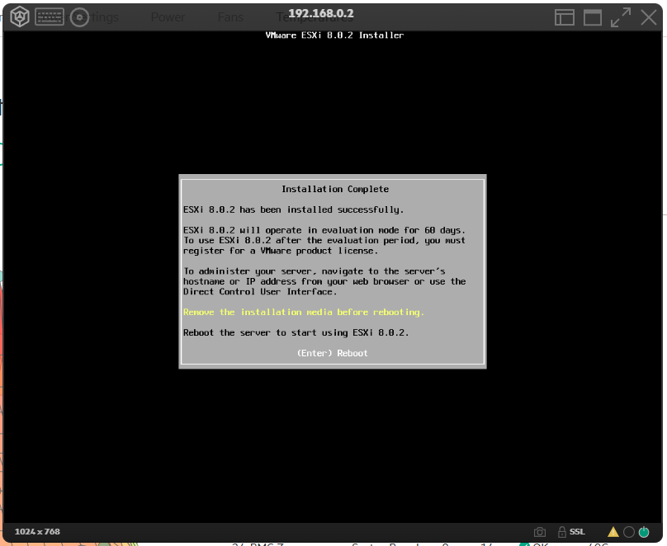
Figure 60: Completed ESXi installation
This screenshot shows the completed ESXi installation screen, confirming that the hypervisor has been successfully deployed on the host. This verification step ensures the server is ready for the vCenter Server Appliance deployment.

Step 2: vCenter Server Appliance (VCSA) Deployment
VCSA 8.0 was deployed in two stages. Stage 1 deploys the appliance OVA to an ESXi host, configuring the target server, datastore, network, and root password. Stage 2 configures the vCenter services including SSO domain, appliance configuration, and service startup.
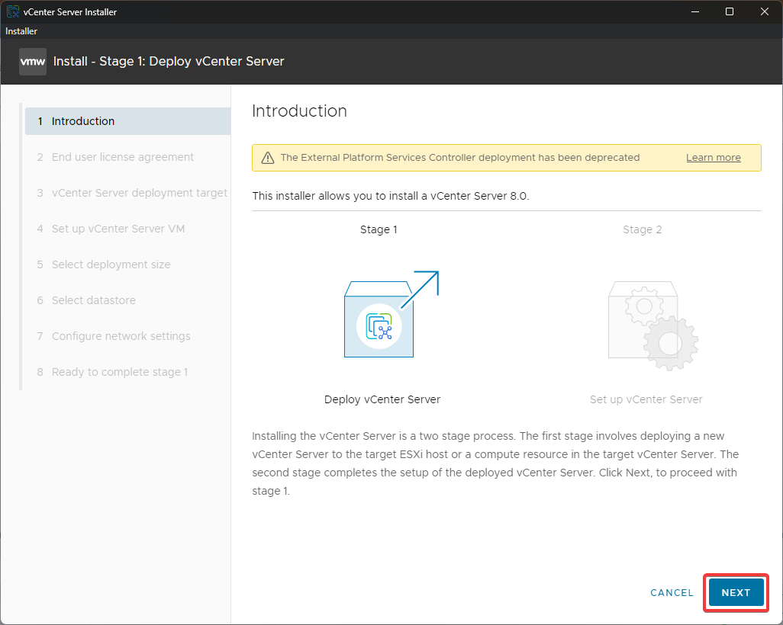
Figure 61: vCenter Server 8.0 installer
This screenshot shows the vCenter Server 8.0 installer interface, which is used to deploy the centralized management appliance. Deploying vCenter is necessary for managing multiple ESXi hosts through a single interface.
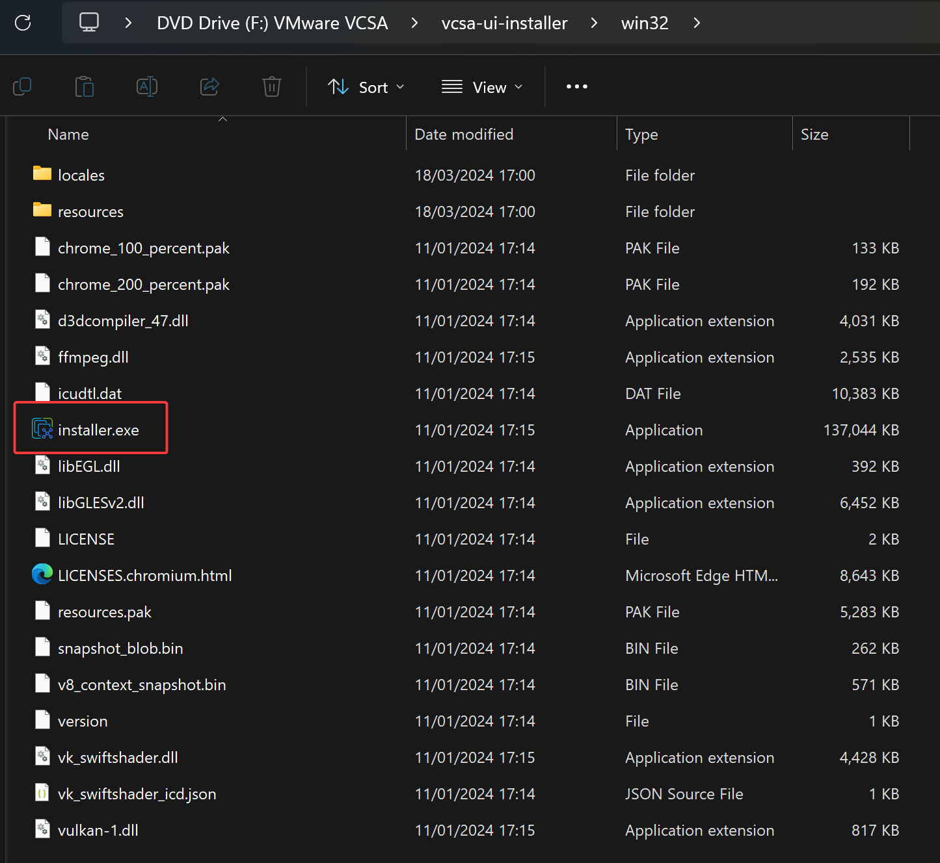
Figure 62: Launching the VCSA installer
This screenshot shows the launch of the vCenter Server Appliance installer, which begins the two-stage deployment process. This step initiates the installation of VMware's centralized management platform.
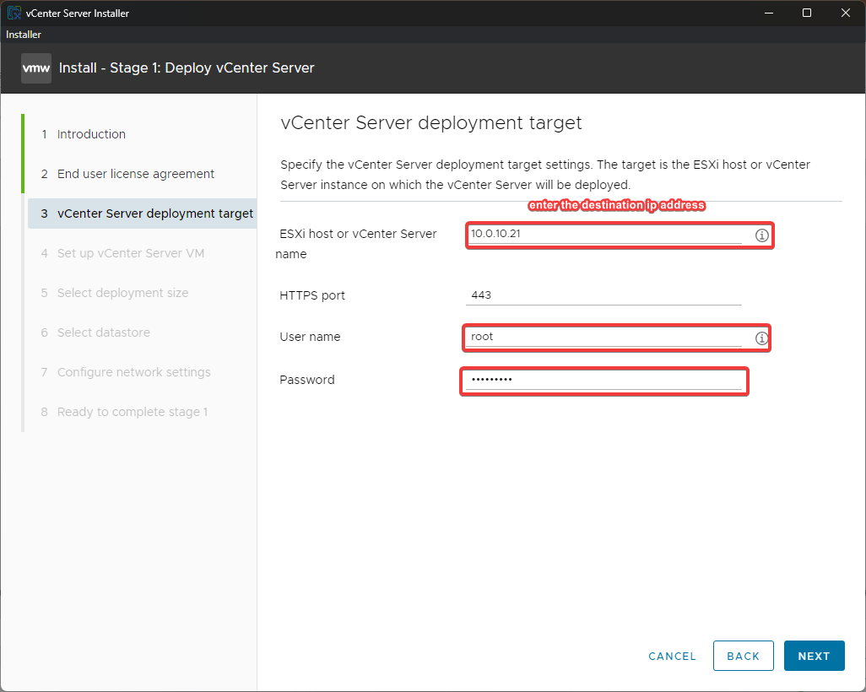
Figure 63: Deployment target selection
This screenshot shows the deployment target selection step, where the ESXi host that will host the vCenter appliance is chosen. Selecting the correct target host ensures the appliance is deployed to an available and properly configured server.
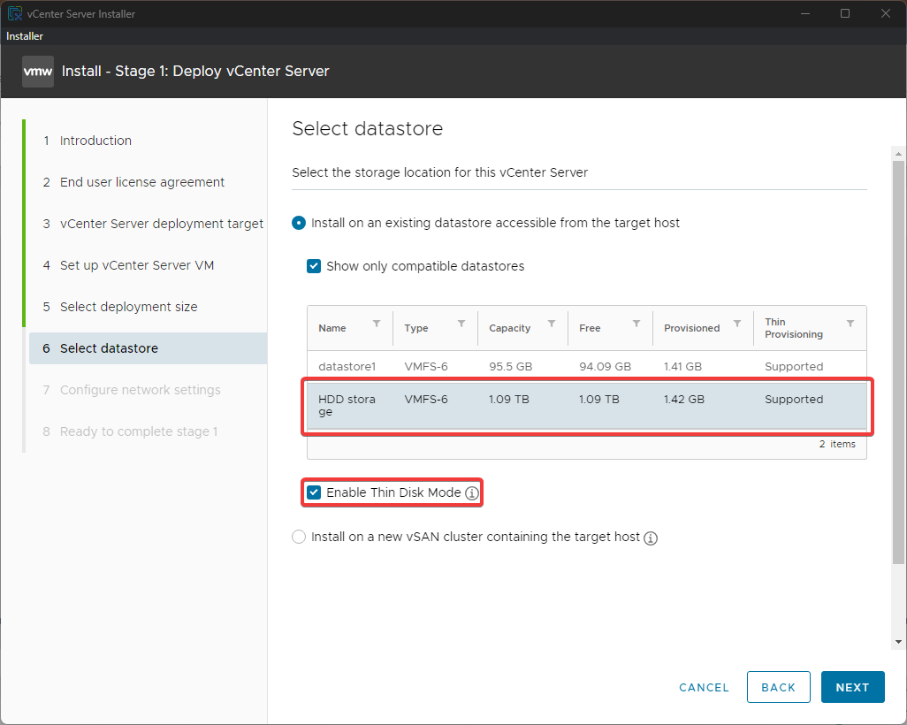
Figure 64: Datastore selection
This screenshot shows the datastore selection step for the vCenter Server Appliance deployment. Choosing an appropriate datastore ensures sufficient storage capacity and performance for the vCenter appliance.
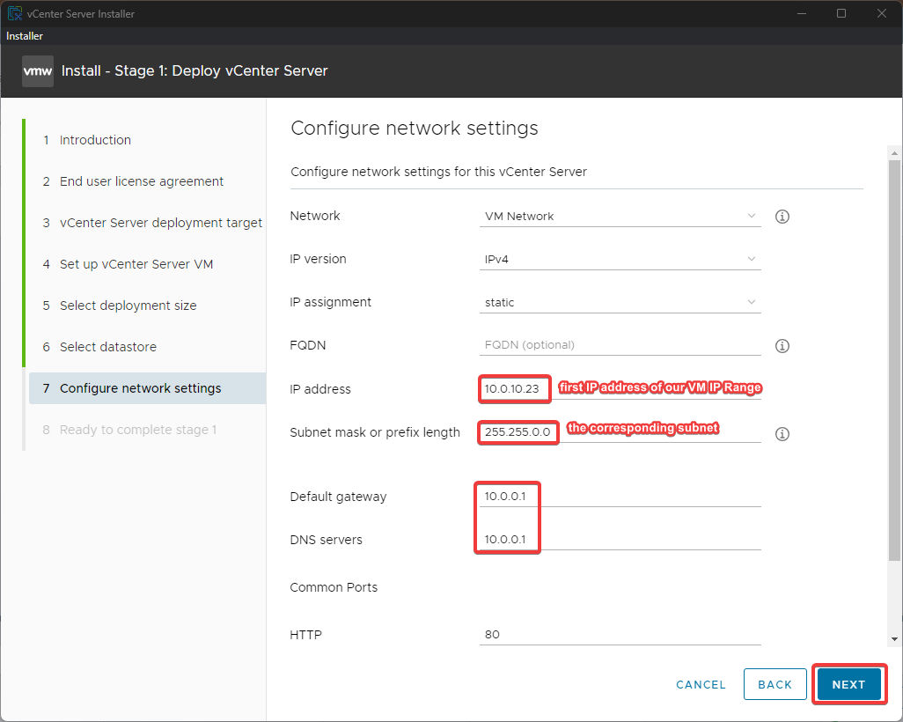
Figure 65: Network configuration
This screenshot shows the network configuration step for the vCenter Server Appliance, where IP settings and network parameters are defined. Proper network configuration ensures the appliance is reachable by administrators and ESXi hosts.
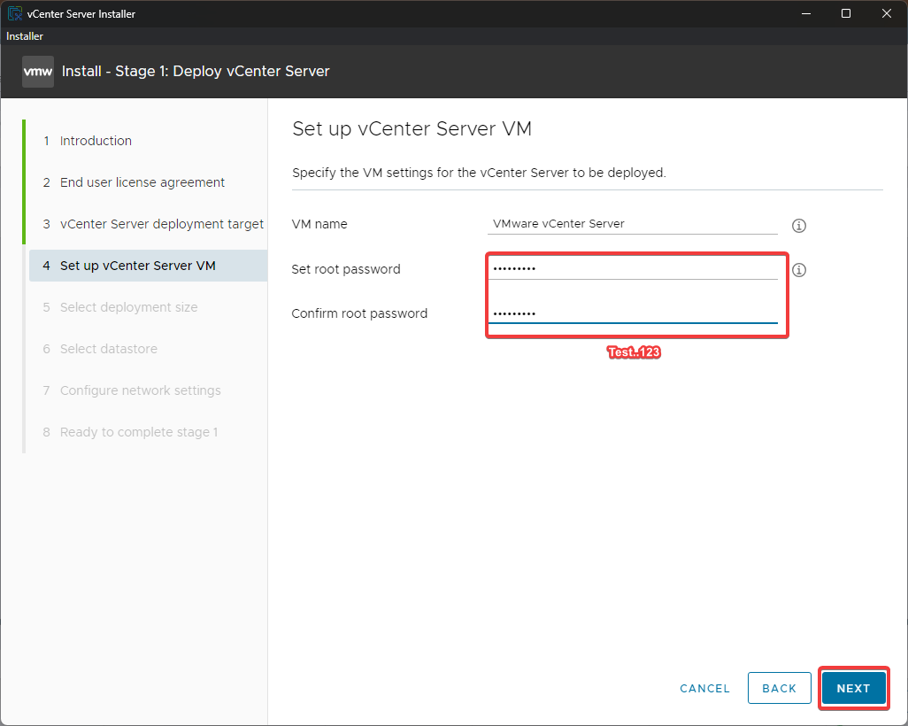
Figure 66: VCSA root password
This screenshot shows the vCenter Server Appliance root password configuration step. Setting a strong root password is critical for securing access to the vCenter management platform.
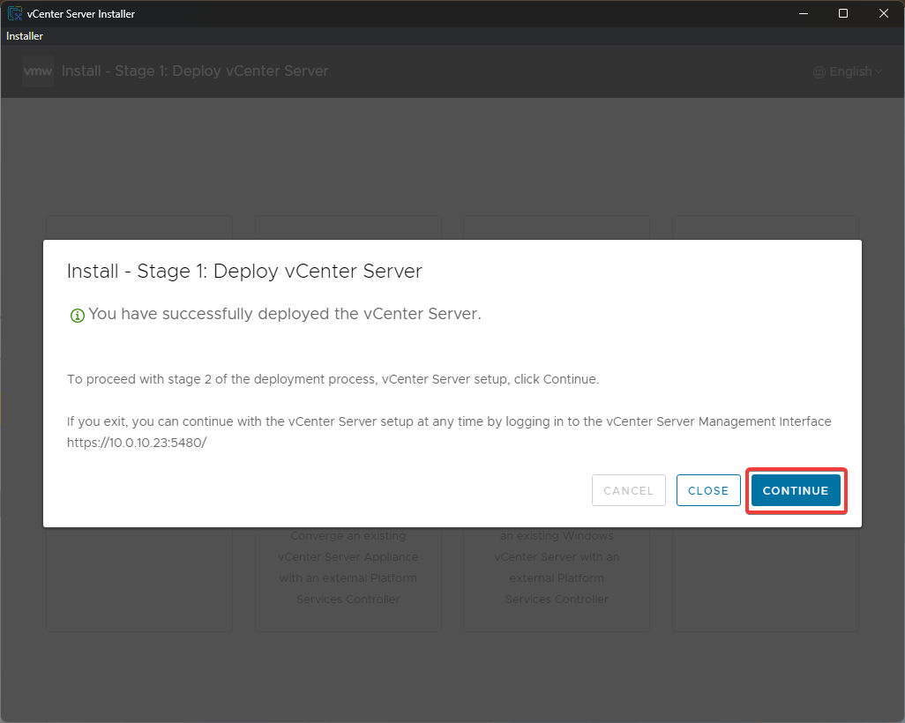
Figure 67: Stage 1 installation complete
This screenshot shows the completion of Stage 1 of the vCenter deployment, confirming the appliance OVA has been successfully deployed to the target host. This milestone indicates readiness for Stage 2 service configuration.
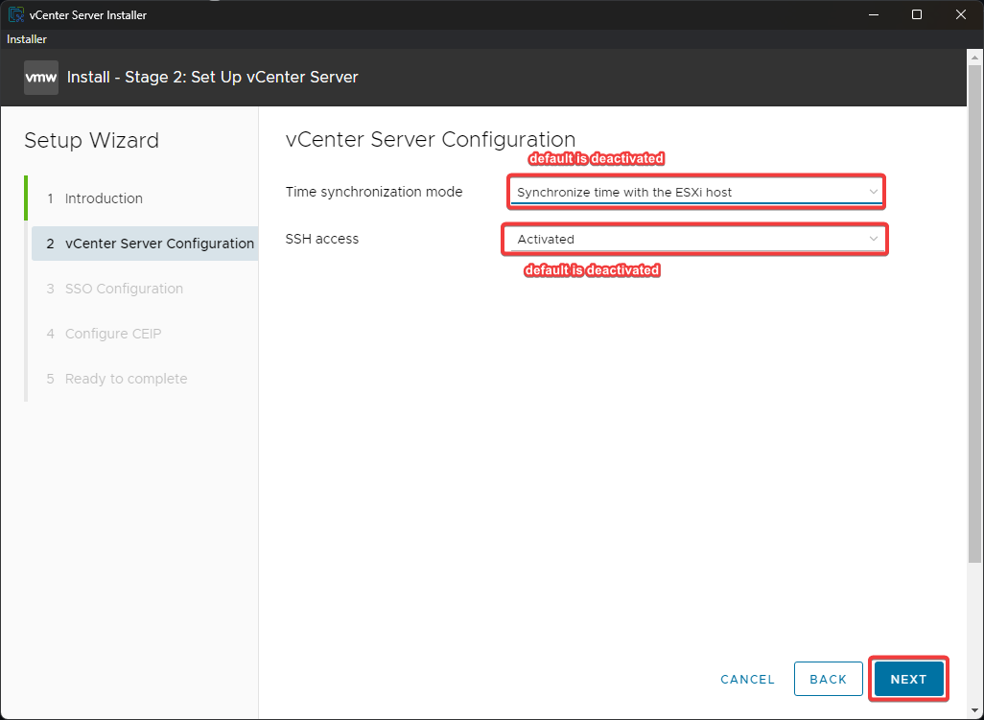
Figure 68: Stage 2 vCenter configuration
This screenshot shows the Stage 2 vCenter configuration screen, where SSO domain and appliance services are configured. Completing this stage finalizes the vCenter deployment and enables centralized management capabilities.
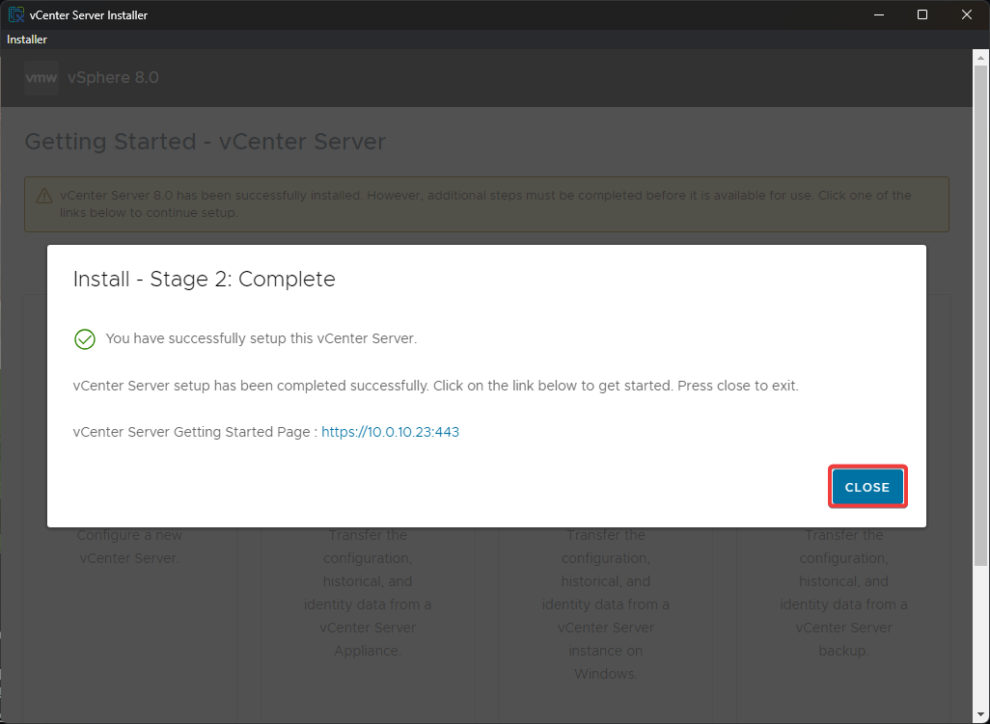
Figure 69: vCenter installation complete
This screenshot shows the vCenter installation completion screen, confirming all services have been successfully configured. This confirms the centralized management platform is fully operational and ready for use.

Step 3: Post-Installation Verification
After deployment, the vCenter web interface was accessed and both ESXi hosts (HP02 and HP04) were visible under the single pane of glass. The first login confirmed successful SSO domain creation and service initialization.
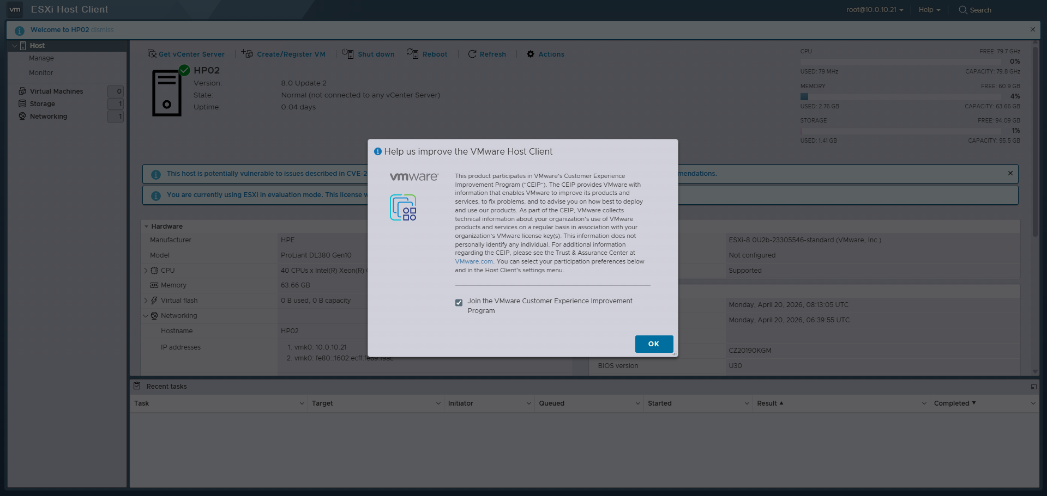
Figure 70: First login to vCenter
This screenshot shows the first login to the vCenter web interface, confirming successful SSO domain creation and service initialization. This verification step demonstrates that the centralized management platform is accessible and both ESXi hosts are visible.

18.4 Proxmox Comparison
Aspect | Proxmox VE | VMware ESXi/vCenter
Installation Complexity | Single guided installer | Two-stage: ESXi + VCSA deployment
Post-Install UI | Built-in web UI immediately | DCUI limited; vCenter required for full GUI
Centralized Management | Built-in cluster (no extra VM) | Requires separate VCSA appliance
Resource Overhead | Minimal (Debian base) | VCSA requires 4 vCPU, 16 GB RAM minimum
Licensing | Free, no subscription needed | Requires vSphere license for most features
Key Difference: Proxmox provides a fully functional web interface immediately after installation with no additional appliances, while VMware requires deploying a separate vCenter Server Appliance for centralized management. This makes Proxmox more accessible for small deployments, though vCenter offers superior enterprise features once deployed.

18.5 Results
ESXi 8.0 U2 was successfully installed on both HP02 and HP04. VCSA 8.0 was deployed and both hosts were added to the vCenter inventory. The centralized management interface provided a unified view of both hypervisors, enabling advanced features like vMotion and DRS.

19. Virtual Machine Creation via GUI (vCenter)

19.1 Objective
Create virtual machines using the vSphere Client web interface, configuring all hardware parameters through the graphical wizard in vCenter.

19.2 Theoretical Background
The vSphere Client provides a comprehensive VM creation wizard that guides administrators through compute resource selection, storage placement, compatibility levels, guest OS customization, and hardware configuration. Unlike Proxmox which uses a single-node wizard, vCenter's wizard integrates with the entire datacenter inventory.

19.3 VMware Implementation

Step 1: Datacenter and Host Setup
Before creating VMs, a datacenter object was created in vCenter, and both ESXi hosts (HP02 and HP04) were added to it. This establishes the inventory hierarchy required for VM placement and resource management.
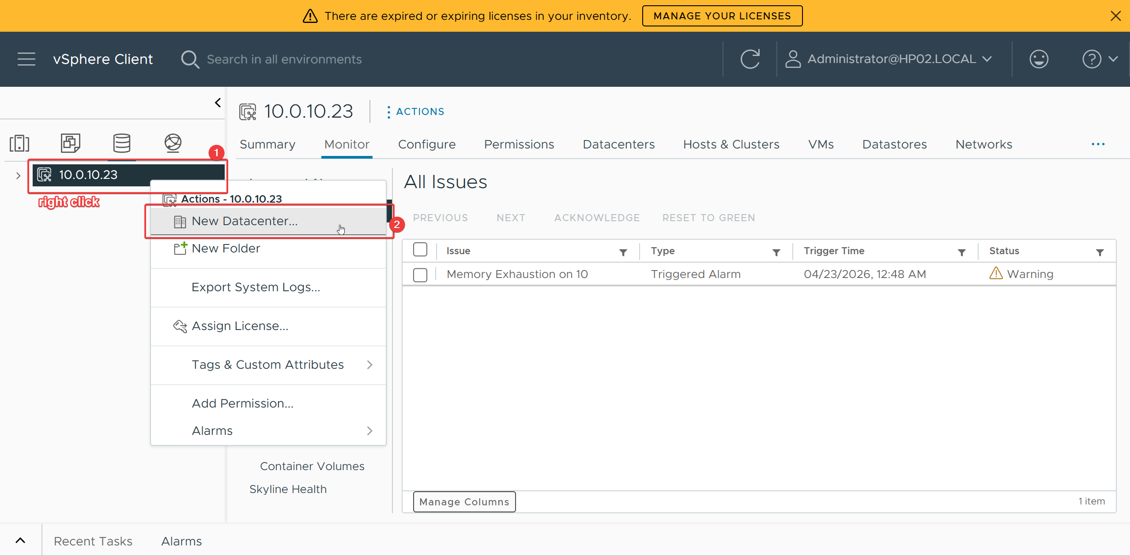
Figure 71: Creating a new datacenter
This screenshot shows the creation of a new datacenter object in vCenter, which establishes the top-level inventory hierarchy. Creating the datacenter is essential for organizing ESXi hosts and enabling VM placement and resource management.
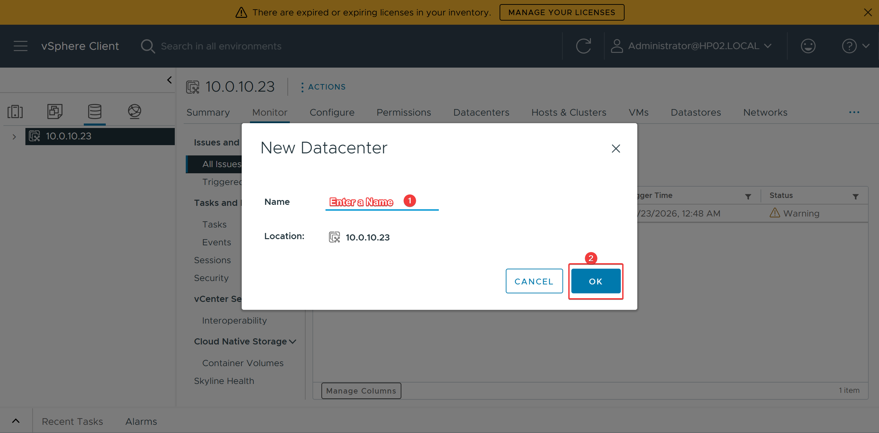
Figure 72: Naming the datacenter
This screenshot shows the datacenter naming step, where the new datacenter object is given a descriptive identifier. Proper naming helps organize the virtual infrastructure and distinguish different environments.
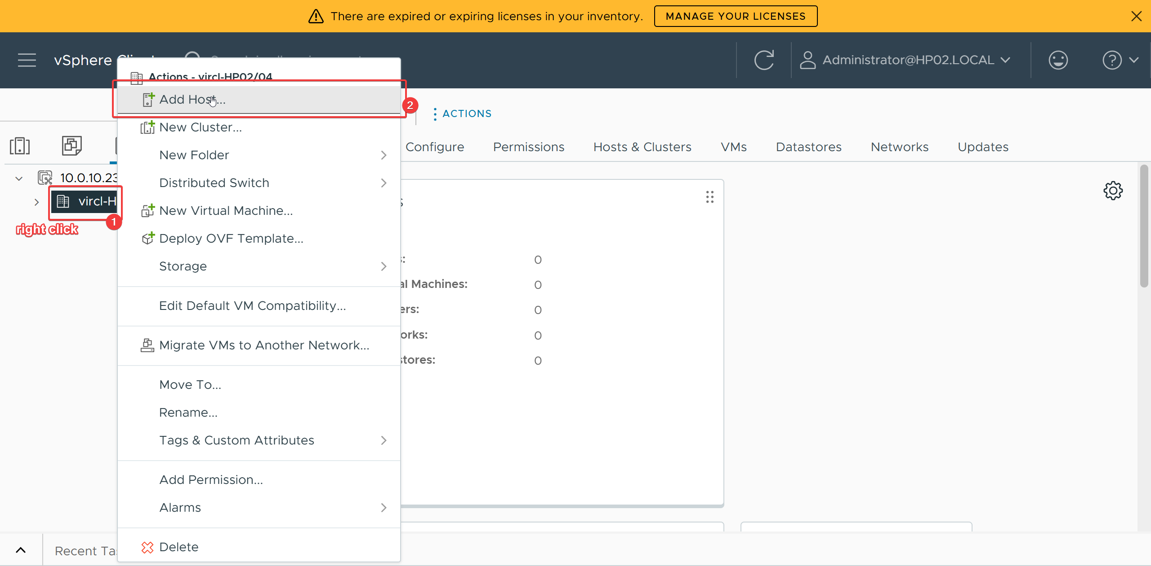
Figure 73: Adding a new host
This screenshot shows the process of adding a new ESXi host to the vCenter datacenter. Adding hosts to the inventory is necessary for vCenter to manage and monitor the hypervisor resources centrally.
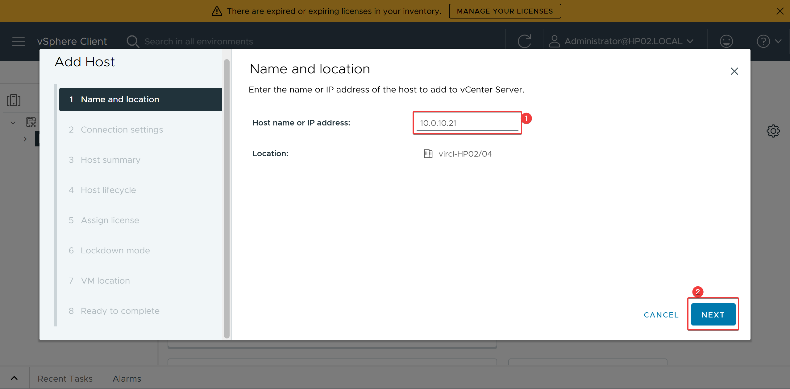
Figure 74: Host IP configuration
This screenshot shows the host IP configuration step when adding an ESXi host to vCenter. Entering the correct IP address ensures vCenter can communicate with and manage the target hypervisor.
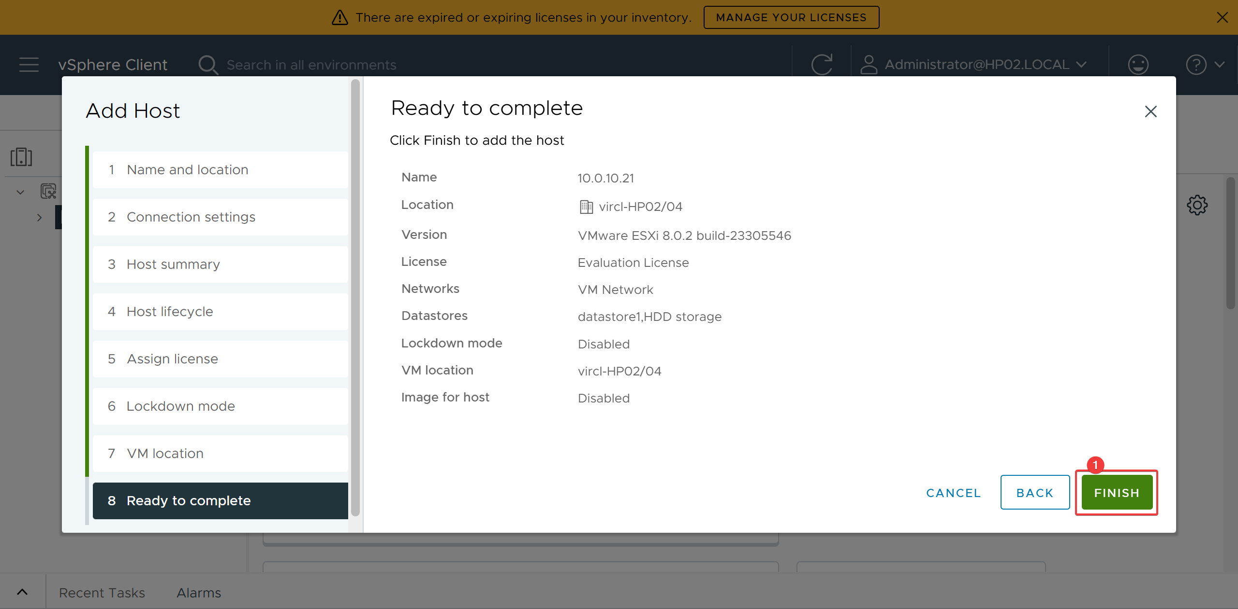
Figure 75: Finished host configuration
This screenshot shows the completed host configuration after adding ESXi hosts to the vCenter datacenter. This confirms the inventory hierarchy is established and both hosts are ready for virtual machine deployment.

Step 2: New VM Wizard
The New Virtual Machine wizard was launched from the vSphere Client. The process involved selecting the creation type (typical or custom), choosing the compute resource (host or cluster), selecting storage, setting compatibility (ESXi 8.0 U2), choosing the guest OS, customizing hardware (CPU, RAM, disk, NIC), and confirming the configuration.
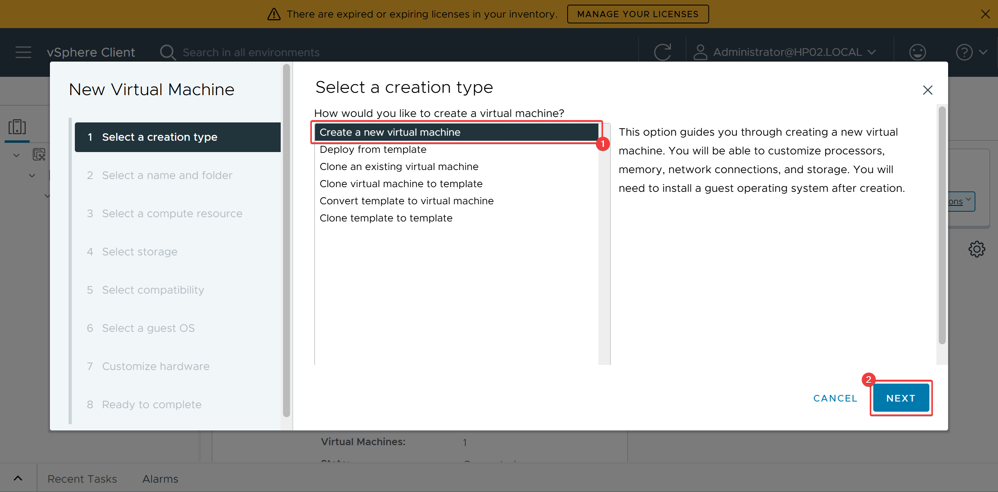
Figure 76: Selection of creation type
This screenshot shows the selection of creation type in the New Virtual Machine wizard, choosing between typical or custom deployment. This step determines the level of control over VM configuration during the deployment process.
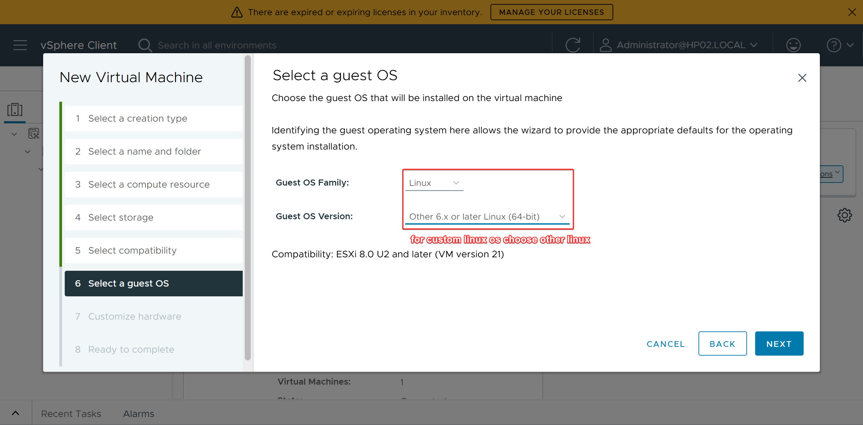
Figure 77: Choosing guest OS
This screenshot shows the guest operating system selection step in the VM creation wizard. Choosing the correct guest OS ensures VMware applies appropriate default settings and compatibility options for the VM.
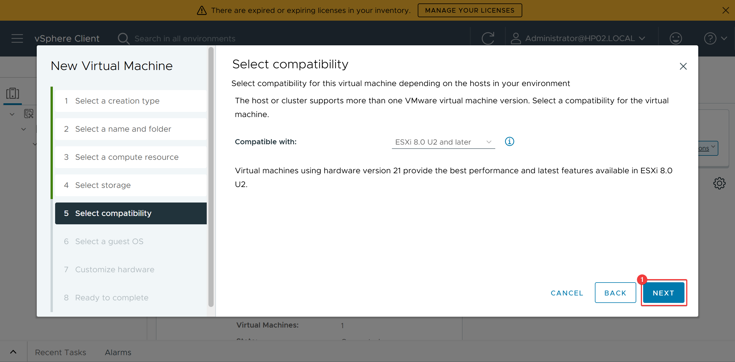
Figure 78: Compatibility selection
This screenshot shows the VM compatibility selection step, where the virtual hardware version is set to ESXi 8.0 U2. Setting compatibility ensures the VM can leverage the latest features while maintaining proper support.
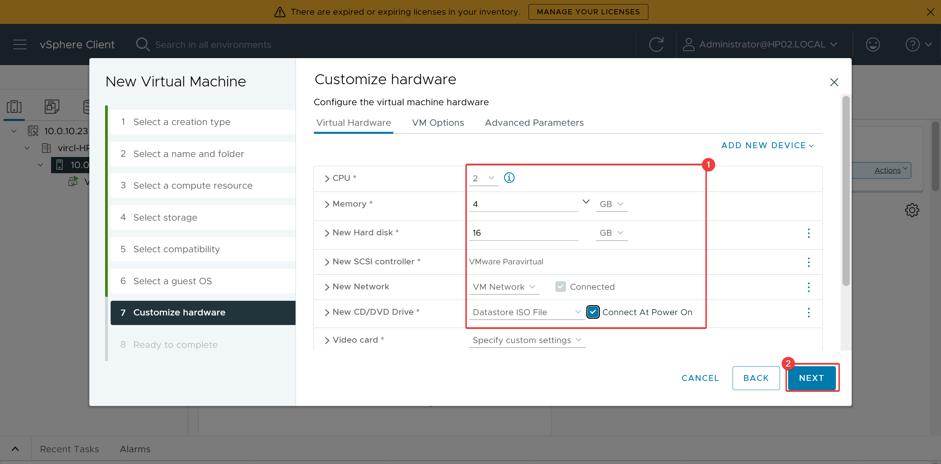
Figure 79: VM hardware configuration
This screenshot shows the VM hardware configuration step, where CPU, memory, disk, and network settings are customized. Configuring hardware properly ensures the VM has sufficient resources for its intended workload.
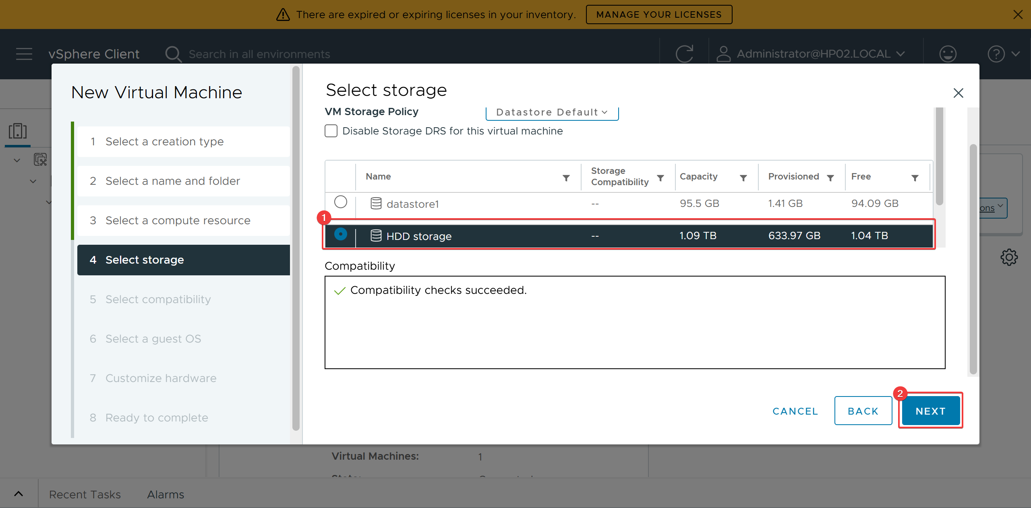
Figure 80: Storage selection
This screenshot shows the storage selection step in the VM creation wizard, where the datastore for the virtual disk is chosen. Selecting appropriate storage ensures adequate capacity and performance for the virtual machine.
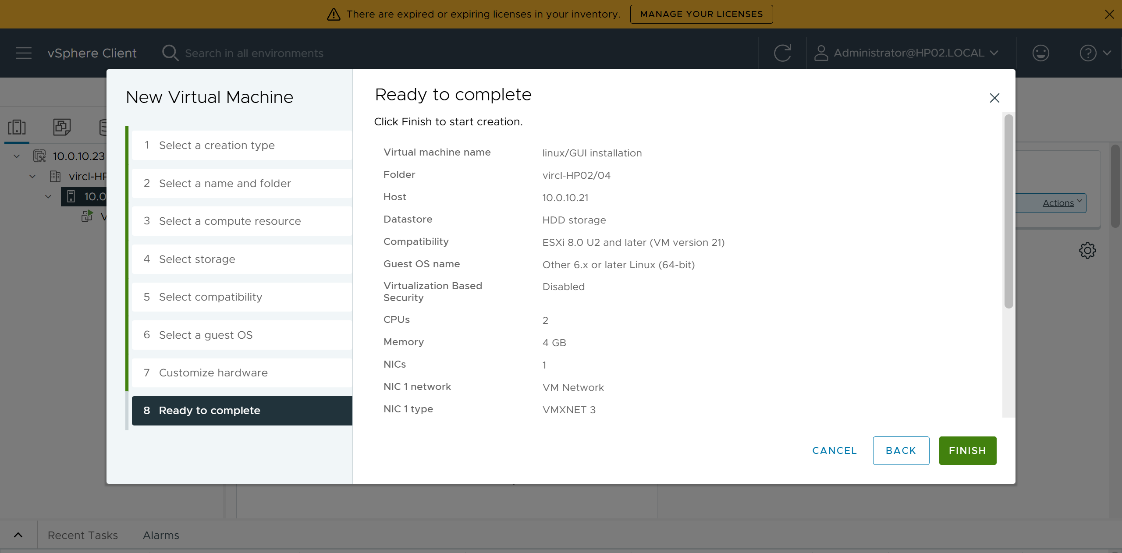
Figure 81: Confirming VM configuration
This screenshot shows the final confirmation screen of the VM creation wizard, summarizing the configured hardware and settings. This verification step allows review of all parameters before deploying the virtual machine.

19.4 Proxmox Comparison
VMware's vSphere Client offers more granular control over virtual hardware versions and has a more extensive guest OS compatibility list. The datacenter/host inventory model is more sophisticated than Proxmox's node-based approach. However, Proxmox's simpler wizard is faster for standard deployments and does not require a separate vCenter appliance.

19.5 Results
Multiple VMs were successfully created through the vSphere Client GUI with proper hardware configuration. The datacenter inventory model provided clear organization of resources across both ESXi hosts.

20. Virtual Machine Creation via CLI

20.1 Objective
Create and manage virtual machines using command-line interface commands on ESXi, demonstrating automation capabilities and understanding of the underlying VMware hypervisor parameters.

20.2 Theoretical Background
VMware provides multiple CLI interfaces for VM management: ESXCLI (local ESXi commands), PowerCLI (PowerShell module for vCenter), and vim-cmd (legacy ESXi command). For direct host management, SSH to the ESXi host enables vim-cmd and esxcli commands.

20.3 VMware Implementation
SSH was enabled on the ESXi host and a connection was established. The esxcli vm process list command showed running VMs, and vim-cmd vmsvc/getallvms listed all registered VMs. New VMs can be created by registering a VMX file or using PowerCLI connected to vCenter.
# List running VMs esxcli vm process list # List all registered VMs vim-cmd vmsvc/getallvms # Get VM info vim-cmd vmsvc/get.summary <vmid> # Power on VM vim-cmd vmsvc/power.on <vmid> # Power off VM vim-cmd vmsvc/power.off <vmid>
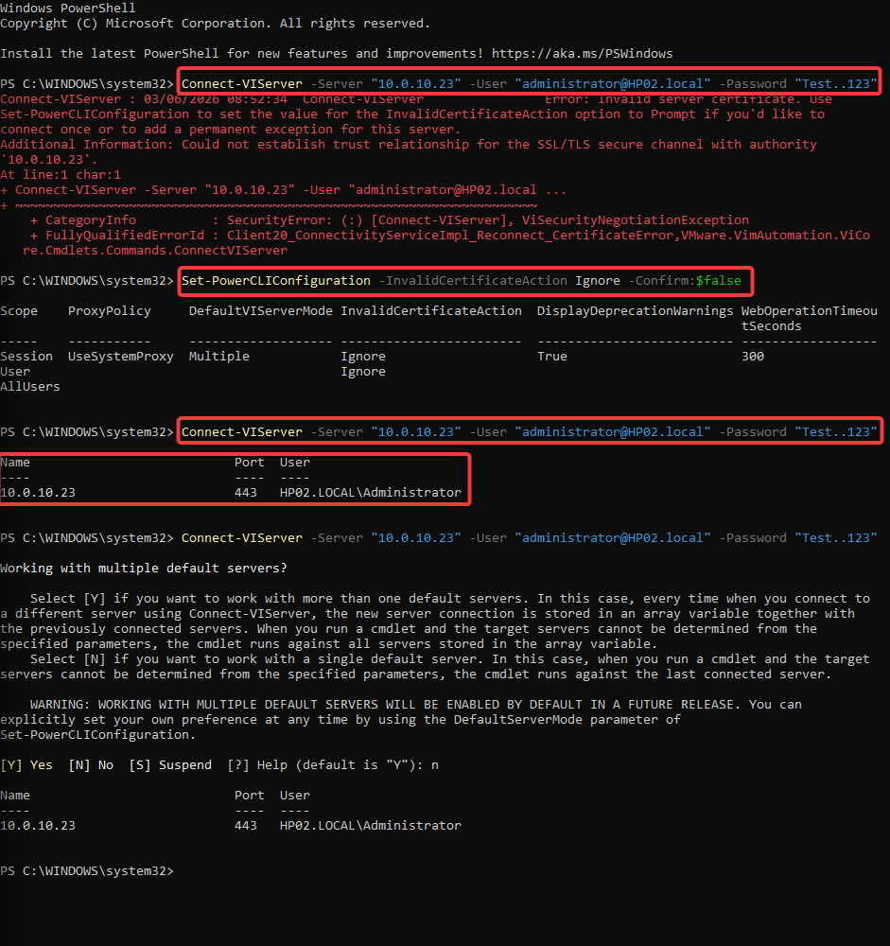
Figure 82: SSH connection to ESXi host
This screenshot shows an SSH connection to an ESXi host, providing command-line access for VM management. Using SSH enables administrators to perform advanced operations directly on the hypervisor when needed.
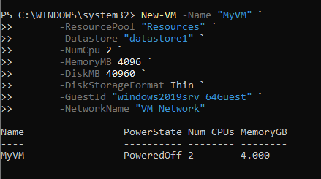
Figure 83: VM creation via CLI
This screenshot shows the execution of a VM creation command via CLI on the ESXi host. This demonstrates that virtual machines can be deployed programmatically without relying solely on the graphical vSphere Client.
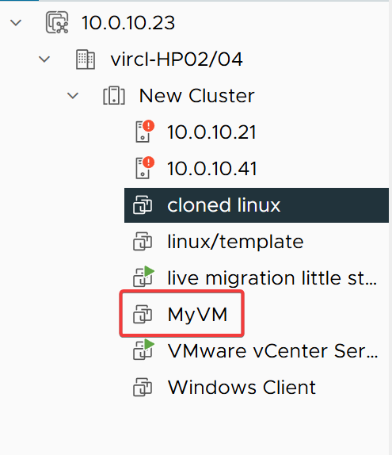
Figure 84: Verification of VM creation
This screenshot shows the verification of a VM created through the command-line interface, confirming the new VM appears in the host inventory. This validation step ensures the CLI-based deployment was successful and the VM is registered.

20.4 Proxmox Comparison
VMware's PowerCLI is significantly more powerful for large-scale automation, offering hundreds of cmdlets for vCenter management. ESXCLI provides deep hardware and system management. Proxmox's qm tool is simpler but sufficient for single-node or small-cluster operations. Both support REST APIs for programmatic access.

20.5 Results
SSH connectivity to ESXi was established and VM management commands were executed successfully. The CLI approach confirmed that ESXi provides robust command-line management, though PowerCLI offers the most comprehensive automation capabilities when connected to vCenter.

21. Operating System Installation

21.1 Objective
Install Windows 11 and Ubuntu Server inside the created virtual machines on VMware, documenting the installation process and post-install configuration.

21.2 Windows 11 Installation
Windows 11 Enterprise Evaluation was installed on a VMware VM with appropriate hardware configuration. The installation proceeded through the standard Windows Setup wizard: language and keyboard selection, storage configuration, installation execution, and profile setup.
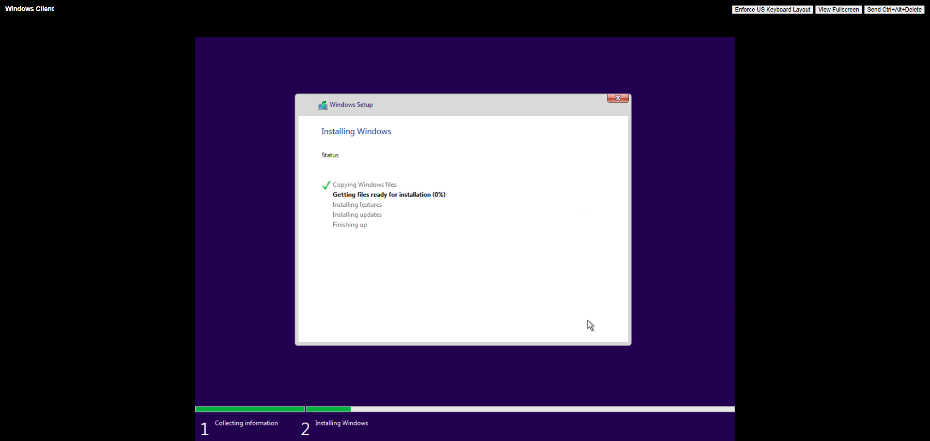
Figure 85: Windows 11 installation
This screenshot shows the Windows 11 installation screen running on a VMware virtual machine. This demonstrates that the guest operating system boots correctly from the installation media and the VM hardware is properly configured.
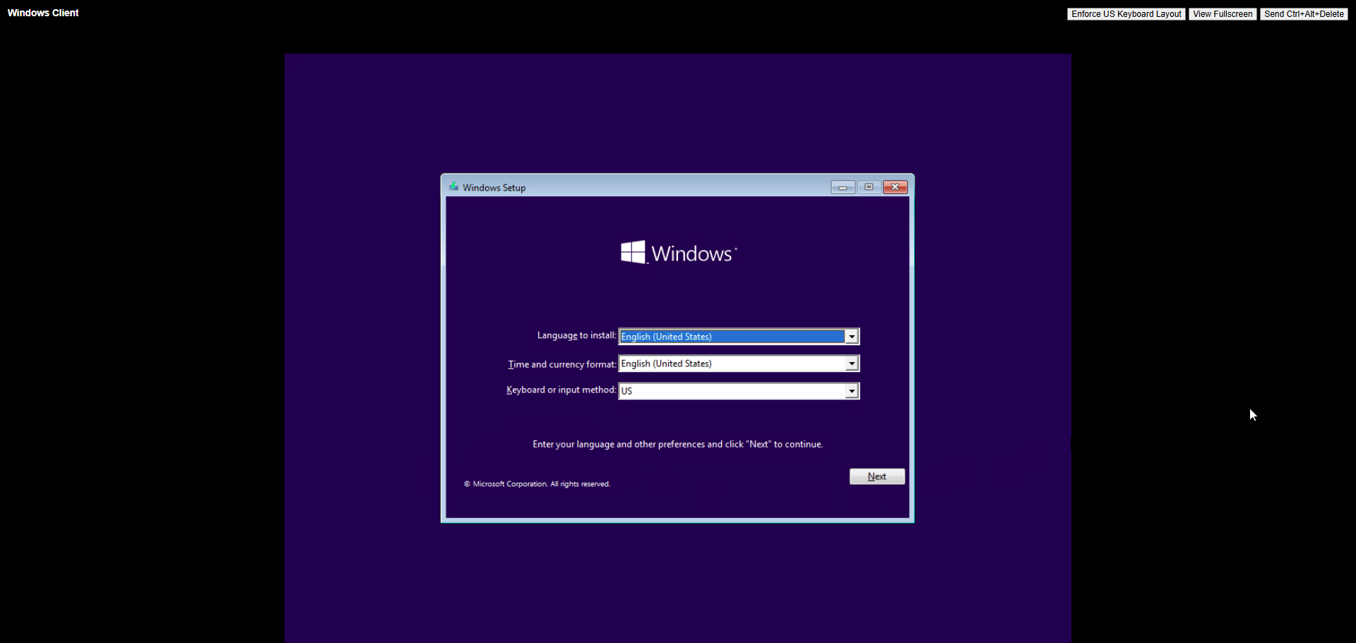
Figure 86: Keyboard layout selection
This screenshot shows the keyboard layout selection step during the Windows 11 installation process. Selecting the correct layout ensures proper input functionality for the guest operating system.
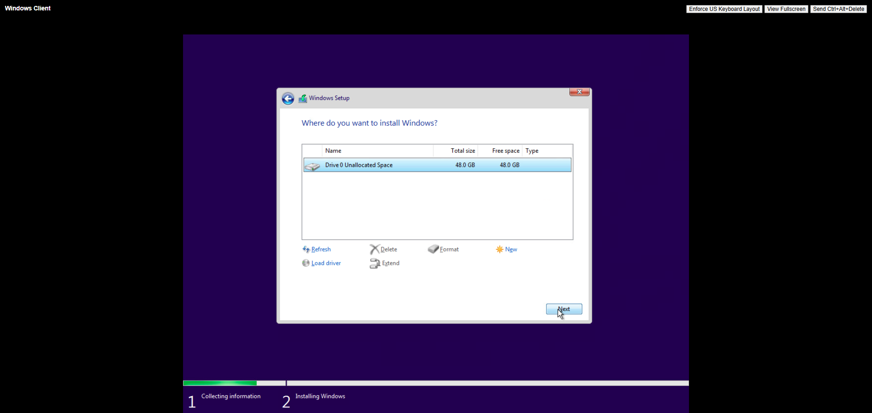
Figure 87: Storage selection
This screenshot shows the storage selection step during the Windows 11 installation, where the virtual disk is chosen for the OS installation. This step allocates the provisioned virtual disk space for the guest operating system.
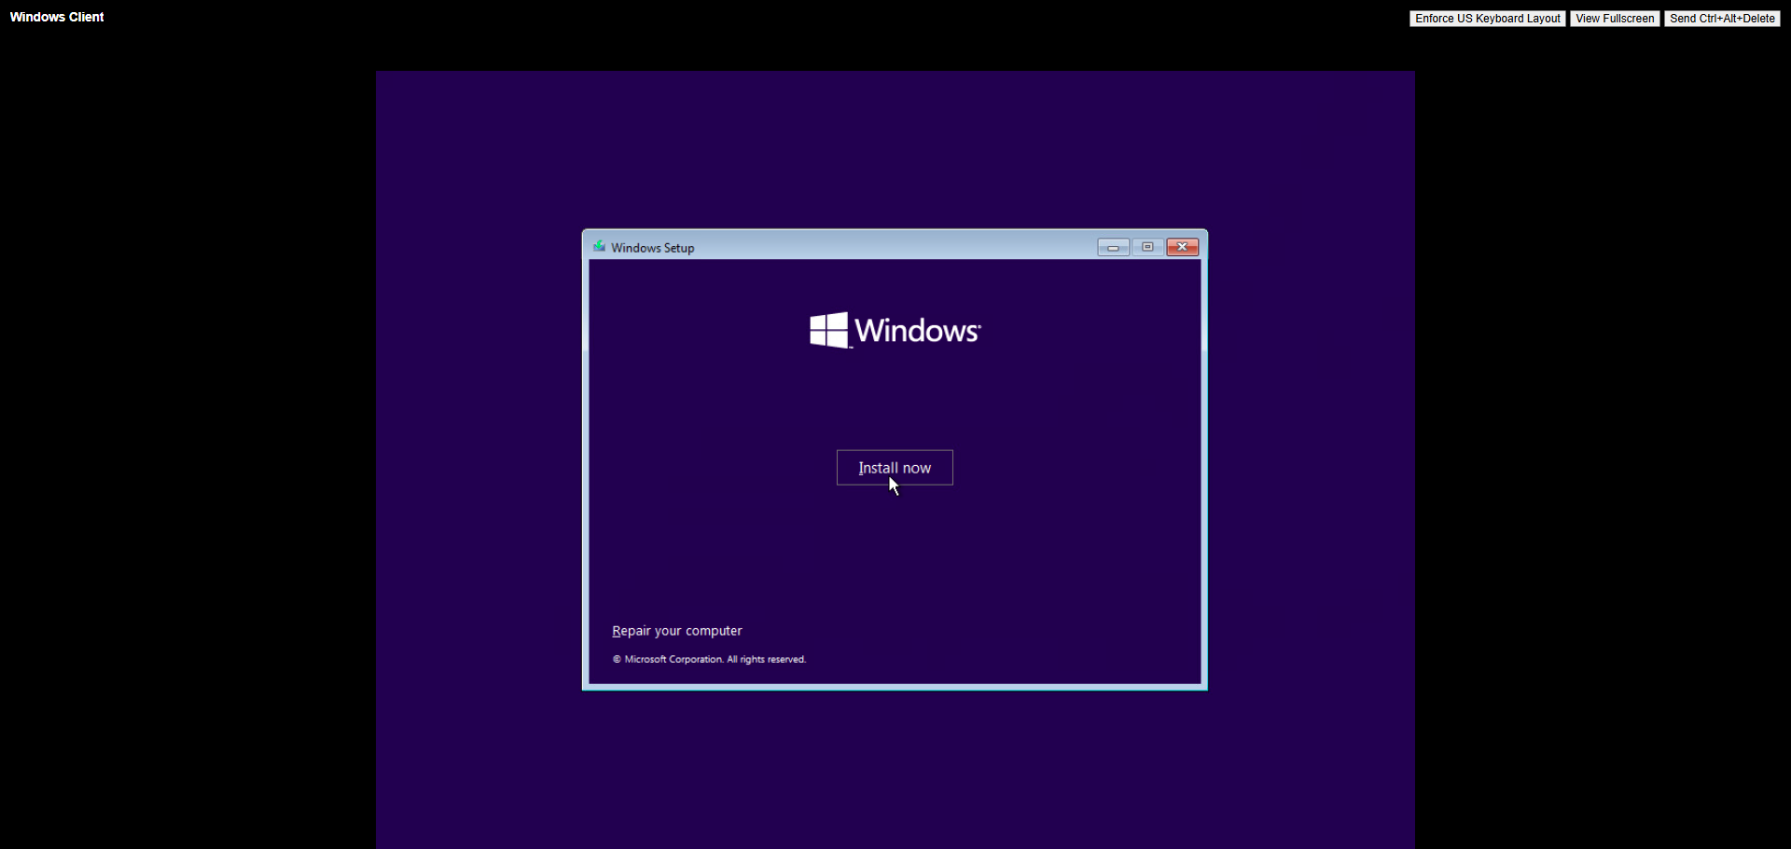
Figure 88: Install button
This screenshot shows the Windows 11 install button confirmation step, where the user initiates the actual OS installation. Clicking install begins writing the operating system files to the virtual disk.
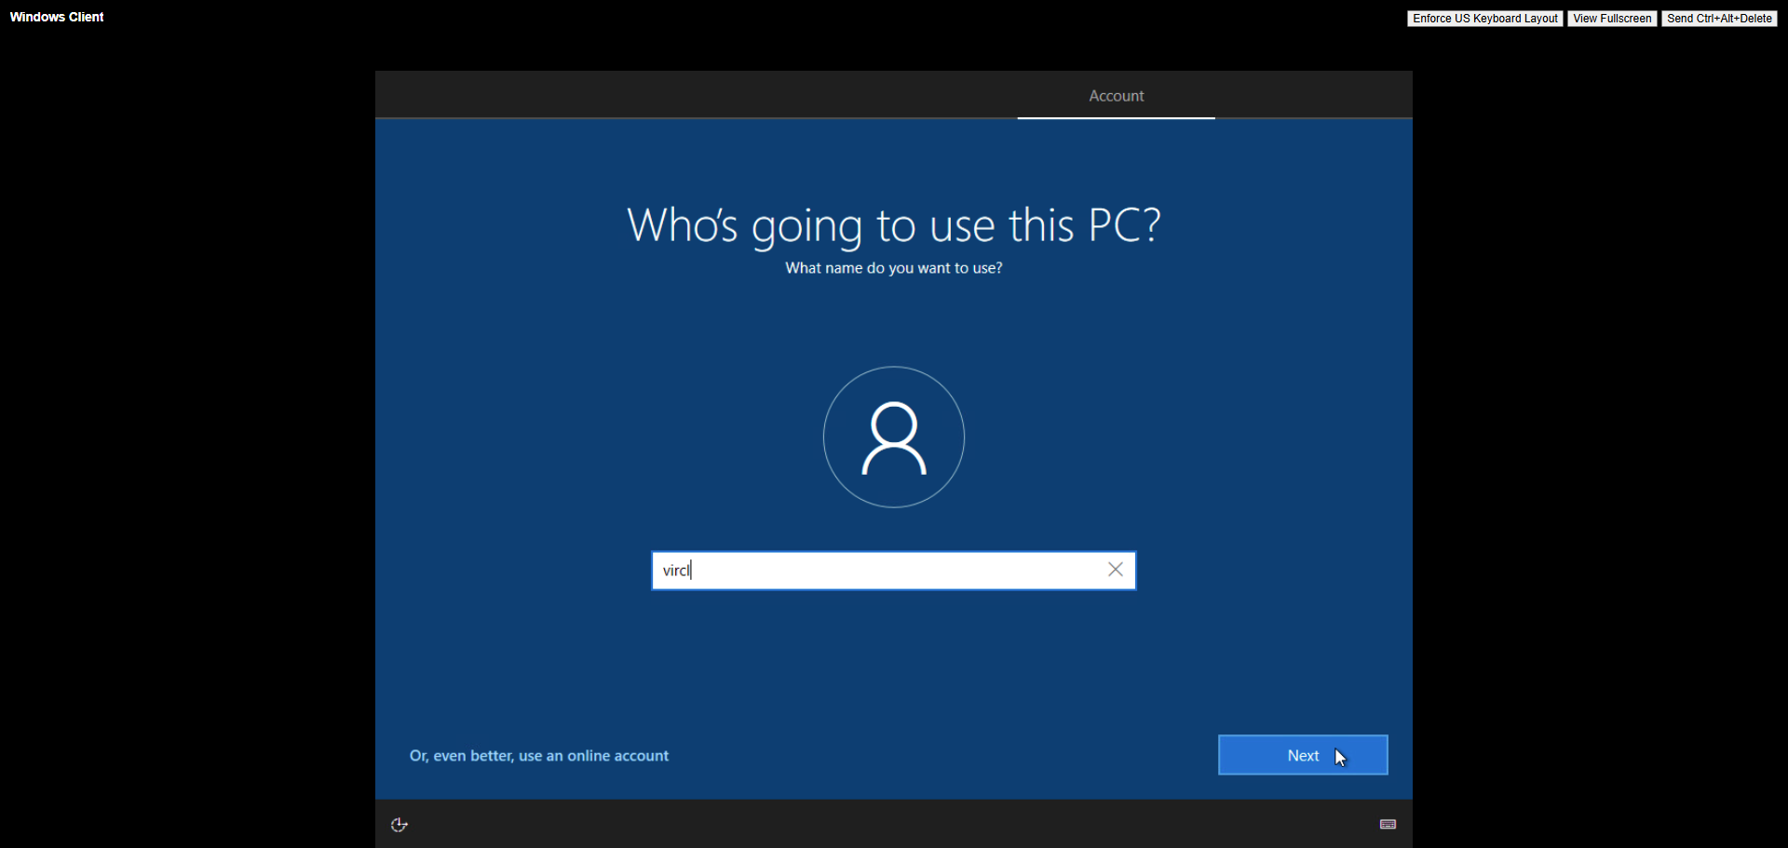
Figure 89: Profile configuration
This screenshot shows the profile configuration step during the Windows 11 installation, where user account and personalization settings are established. Creating a user profile is necessary for logging into the Windows 11 guest environment.

21.3 Ubuntu Server Installation
Ubuntu Server was installed using the standard text-based installer: language selection, keyboard layout, network configuration, storage setup, and profile creation.
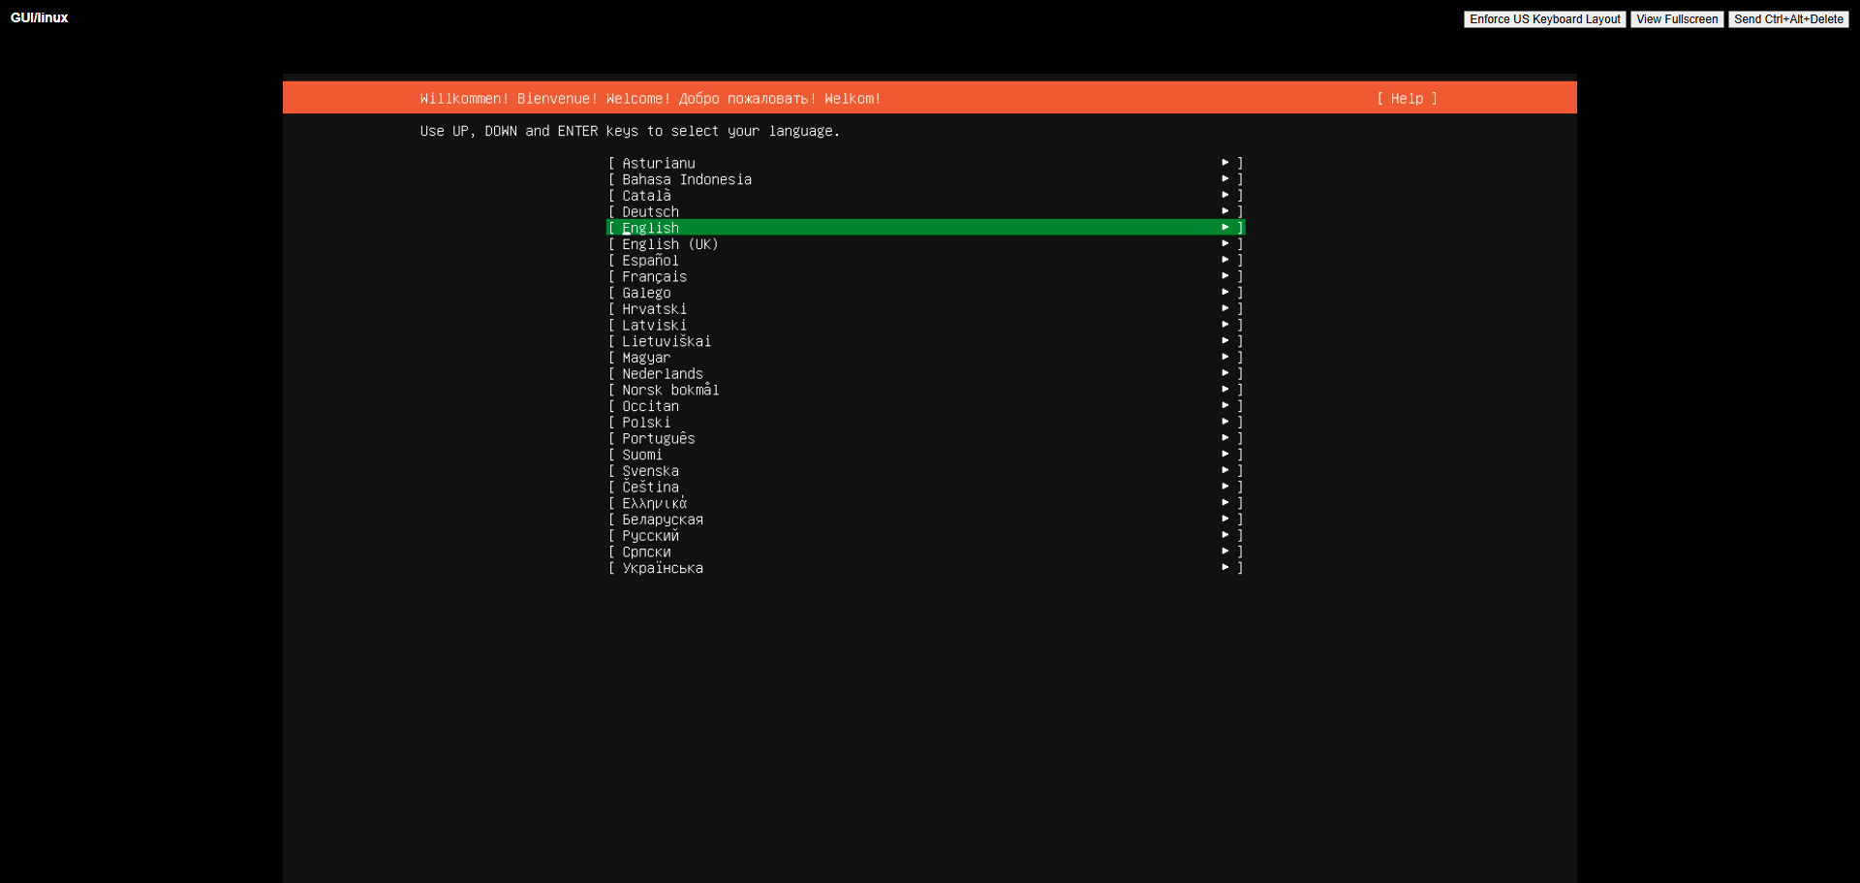
Figure 90: Language selection
This screenshot shows the language selection step in the Ubuntu Server text-based installer. Choosing the correct language is the first step in configuring the guest operating system for regional compatibility.
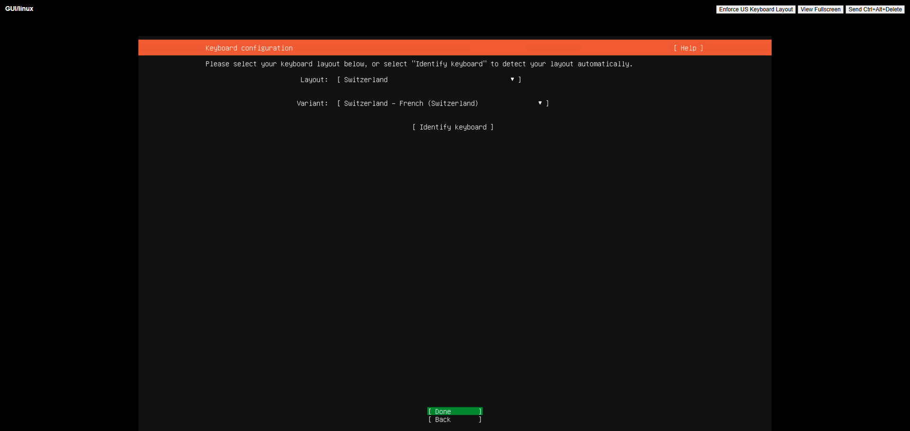
Figure 91: Keyboard selection
This screenshot shows the keyboard layout selection step during the Ubuntu Server installation. Selecting the appropriate keyboard layout ensures accurate character input for the server environment.
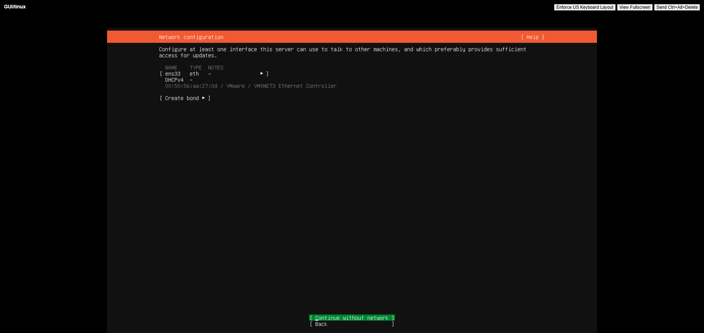
Figure 92: Network configuration
This screenshot shows the network configuration step in the Ubuntu Server installer, where IP settings and network parameters are defined. Proper network configuration ensures the server can communicate on the network after deployment.
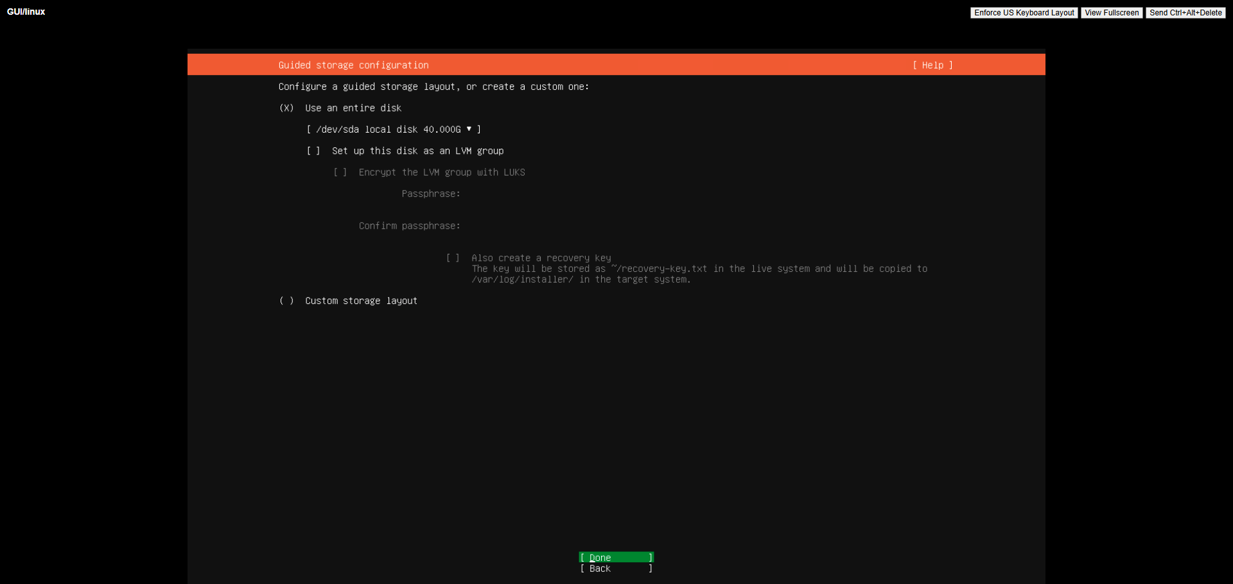
Figure 93: Storage configuration
This screenshot shows the storage configuration step during the Ubuntu Server installation, where disk partitioning and file system setup are performed. Configuring storage correctly is essential for the operating system to install and function properly.
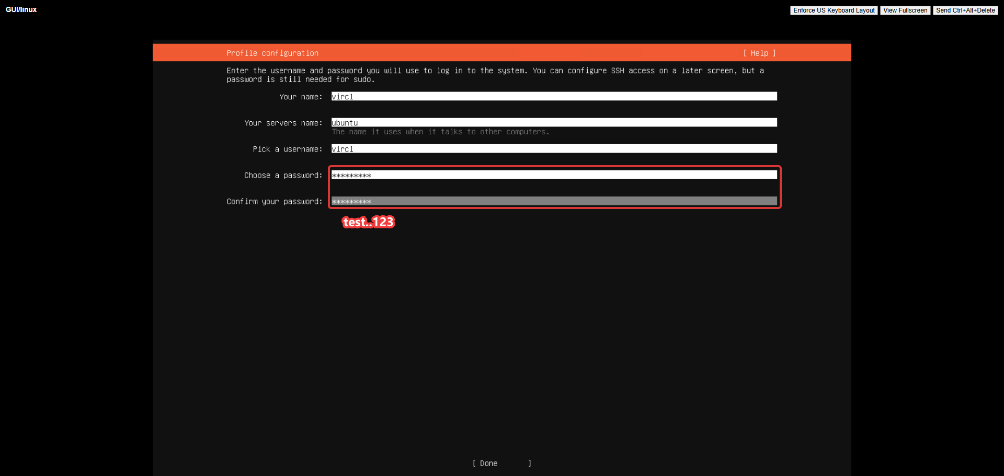
Figure 94: Profile configuration
This screenshot shows the profile configuration step in the Ubuntu Server installer, where user credentials and hostname are set. Creating an administrative user ensures secure access to the server after installation.
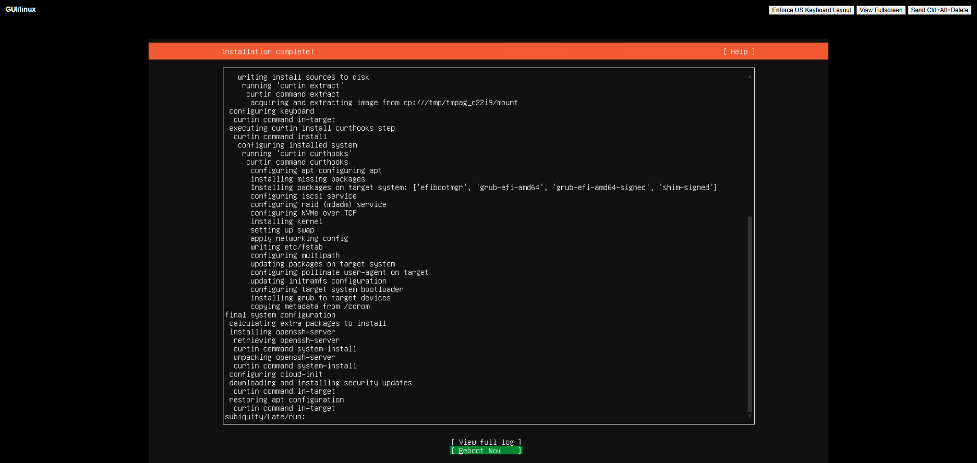
Figure 95: Finished installation
This screenshot shows the completed Ubuntu Server installation, confirming the operating system was successfully deployed on the virtual machine. This verification demonstrates that the guest OS installed correctly and is ready for use.

21.4 Proxmox Comparison
VMware Tools provides deeper integration (drag-and-drop, shared folders, better graphics, heartbeat) compared to QEMU Guest Agent on Proxmox. Windows 11 runs successfully on both platforms when properly configured with UEFI, TPM 2.0, and sufficient resources. VMware's guest OS customization is more mature.

21.5 Results
Both Windows 11 and Ubuntu Server were successfully installed on VMware VMs. The installations were straightforward with VMware's optimized virtual hardware and guest OS support.

22. Virtual Machine Configuration Changes

22.1 Objective
Demonstrate the ability to dynamically modify virtual machine hardware configuration in vSphere, including adding/removing CPU, RAM, disk, and network interfaces.

22.2 Theoretical Background
VMware vSphere supports hot-add capabilities for CPU, memory, and disk on supported guest operating systems. The Edit Settings dialog in vSphere Client provides a comprehensive interface for hardware modification, including advanced options like CPU reservation, memory limits, and SCSI controller types.

22.3 VMware Implementation
VM hardware was reconfigured through the vSphere Client by right-clicking the VM and selecting Edit Settings. CPU cores, RAM allocation, disk size, and network adapters were modified. VMware's hot-add feature allowed some changes without powering off the VM.
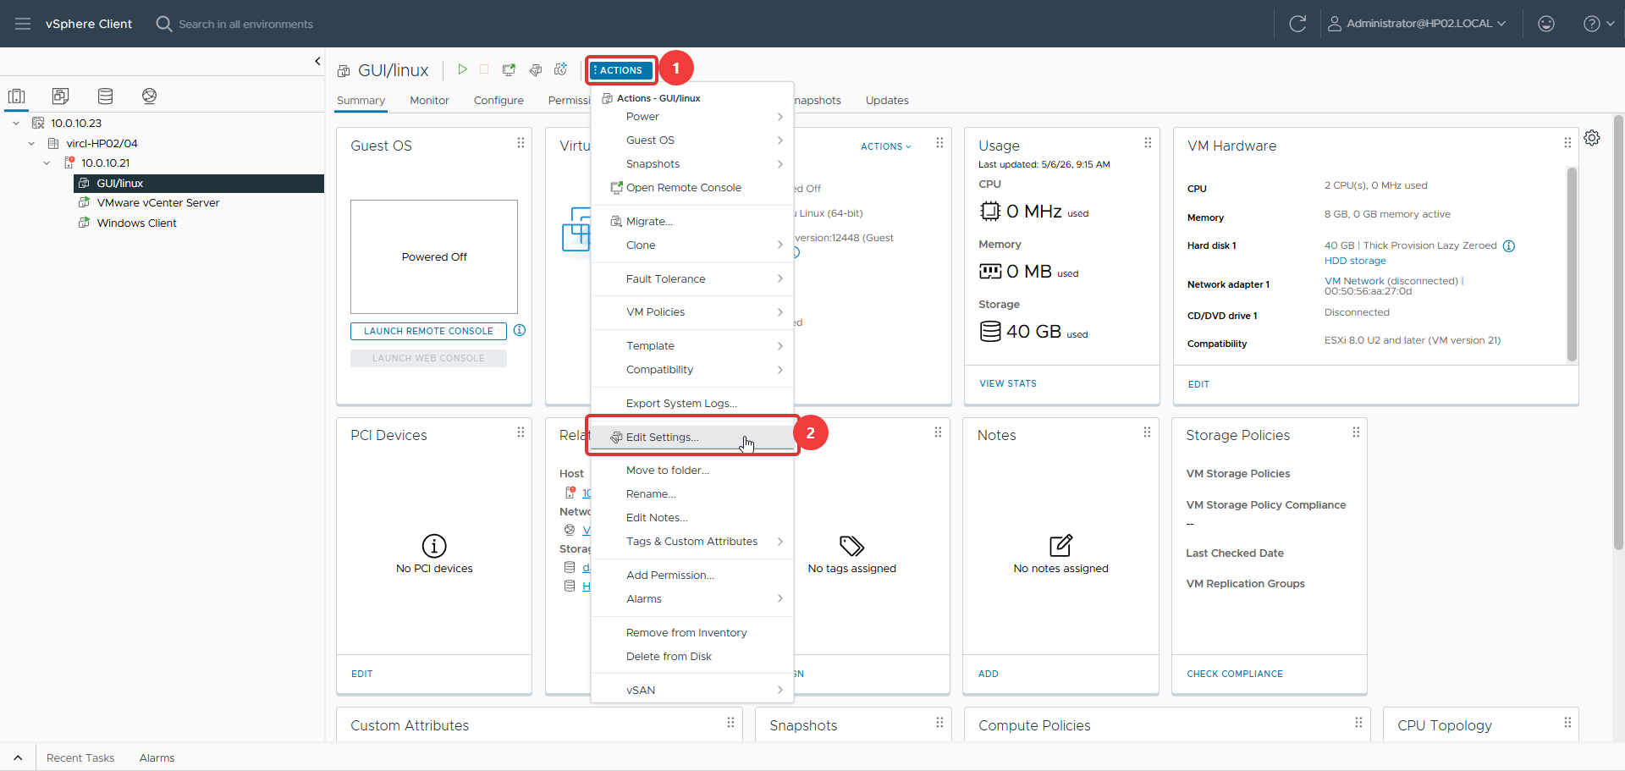
Figure 96: Accessing VM configuration
This screenshot shows the VM configuration settings being accessed through the vSphere Client. This step enables administrators to modify hardware resources such as CPU, memory, and disk to match workload requirements.
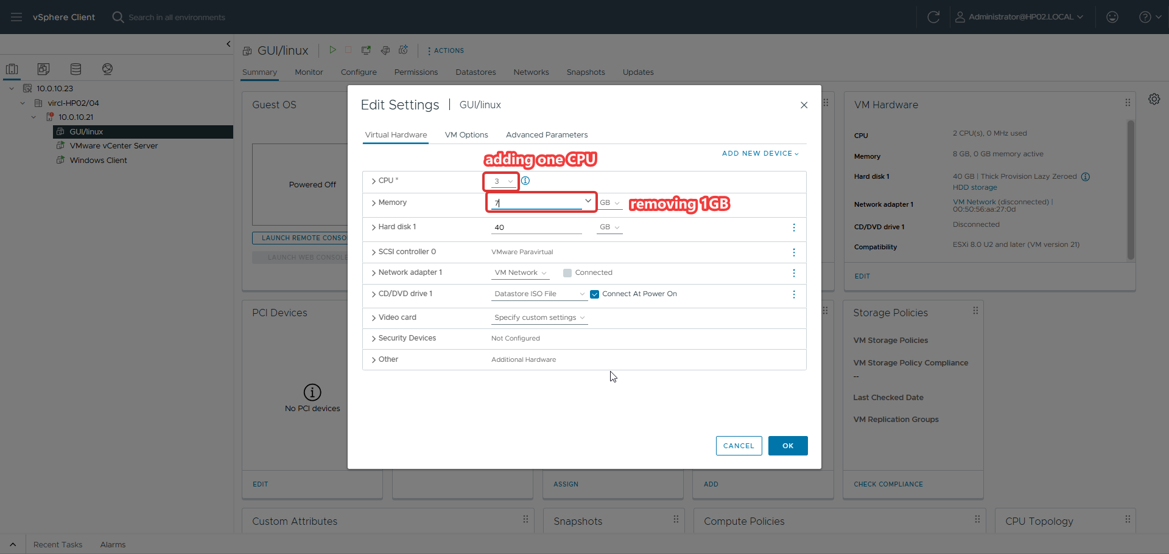
Figure 97: Changing VM hardware configuration
This screenshot shows the modification of VM hardware parameters, demonstrating how CPU, memory, and disk settings can be adjusted. This capability allows dynamic resource allocation to adapt to changing application needs.

22.4 Proxmox Comparison
VMware vSphere offers more granular hot-add capabilities, particularly for network adapters and SCSI controllers, with deeper integration into the guest OS through VMware Tools. Proxmox supports hot-add for CPU and RAM but requires a restart for some hardware changes. VMware's hardware modification interface is more polished.

22.5 Results
VM hardware was successfully modified through the vSphere Client. Hot-add capabilities worked as expected for supported hardware types, demonstrating VMware's mature virtual hardware management.

23. Clone a Virtual Machine

23.1 Objective
Create exact copies of existing virtual machines using VMware's clone functionality, demonstrating both full clones and understanding of linked clone concepts.

23.2 Theoretical Background
VMware vSphere offers multiple clone types: full clones (independent copy of all disks), linked clones (share base disk with delta overlay), and instant clones (fork a running VM in memory). The clone wizard in vSphere Client provides options for customization, resource placement, and storage allocation.

23.3 VMware Implementation
A VM was cloned using the vSphere Client by right-clicking the source VM and selecting Clone → Clone to Virtual Machine. The wizard guided through name and folder selection, compute resource placement, storage selection, clone options, and final confirmation.
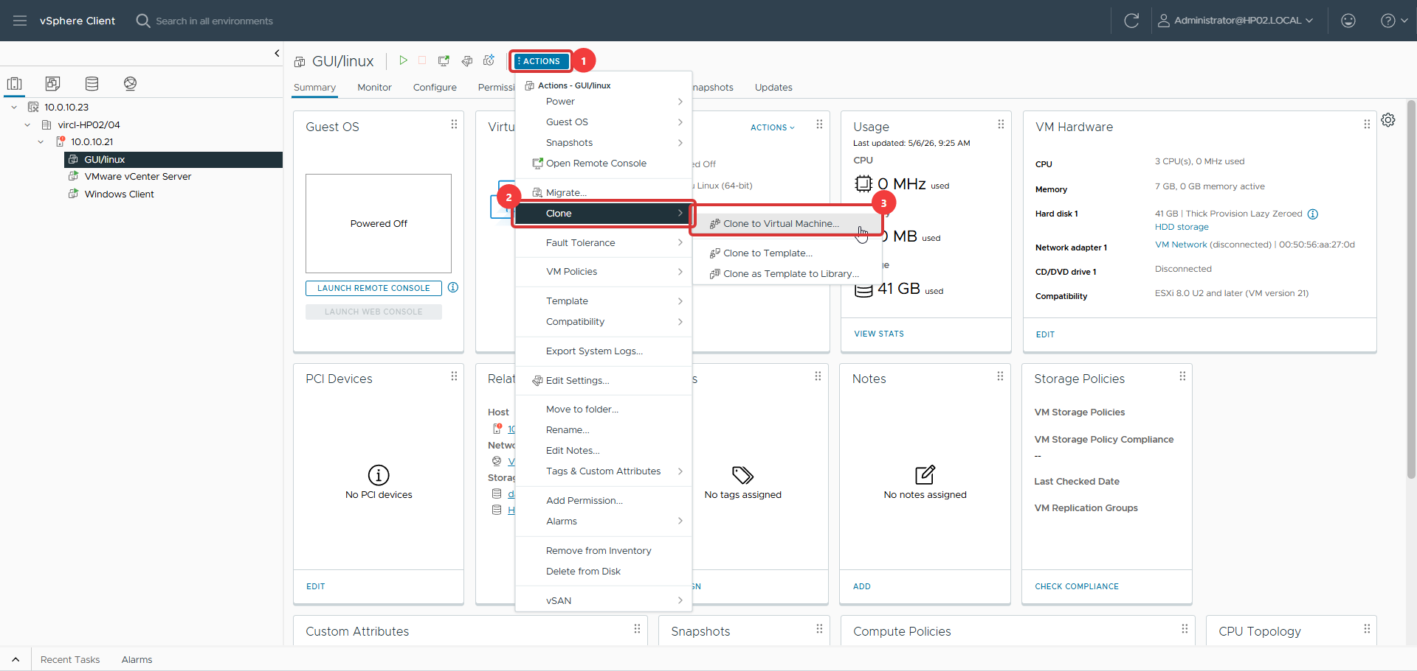
Figure 98: Navigating to clone page
This screenshot shows the navigation to the clone function in the vSphere Client, initiating the VM cloning process. Cloning enables rapid deployment of identical virtual machines without repeating the full installation process.
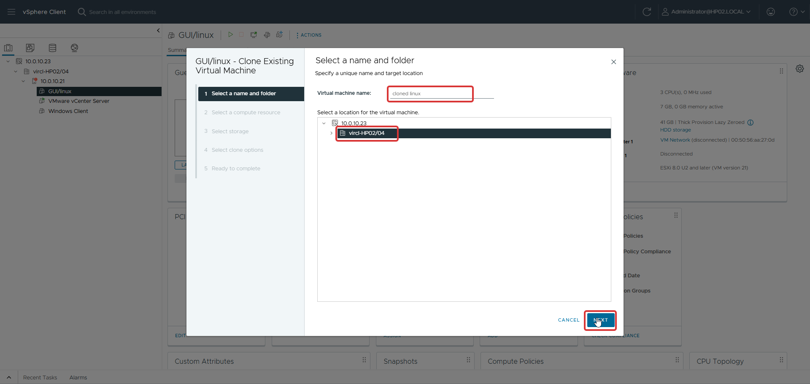
Figure 99: Name and folder selection
This screenshot shows the name and folder selection step in the clone wizard, where the new VM is identified and placed in the inventory. Proper naming and organization help manage virtual machines in the datacenter.
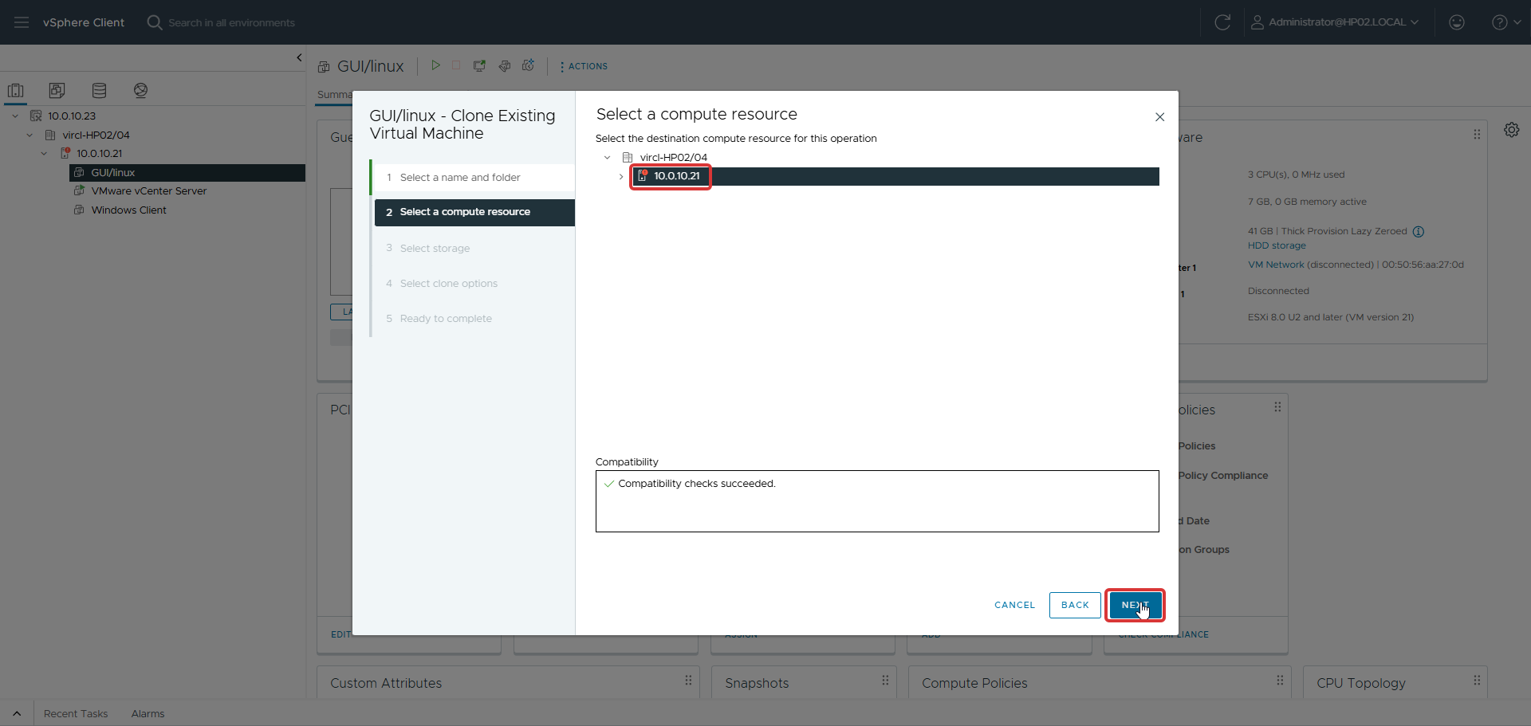
Figure 100: Compute resource selection
This screenshot shows the compute resource selection step, where the destination host or cluster for the cloned VM is chosen. Selecting the appropriate resource ensures the clone receives adequate processing capacity.
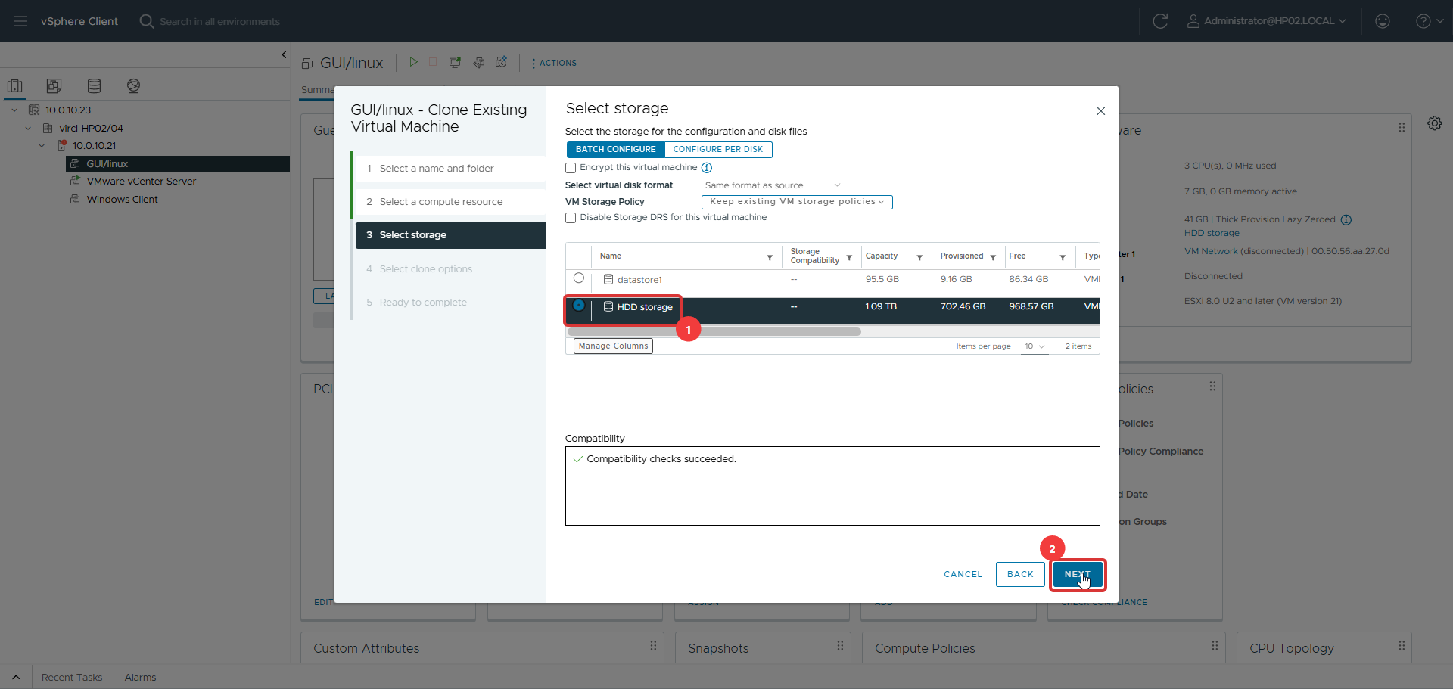
Figure 101: Storage pool selection
This screenshot shows the storage pool selection step in the clone wizard, where the destination datastore for the cloned VM is specified. Choosing the right storage ensures sufficient space and appropriate performance for the clone.
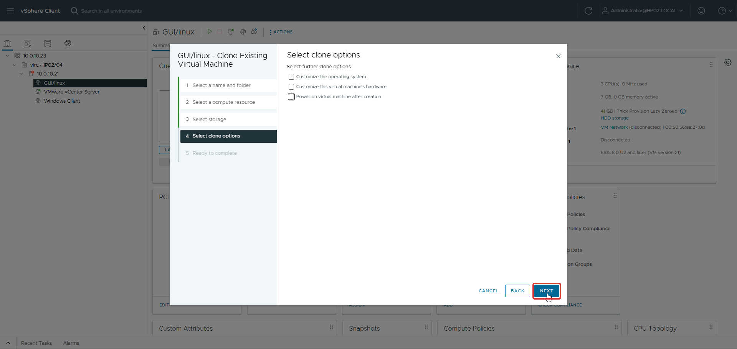
Figure 102: Clone options
This screenshot shows the clone options step, where additional configuration choices for the cloned VM are specified. Configuring clone options correctly ensures the new VM meets specific deployment requirements.
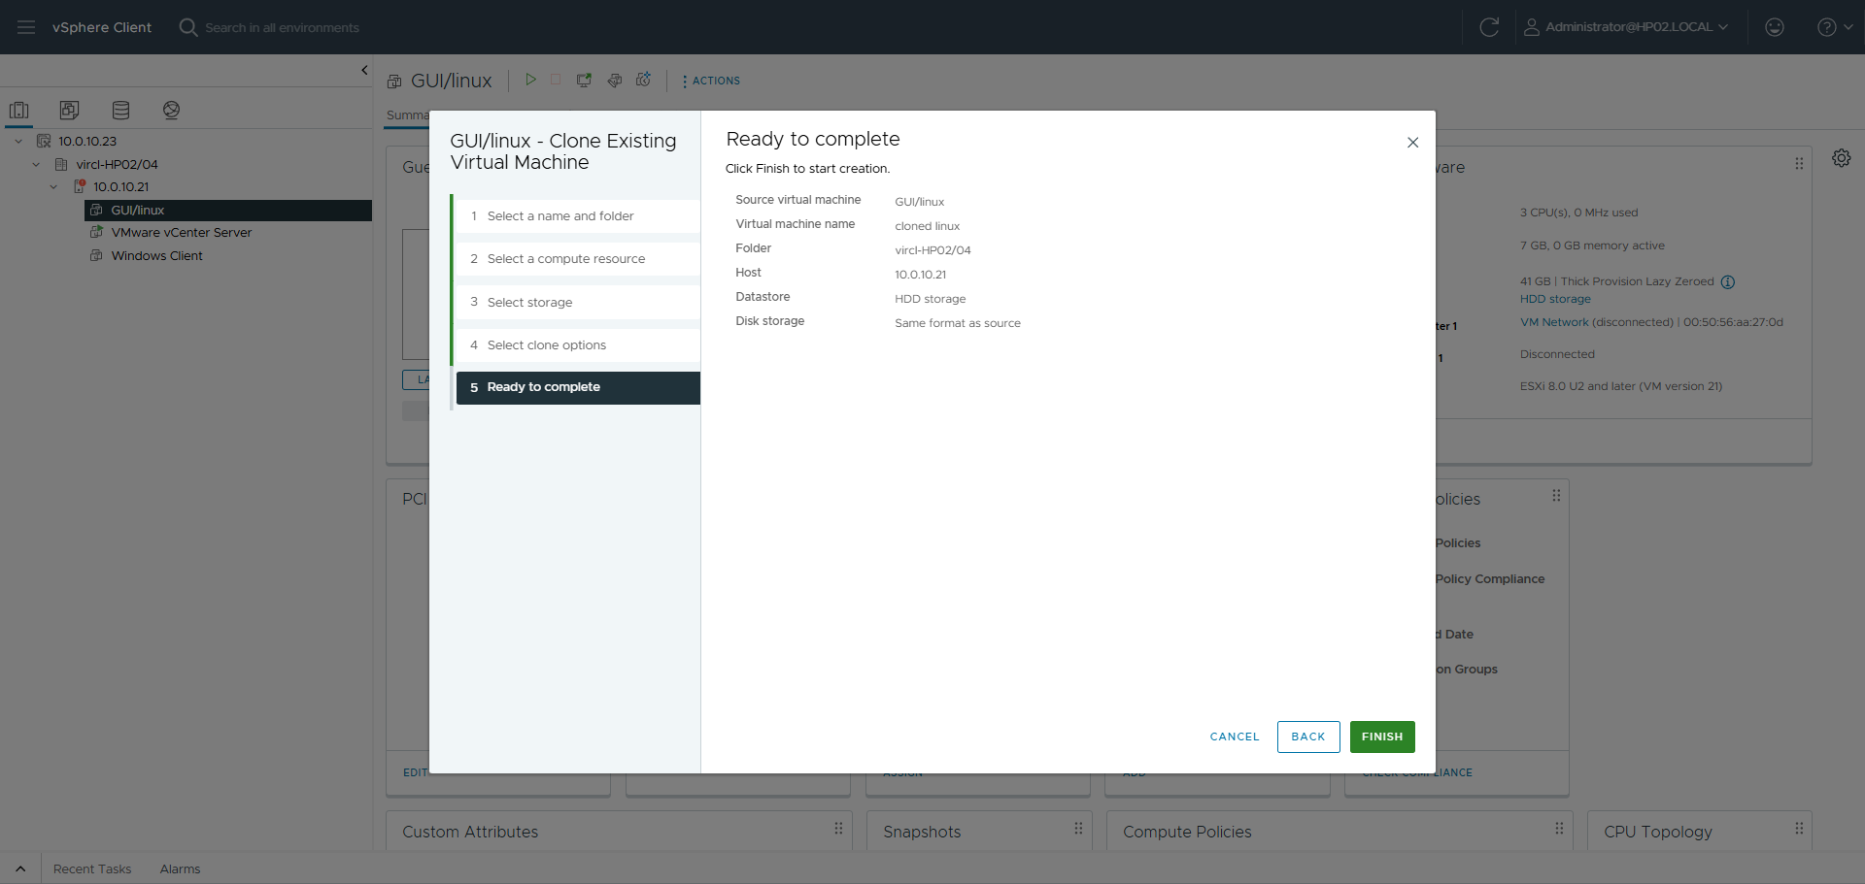
Figure 103: Ready to complete
This screenshot shows the final confirmation screen before completing the clone operation, summarizing the clone configuration. This review step prevents errors and ensures the cloned VM is deployed with the correct settings.

23.4 Proxmox Comparison
VMware vSphere offers Instant Clone technology (forking a running VM in memory), which is significantly faster than traditional cloning and ideal for VDI environments. Proxmox does not have an equivalent feature. VMware's clone wizard also provides guest customization options during cloning, which Proxmox lacks natively.

23.5 Results
VM clones were successfully created through the vSphere Client. The clone wizard provided clear options for resource placement and storage allocation, demonstrating VMware's polished VM lifecycle management.

24. Export a Virtual Machine

24.1 Objective
Export a virtual machine from VMware to a portable OVF format for migration or archival purposes.

24.2 Theoretical Background
The Open Virtualization Format (OVF) is an open standard for packaging and distributing virtual appliances. VMware vSphere can export VMs as OVF templates, producing an OVF descriptor file and one or more VMDK disk files. This format is widely supported across virtualization platforms.

24.3 VMware Implementation
The VM was exported by right-clicking it in vSphere Client and selecting Template → Export OVF Template. The export produced an OVF file and associated VMDK disk files that could be imported into other VMware environments or converted for other platforms.
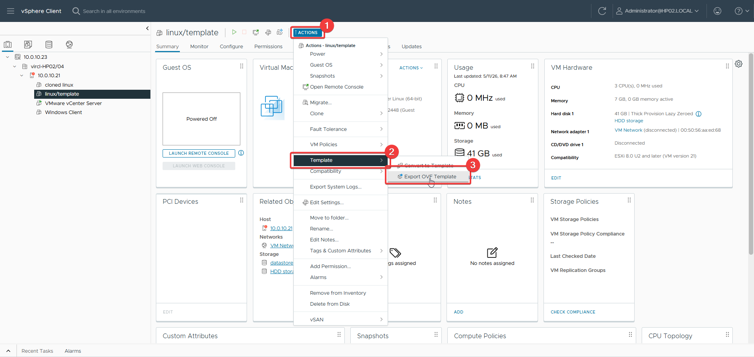
Figure 104: Navigating to export page
This screenshot shows the navigation to the export function in the vSphere Client, which initiates the OVF template export process. Exporting VMs as templates enables portability and migration between different VMware environments.
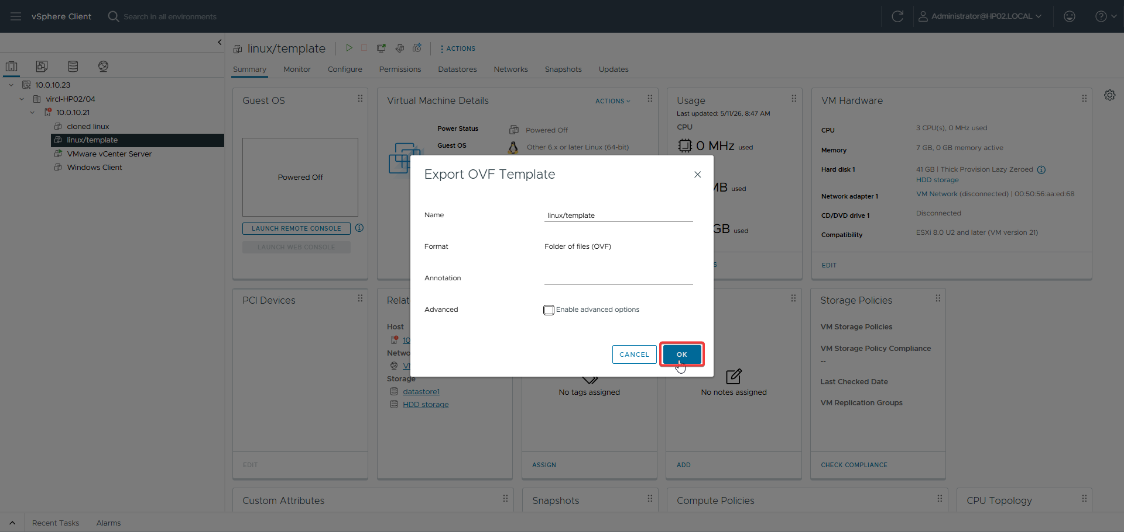
Figure 105: Export OVF Template dialog
This screenshot shows the Export OVF Template dialog, where export parameters and destination settings are configured. This step demonstrates VMware's built-in capability for creating portable VM templates without requiring command-line tools.

24.4 Proxmox Comparison
VMware provides a much more polished export experience through the vSphere Client, with built-in OVF/OVA generation and a guided wizard. Proxmox requires command-line knowledge and manual format conversion using qemu-img, reflecting its open-source, DIY philosophy. VMware's OVF export is more accessible for administrators.

24.5 Results
The VM was successfully exported as an OVF template. The resulting files were verified and confirmed as valid for import into other VMware environments.

25. Virtual Machine Backup & Hypervisor Backup

25.1 Objective
Implement comprehensive backup strategies for both virtual machines and hypervisor configurations on VMware, using third-party solutions and native tools. This is the team's specialization topic and is documented in greater depth.

25.2 Theoretical Background
VMware does not include a built-in backup solution in the base vSphere license (vSphere Data Protection was discontinued). Enterprise VM backup typically requires third-party solutions like Veeam Backup & Replication, which leverages VMware VADP (vStorage APIs for Data Protection) and CBT (Changed Block Tracking) for efficient incremental backups. Hypervisor configuration backup is handled through vCenter's built-in backup scheduler.

25.3 Veeam Backup & Replication Installation
Veeam Backup & Replication was installed as the third-party backup solution. The installation process involved selecting the Veeam type, accepting the license agreement, and completing the setup wizard.
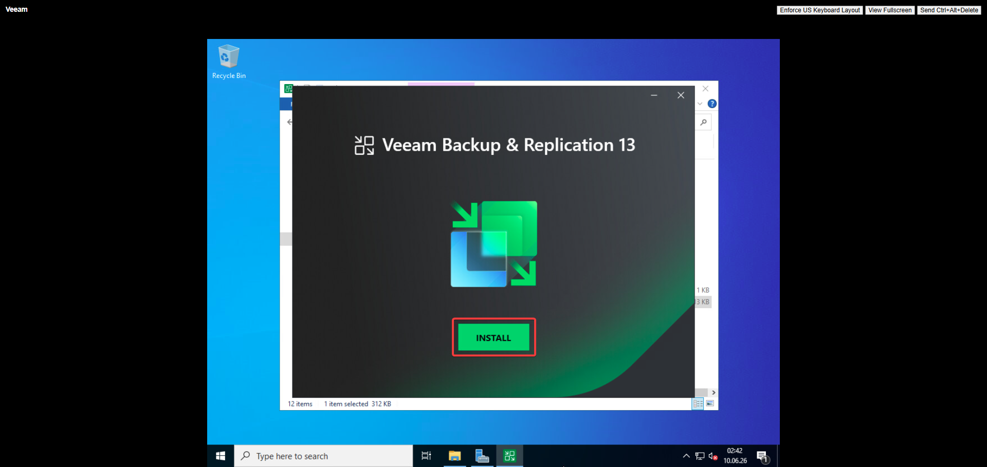
Figure 106: Veeam installation page
This screenshot shows the Veeam Backup & Replication installation page, which begins the setup of the third-party backup solution. Installing Veeam is necessary because VMware requires external tools for comprehensive VM backup.
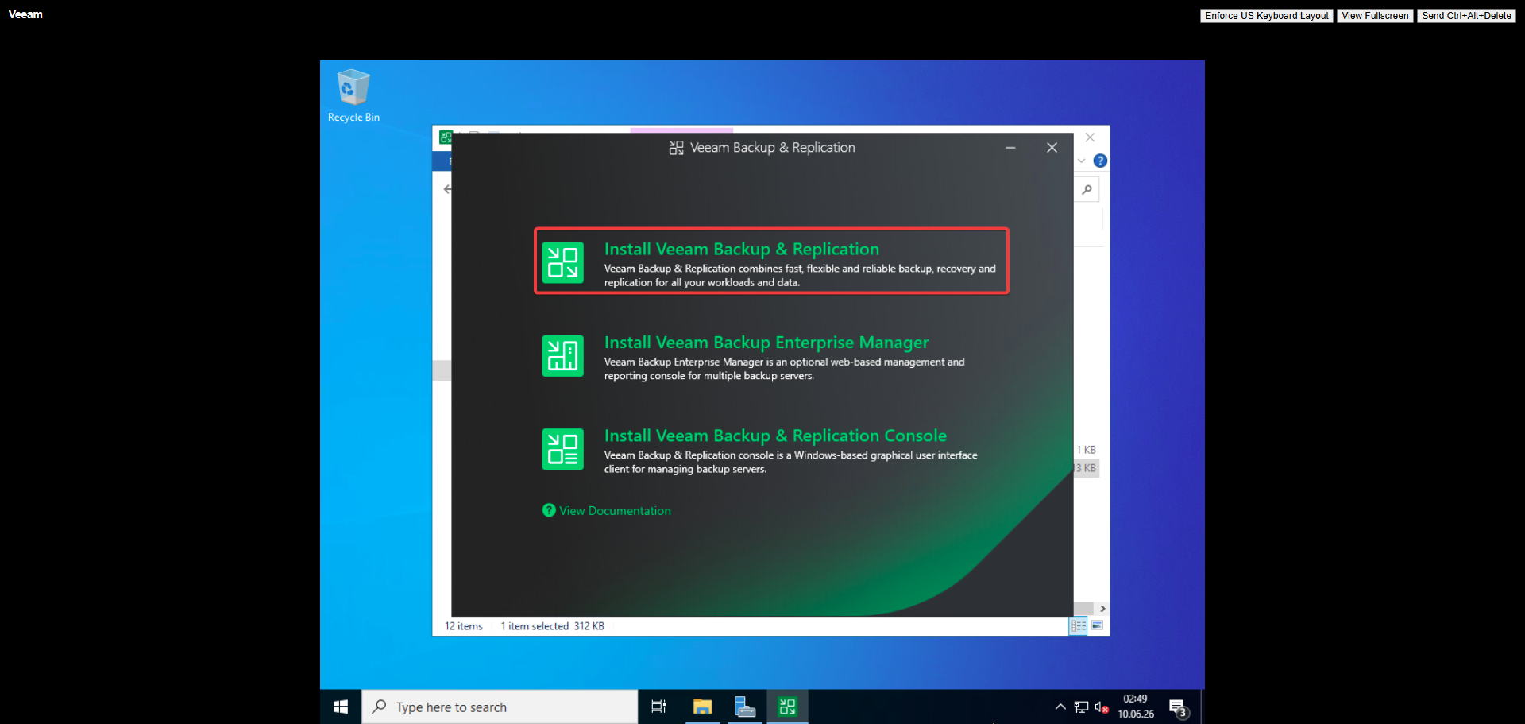
Figure 107: Veeam type selection
This screenshot shows the Veeam type selection step, where the specific edition or deployment type is chosen. Selecting the correct type ensures the installation matches the environment requirements and available licensing.
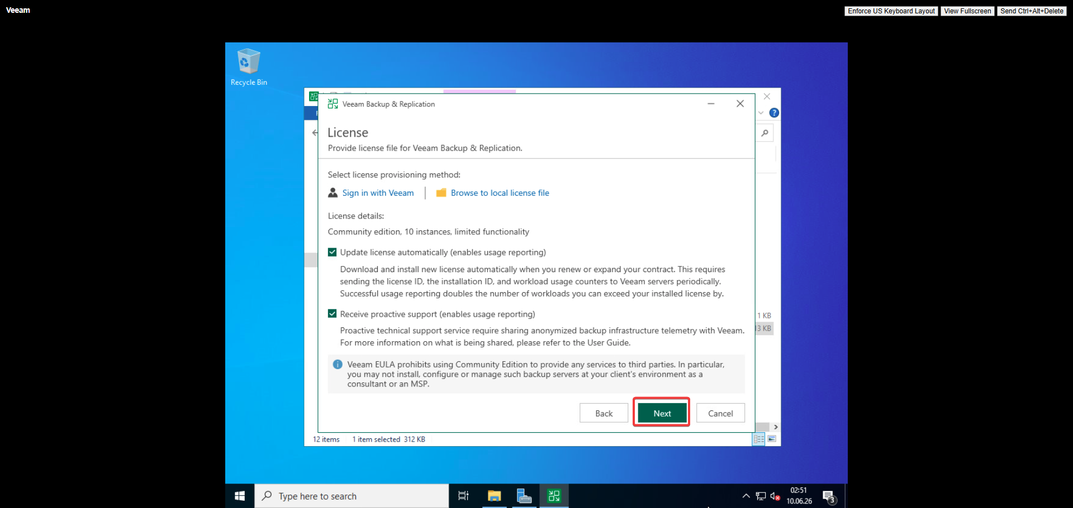
Figure 108: License agreement
This screenshot shows the Veeam license agreement acceptance step during installation. Accepting the license terms is a mandatory prerequisite for completing the backup software installation.
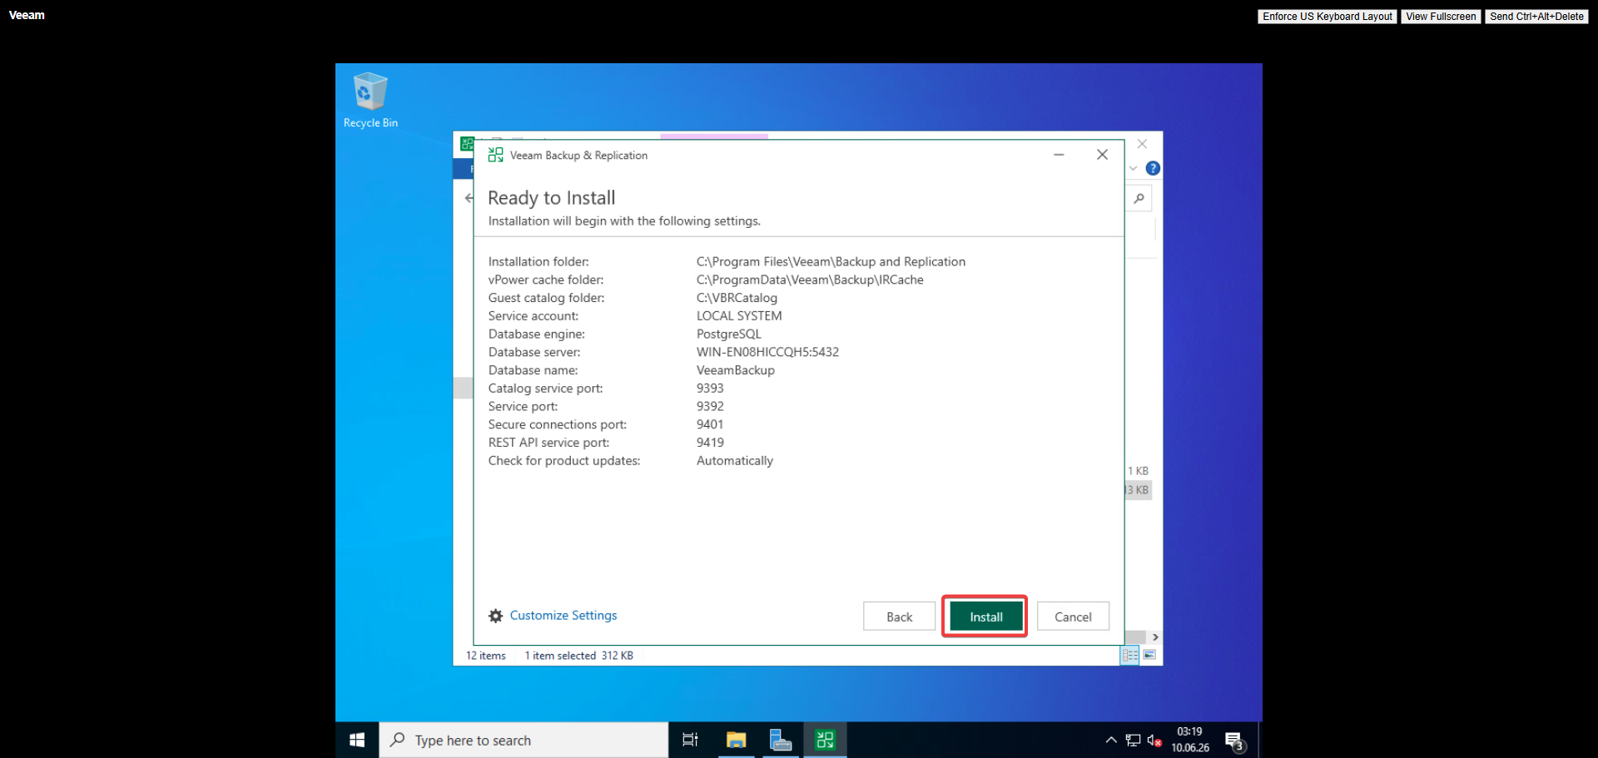
Figure 109: Ready to install
This screenshot shows the ready-to-install confirmation screen, summarizing the Veeam installation settings before execution. This verification step ensures all prerequisites and configurations are correct before proceeding.
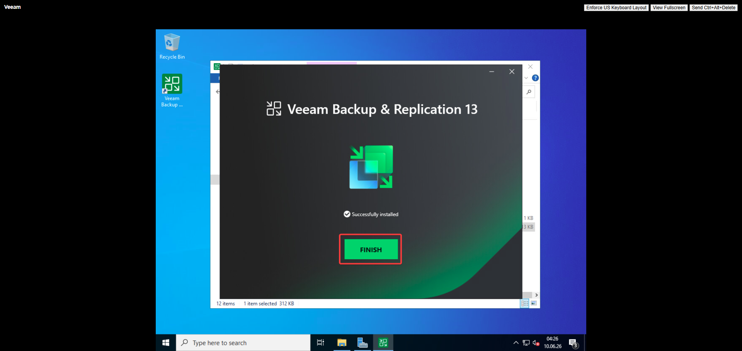
Figure 110: Installation complete
This screenshot shows the Veeam installation completion screen, confirming that Backup & Replication has been successfully installed. This verification step indicates the backup solution is ready for configuration.

25.4 Veeam Configuration
Veeam was configured by adding the vCenter Server as a managed server, providing administrator credentials, and setting up a backup repository. A backup job was then created to protect specific VMs.
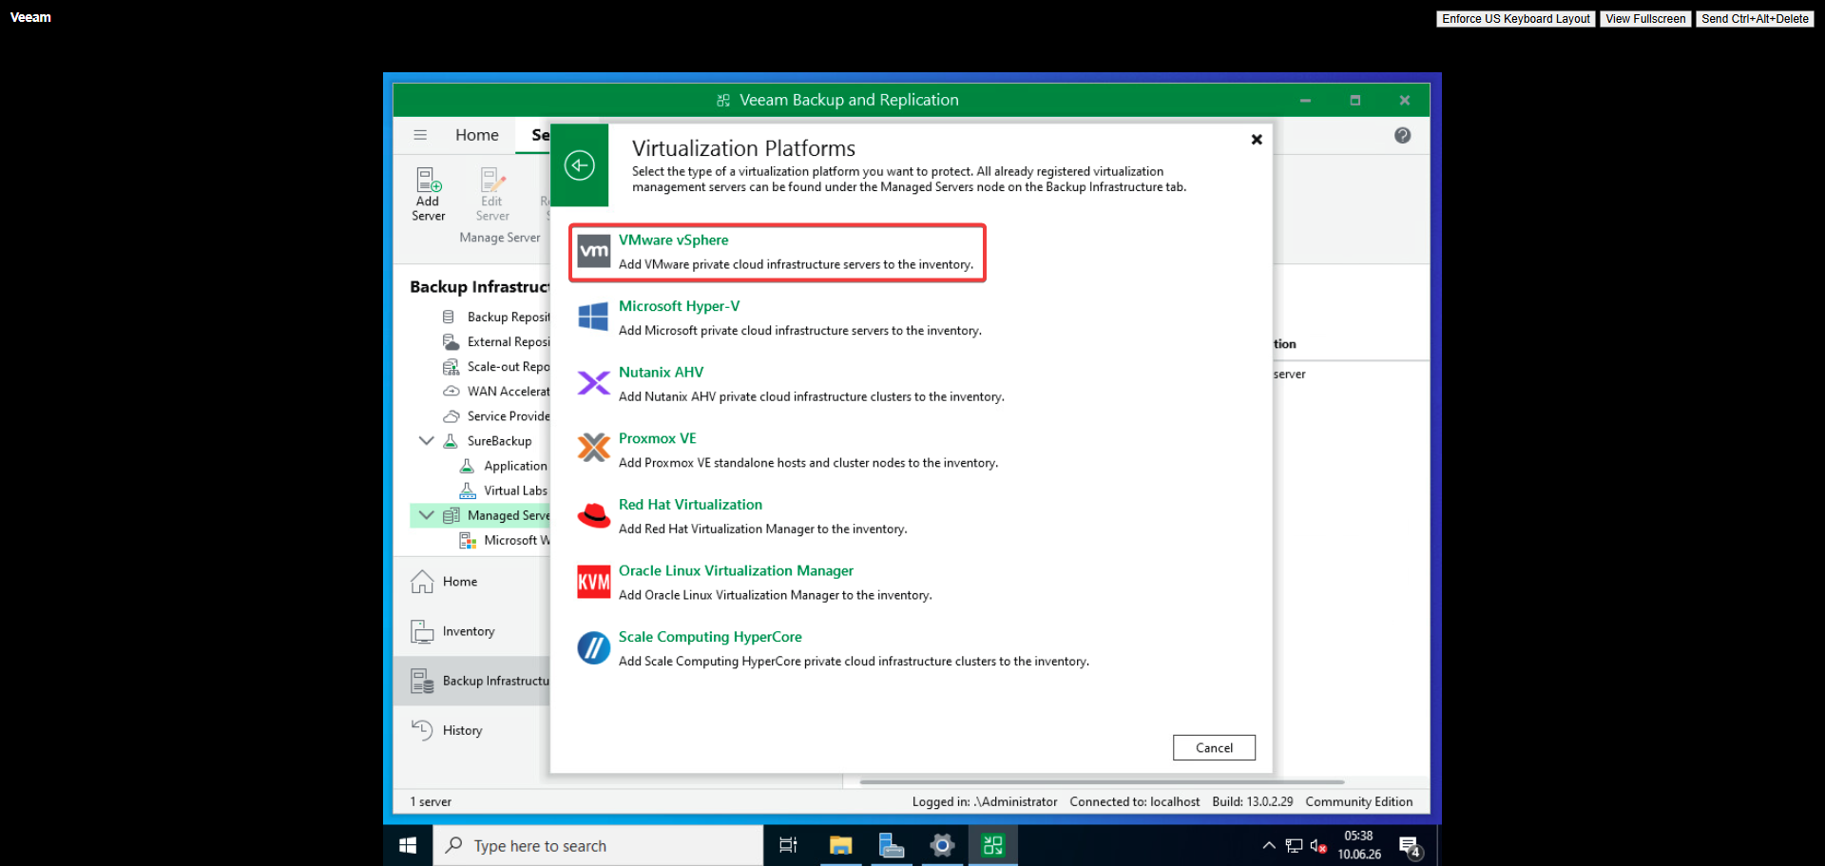
Figure 111: Selecting vSphere
This screenshot shows the selection of vSphere as the managed platform during Veeam configuration. This step establishes the connection between Veeam and the vCenter Server, enabling centralized backup management.
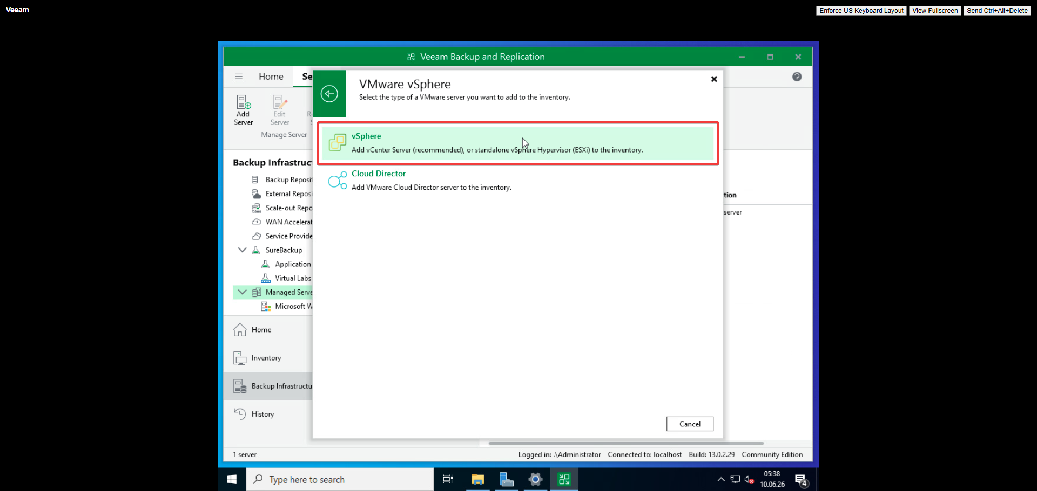
Figure 112: vSphere over Cloud Director
This screenshot shows the vSphere over Cloud Director selection option in the Veeam configuration wizard. This step ensures Veeam targets the correct VMware infrastructure type for backup operations.
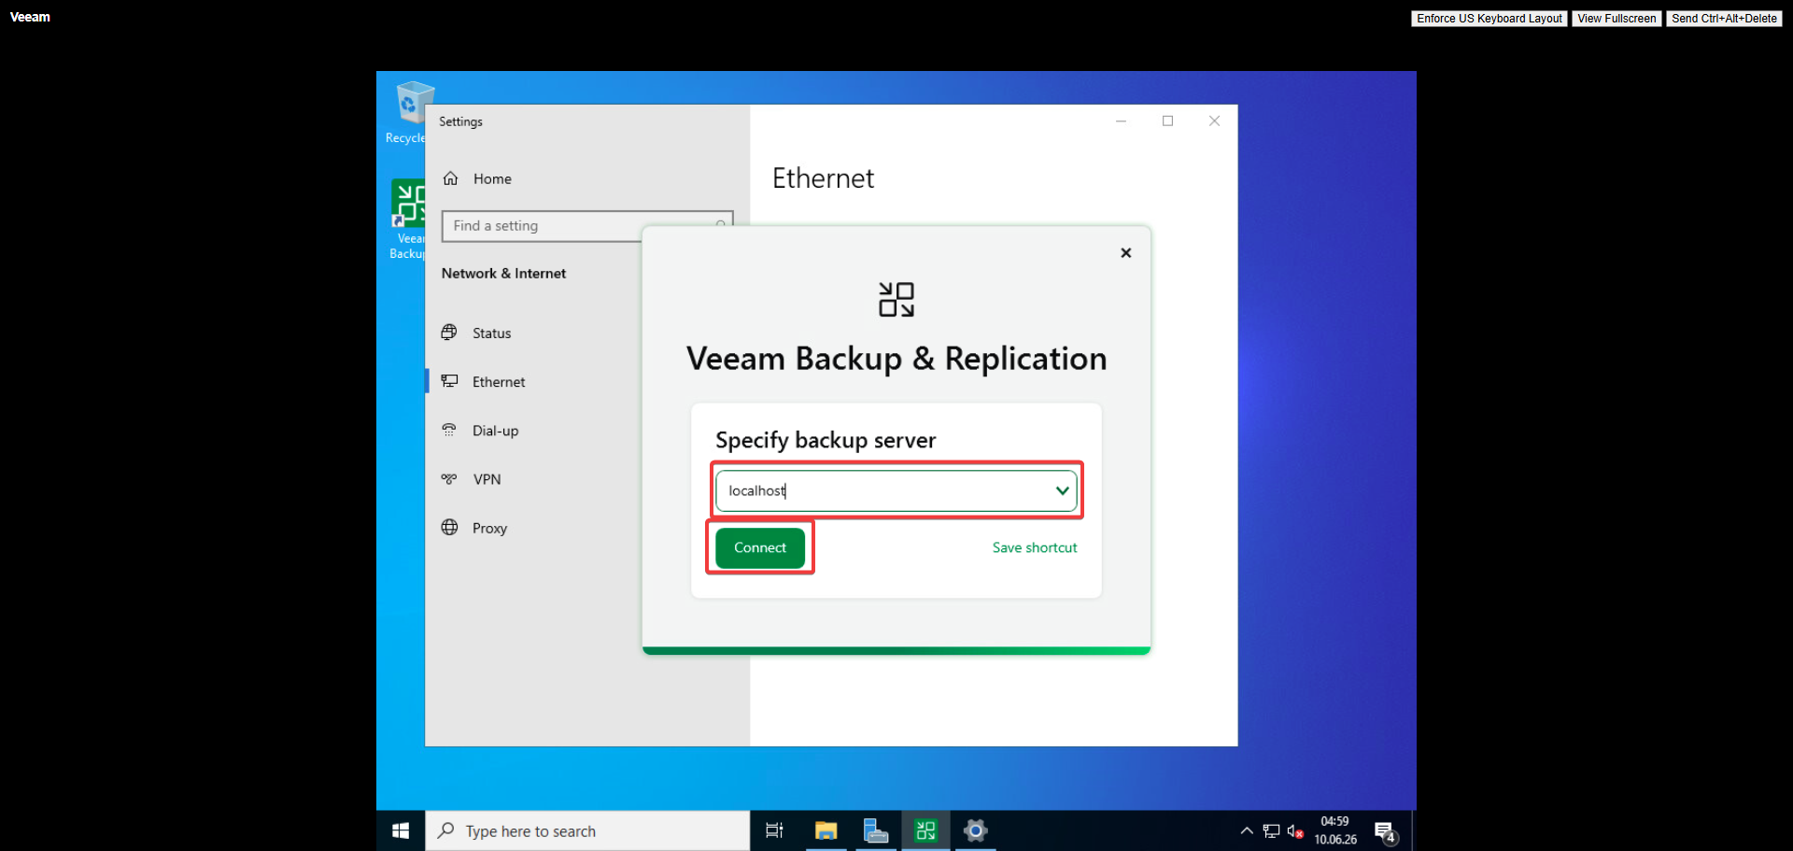
Figure 113: Backup server specification
This screenshot shows the backup server specification step, where the Veeam server details and connection parameters are defined. Configuring the server correctly ensures Veeam can communicate with the VMware infrastructure.
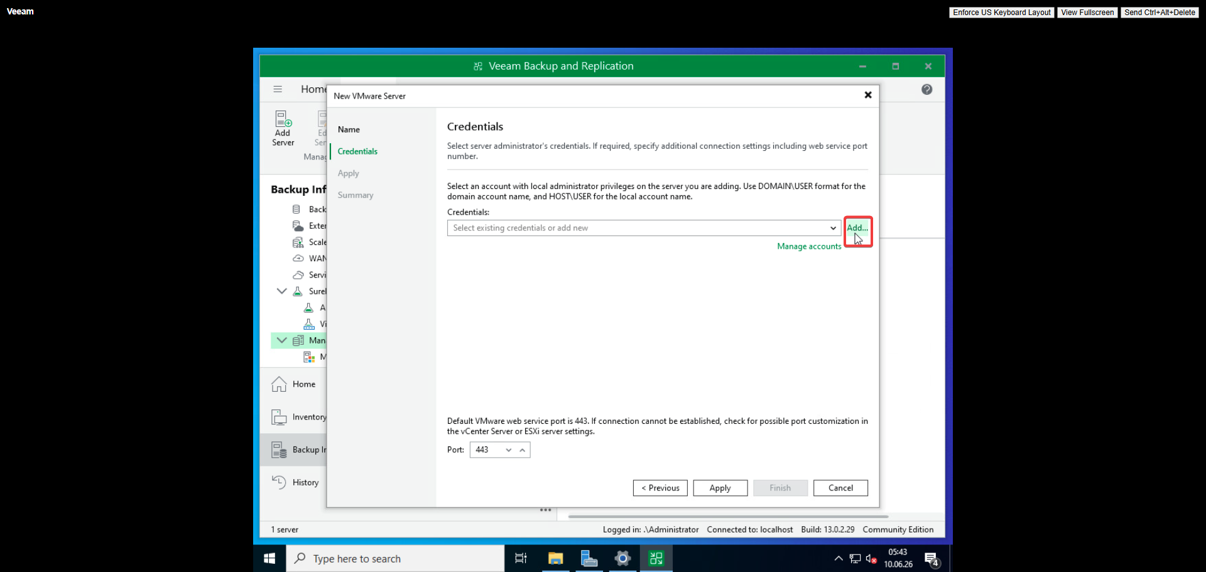
Figure 114: Adding admin credentials
This screenshot shows the administrator credentials being entered to authorize Veeam access to the vCenter Server. Providing valid credentials is essential for Veeam to discover and manage virtual machines for backup.
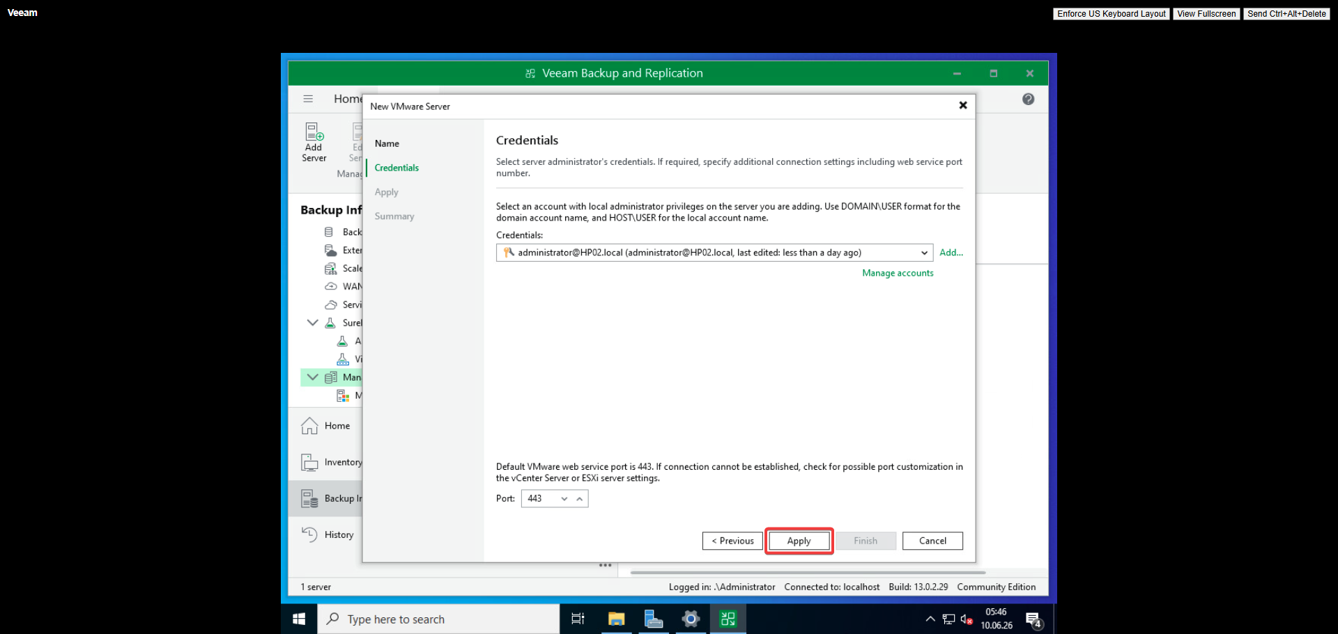
Figure 115: Confirming admin password
This screenshot shows the confirmation of the administrator password for Veeam's vCenter connection. Re-entering the password validates the credentials and prevents authentication errors during backup operations.
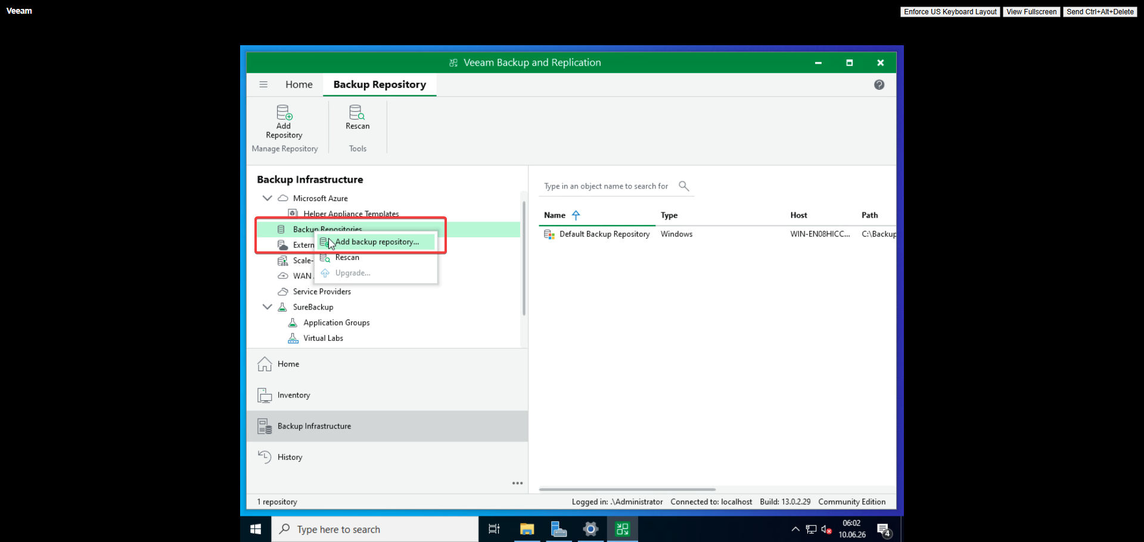
Figure 116: Adding storage repository
This screenshot shows the storage repository addition step, where the backup destination is configured in Veeam. Setting up a repository is necessary for storing backup files and completing the backup infrastructure.
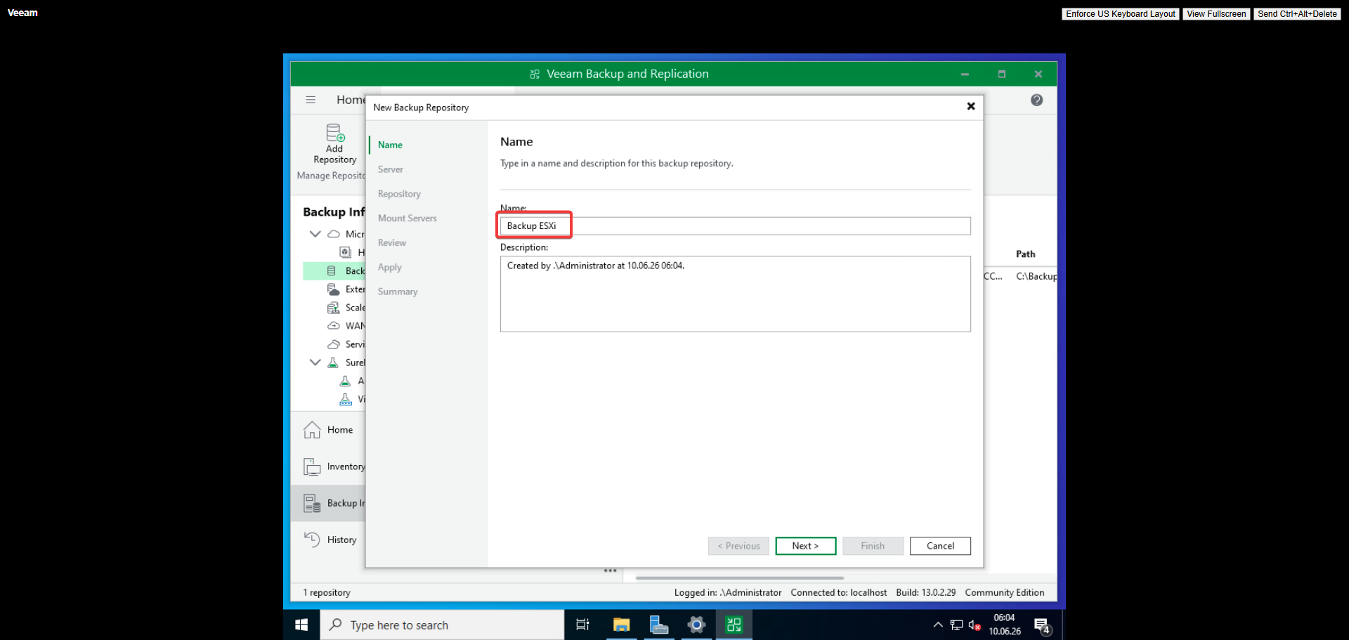
Figure 117: Naming backup repository
The Veeam backup repository is assigned a descriptive name to identify it within the backup infrastructure.
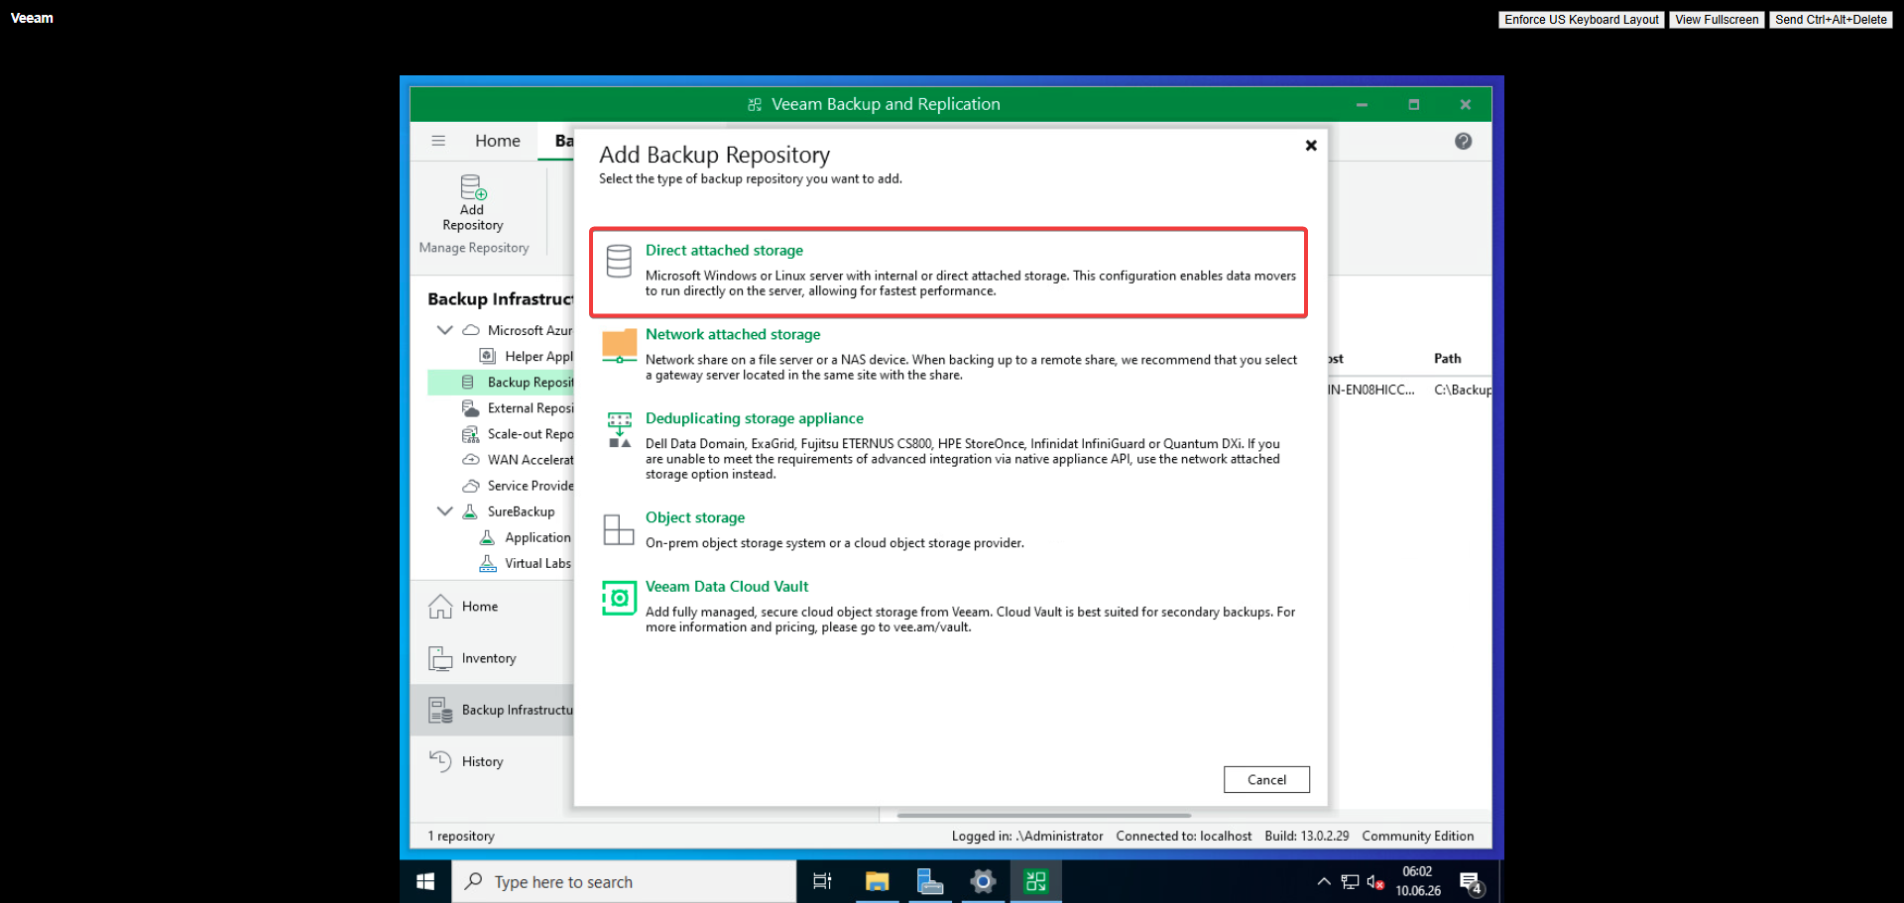
Figure 118: Direct attached storage selection
Direct attached storage is selected as the repository type for storing Veeam backup files.
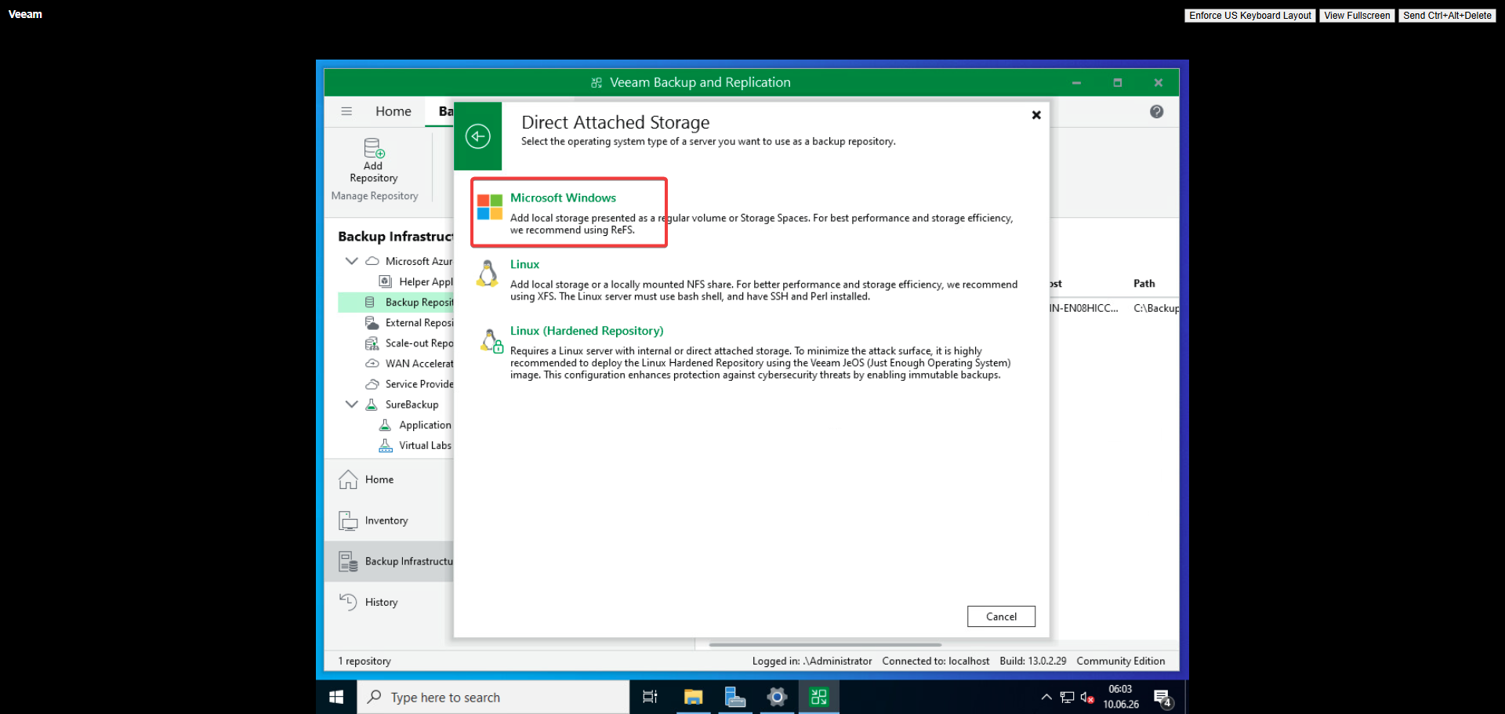
Figure 119: Direct attached storage on Windows
The local Windows filesystem is designated as the direct attached storage location for backup data.
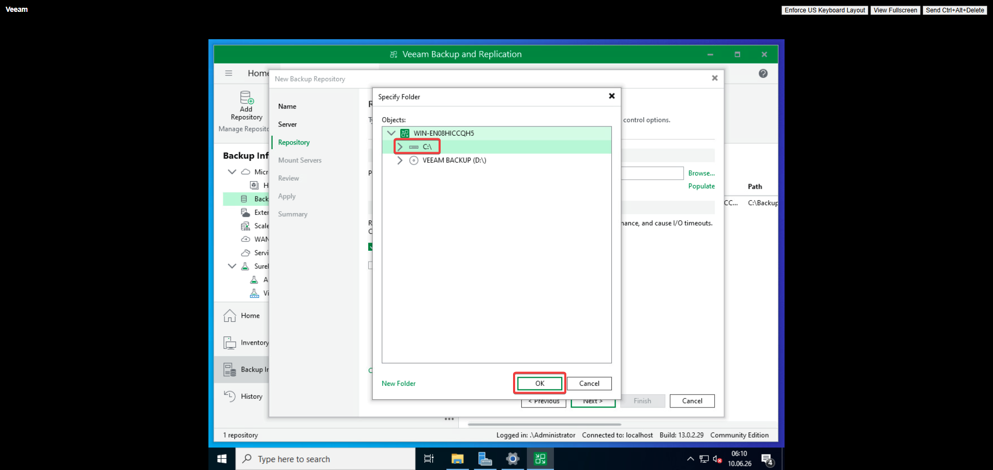
Figure 120: Folder selection
A specific folder is chosen on the local storage to house the backup files and metadata.
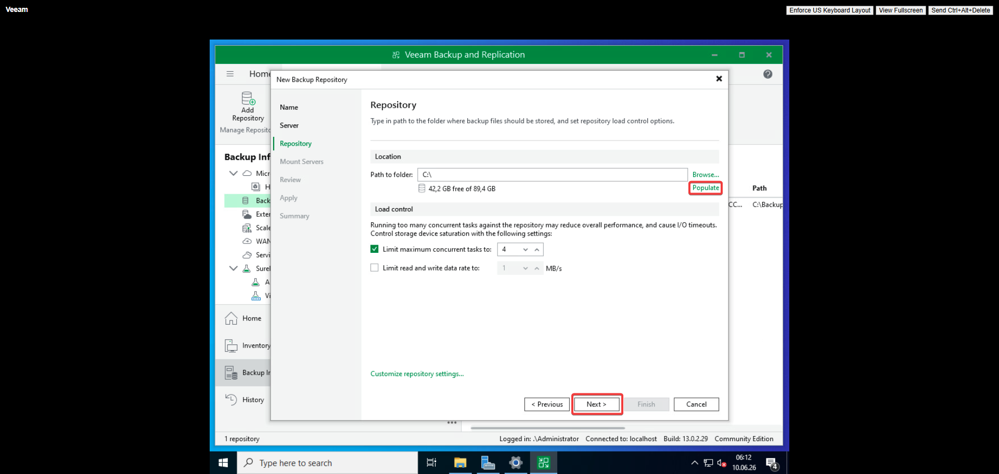
Figure 121: Confirming folder
The selected folder path is verified before the backup repository configuration is finalized.
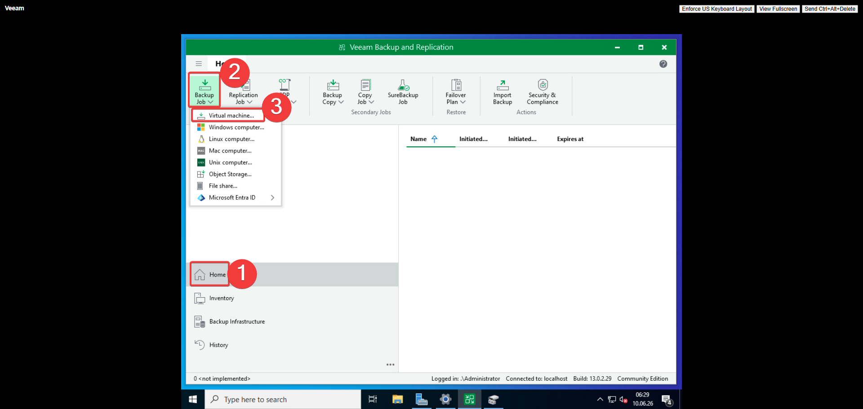
Figure 122: Adding first backup job
The first Veeam backup job is created to begin protecting specific virtual machines.
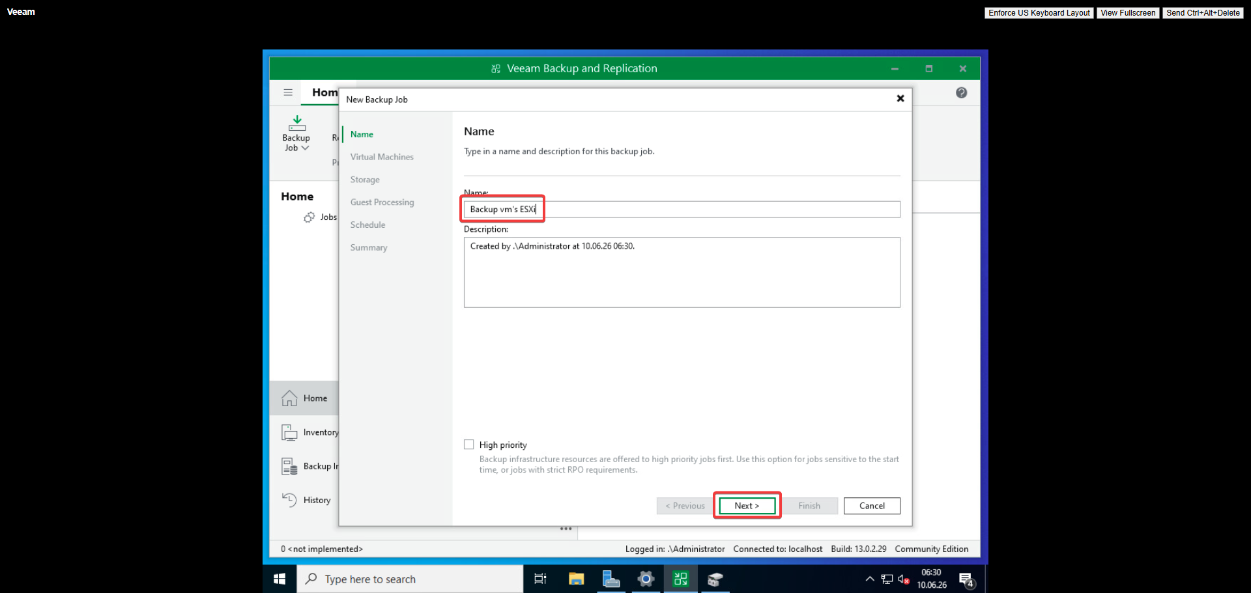
Figure 123: Naming backup job
The backup job is assigned a descriptive name to identify its protected workloads.
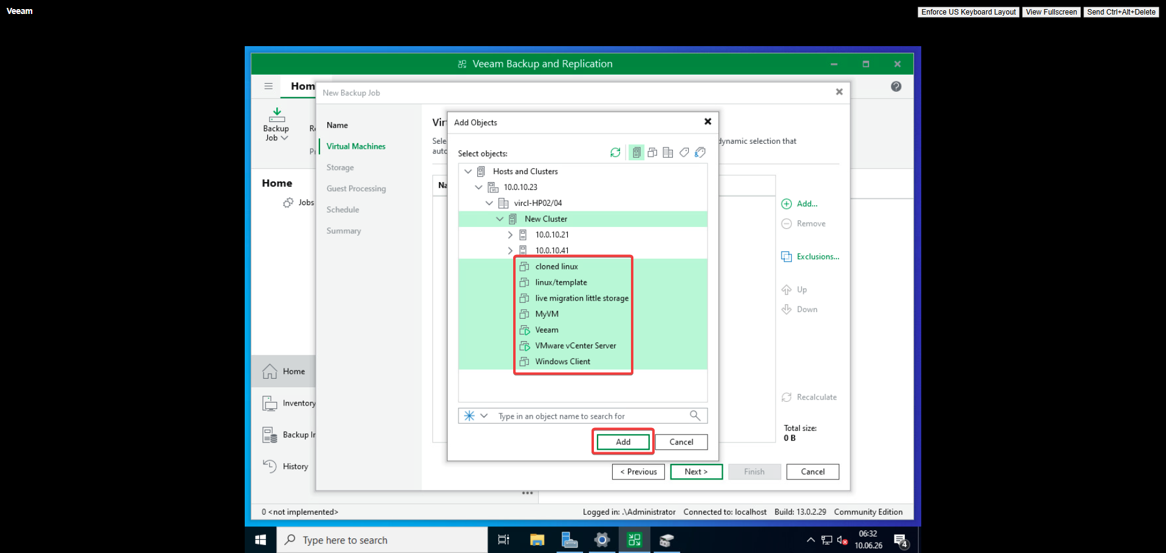
Figure 124: Selecting VM to backup
The target virtual machine is selected for inclusion in the Veeam backup job.
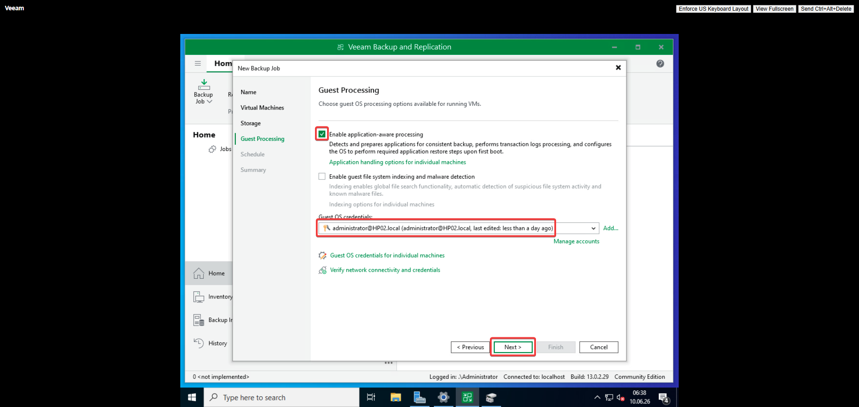
Figure 125: Guest processing selection
Guest processing options are configured to enable application-aware backups inside the VM.
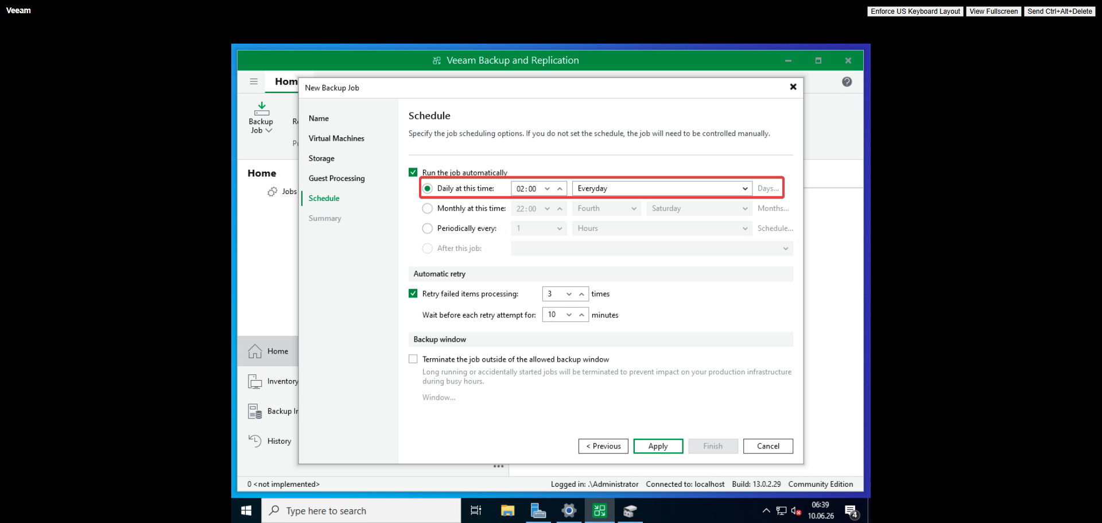
Figure 126: Backup schedule configuration
The backup schedule is configured to define when the job will run automatically.
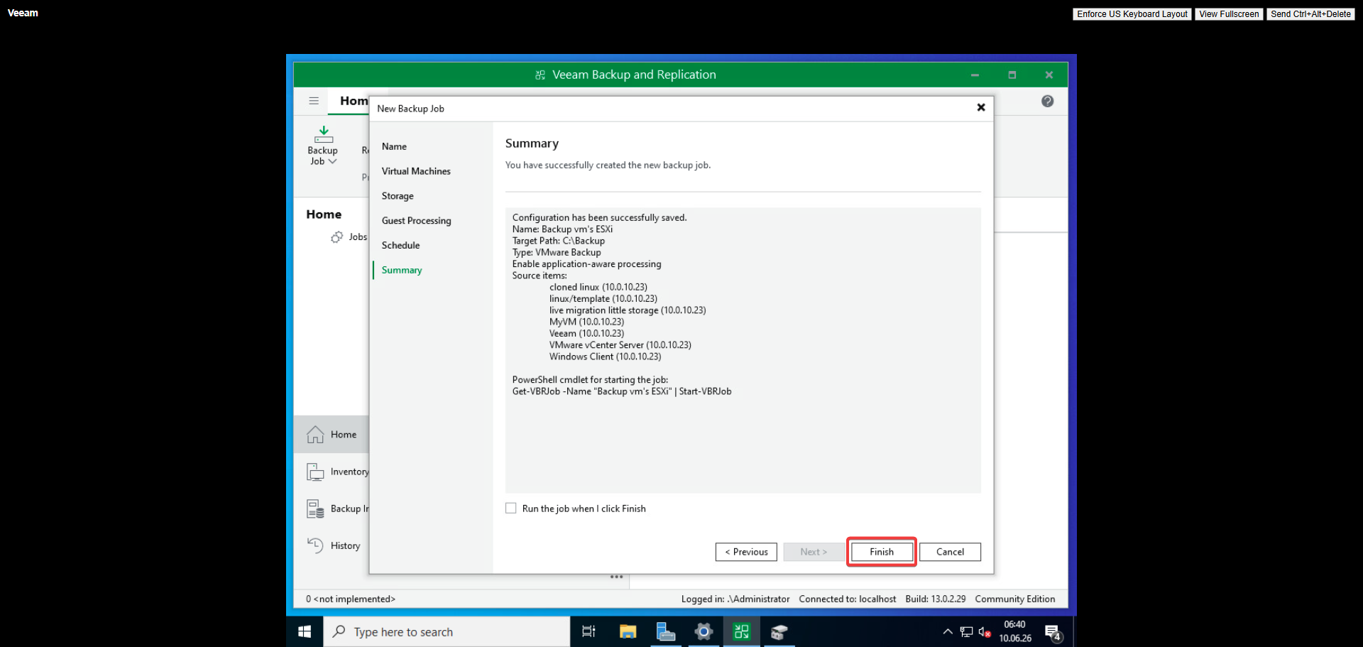
Figure 127: Backup job summary
A summary of the configured backup job is shown for review before creation.
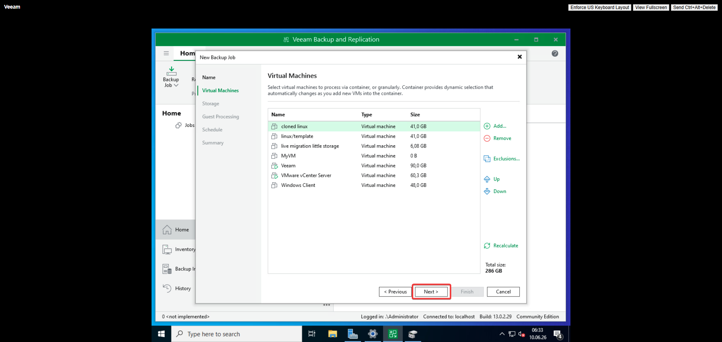
Figure 128: VMs selected for backup job
The selected virtual machines are displayed, confirming which VMs the backup job will protect.

25.5 Hypervisor Configuration Backup
The vCenter Server configuration was backed up by connecting to the vCenter appliance and copying the configuration files to the NAS for safekeeping.
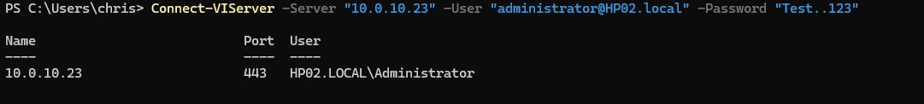
Figure 129: Connecting to vCenter
An SSH connection is established to the vCenter appliance to access its configuration files.
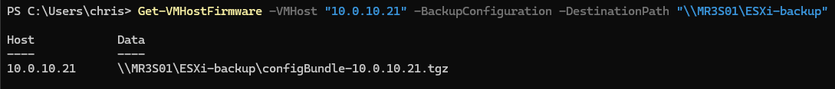
Figure 130: Copying config files to NAS
The vCenter configuration files are copied to the NAS for safekeeping and disaster recovery.

25.6 Proxmox Comparison
Aspect | Proxmox | VMware
VM Backup Tool | vzdump (built-in, free) | Requires 3rd party (Veeam)
Backup GUI | Built-in backup tab | Veeam console or vCenter plugins
Backup Format | VMA (Proxmox native) | Veeam proprietary or VMDK
Scheduling | Built-in scheduler | Veeam job scheduler
Hypervisor Backup | Manual tar of /etc/pve/ | vCenter Configuration Backup
Enterprise Backup | Proxmox Backup Server (free) | Veeam, Rubrik, Cohesity (paid)
Incremental Backup | Yes (with PBS) | Yes (with CBT + VADP)
Cost | €0 | ~$400+/socket/year for Veeam
Key Difference: Proxmox includes built-in backup capabilities at no cost, while VMware requires third-party solutions like Veeam for comprehensive VM backup. Veeam is enterprise-grade with superior features (application-aware processing, instant recovery, replication), but comes at significant cost. Proxmox Backup Server offers comparable enterprise features for free, making Proxmox the clear winner for cost-conscious deployments.

25.7 Results
Veeam Backup & Replication was successfully installed and configured. A backup job was created and executed, confirming that VMs were properly protected. The vCenter configuration was also backed up to the NAS. The implementation demonstrated that while VMware requires additional investment for backup, the third-party ecosystem provides world-class protection.

26. Snapshots

26.1 Objective
Create, manage, and revert virtual machine snapshots in vSphere to enable point-in-time recovery and safe testing environments.

26.2 Theoretical Background
VMware snapshots use a redo-log mechanism: when a snapshot is taken, the original disk becomes read-only and a delta disk (redo log) captures all subsequent writes. VMware's Snapshot Manager provides a visual tree interface for managing complex snapshot hierarchies, including branching and consolidation.

26.3 VMware Implementation
A snapshot was created through the vSphere Client by navigating to the VM's Snapshot page and clicking Take Snapshot. The snapshot captured the VM's disk state and memory. Reverting to a previous snapshot was also tested.
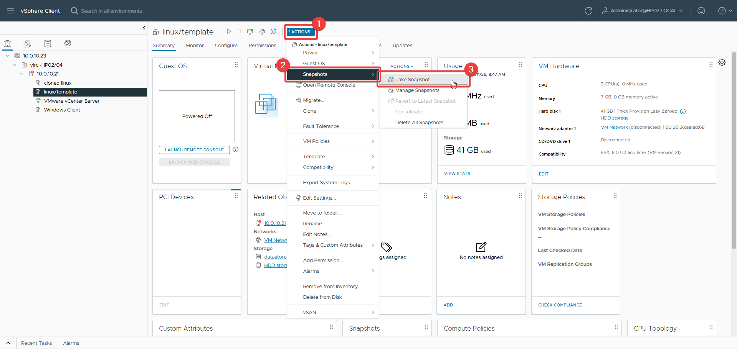
Figure 131: Navigating to snapshot page
The vSphere Client is navigated to the VM snapshot page to create a snapshot.
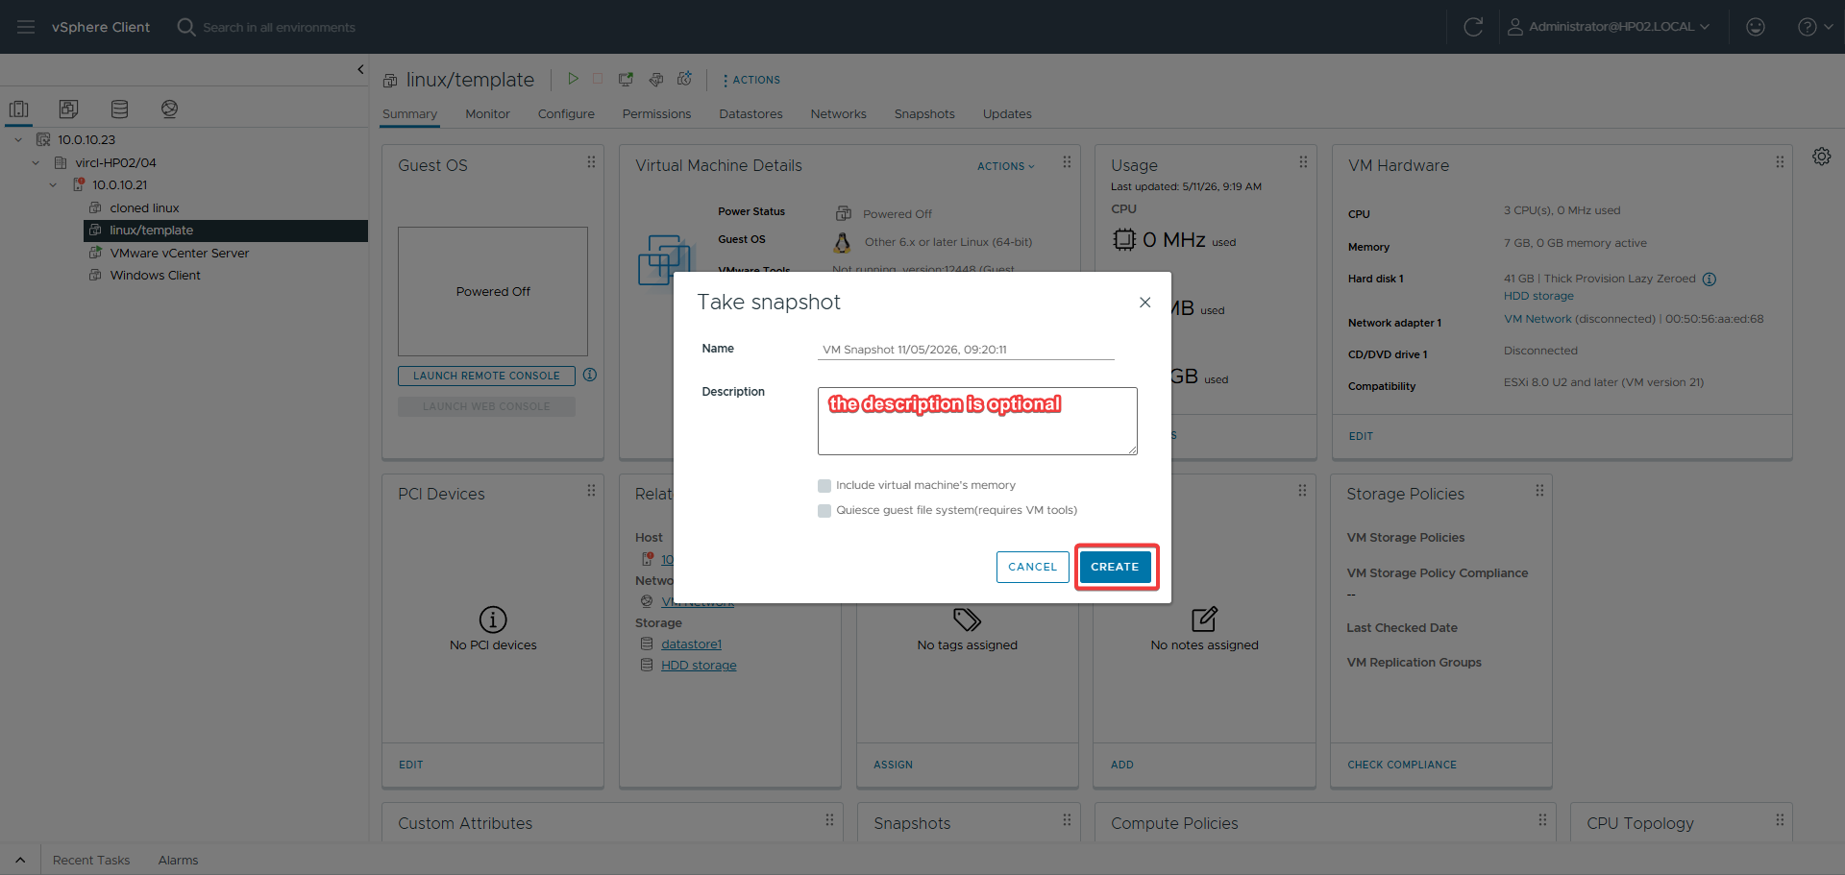
Figure 132: Snapshot configuration
The snapshot creation dialog is configured with a name and description before capturing the VM state.
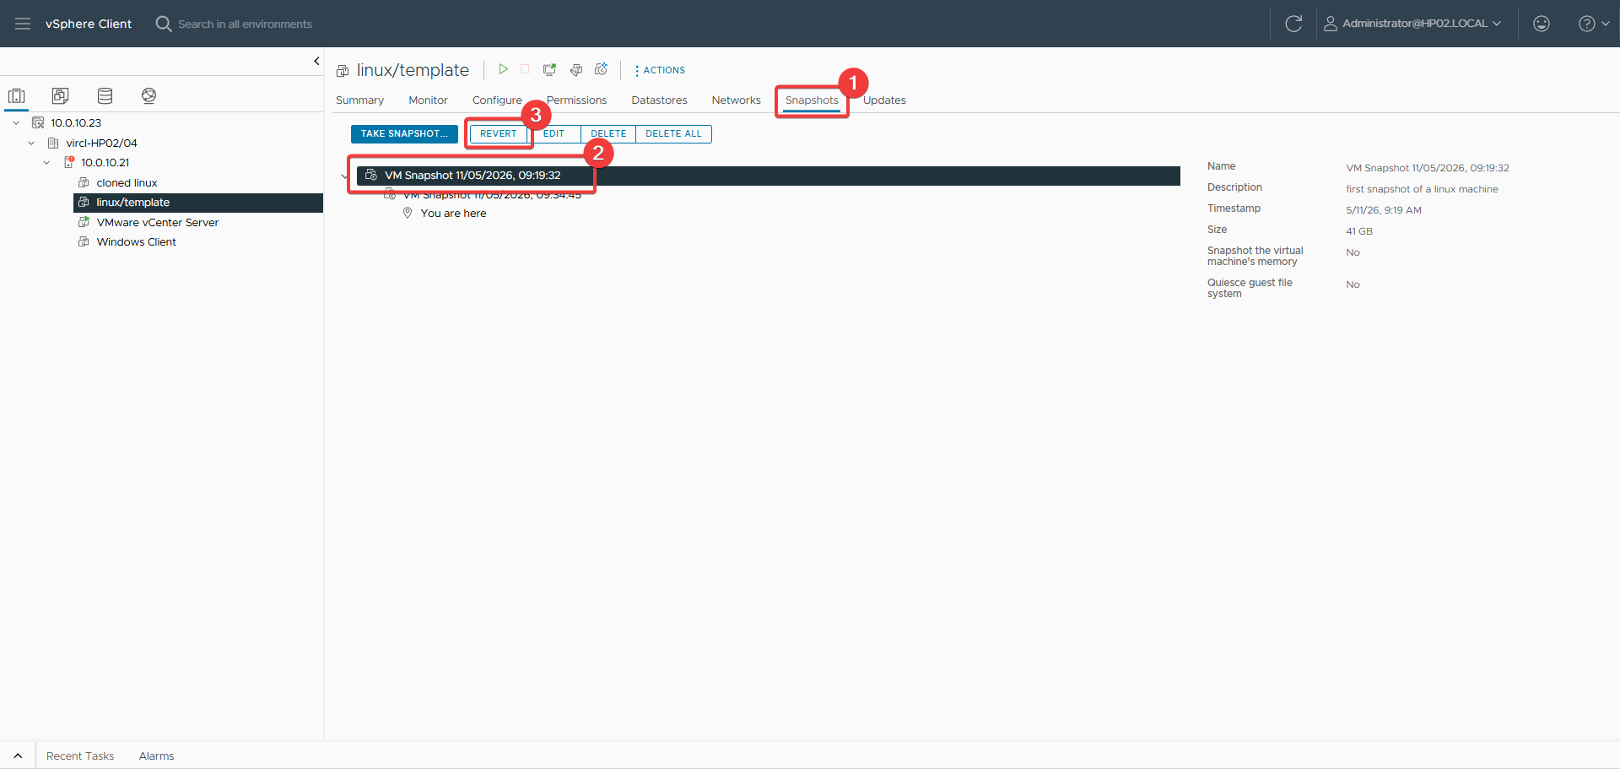
Figure 133: Navigating to revert page
The vSphere Client is navigated to the snapshot revert page to restore a previous state.
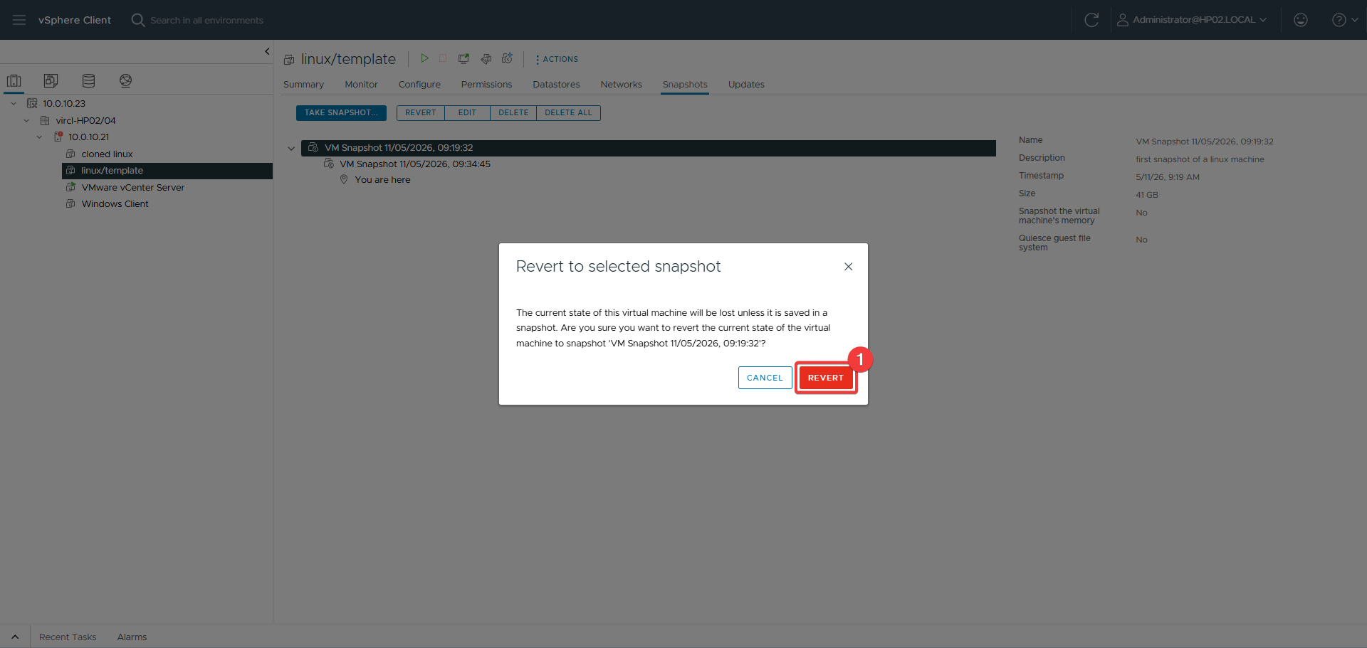
Figure 134: Revert snapshot page
The revert snapshot interface displays the target snapshot to which the VM will be restored.

26.4 Proxmox Comparison
VMware's Snapshot Manager provides a superior visual interface for managing complex snapshot trees, including branching and consolidation. Proxmox uses a simpler linear model. VMware also offers quiesced snapshots through VSS (Volume Shadow Copy Service) on Windows guests, providing application-consistent snapshots that Proxmox cannot match without additional tools.

26.5 Results
Snapshots were successfully created and reverted in vSphere. The Snapshot Manager interface provided clear visibility into the snapshot hierarchy and state.

27. Virtual Machine Templates

27.1 Objective
Convert a configured virtual machine into a template for rapid, standardized deployment of new VMs in the VMware environment.

27.2 Theoretical Background
VMware templates are master copies of VMs that cannot be powered on or edited directly. The Content Library in vCenter provides centralized template management across multiple sites. Guest Customization Specifications allow automatic OS customization (hostname, IP, SID) when deploying from templates, a feature not natively available in Proxmox.

27.3 VMware Implementation
A VM was converted to a template by right-clicking it and selecting Template → Convert to Template. A new VM was then deployed from the template using the clone wizard, selecting compute resources and storage.
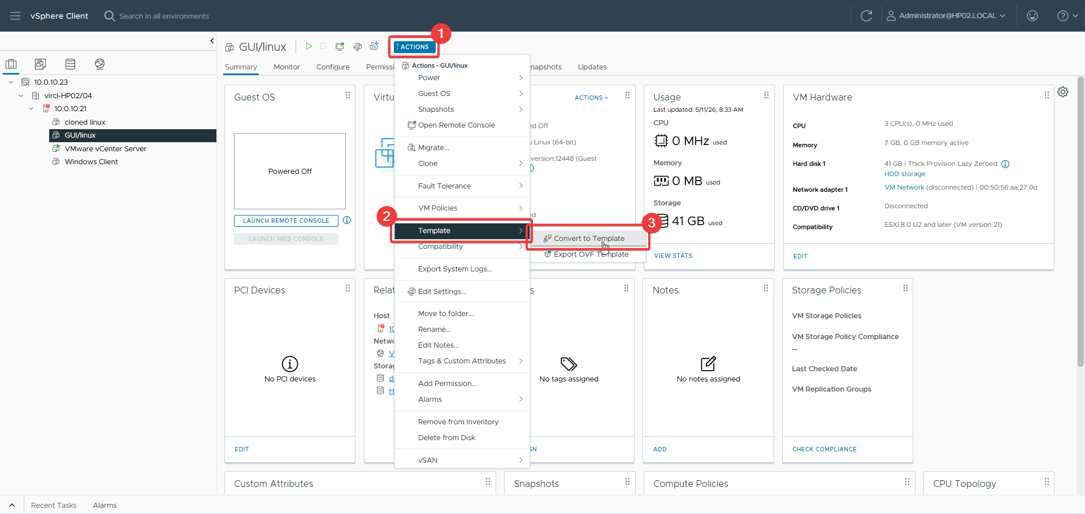
Figure 135: Navigating to template page
The vSphere Client is navigated to the template page to convert a VM to a template.
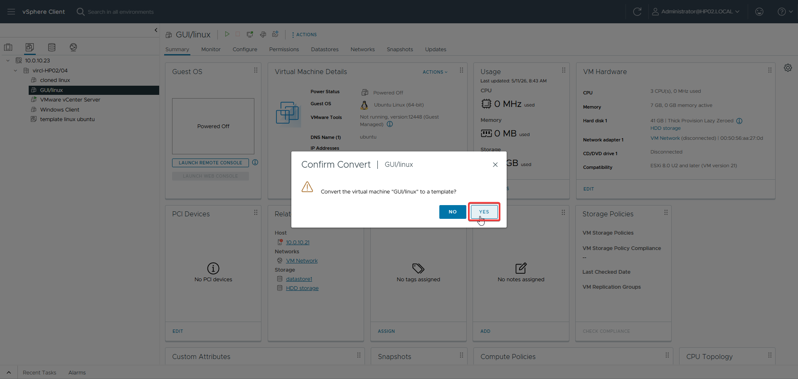
Figure 136: Template conversion confirmation
The VM is converted to a template, making it available for standardized future deployments.
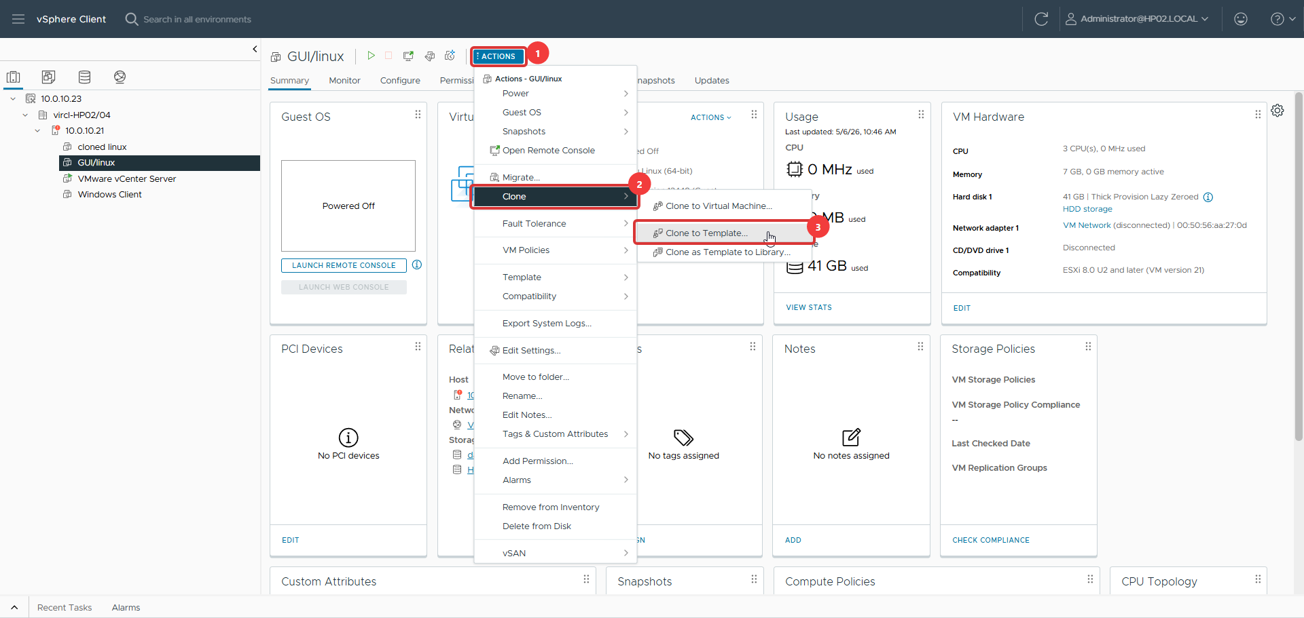
Figure 137: Navigating to clone template
The interface is navigated to the clone template workflow to deploy a new VM.
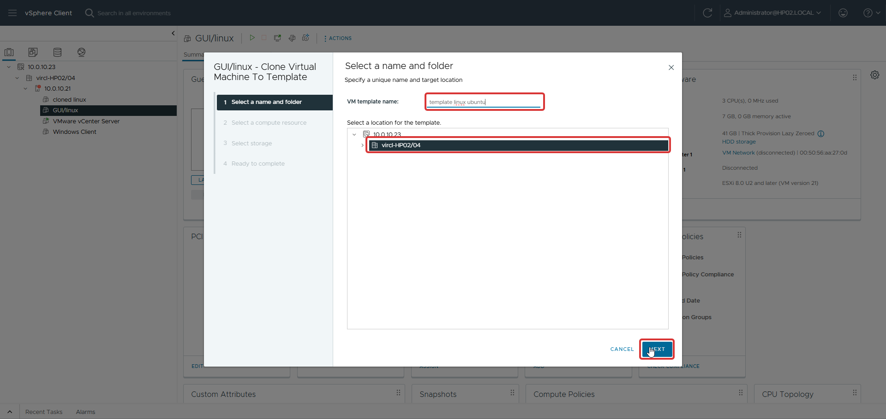
Figure 138: Name and folder selection
The new VM's name and target folder are specified during template deployment.
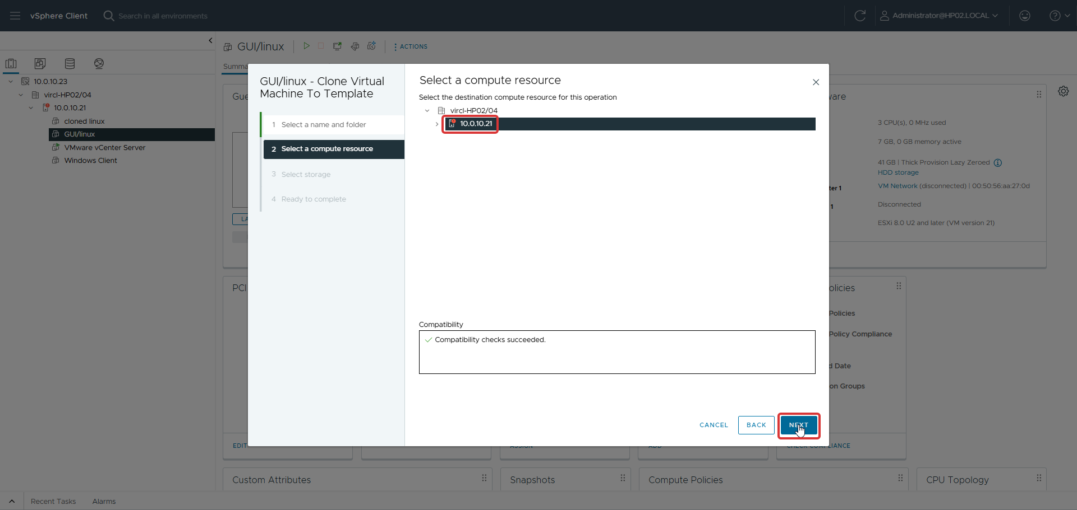
Figure 139: Compute resources selection
The target host or cluster is selected from the available compute resources for the new VM.
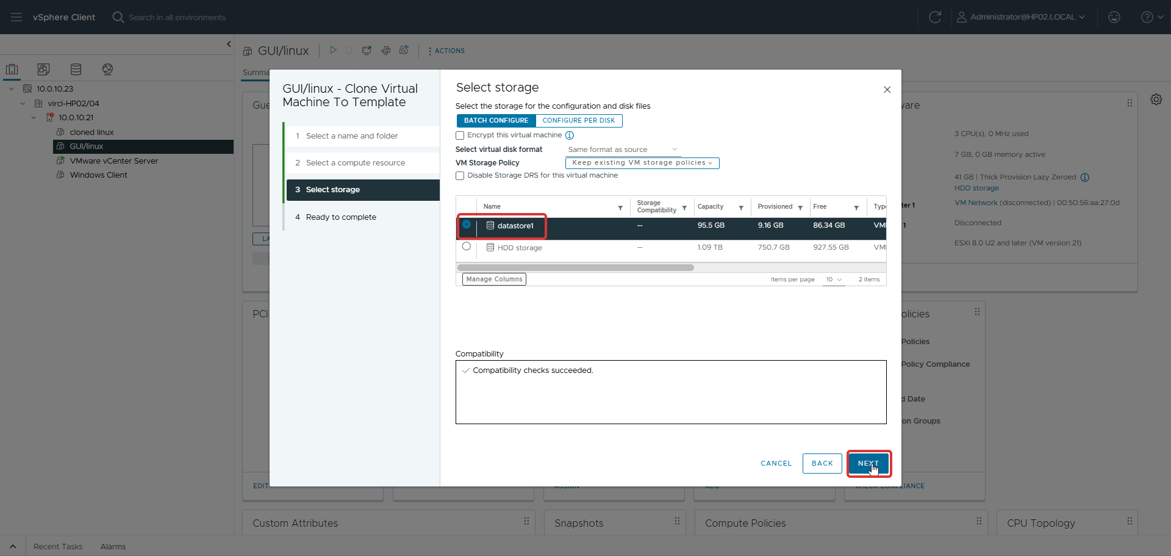
Figure 140: Storage selection
The datastore for the new VM's disks is selected during template deployment.
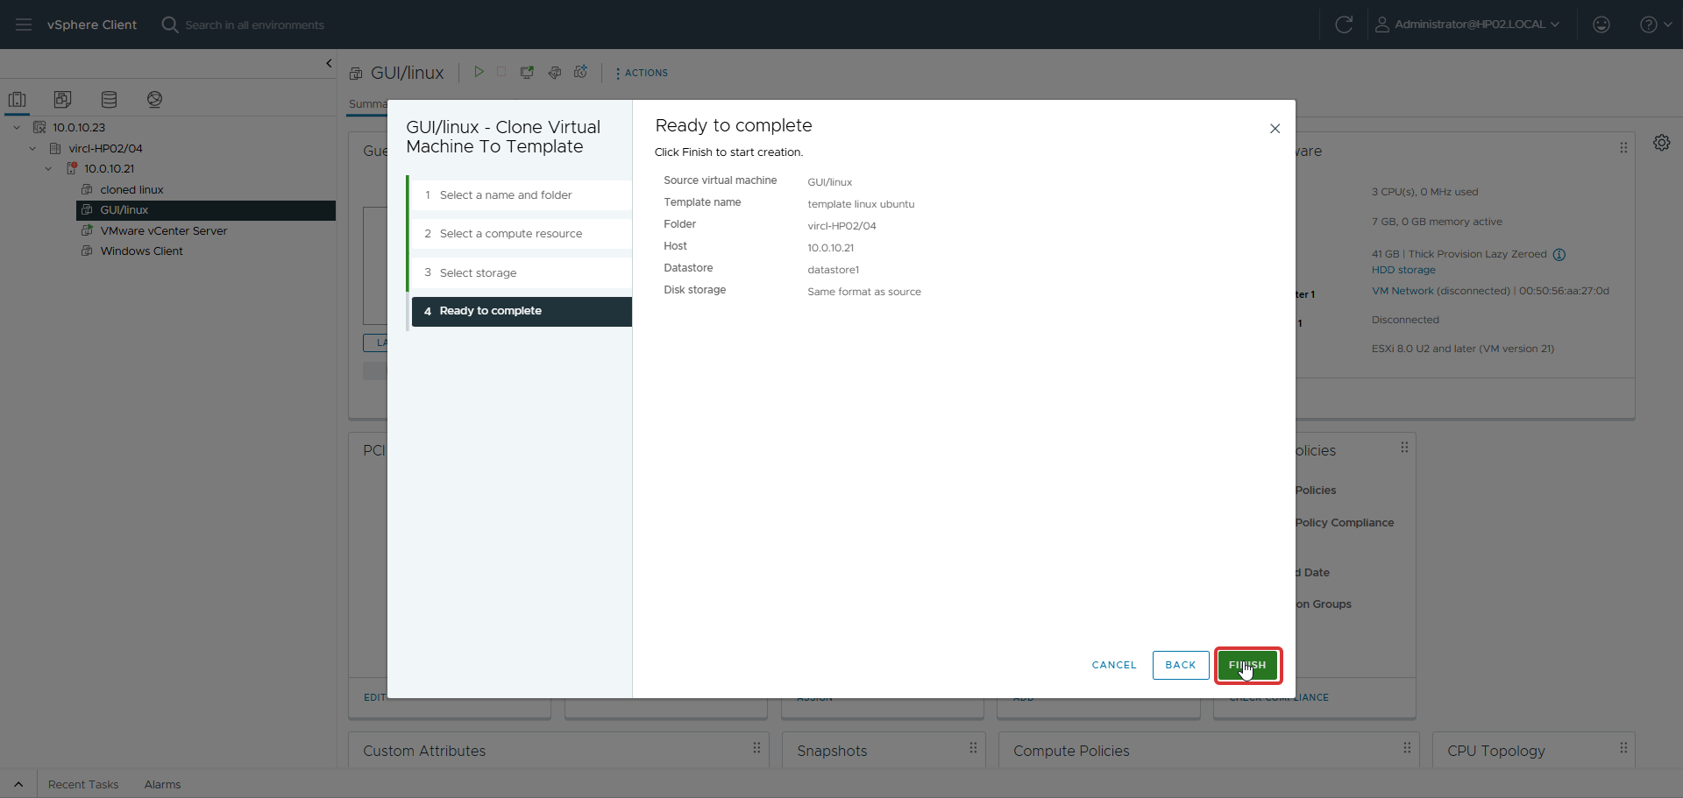
Figure 141: Ready to complete
A summary of the template deployment is shown for review before provisioning the new VM.

27.4 Proxmox Comparison
VMware's Content Library and Guest Customization Specifications provide enterprise-grade template management. When deploying from a template, vSphere can automatically customize the guest OS. Proxmox requires manual post-deployment customization or external tools like cloud-init. VMware's template ecosystem is significantly more mature for large-scale deployments.

27.5 Results
A VM was successfully converted to a template and a new VM was deployed from it. The template workflow in vSphere demonstrated superior enterprise capabilities compared to Proxmox's basic template conversion.

28. Remote Storage Integration

28.1 Objective
Connect VMware ESXi to the CLOIF2 NAS using NFS protocol for shared VM storage, backups, and ISO images.

28.2 Theoretical Background
VMware ESXi supports multiple storage protocols: VMFS (local and SAN), NFS, iSCSI, and vSAN. NFS datastores are mounted at the host level and appear as shared storage in vCenter. Unlike Proxmox which supports both NFS and SMB natively, VMware focuses on NFS and iSCSI for network storage.

28.3 VMware Implementation
The NAS was added as an NFS datastore through the vSphere Client: Storage → New Datastore → NFS → enter NAS details (IP, path, NFS version). Initial attempts encountered issues with incorrect file paths and ACL/access permissions on the NAS. After correcting the export path and permissions, the datastore was successfully mounted.
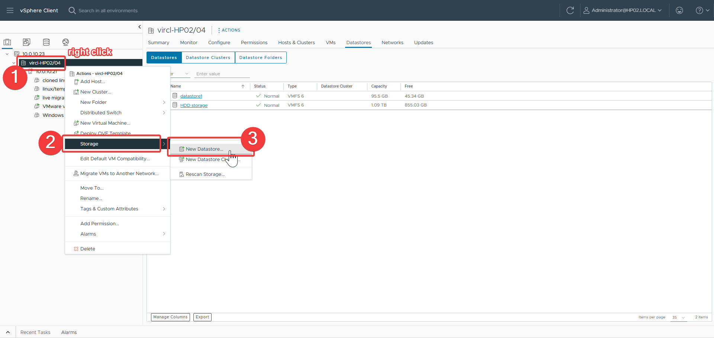
Figure 142: Navigating to add storage
The vSphere Client is navigated to the storage page to add a new NFS datastore.
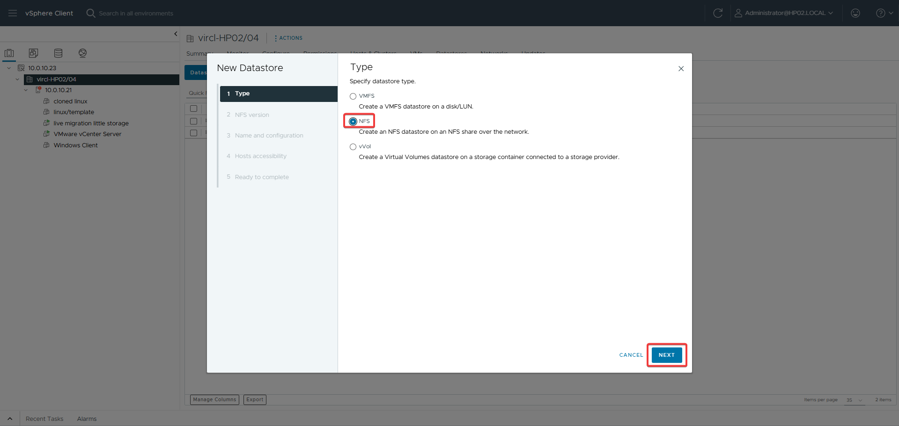
Figure 143: Storage type selection
NFS is selected as the storage type for adding the NAS as a network datastore.
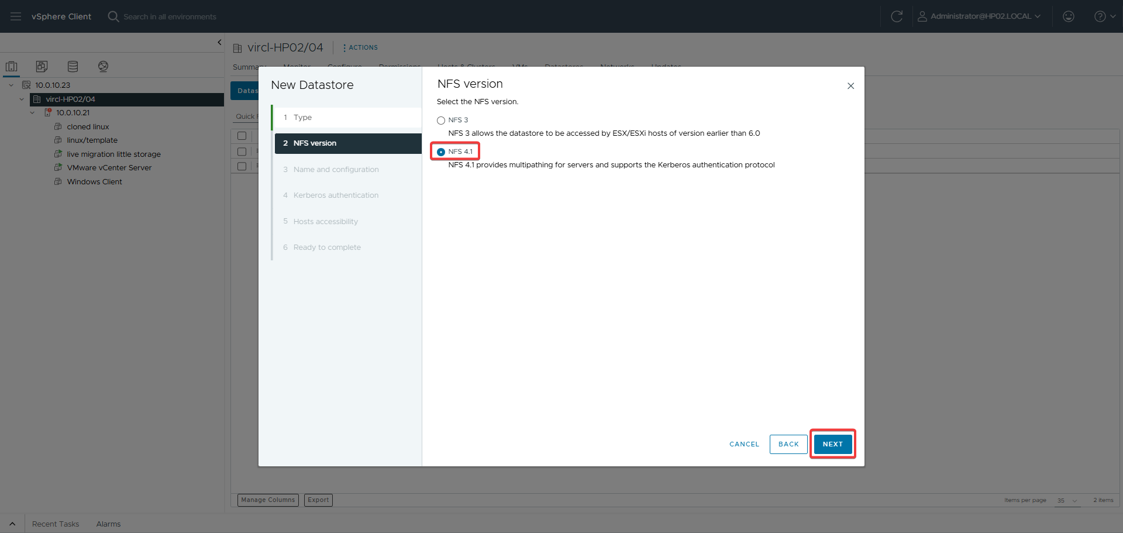
Figure 144: NFS version selection
The appropriate NFS protocol version is selected for compatibility with the NAS export.
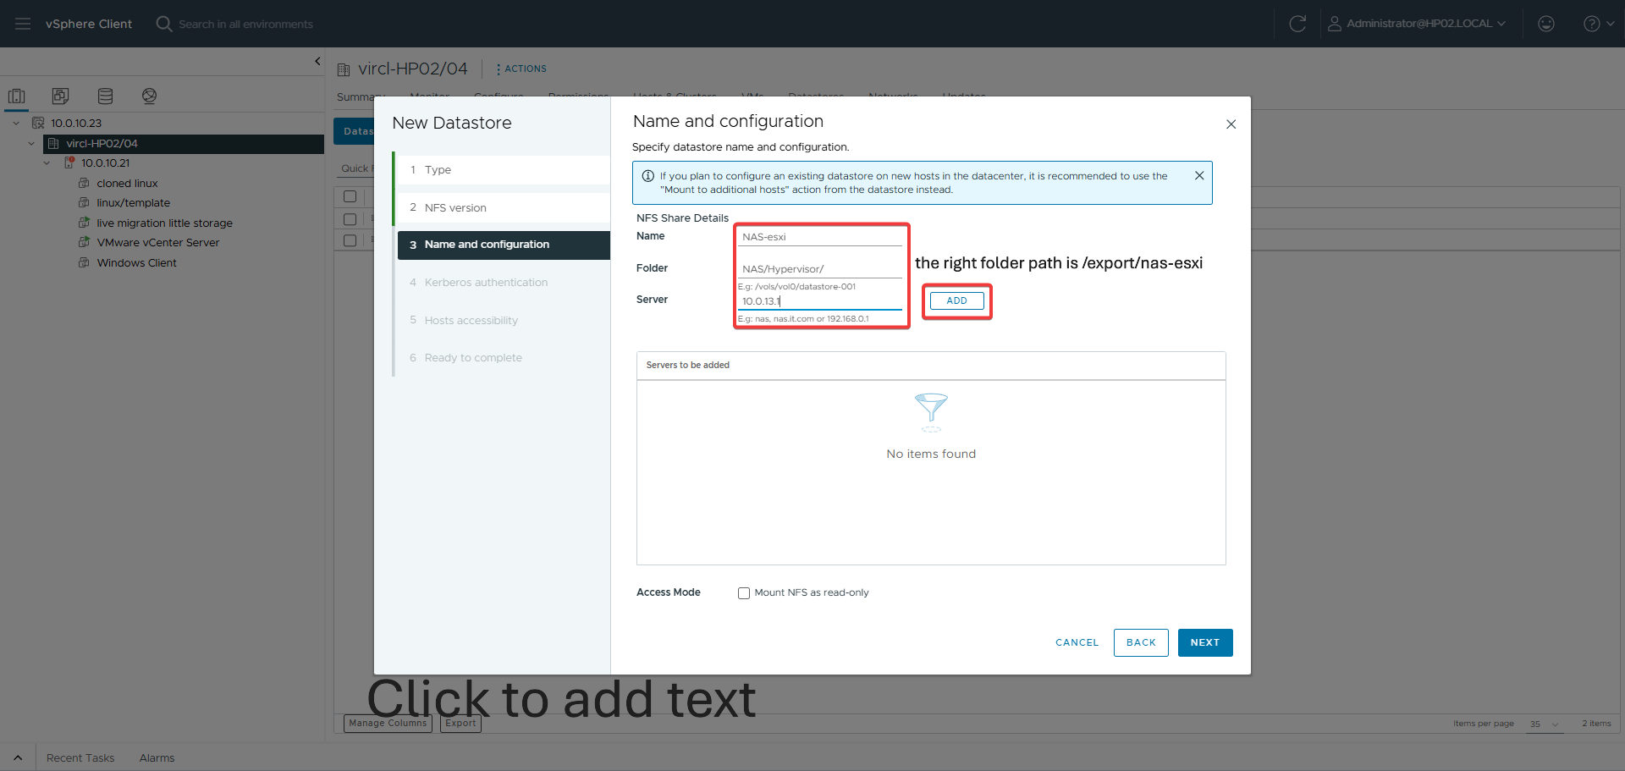
Figure 145: NAS not yet added
The initial NAS connection attempt shows it is not yet added, indicating a configuration issue.
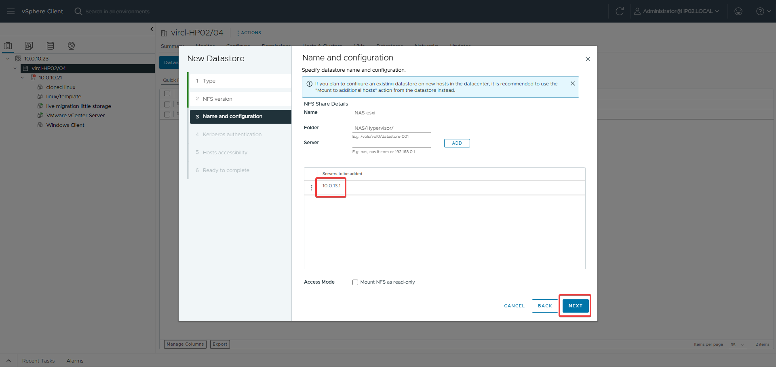
Figure 146: NAS successfully added
The NAS is successfully added as an NFS datastore after correcting the export path and permissions.
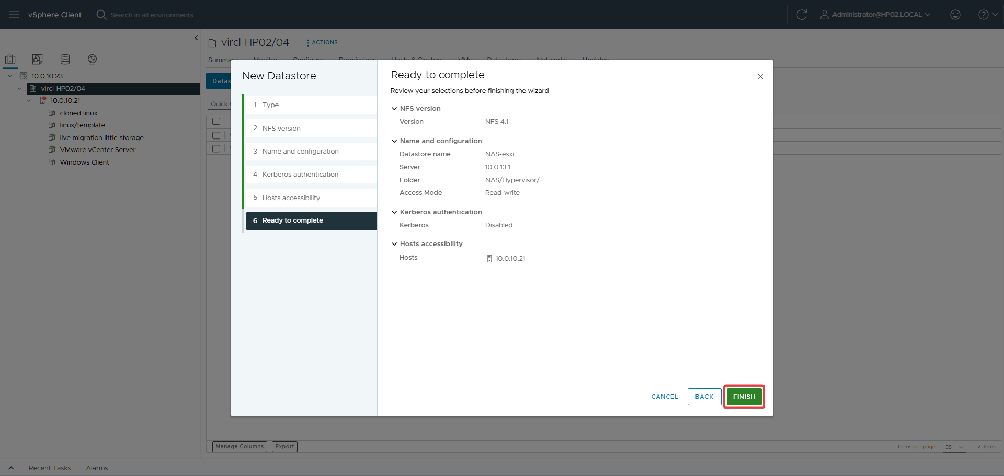
Figure 147: Ready to complete
The final summary confirms the NFS datastore configuration before completing the addition.

28.4 Proxmox Comparison
Proxmox supports a wider variety of storage types natively, including ZFS, Ceph, and SMB/CIFS. VMware focuses on VMFS (its proprietary filesystem) and vSAN for enterprise deployments, with NFS as the primary network-attached option. Both handle NFS well for shared storage, but Proxmox's broader protocol support offers more flexibility.

28.5 Results
The NAS was successfully connected as an NFS datastore after resolving path and ACL issues. VMs could be stored on the remote storage, enabling shared storage capabilities for features like vMotion.

29. Live Migration — Storage to Storage

29.1 Objective
Move a virtual machine's disk from local storage to remote NAS storage while the VM is both running and stopped, demonstrating Storage vMotion.

29.2 Theoretical Background
Storage vMotion is VMware's technology for migrating VM disks between datastores while the VM remains running. It uses a mirror driver to copy blocks in the background, then performs a fast switchover. This requires vCenter and shared-nothing migration is supported for standalone hosts.

29.3 VMware Implementation
Storage migration was initiated through the vSphere Client by right-clicking the VM and selecting Migrate. For a stopped VM, only storage migration was selected. For a running VM, the migration type was set to change storage only. The target datastore was selected and the migration completed successfully.
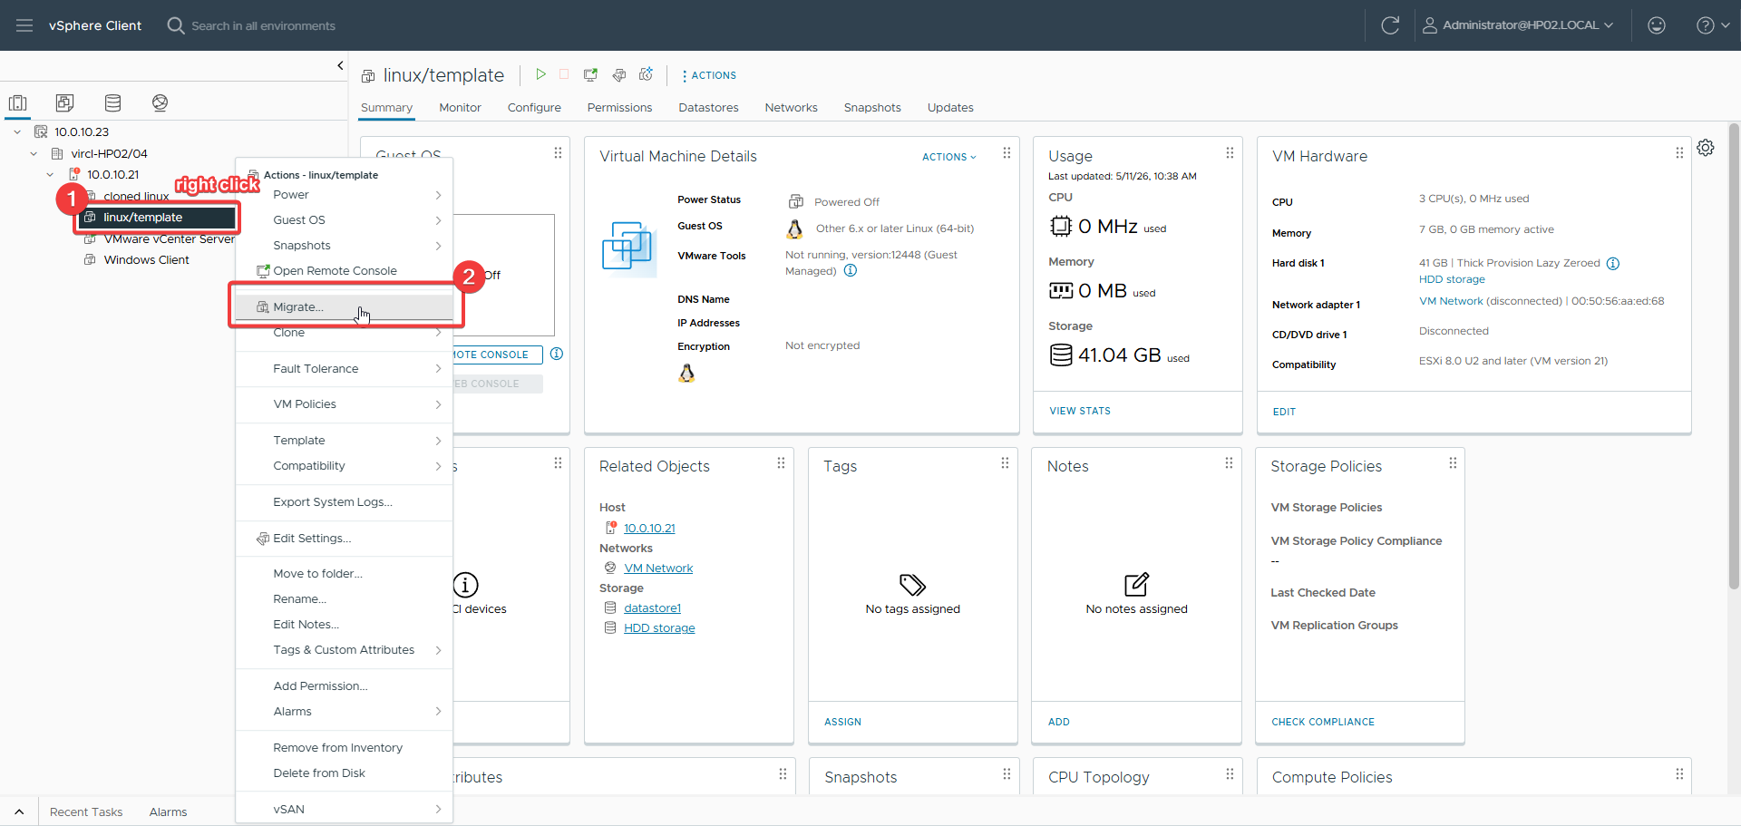
Figure 148: Navigating to migration page
The vSphere Client is navigated to the VM migration page to initiate storage migration.
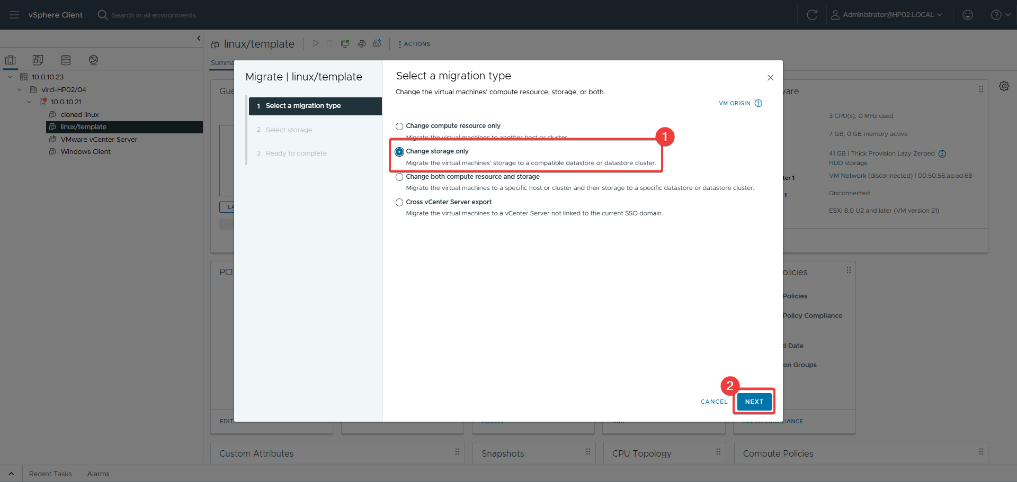
Figure 149: Choosing storage migration
The storage migration option is selected to move the VM's disks to a different datastore.
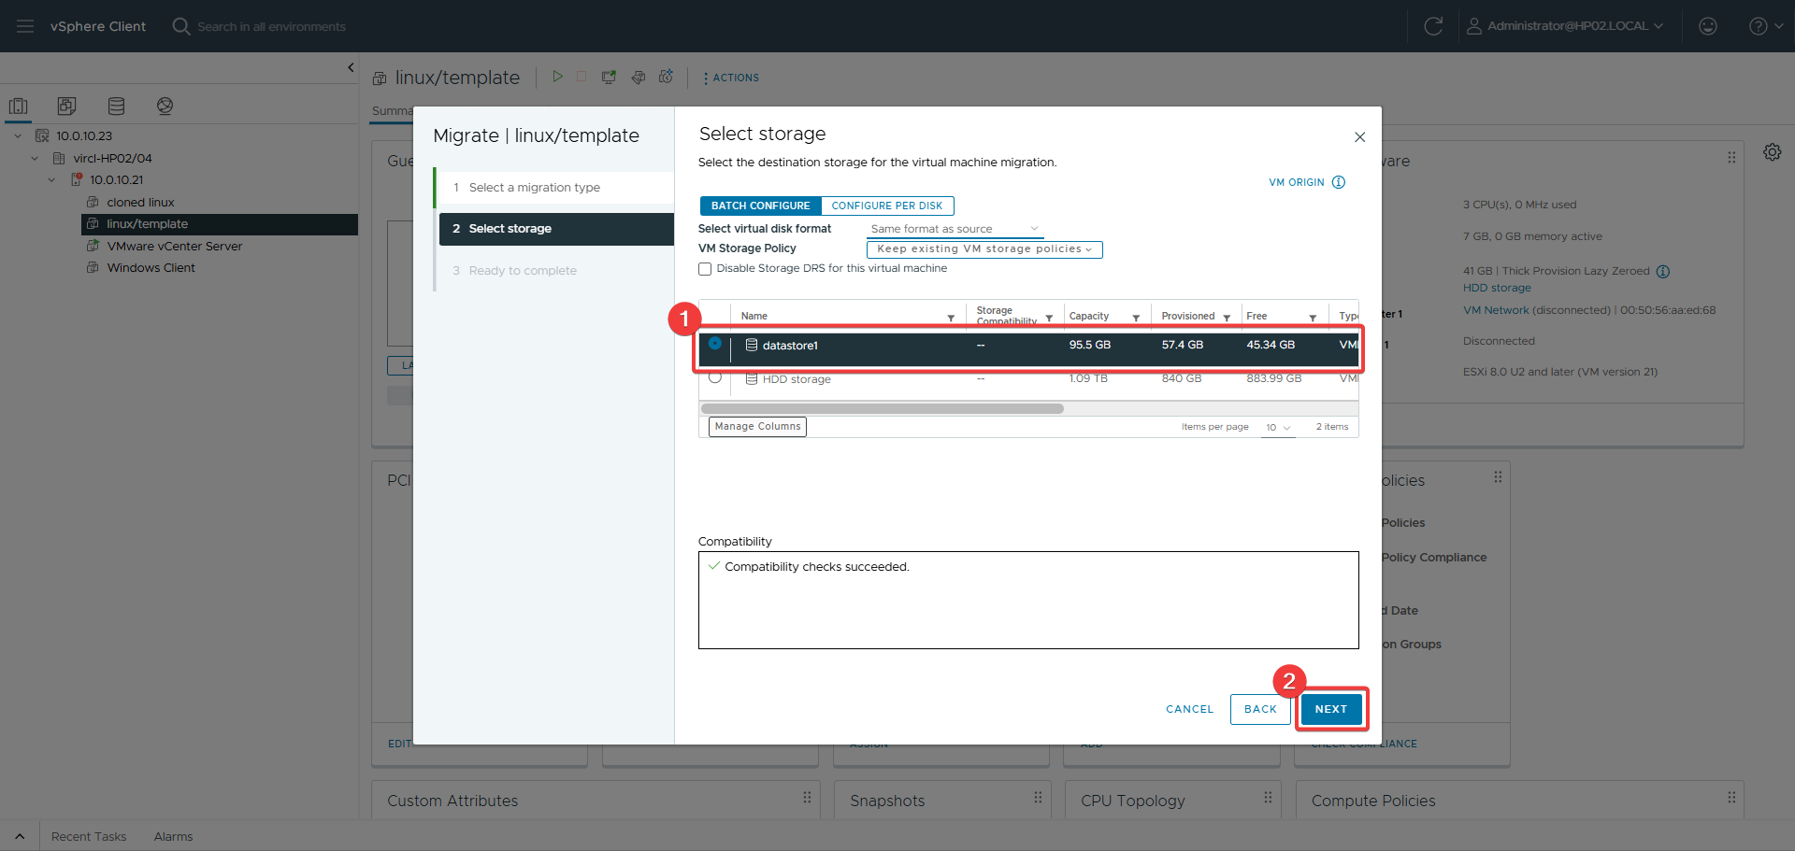
Figure 150: Selecting target storage
The destination datastore is selected where the VM's disk files will be moved.
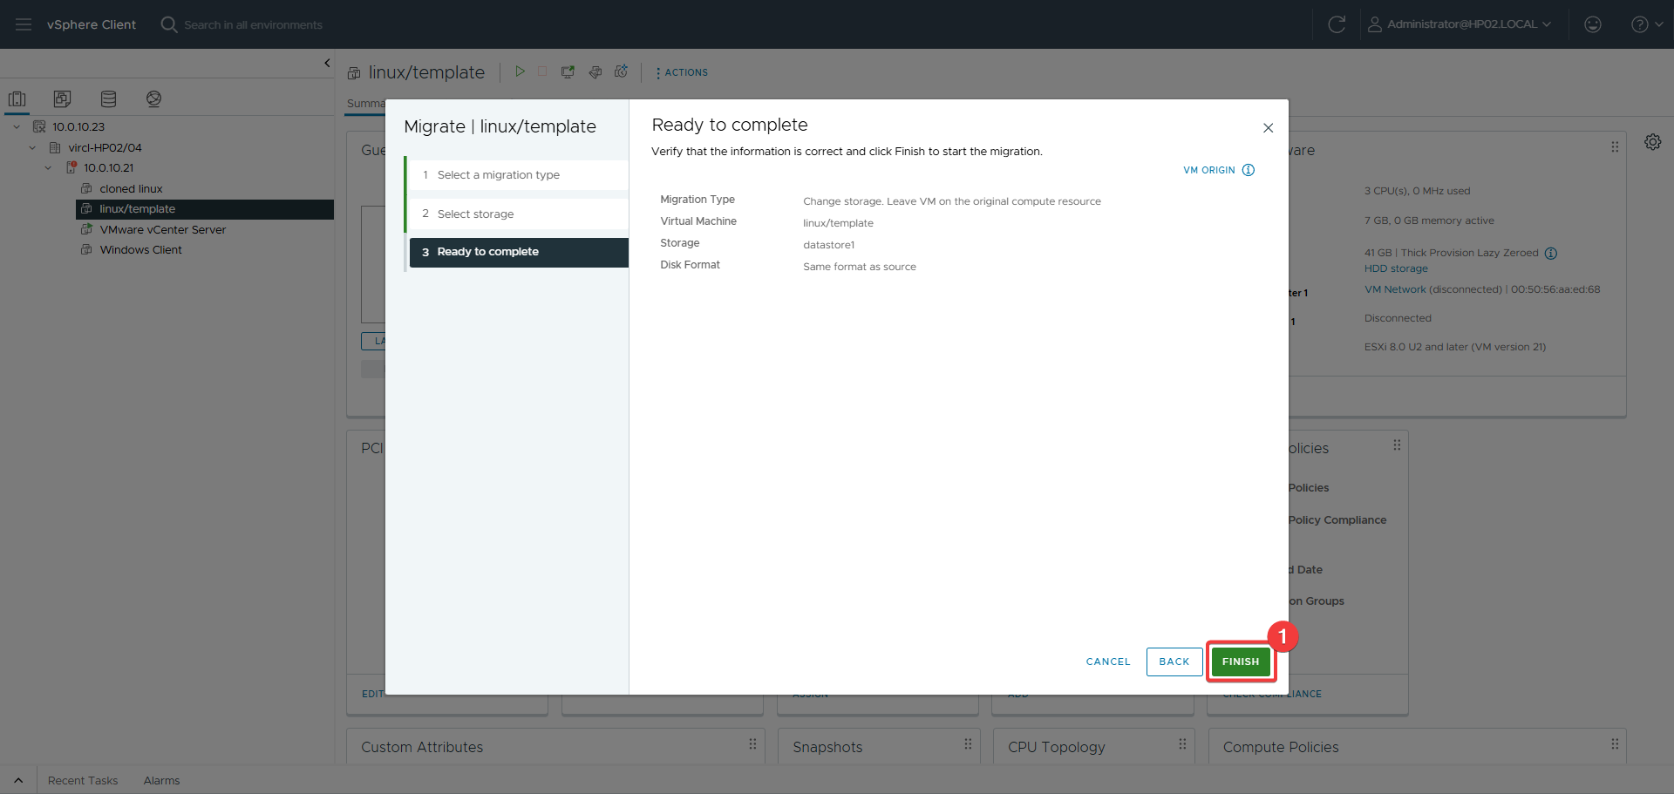
Figure 151: Ready to complete
The migration plan is summarized for review before the storage migration is executed.
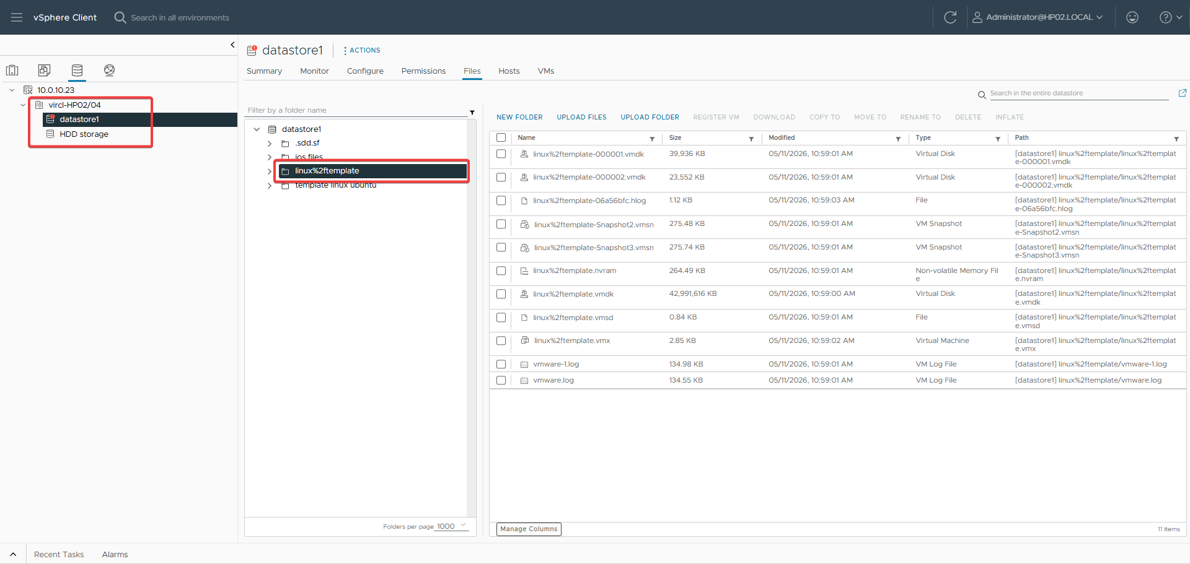
Figure 152: Verification of migration
The completed migration is verified to confirm the VM is now running on the target datastore.

29.4 Proxmox Comparison
VMware's Storage vMotion is a mature, highly optimized feature with deep integration into vCenter's resource management and performance monitoring. Proxmox's Move Disk achieves the same functional result but with a simpler implementation and less granular progress tracking. Both support live migration of running VMs between different storage types.

29.5 Results
Storage migration was successfully completed for both running and stopped VMs. The VM disks were verified on the target datastore, confirming that Storage vMotion operated as expected.

30. Live Migration — Hypervisor to Hypervisor

30.1 Objective
Migrate a virtual machine from one ESXi host (HP02) to another (HP04) while the VM is both running and stopped, demonstrating vMotion.

30.2 Theoretical Background
vMotion is VMware's live migration technology that moves a running VM from one host to another with zero downtime. It transfers the VM's memory state over the vMotion network while the VM continues running, then performs a fast switchover. Enhanced vMotion Compatibility (EVC) masks CPU differences between hosts.

30.3 VMware Implementation — Running VM
A running VM was migrated using the vSphere Client Migrate wizard. The migration type was set to change compute resource only, then the target host was selected. vMotion priority and network settings were configured, and the migration completed without VM downtime.
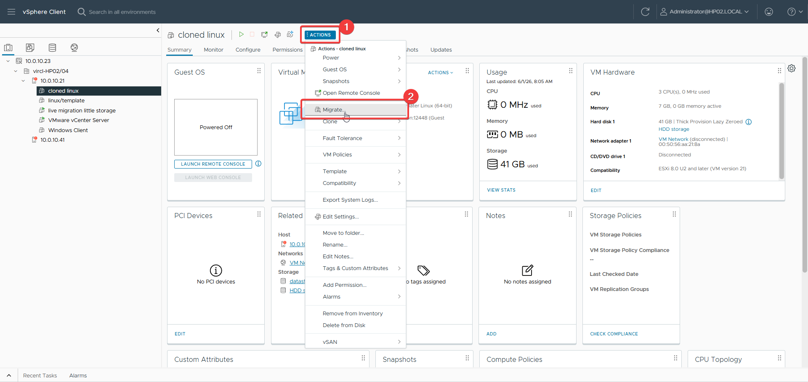
Figure 153: Navigating to migration page
The vSphere Client is navigated to the migration page to begin a compute resource migration.
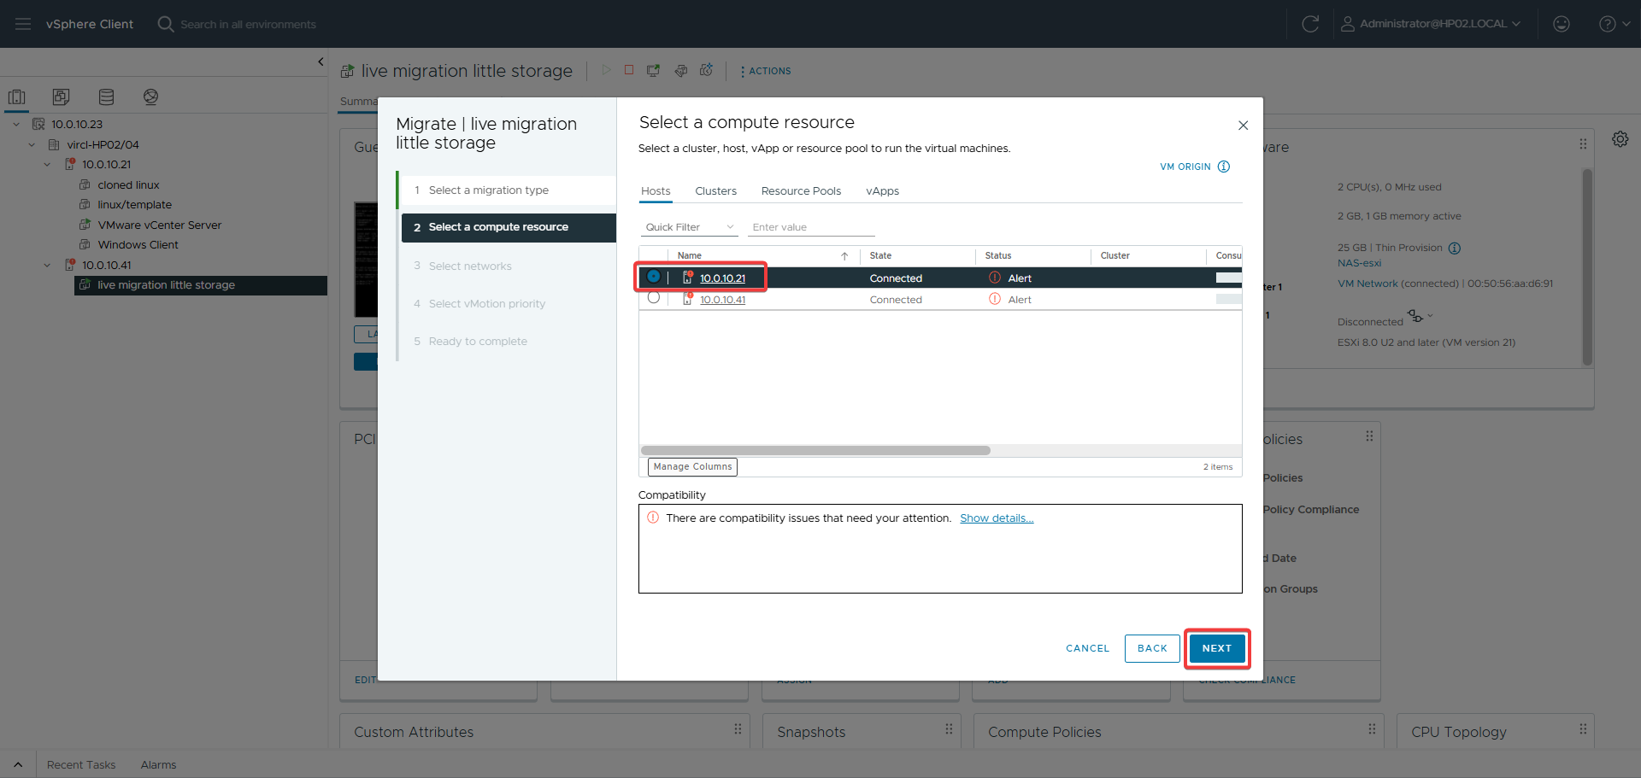
Figure 154: Selecting new server
The target ESXi host is selected to receive the migrated virtual machine.
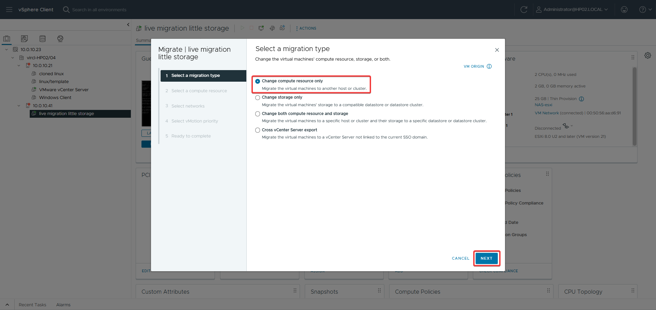
Figure 155: Choosing migration type
The migration type is set to change only the compute resource while keeping current storage.
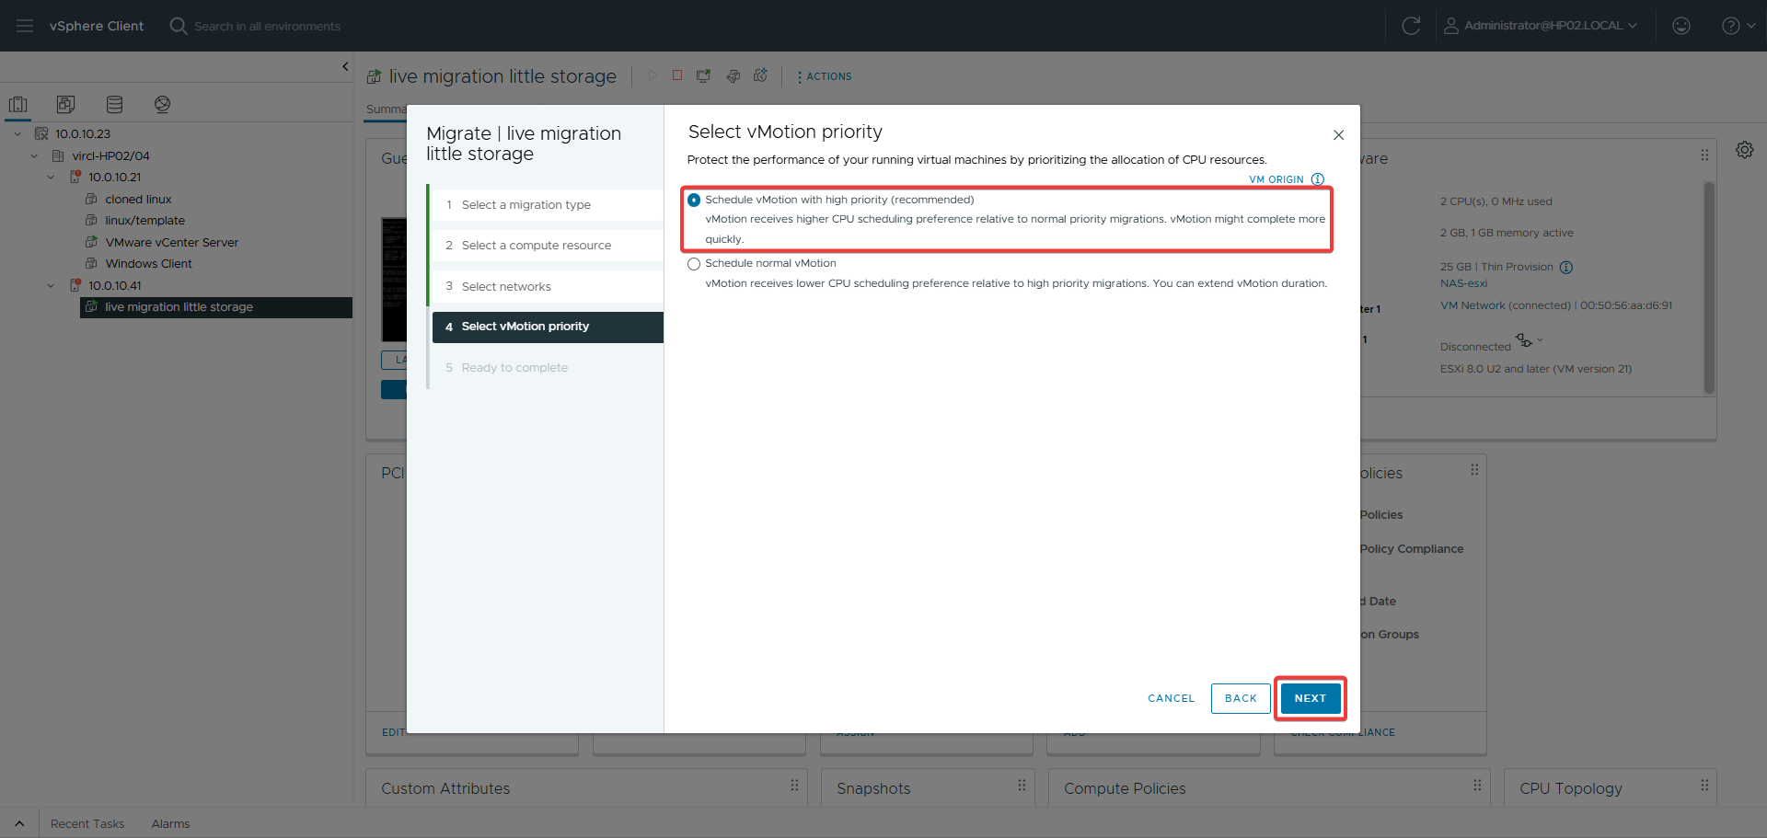
Figure 156: vMotion priority selection
The vMotion priority is configured to control resource allocation during the live migration.
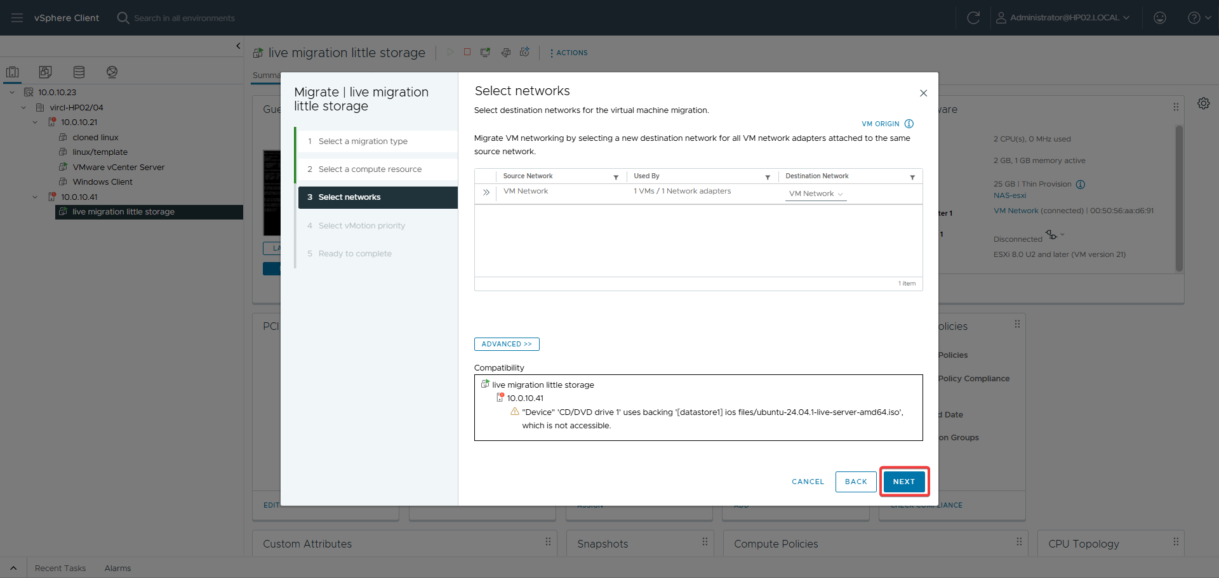
Figure 157: Network selection
The network for vMotion traffic is selected to ensure seamless connectivity during live migration.
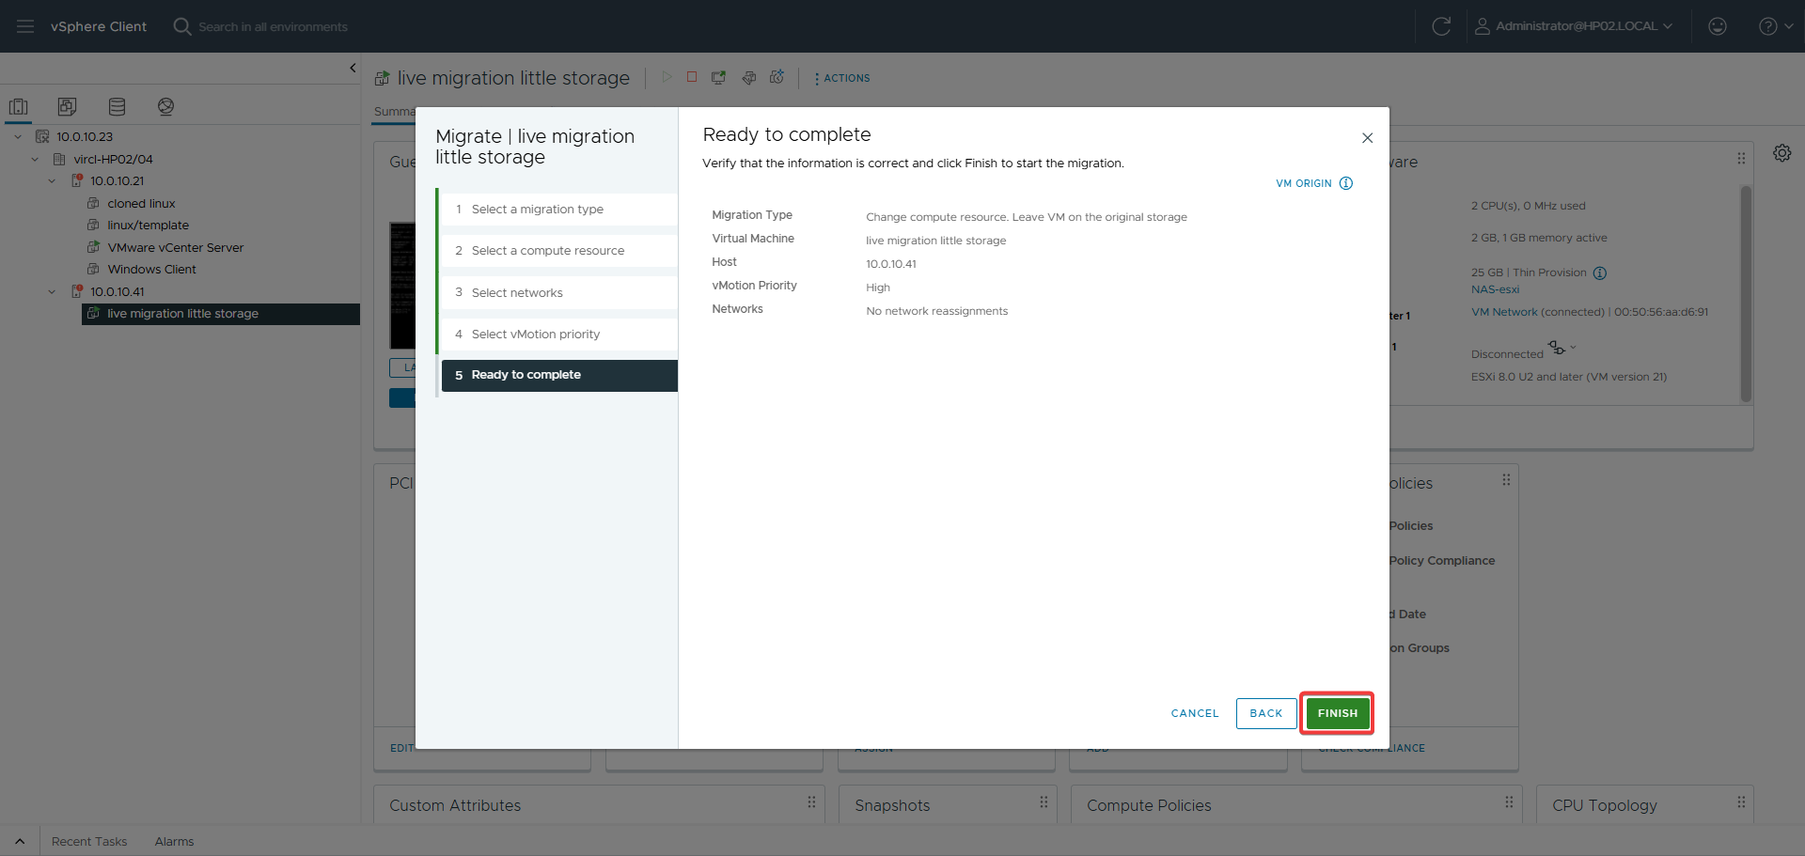
Figure 158: Ready to complete
The hypervisor migration plan is summarized for review before the live migration begins.

30.4 VMware Implementation — Stopped VM
A stopped VM was also migrated between hosts using the same wizard, selecting the target host and confirming the migration.
Figure 159: Stopped VM migration page
The migration page is accessed for a stopped VM to demonstrate offline compute migration.
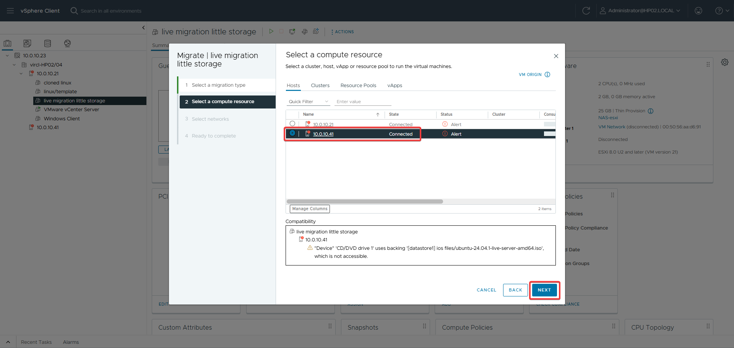
Figure 160: Stopped VM server selection
The target host is selected for the stopped VM migration.
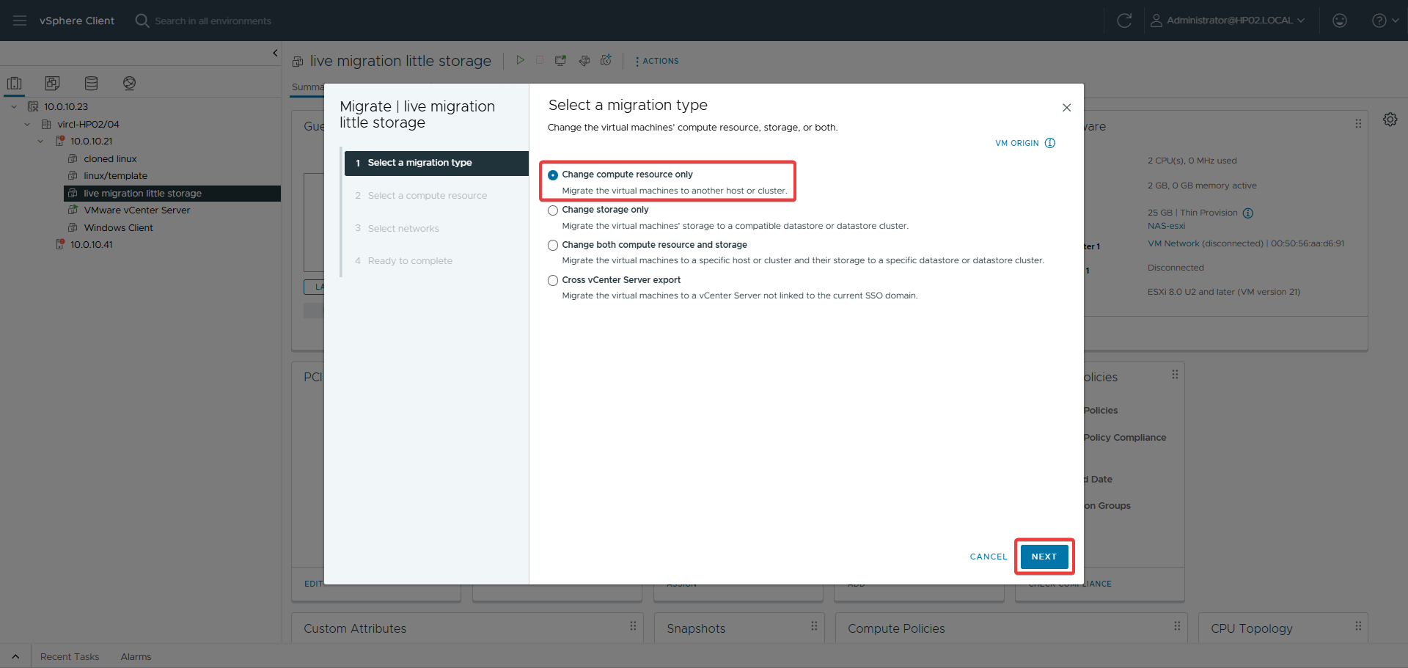
Figure 161: Stopped VM migration type
The migration type is selected for the stopped VM, allowing compute and storage moves.
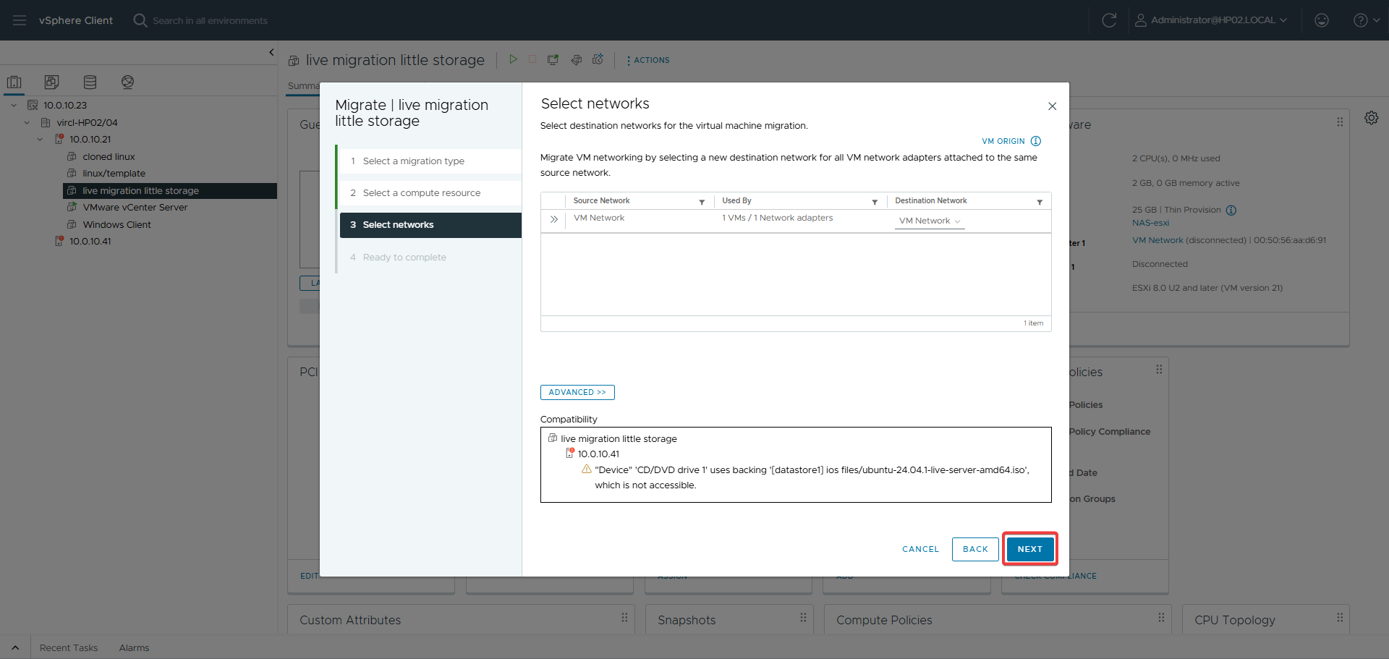
Figure 162: Stopped VM network selection
The network settings are configured for the stopped VM migration to ensure proper connectivity.
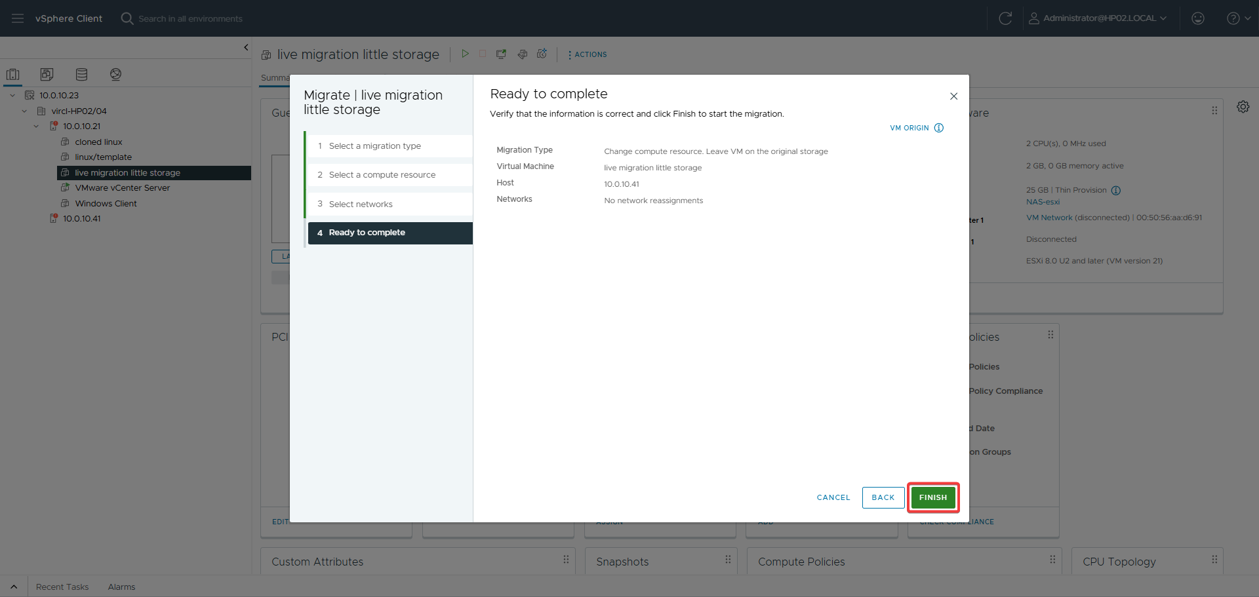
Figure 163: Stopped VM ready to complete
The stopped VM migration summary is displayed for final review before execution.

30.5 Proxmox Comparison
VMware vMotion is the industry benchmark for live migration, with decades of optimization and features like EVC (masking CPU differences between hosts) and cross-vCenter migration. Proxmox migration works well for homogeneous environments but lacks advanced CPU compatibility features. VMware's vMotion is more reliable for mixed-generation hardware.

30.6 Results
Both running and stopped VMs were successfully migrated between HP02 and HP04 using vMotion. The running VM migration completed with zero downtime, demonstrating VMware's mature live migration technology.

31. User Management & Permissions

31.1 Objective
Create user accounts and assign role-based permissions in vCenter to secure the VMware environment and delegate limited access to specific resources.

31.2 Theoretical Background
VMware vCenter uses SSO (Single Sign-On) domain users with global permissions and object-level permissions. Roles define sets of privileges (e.g., Administrator, Read-only, Virtual Machine Power User). Permissions can be assigned at any inventory object level with propagation to child objects.

31.3 VMware Implementation
Users were created in the vCenter SSO domain and global permissions were assigned. The vSphere Client provides interfaces for user management and permission assignment across the inventory hierarchy.
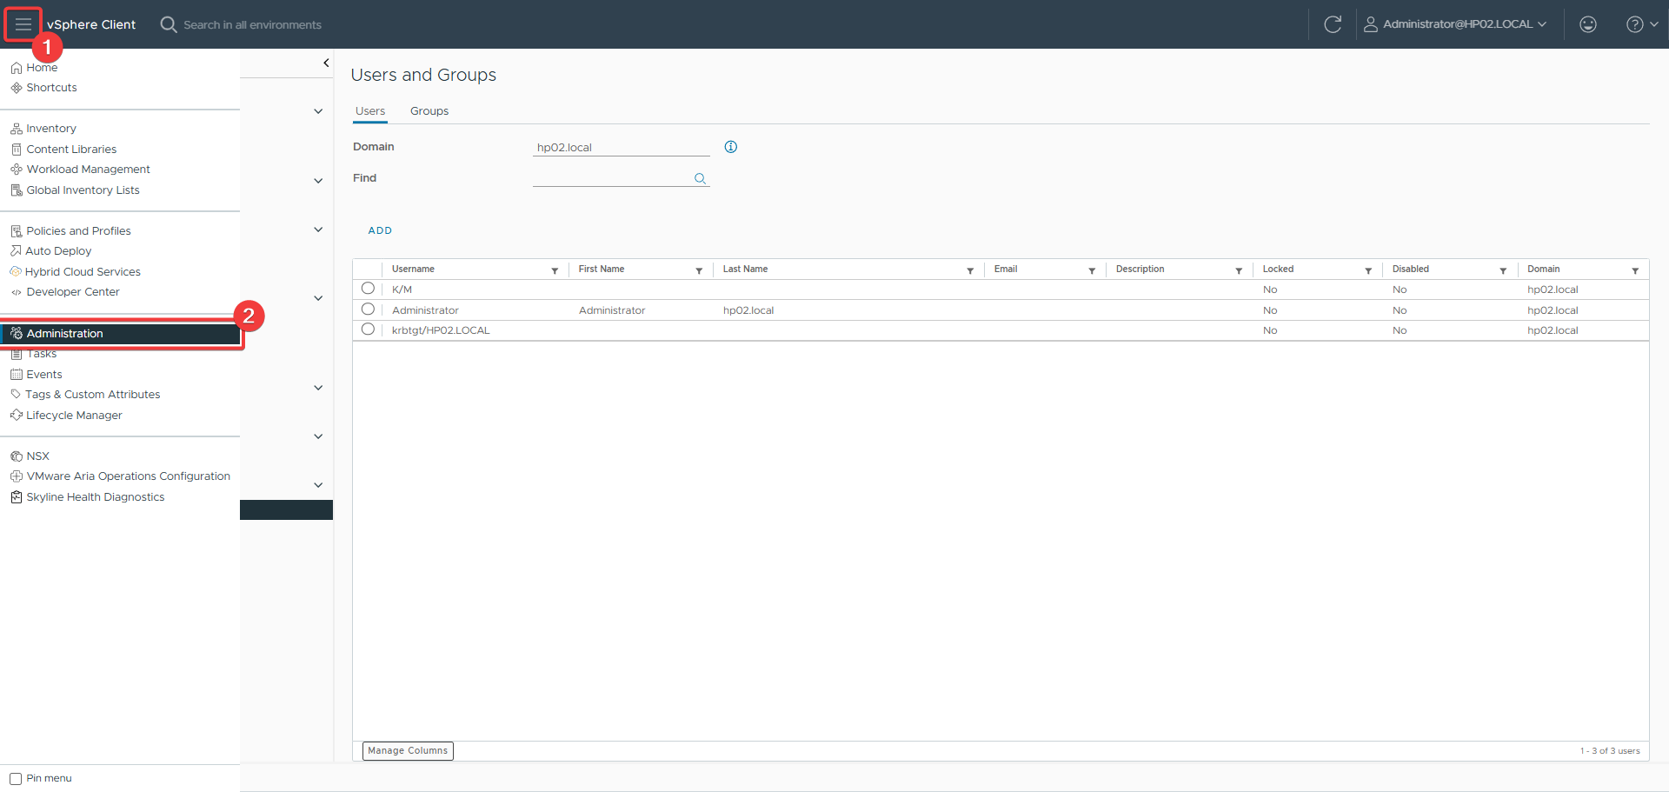
Figure 164: Navigating to user config
The vSphere Client is navigated to the user management page to create SSO users.
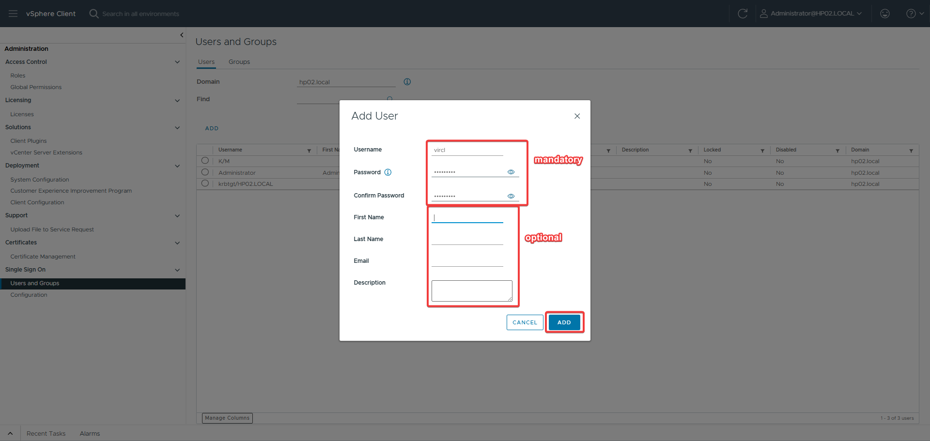
Figure 165: Add user page
The user creation interface is displayed to add a new user to the vCenter SSO domain.
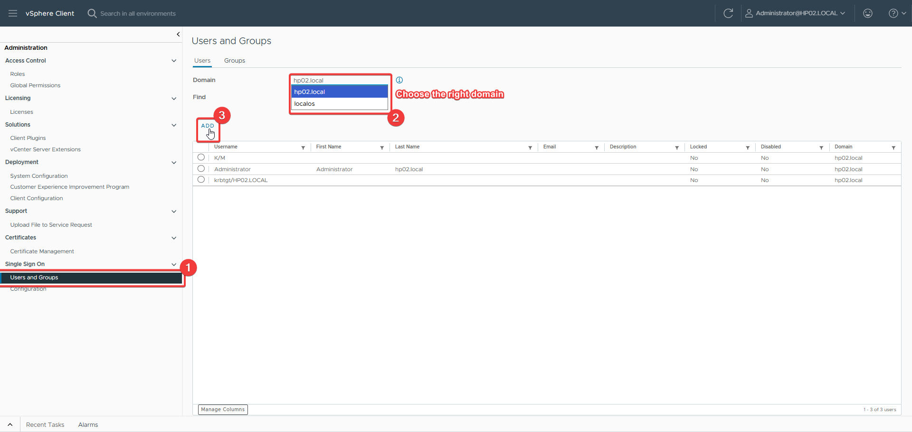
Figure 166: Adding user with correct domain
The new user is configured with the correct SSO domain for proper vCenter authentication.
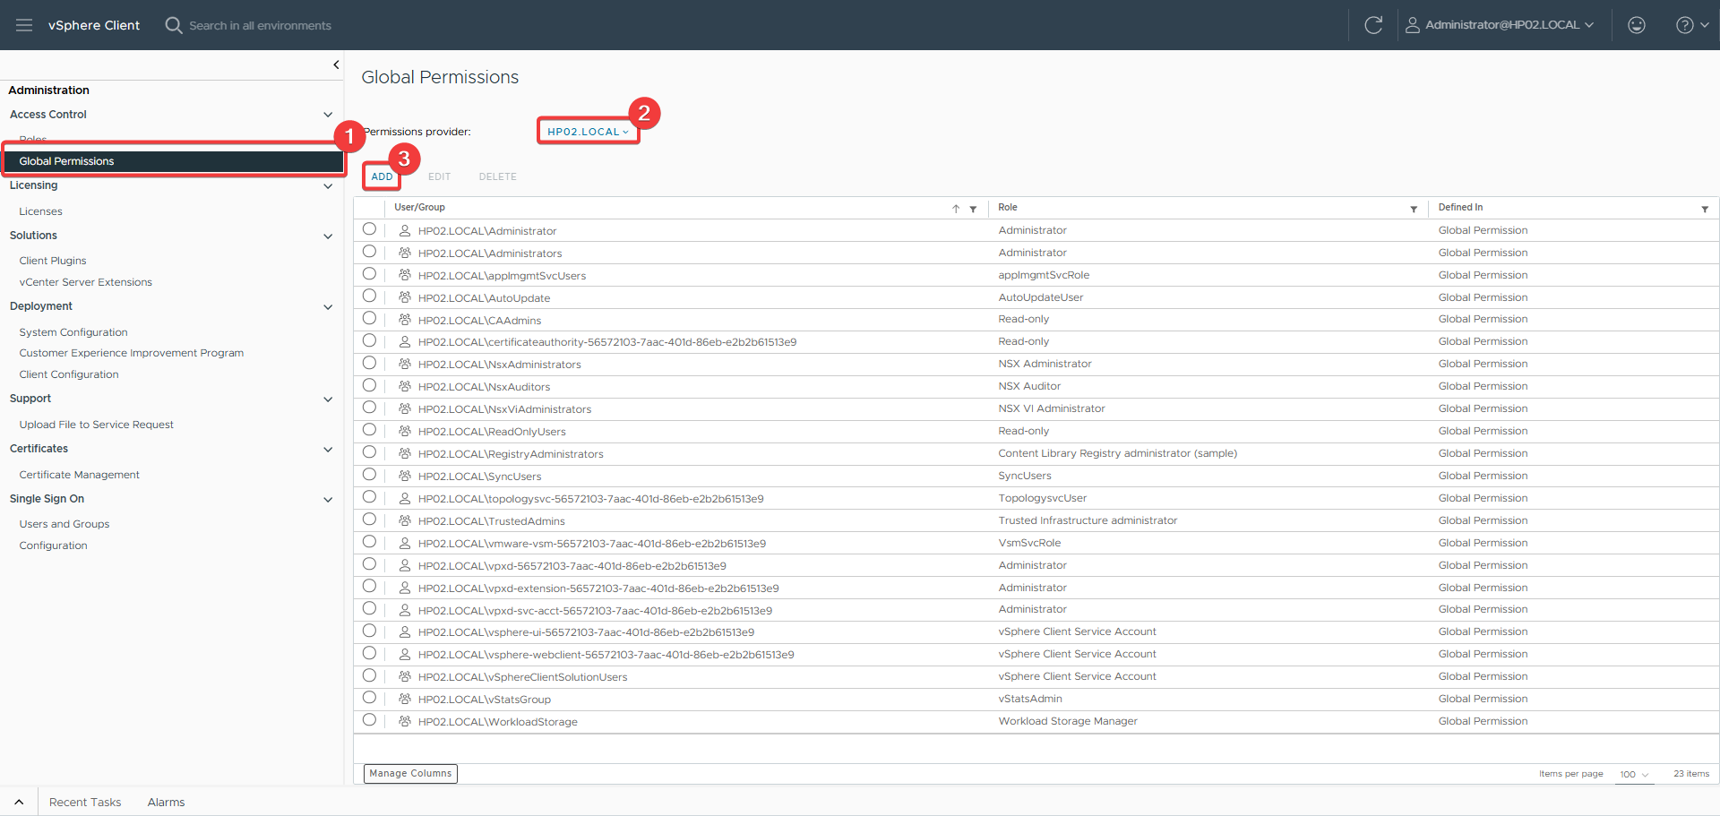
Figure 167: Navigating to permissions
The vSphere Client is navigated to the permissions page to assign global access rights.
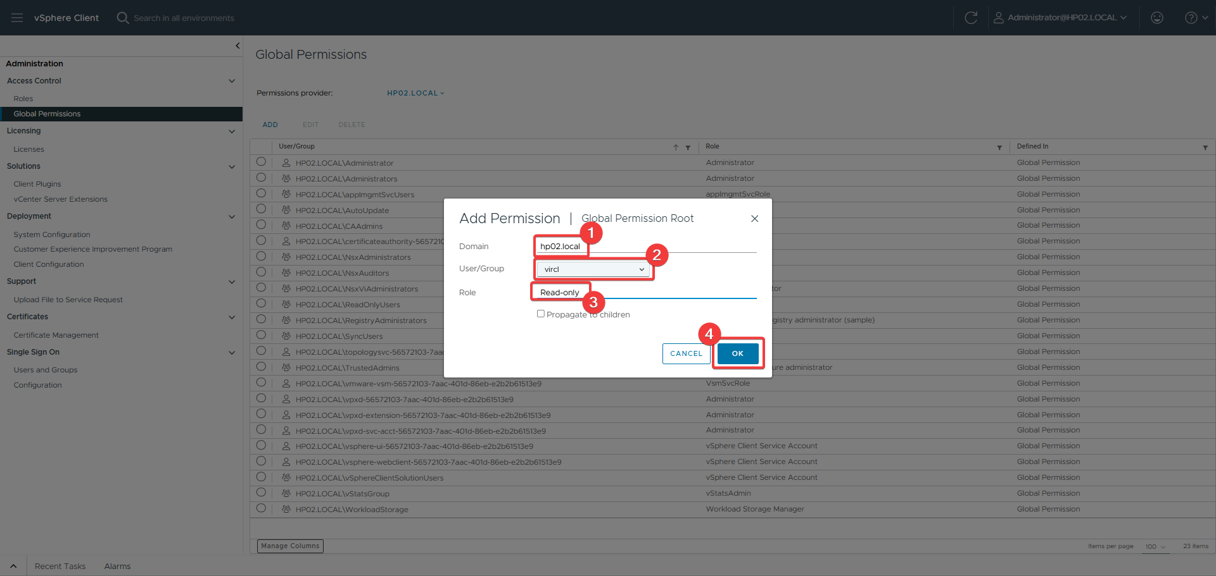
Figure 168: Adding global permission
A global permission is assigned to control access rights across the vCenter inventory hierarchy.

31.4 Proxmox Comparison
VMware vCenter provides more granular permission management with object-level inheritance and integration with enterprise identity systems (Active Directory, LDAP). Proxmox uses a simpler path-based permission model that is easier to understand but less flexible for complex hierarchies. VMware's SSO integration is superior for enterprise environments.

31.5 Results
Users were successfully created in the vCenter SSO domain and permissions were assigned. The global permission model provided clear access control across the vCenter inventory.

32. Hypervisor Patching & Updates

32.1 Objective
Update both ESXi hosts to the latest available patches using vSphere Lifecycle Manager, ensuring security patches and bug fixes are applied while maintaining cluster stability.

32.2 Theoretical Background
vSphere Lifecycle Manager (vLCM) provides centralized update orchestration for ESXi hosts. It uses baselines and baseline groups to define desired patch levels, then performs compliance checking and automated remediation. This is significantly more sophisticated than Proxmox's APT-based approach.

32.3 VMware Implementation
vSphere Lifecycle Manager was accessed through the vSphere Client. A new baseline was created for the latest updates, compliance was checked against both hosts, and remediation was performed. The cluster update workflow ensured that hosts were patched in a controlled manner.
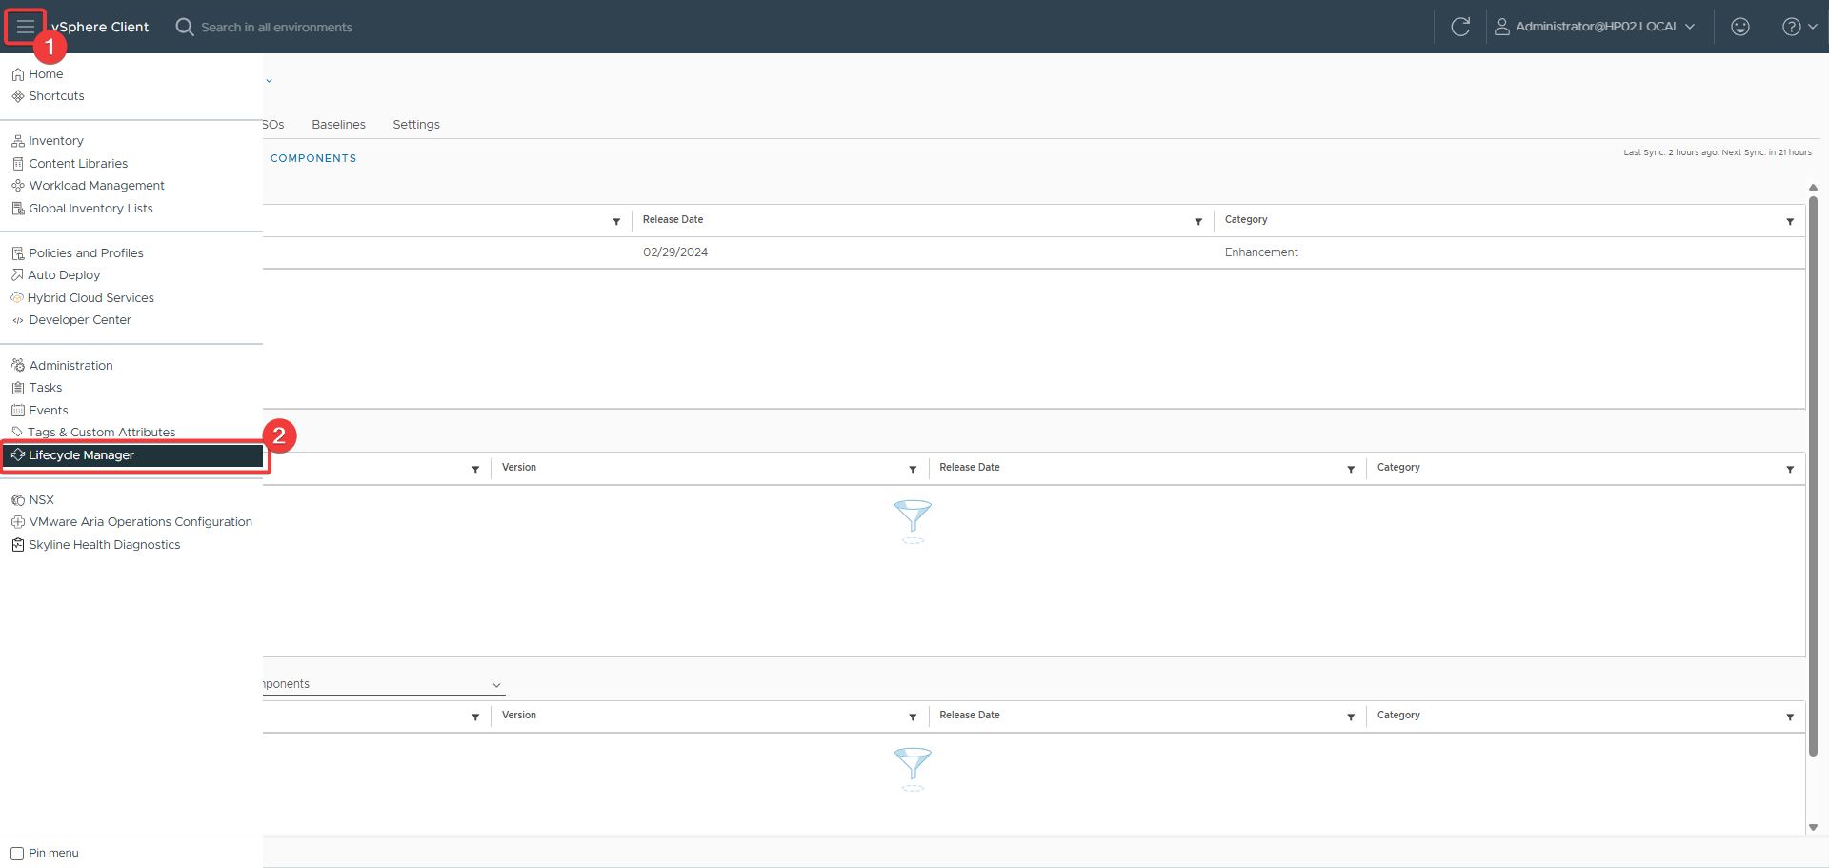
Figure 169: vSphere Lifecycle Manager
The vSphere Lifecycle Manager interface is opened to manage updates for the ESXi hosts.
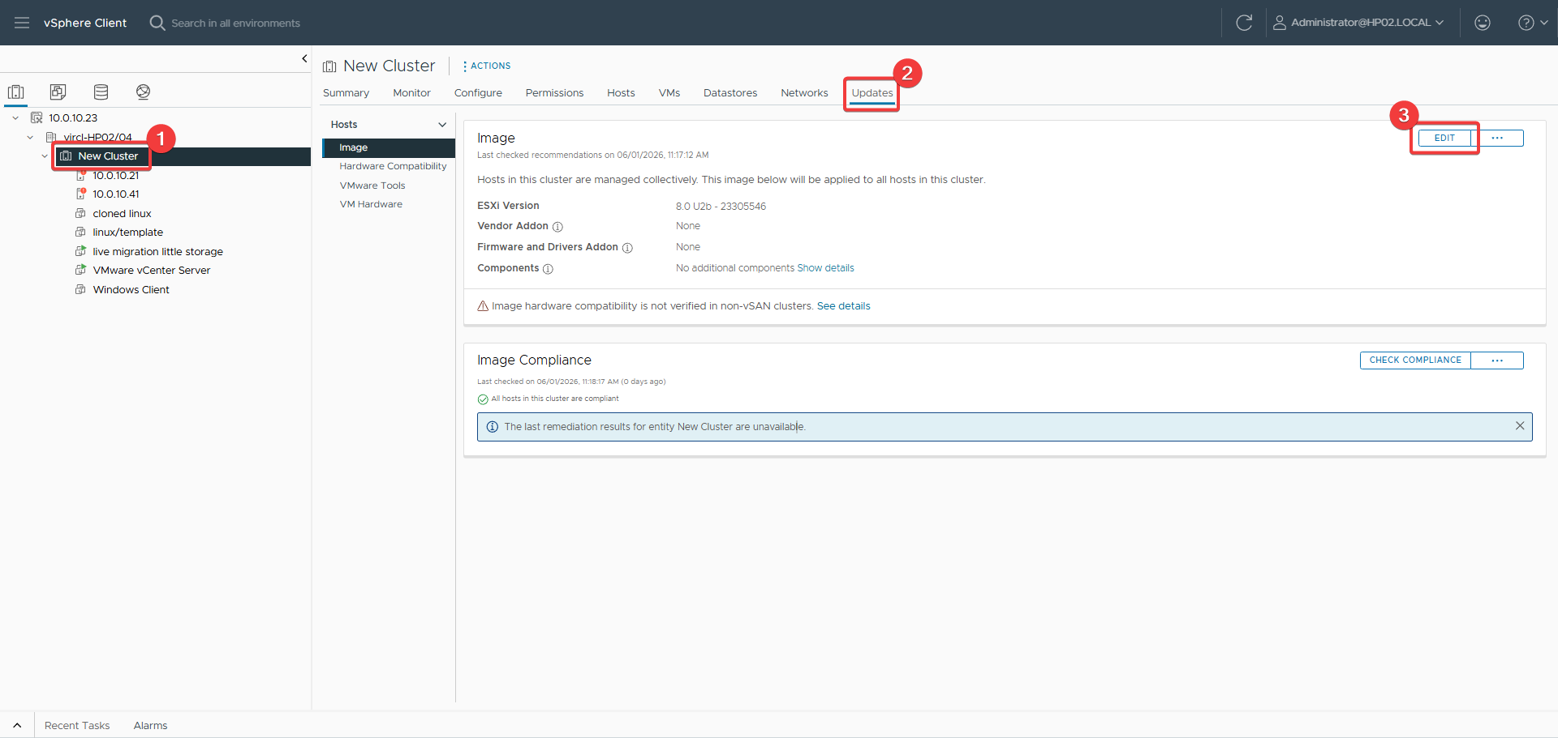
Figure 170: Cluster update path
The cluster update path is selected to define which updates will be applied to hosts.
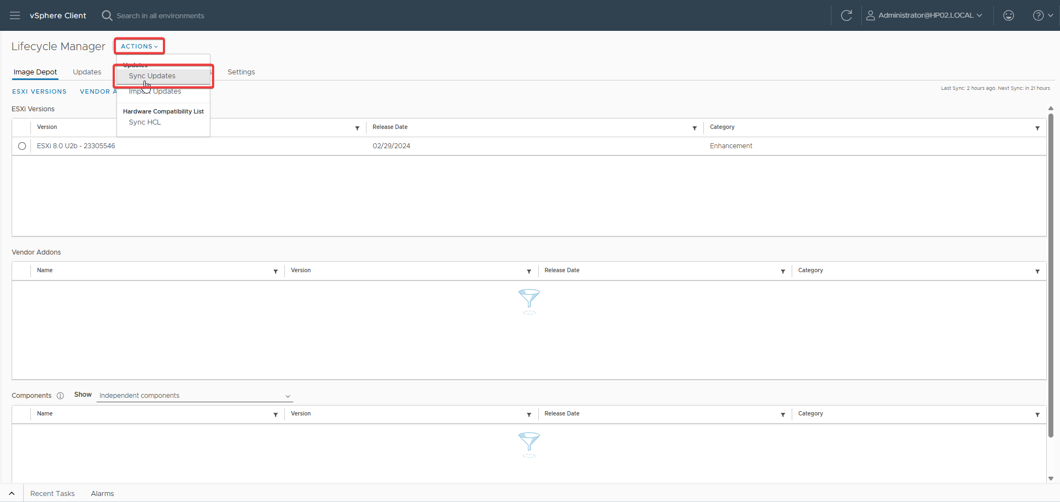
Figure 171: Getting new updates
The system retrieves the latest available updates to build the baseline for host compliance.
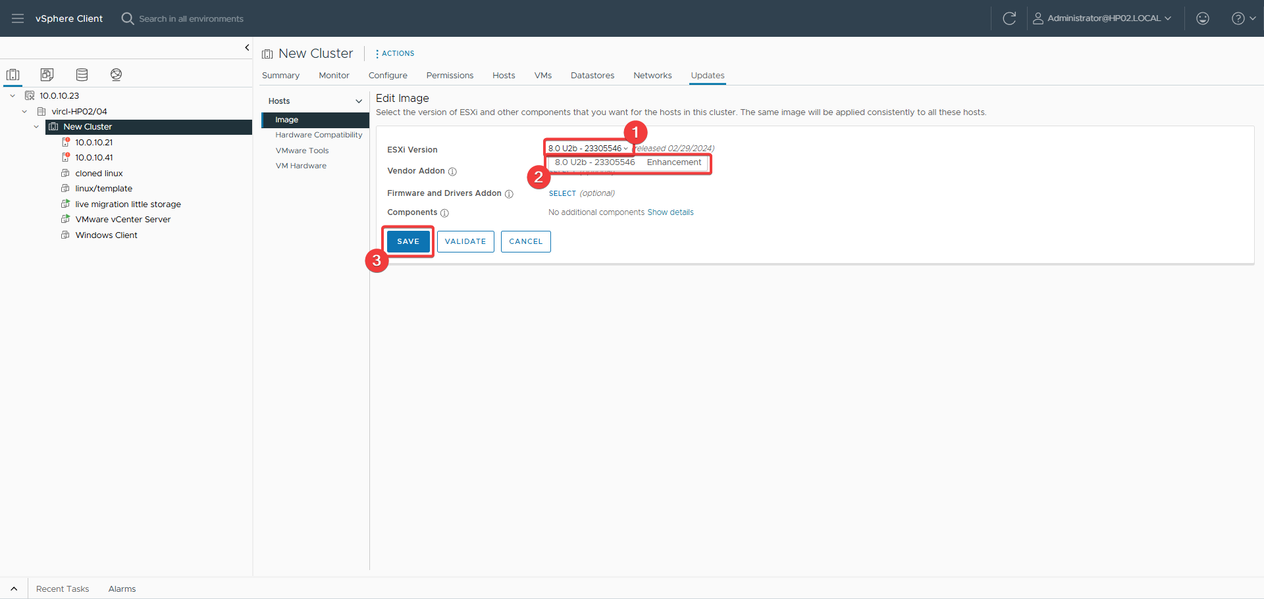
Figure 172: Selecting new update
The specific update is selected to be included in the baseline for host remediation.

32.4 Proxmox Comparison
VMware's vSphere Lifecycle Manager provides enterprise-grade update orchestration with baseline compliance checking, automated remediation, and cluster-aware patching. Proxmox uses standard Linux package management (APT), which is simpler but requires more manual oversight and lacks centralized compliance reporting. VMware's approach is superior for large-scale enterprise environments.

32.5 Results
Both ESXi hosts were successfully patched using vSphere Lifecycle Manager. The baseline compliance checking confirmed that all hosts met the desired patch level, demonstrating VMware's mature update management capabilities.

33. Proxmox vs VMware — Comparative Analysis

33.1 Feature Comparison Matrix
Feature | Proxmox VE 9.1.1 | VMware ESXi 8.0 U2 | Winner
Licensing Cost | Free (no subscription required) | Subscription-only (Broadcom) | Proxmox
Web UI Quality | Modern, responsive, built-in | vSphere Client (requires vCenter) | Proxmox
CLI Power | qm tool, REST API | PowerCLI, ESXCLI | VMware
Backup Solution | Built-in vzdump + PBS (free) | Requires 3rd party (Veeam) | Proxmox
Snapshot Management | Linear list | Visual tree + VSS quiescing | VMware
Template Management | Basic clone | Content Library + Guest Customization | VMware
Live Migration | Online/Offline (cluster) | vMotion (industry standard) | VMware
User Management | Path-based RBAC | Object-based RBAC + SSO | VMware
Patching | APT (Linux standard) | vSphere Lifecycle Manager | VMware
Community Support | Active forums, wiki | Broadcom support (paid) | Proxmox

33.2 Cost Analysis
Component | Proxmox | VMware
Hypervisor | €0 | ~$200-400+/socket/year
Cluster Management | €0 (built-in) | vCenter license required
Backup | €0 (PBS free) | Veeam ~$400+/socket/year
Total (2 nodes, 3 years) | €0-5,610 | ~$6,000-15,000+

33.3 Use Case Recommendations
Scenario | Recommendation | Reasoning
Small Business / Homelab | Proxmox | Zero licensing cost, full features
Enterprise (Existing VMware) | VMware | Ecosystem investment, compliance
Educational Environment | Proxmox | Free, excellent learning platform
Startups / Cost-Conscious | Proxmox | Predictable costs, no vendor lock-in

33.4 Personal Assessment
For this educational project, both Proxmox VE and VMware ESXi/vSphere were implemented and evaluated. Proxmox proved ideal for zero-cost exploration of enterprise features, with its built-in web UI eliminating the need for separate management appliances. VMware demonstrated superior enterprise capabilities in areas like vMotion, Storage vMotion, Lifecycle Manager, and third-party ecosystem integration (Veeam). The choice between platforms depends on context: budget, existing investments, team skills, and compliance requirements. For students and small organizations, Proxmox removes financial barriers while delivering professional-grade virtualization. For large enterprises with strict compliance needs, VMware's ecosystem and certifications justify the cost despite recent Broadcom licensing changes.

34. Problems & Impediments

34.1 Issues Encountered and Solutions
# | Issue | Root Cause | Solution
1 | Proxmox export fails — no GUI button | LVM disks are block devices, not files | Used qemu-img convert from /dev/pve/vm-100-disk-0 to QCOW2
2 | Hypervisor backup — no GUI button | Proxmox doesn't expose /etc/pve backup in GUI | Used tar archive of /etc/pve and network configs
3 | Template creation blocked | VM 100 had a snapshot | Removed snapshot first, then converted
4 | NFS storage add — Read-only file system | NAS export was read-only (ro) | Changed to rw,no_root_squash in OMV
5 | Hypervisor migration blocked | Snapshot retained CD/DVD hardware config | Deleted snapshot or removed CD/DVD device
6 | Patching — DNS resolution failure | /etc/resolv.conf was missing on HP03 | Created file with nameserver 8.8.8.8
7 | Proxmox GUI updater blocked | No active subscription | Used no-subscription repository via CLI
8 | Windows 11 won't boot | Missing UEFI + TPM 2.0 + Q35 | Recreated VM with proper parameters

34.2 Lessons Learned
• Read documentation first — many issues are documented but easy to overlook
• Test in isolation before applying changes to production VMs
• Snapshot hygiene is critical — remove unnecessary snapshots promptly
• DNS resolution is critical for package management — always verify /etc/resolv.conf
• NFS/SMB permissions are a common source of frustration — verify at both NAS and client levels
• vCenter deployment requires significant resources — plan for 4 vCPU and 16 GB RAM minimum
• Veeam licensing costs must be factored into VMware total cost of ownership
• NFS datastore path and ACL configuration must be correct before adding to ESXi
• vSphere Lifecycle Manager baselines provide reliable update orchestration — use them instead of manual patching

35. Personal Conclusion

35.1 Project Reflection
This project provided comprehensive hands-on experience with enterprise server virtualization technologies. Over the course of several weeks, I progressed from basic hypervisor installation to advanced operations including clustering, live migration, and backup automation. The progression mirrored real-world virtualization adoption: deploy, configure, operate, secure, maintain.

35.2 Technical Growth
Skills acquired include Type-1 hypervisor deployment and management, virtual machine lifecycle management, storage protocol configuration, network configuration in virtualized environments, Bash scripting for automation, RBAC and security hardening, and Linux system administration. The backup specialization required understanding both VM-level and hypervisor-level protection strategies, learning that effective backup is not just about creating copies but about choosing the right mode, testing restores, protecting configuration, and automating jobs.

35.3 Platform Assessment
Proxmox VE strengths include incredible value (enterprise features at zero cost), an intuitive web interface, strong Linux integration, an active community, and no artificial feature limitations. Weaknesses include some features requiring CLI access, less polish than VMware for large enterprises, a smaller ecosystem of certified third-party tools, and less sophisticated guest OS customization.

35.4 Final Thoughts
Virtualization is no longer optional in modern IT infrastructure — it is foundational. This project reinforced that the choice between Proxmox and VMware is not about capability (both are excellent) but about context: budget, existing investments, team skills, and compliance requirements. For a student or small organization, Proxmox VE removes financial barriers while delivering professional-grade virtualization. For a Fortune 500 company with strict compliance needs, VMware's ecosystem and certifications justify the cost. The most important takeaway is that the concepts are transferable. Understanding Proxmox's vzdump makes Veeam easier to learn. Mastering Proxmox migration prepares you for vMotion. The underlying virtualization principles — resource abstraction, isolation, portability — are universal.

Appendix A: Proxmox CLI Quick Reference
# VM Management qm create <id> --name <name> --memory <MB> --cores <N> ... qm start <id> qm stop <id> qm shutdown <id> qm destroy <id> qm list qm config <id> # VM Modification qm set <id> --memory <MB> qm set <id> --cores <N> qm set <id> --scsi<N> <storage>:<size> qm set <id> --net<N> virtio,bridge=<bridge> qm disk resize <id> <disk> +<size> # Clone & Template qm clone <src> <dst> --name <name> --full qm template <id> # Snapshot qm snapshot <id> <name> --description "..." qm rollback <id> <name> qm delsnapshot <id> <name> # Backup & Restore vzdump <id> --mode snapshot --compress zstd qmrestore <backup-file> <new-id> # Cluster pvecm create <cluster-name> pvecm add <existing-node-ip> pvecm status # Update apt update && apt upgrade -y pveversion

Appendix B: Glossary
The following terms are used throughout this documentation and are defined for clarity.

Hypervisor
A software layer that abstracts physical hardware resources and enables multiple virtual machines to run on a single physical host. Type-1 hypervisors run directly on hardware; Type-2 runs atop an existing OS.

KVM (Kernel-based Virtual Machine)
The Linux-native virtualization module that provides full hardware virtualization. Proxmox VE uses KVM to run virtual machines with near-native performance.

LXC (Linux Containers)
An OS-level virtualization technology that isolates processes and resources on a shared Linux kernel. Proxmox VE supports LXC for lightweight containerization alongside full VMs.

QEMU
An open-source machine emulator and virtualizer that works with KVM to provide hardware emulation for virtual machines, including disk, network, and display devices.

QCOW2
QEMU Copy-On-Write version 2, a disk image format that supports snapshots, compression, and thin provisioning. Proxmox VE commonly uses QCOW2 for VM disks.

vzdump
Proxmox VE's built-in backup utility that creates compressed archives (VMA format) of virtual machines. It supports snapshot, suspend, and stop backup modes.

VMA
Virtual Machine Archive, the native backup format used by Proxmox VE's vzdump tool. VMA files contain the full VM state and can be restored with qmrestore.

LVM (Logical Volume Manager)
A Linux storage management framework that allows dynamic allocation, resizing, and snapshotting of logical volumes. Proxmox uses LVM for local VM storage.

NFS (Network File System)
A distributed file system protocol that enables remote hosts to mount storage over a network. Used in this project to connect Proxmox and VMware to the CLOIF2 NAS.

SMB/CIFS
Server Message Block / Common Internet File System, a network file-sharing protocol supported by Windows and Linux. Used for ISO and backup repository access.

iLO (Integrated Lights-Out)
HP's out-of-band management processor that provides remote console, power control, and virtual media mounting even when the server OS is offline.

vMotion
VMware's live migration technology that moves a running VM from one ESXi host to another with zero downtime, transferring memory state over the network.

Storage vMotion
VMware's technology for migrating a VM's disk files between datastores while the VM remains running, using a mirror driver for background copying.

DRS (Distributed Resource Scheduler)
A VMware vCenter feature that automatically balances VM workloads across ESXi hosts based on resource utilization and predefined policies.

HA (High Availability)
A VMware vSphere feature that automatically restarts VMs on surviving hosts after a hardware failure, minimizing service downtime.

vSAN
VMware's software-defined storage solution that aggregates local disks across ESXi hosts into a shared datastore with policy-based management.

VMFS (Virtual Machine File System)
VMware's proprietary clustered filesystem optimized for storing virtual machine files on block storage devices.

VADP (vStorage APIs for Data Protection)
VMware's API framework that enables third-party backup solutions like Veeam to perform efficient, agentless VM backups.

CBT (Changed Block Tracking)
A VMware feature that tracks modified disk blocks since the last backup, enabling incremental backups to transfer only changed data.

Veeam Backup & Replication
A third-party enterprise backup solution for VMware and Hyper-V environments, offering application-aware processing, instant recovery, and replication.

VSS (Volume Shadow Copy Service)
A Microsoft Windows service that enables application-consistent snapshots by coordinating quiescing of running applications before capturing disk state.

OVF (Open Virtualization Format)
An open standard for packaging and distributing virtual appliances, consisting of a descriptor file and one or more disk images.

OVA (Open Virtualization Appliance)
A single-file archive format (TAR) containing an OVF package, simplifying distribution and portability of virtual machines.

UEFI (Unified Extensible Firmware Interface)
A modern firmware interface that replaces legacy BIOS, required for Windows 11 and supporting Secure Boot and TPM.

SeaBIOS
An open-source legacy BIOS implementation used by QEMU/KVM for guest operating systems that do not require UEFI.

VirtIO
A paravirtualized I/O driver framework for KVM/QEMU that provides high-performance disk and network interfaces for virtual machines.

TPM (Trusted Platform Module)
A hardware security chip that provides cryptographic functions, required by Windows 11 and used for BitLocker and measured boot.

cloud-init
A multi-distribution package for early initialization of cloud instances, enabling automatic configuration of hostname, network, and users.

Content Library
A VMware vCenter feature that provides centralized storage and distribution of VM templates, ISO images, and other content across multiple sites.

RBAC (Role-Based Access Control)
A security model where permissions are assigned to roles, and roles are assigned to users or groups, enforcing the principle of least privilege.

SSO (Single Sign-On)
An authentication mechanism that allows users to log in once and gain access to multiple services. VMware vCenter uses SSO domains for centralized identity management.

EVC (Enhanced vMotion Compatibility)
A VMware feature that masks CPU differences between ESXi hosts, enabling vMotion across heterogeneous hardware generations.

VDI (Virtual Desktop Infrastructure)
A desktop virtualization technology that hosts user desktops on centralized servers, enabling remote access and simplified management.

RAID (Redundant Array of Independent Disks)
A data storage technology that combines multiple disk drives for performance, capacity, or redundancy. The CLOIF2 NAS uses RAID5.

Thin Provisioning
A storage allocation strategy where disk space is allocated on demand rather than upfront, reducing initial storage consumption and enabling overprovisioning.

Snapshot
A point-in-time capture of a VM's disk state, enabling rollback to a previous configuration. Snapshots use delta disks to track changes.

Template
A master copy of a VM that cannot be powered on or edited directly, used to rapidly deploy standardized virtual machines.

Live Migration
The process of moving a running VM from one host or storage device to another without service interruption, also called vMotion or online migration.

Cluster
A group of hypervisor nodes configured for shared management, enabling centralized administration, live migration, and high availability.

pmxcfs
Proxmox Cluster File System, a special distributed filesystem that synchronizes configuration files across all nodes in a Proxmox cluster via Corosync.

APT (Advanced Package Tool)
Debian's package management system used by Proxmox for installing, updating, and removing software packages and security patches.

ZSTD
Zstandard, a fast lossless compression algorithm developed by Facebook. Proxmox uses ZSTD for backup compression due to its excellent speed/ratio balance.

pvecm
The Proxmox cluster management CLI tool used to create, join, and monitor Proxmox VE clusters.

qm
The Proxmox VM management CLI tool (QEMU Manager) used to create, configure, start, stop, and clone virtual machines.

esxcli
VMware's command-line interface for ESXi host management, covering hardware, network, storage, and system configuration.

vim-cmd
A legacy VMware CLI tool on ESXi hosts for direct VM and service management when vCenter is unavailable.

PowerCLI
VMware's PowerShell module for automating vCenter and ESXi management, offering hundreds of cmdlets for large-scale operations.

vSphere Client
VMware's web-based management interface for vCenter, providing a graphical interface for VM lifecycle, resource, and configuration management.

vCenter Server Appliance (VCSA)
A preconfigured Linux-based virtual appliance that hosts vCenter Server services, providing centralized management of ESXi hosts.

vSphere Lifecycle Manager (vLCM)
VMware's centralized update and compliance tool for ESXi hosts, using baselines and automated remediation.

Proxmox VE
An open-source Type-1 hypervisor platform based on Debian Linux, combining KVM virtualization and LXC containerization with a unified web interface.

VMware ESXi
A proprietary Type-1 hypervisor developed by VMware (now Broadcom), using the VMkernel microkernel architecture optimized for virtualization.

OpenMediaVault
A free Linux-based NAS solution built on Debian, providing web-based management of file sharing, storage, and services.

Areca RAID
A hardware RAID controller brand used in the CLOIF2 NAS to manage the RAID5 storage pool.
Term | Definition
Hypervisor | Software that creates and runs virtual machines
Type-1 (Bare-Metal) | Hypervisor runs directly on hardware
KVM | Kernel-based Virtual Machine (Linux virtualization)
QEMU | Quick Emulator (hardware emulation platform)
LXC | Linux Containers (OS-level virtualization)
VM | Virtual Machine — emulated computer system
QCOW2 | QEMU Copy-On-Write version 2 (disk image format)
LVM | Logical Volume Manager (Linux storage abstraction)
NFS | Network File System (distributed file protocol)
SMB/CIFS | Server Message Block / Common Internet File System
iSCSI | Internet Small Computer Systems Interface (block storage over IP)
iLO | Integrated Lights-Out (HP remote management)
RBAC | Role-Based Access Control
OVF/OVA | Open Virtualization Format / Archive
VMDK | Virtual Machine Disk (VMware format)
VMA | Virtual Machine Archive (Proxmox format)
ZSTD | Zstandard compression algorithm
TPM | Trusted Platform Module (hardware security chip)
UEFI | Unified Extensible Firmware Interface (modern BIOS replacement)
vMotion | VMware live migration technology
HA | High Availability — automatic failover
vSAN | Virtual SAN (VMware software-defined storage)
PBS | Proxmox Backup Server
OMV | OpenMediaVault (NAS operating system)
VADP | vStorage APIs for Data Protection (VMware backup API)
CBT | Changed Block Tracking (incremental backup)
vLCM | vSphere Lifecycle Manager
EVC | Enhanced vMotion Compatibility
VSS | Volume Shadow Copy Service (Windows)

Appendix C: Sources and References
The following sources were consulted during the research, implementation, and documentation of this project. All official documentation was accessed in June 2026.
Proxmox VE. (2026). Proxmox VE Administration Guide. Proxmox Server Solutions GmbH. https://pve.proxmox.com/wiki/Main_Page
Proxmox VE. (2026). Proxmox VE 9.1 Release Notes. https://pve.proxmox.com/wiki/Roadmap
VMware by Broadcom. (2026). VMware ESXi 8.0 Documentation. https://docs.vmware.com/en/VMware-vSphere/8.0
VMware by Broadcom. (2026). vCenter Server 8.0 Installation Guide. https://docs.vmware.com/en/VMware-vSphere/8.0/vsphere-vcenter-installation
Veeam Software. (2026). Veeam Backup & Replication Documentation. https://helpcenter.veeam.com/docs/backup/vsphere
Canonical Ltd. (2026). Ubuntu Server 24.04 LTS Documentation. https://ubuntu.com/server/docs
Microsoft Corporation. (2026). Windows 11 Enterprise Evaluation. https://www.microsoft.com/en-us/evalcenter/evaluate-windows-11-enterprise
OpenMediaVault. (2026). OpenMediaVault 7 Documentation. https://docs.openmediavault.org/
Hewlett Packard Enterprise. (2016). HP iLO 4 User Guide. https://support.hpe.com/hpesc/public/docDisplay?docId=c04437768
QEMU Project. (2026). QEMU Documentation. https://qemu.readthedocs.io/
Linux Kernel Organization. (2026). KVM Documentation. https://www.kernel.org/doc/html/latest/virt/kvm/
OASIS. (2024). Open Virtualization Format (OVF) Specification 2.1.1. https://www.dmtf.org/standards/ovf
Internet Engineering Task Force. (2000). RFC 3010 - NFS version 4 Protocol. https://datatracker.ietf.org/doc/html/rfc3010
Microsoft. (2024). Server Message Block (SMB) Protocol. https://docs.microsoft.com/en-us/windows-server/storage/file-server/file-server-smb-overview
Facebook/Open Source. (2026). Zstandard Compression. https://facebook.github.io/zstd/
Debian Project. (2026). APT User Guide. https://wiki.debian.org/Apt
Corosync Cluster Engine. (2026). Corosync Documentation. https://corosync.github.io/corosync/
VMware by Broadcom. (2026). vSphere Lifecycle Manager Documentation. https://docs.vmware.com/en/VMware-vSphere/8.0/vsphere-lifecycle-manager
Red Hat, Inc. (2026). Logical Volume Manager (LVM) Administration. https://access.redhat.com/documentation/en-us/red_hat_enterprise_linux/9/html/logical_volume_manager_administration/
Intel Corporation. (2024). UEFI Specification. https://uefi.org/specifications

List of Figures

The following list contains all screenshots, diagrams, and images documented in this report, organized by figure number.
Figure 1: Selecting the boot media in iLO Virtual Media
Figure 2: Proxmox boot menu
Figure 3: Target drive selection
Figure 4: Network configuration
Figure 5: Root password configuration
Figure 6: Installation summary
Figure 7: Post-installation web interface
Figure 8: ISO image upload to local storage
Figure 9: General settings
Figure 10: OS selection
Figure 11: Disk configuration
Figure 12: CPU configuration
Figure 13: Memory configuration
Figure 14: Network configuration
Figure 15: Confirmation and summary
Figure 16: SSH console to Proxmox node
Figure 17: VM creation via CLI command
Figure 18: Ubuntu Server — login prompt after installation
Figure 19: Windows 11 — desktop environment
Figure 20: VM hardware configuration tab
Figure 21: Ubuntu Server — login prompt after installation
Figure 22: Clone VM — source selection
Figure 23: Windows 11 — desktop environment
Figure 24: VM hardware configuration tab
Figure 25: Adding a new disk
Figure 26: Clone VM — source selection
Figure 27: Clone VM — result in VM list
Figure 28: Export VM — qemu-img convert command
Figure 29: VM Backup — Backup tab interface
Figure 30: VM Backup — Completed backup file (2.86 GB)
Figure 31: Custom backup script in nano editor
Figure 32: Hypervisor backup — tar command and archive verification
Figure 33: Snapshot creation dialog
Figure 34: Snapshot list and management
Figure 35: Template conversion
Figure 36: Template icon and deployment
Figure 37: NAS share creation in OpenMediaVault
Figure 38: Proxmox NFS storage add dialog
Figure 39: NFS storage configuration
Figure 40: SMB storage add dialog
Figure 41: Storage list showing both NFS and SMB
Figure 42: Storage migration — running VM
Figure 43: Storage migration — stopped VM
Figure 44: Storage migration — progress dialog
Figure 45: Cluster creation
Figure 46: Cluster status verification
Figure 47: Hypervisor migration — select VM and click Migrate
Figure 48: Migration dialog — source and target nodes
Figure 49: Migration progress
Figure 50: VM successfully migrated to HP03
Figure 51: User creation dialog
Figure 52: User list with groups
Figure 53: Permission assignment
Figure 54: Group permissions configuration
Figure 55: Role-based access control overview
Figure 56: Repository configuration — adding no-subscription repo
Figure 57: Repository list
Figure 58: apt update output
Figure 59: apt upgrade output
Figure 60: Version verification after patching
Figure 61: ESXi installation screen
Figure 62: End User License Agreement
Figure 63: Root password configuration
Figure 64: Completed ESXi installation
Figure 65: vCenter Server 8.0 installer
Figure 66: Launching the VCSA installer
Figure 67: Deployment target selection
Figure 68: Datastore selection
Figure 69: Network configuration
Figure 70: VCSA root password
Figure 71: Stage 1 installation complete
Figure 72: Stage 2 vCenter configuration
Figure 73: vCenter installation complete
Figure 74: First login to vCenter
Figure 75: Creating a new datacenter
Figure 76: Naming the datacenter
Figure 77: Adding a new host
Figure 78: Host IP configuration
Figure 79: Finished host configuration
Figure 80: Selection of creation type
Figure 81: Choosing guest OS
Figure 82: Compatibility selection
Figure 83: VM hardware configuration
Figure 84: Storage selection
Figure 85: Confirming VM configuration
Figure 86: SSH connection to ESXi host
Figure 87: VM creation via CLI
Figure 88: Verification of VM creation
Figure 89: Windows 11 installation
Figure 90: Keyboard layout selection
Figure 91: Storage selection
Figure 92: Install button
Figure 93: Profile configuration
Figure 94: Language selection
Figure 95: Keyboard selection
Figure 96: Network configuration
Figure 97: Storage configuration
Figure 98: Profile configuration
Figure 99: Finished installation
Figure 100: Accessing VM configuration
Figure 101: Changing VM hardware configuration
Figure 102: Navigating to clone page
Figure 103: Name and folder selection
Figure 104: Compute resource selection
Figure 105: Storage pool selection
Figure 106: Clone options
Figure 107: Ready to complete
Figure 108: Navigating to export page
Figure 109: Export OVF Template dialog
Figure 110: Veeam installation page
Figure 111: Veeam type selection
Figure 112: License agreement
Figure 113: Ready to install
Figure 114: Installation complete
Figure 115: Selecting vSphere
Figure 116: vSphere over Cloud Director
Figure 117: Backup server specification
Figure 118: Adding admin credentials
Figure 119: Confirming admin password
Figure 120: Adding storage repository
Figure 121: Naming backup repository
Figure 122: Direct attached storage selection
Figure 123: Direct attached storage on Windows
Figure 124: Folder selection
Figure 125: Confirming folder
Figure 126: Adding first backup job
Figure 127: Naming backup job
Figure 128: Selecting VM to backup
Figure 129: Guest processing selection
Figure 130: Backup schedule configuration
Figure 131: Backup job summary
Figure 132: VMs selected for backup job
Figure 133: Connecting to vCenter
Figure 134: Copying config files to NAS
Figure 135: Navigating to snapshot page
Figure 136: Snapshot configuration
Figure 137: Navigating to revert page
Figure 138: Revert snapshot page
Figure 139: Navigating to template page
Figure 140: Template conversion confirmation
Figure 141: Navigating to clone template
Figure 142: Name and folder selection
Figure 143: Compute resources selection
Figure 144: Storage selection
Figure 145: Ready to complete
Figure 146: Navigating to add storage
Figure 147: Storage type selection
Figure 148: NFS version selection
Figure 149: NAS not yet added
Figure 150: NAS successfully added
Figure 151: Ready to complete
Figure 152: Navigating to migration page
Figure 153: Choosing storage migration
Figure 154: Selecting target storage
Figure 155: Ready to complete
Figure 156: Verification of migration
Figure 157: Navigating to migration page
Figure 158: Selecting new server
Figure 159: Choosing migration type
Figure 160: vMotion priority selection
Figure 161: Network selection
Figure 162: Ready to complete
Figure 163: Stopped VM migration page
Figure 164: Stopped VM server selection
Figure 165: Stopped VM migration type
Figure 166: Stopped VM network selection
Figure 167: Stopped VM ready to complete
Figure 168: Navigating to user config
Figure 169: Add user page
Figure 170: Adding user with correct domain
Figure 171: Navigating to permissions
Figure 172: Adding global permission

